Fig 1
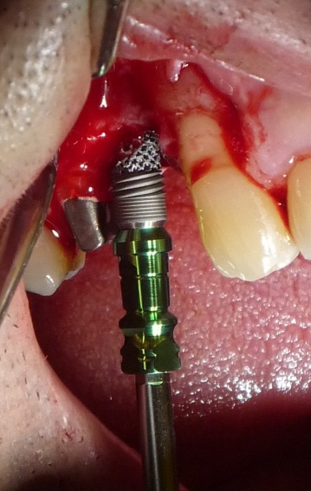
Fig 2
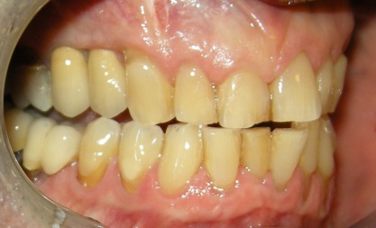

Fig 3
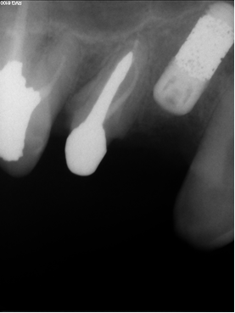

Fig 4
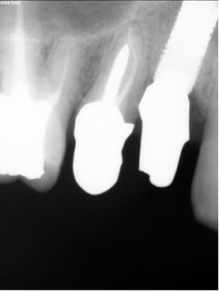

Figures legend
Fig. 1: TM Dental Implant placed in the maxilla; intraoral view.
Fig 2: TM Dental Implant; final restoration.
Fig 3: TM Dental Implant placed in the maxilla; periapical radiograph.
Fig 4: TM Dental Implant; periapical radiograph 18 months after placement.

