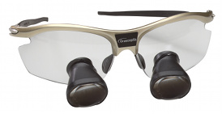 ***Figure1: Compound loupes mounted on eyeglasses***

***Figure2:Parts of a surgical microscope***

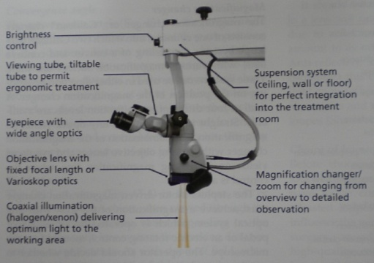

**Figure 3:Microsurgical triad**

**ILLUMINATION**

**MAGNIFICATION**

**INCREASED PRECISION**

*Figure4:* MICRO MIRRORS

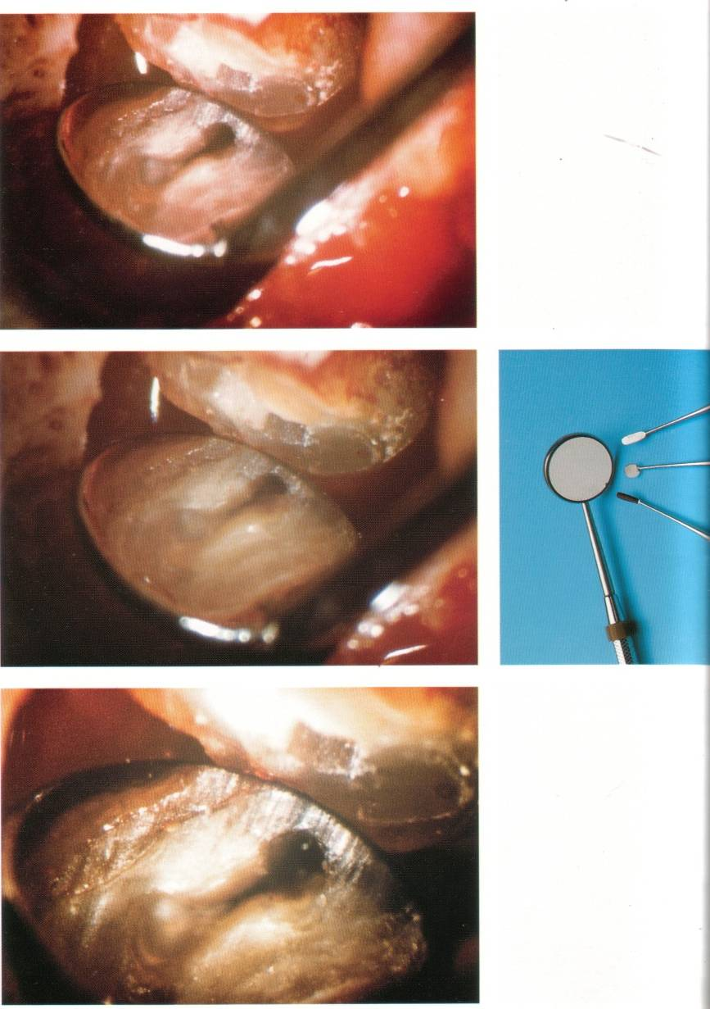

***Figure5: Microsutures and microinstruments at X10 AND X20 magnification.***



***Figure6: Microsurgical treatment of maxillary cuspid recession with***

***free gingival graft***

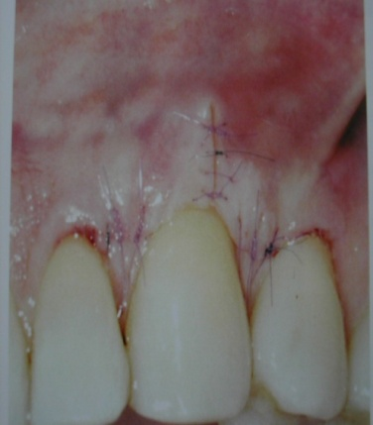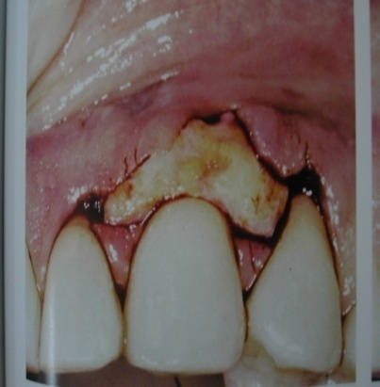

***Figure7:*** ***Intrasulcular incisions (A, B), Horizontal incision (C)***

