An Odontogenic Myxoma of Maxilla;A case report
Abstract
Odontogenic myxoma (OM) is a relatively rare benign odontogenic tumor of mesenchymal origin. OM is common in mandible than in maxilla. It is an asymptomatic lesion that shows an infiltrative growth pattern. When the maxillary sinus is involved, it often fills the entire antrum. Odontogenic tumors are uncommon in maxillary molar area which often leads to diagnostic dilemma as this region of maxilla is in vicinity of vital structure, and radiographic over lapping of structures is always present. We present a similar case of 17 year old young male patient who reported with a swelling in the left maxilla which infiltrated the maxillary sinus in a short duration of time.
Key words; Maxillary Sinus, Myxoma; Odontogenic Tumor;
Introduction
Odontogenic Myxoma is considered to be relatively rare benign tumor of mesenchymal origin. It is found in the skin and subcutaneous tissue, heart and also in various sites of the head and neck region.¹ Myxomas of the jaw bones have been traditionally considered to have an odontogenic origin due to the close relation to teeth. According to the literature, OM represents between 3% and 10% of all odontogenic tumors.² Histologicaly it is composed of spindle or stellate shaped cells in an abundant mucous intercellular substance, with little collagen. Those cases with higher amounts of collagen may be termed as myxofibroma.³ Radiographic appearance varies from unilocular to multilocular radiolucency. OM exhibits aggressive infiltration of the adjacent tissue, as it is not encapsulated complete surgical removal is difficult.^{4,5} It has a high tendency to recur and can transform into malignant lesion, hence radiographic, histopathological interpretation are important to establish appropriate surgical management. The treatment options can include curettage with peripheral ostectomy, segmental resection and radical resections for the more aggressive lesions.^{5,7}
Case report
A 17-year-old young male patient visited us with a complaint of swelling in left maxillary molar region, which enlarged to the present size within a span of 3 months. Extra oral swelling was evident in the left side of maxilla (Fig 1). Intra oral examination revealed swelling in the first molar region, obliterating the buccal vestibule. Multilocular radiolucency extending from the distal aspect of canine to the maxillary tuberosity region was observed on Panoramic (Fig 2) and occlusal radiograph (Fig 3). The Computed tomographic (CT) scan showed swelling with bony expansion and thinning of cortical plates with strong enhancement of the mass lesion in the anterior maxilla (Fig 4). Based on a clinical diagnosis of ameloblastoma, a biopsy was performed. The microscopic examination of heamtoxyillin and eosin (H and E) stained section showed fine fibrillar mucoid stroma with evenly spaced spindle, stellate shaped cells, mild to moderate amount of collagen was observed. (Fig-5). The mucoid nature was confirmed with a positive reaction with alcian blue stain (Fig-6), Periodic Acid-Schiff stain was negative. Subsequently the lesion was diagnosed as OM, surgical resection followed by prosthetic reconstruction was proposed.
Discussion
Sivakumar et al.³ suggested that OM is a tumor of a dual fibroblastic-histiocytic origin and the cells comprising odontogenic myxoma are of myofibroblastic origin. The histogenesis of OM is related to the odontogenic ectomesenchyme of a developing tooth or undifferentiated mesenchymal cells in the periodontal ligament..The odontogenic origin has been supported by following reasons.
- Exclusive occurrence in the tooth-bearing areas of the jaws.
- Association with an unerupted tooth or a developmentally absent tooth.
- Frequent occurrence in young individuals.
- Histological similarity between OM and pulpal ectomesenchyme.
- Occasional presence of sparse amounts of odontogenic epithelium.
- Its uncommon occurrence in other parts of the skeleton.⁶
The majority of cases are reported in second and third decade of life. According to Kaffe et al.⁷ Mandibular OM accounted for 66.4% and 33 .6% in the maxilla. According to Lu Y et al.⁸ 52% in the mandible and 48% were located in the maxilla. 65% of the mandibular cases were located in premolar-molar region, 97 % cases were seen in the same area of maxilla.
OM usually is a central lesion, and the radiographic appearance is important to establish the diagnosis. The radiographic characteristics of OM are variable depending on its developmental stage. Multilocular radiolucency with either distinct or poorly defined margins is observed in adults and in the posterior part of the jaw. Unilocular appearance is seen in anterior jaw of young children. ^{5,7,10} J Zang et al.⁵ examined radiographic appearances of 41 OM, which were divided into six types. These were Type I—unilocular; Type II—multilocular (including honeycomb, soap bubble and tennis racquet patterns); Type III—involvement of local alveolar bone; Type IV—involvement of the maxillary sinus; Type V—osteolytic destruction and Type VI—a mix of osteolytic destruction and osteogenesis. Kaffe et al.⁷ in his radiographic study revealed an interesting correlation between size and locularity, unilocular lesions were smaller than 4 cm, and multilocular lesions were larger than 4cm. In the present case the lesion was multilocular and larger than 4 cm. It is difficult to differentiate solid ameloblastoma, Odontogenic Keratocyst and OM, using radiographs as all these lesions exhibit multiloculation. Dental radiographs are bidimensional projection of tridimensional structure, and therefore superimposition of anatomic landmarks can masquerade important findings.
Asuami et al.⁹ examined the dynamic Magnetic resonance imaging (MRI) features to differentiate these lesions, solid areas of ameloblastoma showed an earlier enhancement than whole areas of OM, these results indicated that the dynamic MRI features of the tumor substance of ameloblastoma differs from OM. Due to the scarcity of studies using MR imaging, the characteristics of the OM have not been established satisfactorily.¹⁰
T Koseki, et al.¹¹ studied CT characteristic of OM. They found tumor borders were generally well defined with a smooth margin both for bony and soft tissue structures. Cortical plate continuity was lost in numerous patients and intralesional trabeculations were observed.. In the present case bony expansion in the maxilla was present which measured 4.95x3.60 cm. Thinning and erosion of cortical plates was presnt in anterior and posterior region of maxilla , intralesional trabeculations were seen. D.S. MacDonald-Jankowski¹² suggested both CT and radiographs should be used in an investigation of an OM. CT asses perforation and pattern of septa while radiographs allow a better assessment of the degree of definition of the lesion's margins with adjacent normal bone.
On gross examination, the specimen appears infiltrative mass of mucoid or slimy material. Microscopically, it is made up of loosely arranged spindle and stellate shaped cells, many of which have long fibrillar processes that tend to intermesh. In cases of myxofibroma the amount of collagen in the mucoid stroma is more prominent. ¹³ The mucoid nature was confirmed with a positive reaction with alcian blue staining and negative periodic acid- Schiff staining. Epithelial islands are not commonly observed in myxomas of the jaws which do not play significant role in OM. Akihiro Kimura et al.¹⁴ reported a case of OM the interesting feature was the presence of “active-looking” and irregularly proliferating epithelial islands with a microcystic appearance. Immunohistochemical positivity with CK 19 supports the odontogenic origin and high labeling index for Ki-67 indicates “active epithelium”which is never been reported. OMs are extensively described as case reports however the invasive behaviour of these lesions has not been explained.
The tumor is not radiosensitive, and surgery is the treatment of choice. Surgical procedures vary from currettage, enucleation, local excision, partial and total jaw resection. The lack of a capsule and infiltrative growth pattern is responsible for high rate of recurrence when conservative enucleation and curettage are performed.¹³ Boffano P et al.¹⁵ proposed the protocol to perform conservative surgery by enucleation and curettage when lesions were smaller than 3 cm, whereas a segmental resection with immediate reconstruction is preferred in patients affected by bigger tumor.
Resection of jaw was planned for this patient as lesion in maxilla is in close relation to vital structure, resection procedures minimize the risk of involvement of these structures and also reduce recurrence rate. The patient is on follow up and no sign of recurrence is noted.
Conclusion
Odontogenic Myxoma is an uncommon tumor of uncertain behaviour. OM and other odontogenic tumors share common features on conventional radiographs which lead to diagnostic dilemma. In order to establish treatment protocol various radiographic modalities can be used to determine the extent of the lesion. Histopathological examination is essential to provide conclusive diagnosis and treatment planning.

References
1) Leiser Y, Abu-El-Naaj I, Peled M. Odontogenic myxoma. A case series and review of the surgical management. J Craniomaxillofac Surg.2009;37:206-09.
2) Martínez-Mata G, Mosqueda-Taylor A, Carlos-Bregni R, de Almeida OP, Contreras-Vidaurre E, Vargas PA.et al. Odontogenic myxoma: Clinico-pathological, immunohistochemical and ultrastructural findings of a multicentric series. Oral Oncol. 2008; 44:601– 07.

3) Sivakumar G, Kavitha B, Saraswathi TR, Sivapathasundharam B. Odontogenic myxoma of maxilla. Indian J Dent Res. 2008;19(1):62-65.
4) Halfpenny W, Verey A, Bardsley V. Myxoma of the mandibular condyle: A case report and review of the literature. Oral Surg Oral Med Oral Pathol Oral Radiol Endod.2000;90: 348-53.

5) Zhang J, Wang H, He X, Niu Y, Li X.Radiographic examination of 41 cases of odontogenic myxomas on the basis of conventional radiographs. Dentomaxillofac Radiol.2007;36(3):160-67.

6) Carolina Cavalieri Gomes, Marina Gonçalves Diniz, Alessandra Pires Duarte, Vanessa Fátima Bernardes,Ricardo Santiago Gomez.Molecular review of odontogenic myxoma. Oral Onco.2011;47(5):325-28.
7) Kaffe I, Naor H, Buchner A. Clinical and radiological features of odontogenic myxoma of the jaws. Dentomaxillofac Radiol. 1997;26(5):299-03.
8)Lu Y, Xuan M, Takata T, Wang C, He Z, Zhou Z, Mock D, Nikai H. Odontogenic tumors A demographic study of 759 cases in a Chinese population.Oral Surg Oral Med Oral Pathol Oral Radiol Endod 1998;86:707-14.
9)Asaumi J, Matsuzaki H, Hisatomi M, Konouchi H, Shigehara H, Kishi K. Application of dynamic MRI to differentiating odontogenic myxomas from ameloblastomas. Eur J Radiol. 2002;43(1):37-41.
10)Raphael N Aquilino, Fabricio M Tuji, Nayene L M, Eid Omar F Molina, Hea Y Joo, Francisco Haiter Neto. Odontogenic myxoma in the maxilla: A case report and characteristics on CT and MR. Oral Oncol 2006;42:133–36.
11)Koseki T, Kobayashi K, Hashimoto K, Ariji Y, Tsuchimochi M , Toyama M et al. Computed tomography of odontogenic myxoma. Dentomaxillofac Radiol. 2003;32(3):160-65.
12) D.S. MacDonald-Jankowskia, R.W.K. Yeungb, T. Lic, K.M. Leeb; Computed tomography of odontogenic myxoma. Clin Radiol.2004:59;281–87.
13) Simon EN, Merkx MA, Vuhahula E, Ngassapa D, Stoelinga PJ.Odontogenic myxoma: a clinicopathological study of 33 cases. Int. J. Oral Maxillofac. Surg. 2004;33 :333–37.
14) Akihiro Kimura,Hiromasa Hasegawa, Ken Satou,Yutaka Kitamura, Odontogenic myxoma showing active epithelial islands with microcystic features. J Craniomaxillofac Surg. 2001;59(10)1226–28
15) Boffano P, Gallesio C, Barreca A, Bianchi FA, Garzino-Demo P, Roccia F. Surgical treatment of odontogenic myxoma. J Craniofac Surg. 2011;22(3):982-87.

LEGEND
Figure 1- Swelling present in the left maxilla.
Figure 2- OPG showing multilocular appearance in the left maxilla.
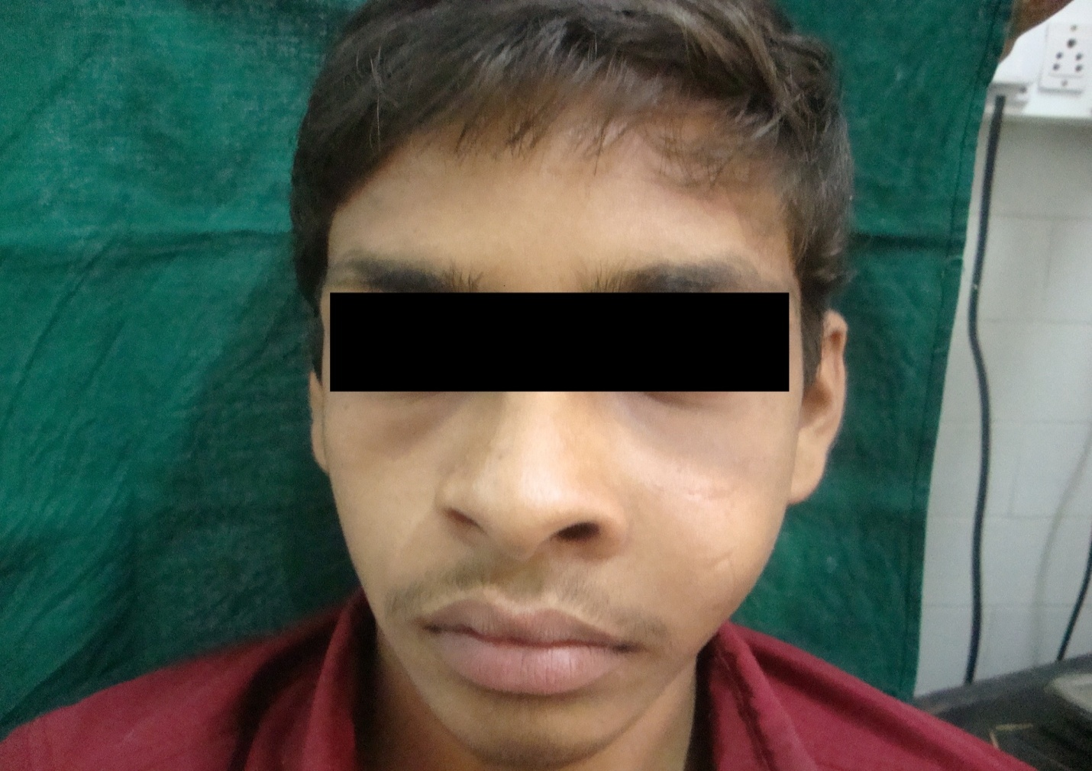
Figure 3 –Occlusal radiograph showing multilocular radiolucency extending from distal aspect of canine to the third molar region.
Figure- 4. C.T Scan showing the extent of the lesion.
Figure -5 H&E section showing stellate shaped cells in the fine fibrillar stroma.(100x)
Figure- 6 Alcian blue positive reaction (40x)

