Chart 1: Mean calcium loss (in ppm) from radicular dentin following treatment with various irrigating solutions

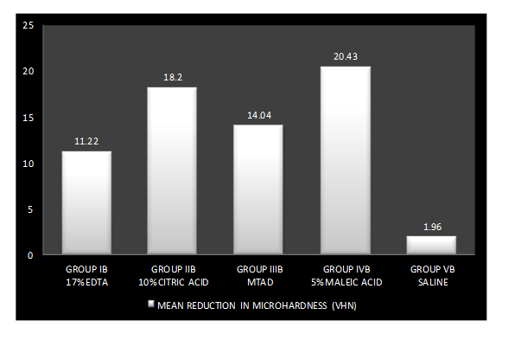
Chart 2: Mean reduction in microhardness (in VHN) of radicular dentin following treatment with various irrigating solutions

Scattered diagram depicting spearman’s correlation test to assess correlation between calcium loss and microhardness reduction
