Assessment of osteogenic material with and without low intensity laser activation in acceleration of healing intra-bony defects

Abstract
The purpose of this study was to evaluate the efficacy of a new material with and without Low intensity laser treatment in accelerating bone formation of an apical radiolucency through a surgical procedure.
In this study total of 30upper anterior maxillary teeth., with periapical lesions ranging from 5-8mm in diameter. Patients were divided randomly into three groups: Group A:Curettage and Filling osseous defect with Nanobone graft only(n=10).Group B: Curettage and treating the Osseous defect with Laser only(n=10).Group C: Curettage and Filling Osseous defect with Nanobone graft and treating the defect with Low intenisty laser(n=10). Cone beam was taken to determine the presence of periapical radiolucency and its approximate size, all patients were followed up using CBCT at 3, 6 and 12 months interval for evaluation of the bone density and size of the radiolucent area. Results: The results of our present study in case of panoramic view (CBCT), it was found that group A (NBG) and C(L+NBG) showed increase in the grey scale value(bone density), while the third group B(LG) had shown lowest grey scale value, on the other hand, in case of cross-section view(CBCT), it was found that group C(L+NBG) had shown the highest grey scale value regarding the other two groups (NBG, LG).
Conclusion: The use of Nano-bone graft and Low intensity laser technique in endodontic surgery is considered an optimum choice, as they both accelerate bone and tissue healing, the use of Low intensity laser decrease the post-operative pain and symptoms, the use of CBCT is considered the only effective method for measuring the bone density or the grey value.
Introduction
The healing of the supporting structure and the resolution of the infection is very important to clam the success of the endodontic treatment. Various tissue cells participate in the healing process. The pattern of healing depends on several factors, two of which are decisive which are: the regeneration potential and the speed by which the tissue cells bordering the defect react.
The new era in medicine is based on the use of the body’s own physiologic way of healing or forming certain tissues in curing diseases or influencing the body to respond in certain ways towards diseases.
Many researchers have suggested the use of bone subsititutes or grafts to fill the space created after removal of periapical pathological lesions surgically in order to speed up the healing process; however the performing of a surgical procedure and the necessity of elevating a flap to remove the pathologic lesion makes the environment already open and the exposed bone ready for a bone substitute or graft. While when bone resorption is of small diameter and the treatment of choice is a conservative non-surgical endodontic treatment this creates a difficulty to take advantage of filling the space with bone substitute.
Development of Osteoconductive and Osteo inductive materials in a gel form with in a syringe that can allow delivery of such materials easily into the bony defect.
One of these biomaterials is the NanoBone, which is a recently developed granular material consisting of nanocrystalline hydroxyapatite (ncHA) embedded in a silica gel matrix, which offers several of the advantages ofnanostructuralbiomaterials^{(1,2)}.NanoBone is completely converted to autologous bone within 12 - 14 months in a process of natural remodelling⁽¹⁾

Laser is an acronym for light amplification by stimulated emission of radiation. It is classified according to power into low power lasers(LPL) which is also called low intensity lasers (LIL) which is used in biomodulation, stimulation of healing, decreasing inflammation and pain relief ⁽³⁾
The beneficial effect of LIL on bone was proved by many authors. It was observed that the collagen production, osteoblastic activity and increased bone mineral density, also it was found that LIL promotes bone regeneration and improves bone density in several studies.^{(4), (5), (6)}
Cone beam computed tomography allowed for 3D measurements which solved most of the measurments problem done with 2D image and low radiation dose in comparison with CT.

Material &Methods

Material used in this study was optodan(LIL), ARTOSS (GmbH)(Nano bone graft), Patients with total of 30 affected upper anterior teeth were divided into three groups randomly with total of 10 teeth for each group, then all patients were undergone for a periapical radiograph, an access cavity through the lingual surface of the anterior teeth, rubber dam were applied, working length will be determined by an apex locator(MortiaII) and cleaning and shaping was done in a crown down technique using Next rotary files mounted on X- Smart endomotor. Then root canals were dried and filled with Tri-antibiotic paste and sealed with Resin-modified Glass inomer(Fuji2) For one week, then Patients were examined clinically to ensure that there is no swelling or pain with percussion . Then obturation followed.
Group A:Curettage and Filling osseous defect with Nanobone graft only(n=10).Group B: Curettage and treating the Osseous defect with Laser only(n=10).Group C: Curettage and Filling Osseous defect with Nanobone graft and treating the defect with Low intenisty laser(n=10). Cone beam was taken to determine the presence of periapical radiolucency and its approximate size, all patients were followed up using CBCT at 3, 6 and 12 months interval for evaluation of the bone density and size of the radiolucent area.

Results

The statistical analyses of the radiographic data of the three groups are presented in tables (1).Fig()
( In cross-section View) Treatment of bony defects with L+ NBG (group B) showed the statistically significantly highest mean rate of increase in mean Grey scaleSignificant at P ≤ 0.05.

(In Panoramic view), there was no statistically significant difference between rates of increase in NBG (group A) and L + NBG( group B) groups; both showed the statistically significantly highest mean rate. LG group showed the statistically significantly lowest mean rate of increase in mean Grey scale.

Table (1 ): Mean, standard deviation (SD) values and results of Kruskal-Wallis test for comparison between rate of increase in grey scale values per month in the three groups

View | LG |  | NBG |  | L + NBG |  | P-value
 | Mean | SD | Mean | SD | Mean | SD
Panoramic | 31.6^{B} | 4.3 | 46.6^{A} | 11.3 | 48.0 ^{A} | 15.1 | 0.031*
Cross-Sectional | 29.7 ^{B} | 4.6 | 36.4 ^{B} | 10.5 | 47.4 ^{A} | 6.2 | 0.019*
*: Significant at P ≤ 0.05, *: Significant at P ≤ 0.05, Different superscripts in the same row are statistically significantly different.

Figure (): Bar chart representing mean values for rate of increase in Grey scale per month

We compared between groups In either Panoramic or Cross-Sectional views, there was no statistically significant difference between mean Grey scale values in the three groups through all study periods.

Table (2): Mean, standard deviation (SD) values and results of Kruskal-Wallis test for comparison between grey scale values in the three groups (Panoramic view)
Time | LG |  | NBG |  | L + NBG |  | P-value
 | Mean | SD | Mean | SD | Mean | SD
Base line | 291.5 | 130.8 | 245.7 | 110.0 | 201.2 | 141.0 | 0.399
3 months | 382.8 | 94.1 | 493.9 | 117.6 | 359.4 | 134.6 | 0.139
6 months | 524.9 | 166.5 | 672.1 | 126.5 | 545.1 | 117.1 | 0.139
12 months | 670.2 | 135.5 | 804.9 | 118.3 | 777.2 | 162.3 | 0.229
*: Significant at P ≤ 0.05

Figure ( ): Bar chart representing mean values for Grey scale in the three groups (Panoramic view)

Table ( 2): Mean, standard deviation (SD) values and results of Kruskal-Wallis test for comparison between grey scale values in the three groups (Cross-Sectional view)
Time | LG |  | NBG |  | L + NBG |  | P-value
 | Mean | SD | Mean | SD | Mean | SD
Base line | 420.2 | 134.3 | 470.5 | 142.0 | 326.6 | 56.2 | 0.189
3 months | 529.5 | 123.6 | 644.4 | 172.0 | 428.5 | 83.7 | 0.065
6 months | 635.0 | 122.8 | 804.6 | 194.3 | 667.0 | 128.0 | 0.264
12 months | 776.3 | 98.3 | 907.7 | 192.6 | 895.8 | 42.9 | 0.086
*: Significant at P ≤ 0.05

Figure (2 ): Bar chart representing mean values for Grey scale in the three groups (Cross-sectional view)

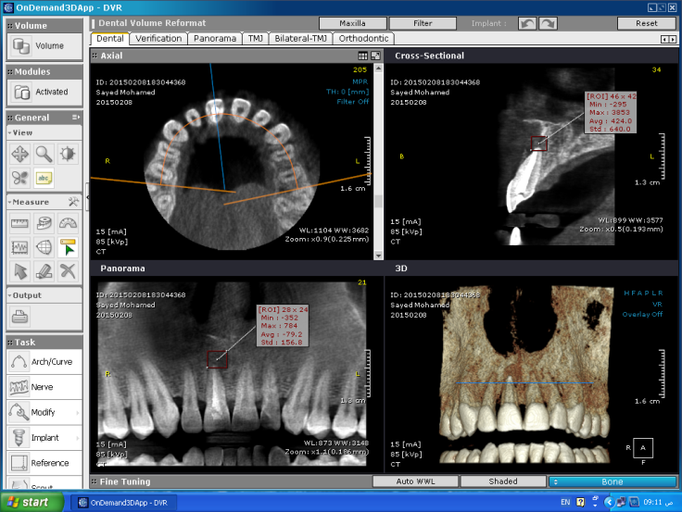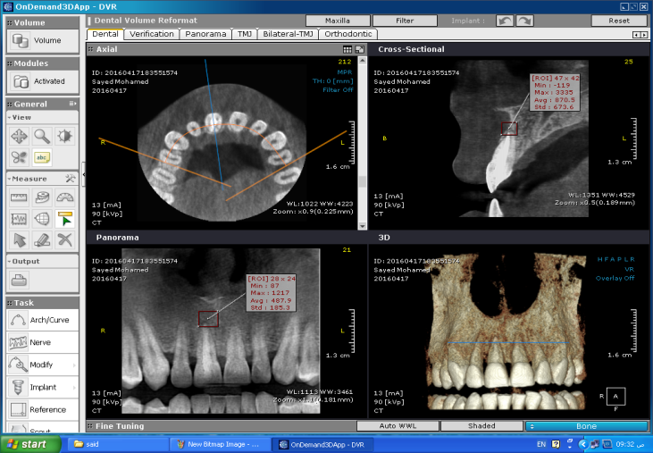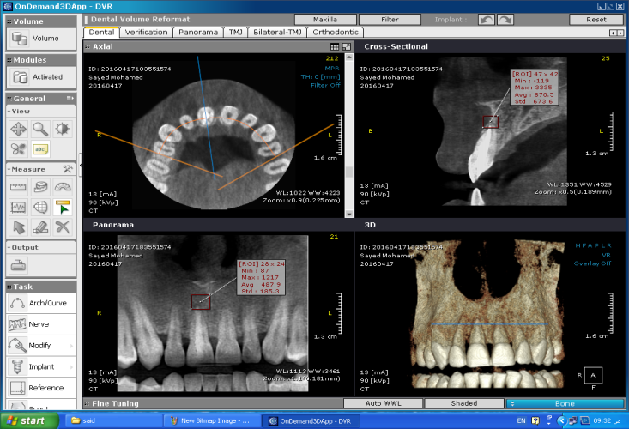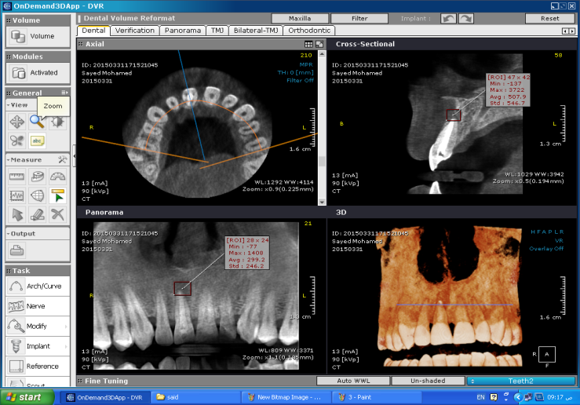
Case report Group C
Nano+Laser group

Fig(1): Showing baseline
Fig(2): Bone healing After 3 month
Fig(3): Bone healing after 6 month
Fig(4): Bone healing after 12 months

Discussion

Many materials were used to enhance healing such as Bioactive Calcium phosphate ceramics are the largest family of alloplastic materials such as HA and TCP, they had been used in many occations, but, the most, enhancment of bone fill after periapicalsurgery^{(7,8,9,10)}. They both appeared to be biocompatiable^{(11,12,13,14,15)}

MTA was able to induce bone regeneration,regulated BMP2 expression and calcification ^{(16,17,18)}, more recent materials like Biodentine, Biodentine has been combined with platelet rich fibrin for a novel approach for bone augmentation in infected periapical cyst^{(19,20,21)}
Nanobone were introduced in this study, ARTOSS (GmbH)(Nanocrystallinehydroxylapatite (HA) is embedded in a highly porous silica gel matrix.), there were granules, blocks and recently putty.

To extend the usability of NanoBone, handling of NanoBone SBX Putty in an applicator designed for quick delivery. This easy-to-use device facilitates rapid implantation of our advanced bone graft in a controlled and precise manner, it differs from other forms that it Saves time with quick and easy application and NanoBone granulate embedded in an aqueous gel^{(22,23,24)}.
NanoBone Putty from Artoss GmbH is a synthetic and absorbable bone autograft substitute with osteoconductive and osteoinductive properties. The nanostructure gives it a large internal surface area, which is key to protein adhesion and therefore to rapid regeneration, Controlled osteoinduction by active agglomeration of growth factors(BMPs)⁽²⁵⁾.
The power of nanobiology, nanobone consists of nanocrystals of HA dispersed in a amorphous silica gel matrix. The HA nanocrystals have similar size, chemistry and morphology to the HA in human bone. These nanocrystals are not bound to one another and autologous proteins adsorb rapidly, on the other hand, the amorphous silics gel matrix holds HA nanocrystals in place is highly nanoporous with an extremely large internal surface area that attracts autologous proteins that are critical for new bone formation. Amorphous silica gel martix is also very hydrophilic and relases silicon dioxode, which triggers angiogenesis and new bone formation.^{(26,27,28)}
NanoBone incorporates nano-crystalline HA (3 nm x 50 nm) into an amorphous silica gel (ASG). This allows for sequestration of nano sized HA particles at the surgical site while upregulating the bone healing cascade through the influence of silicon⁽²⁷⁾.
The very large internal surface area of NanoBone strongly attracts and binds autologous osteopontin, Osteocalcin and BMP-2 molecules that are critical for new bone formation. The internal surface area also determines the resorption rate of bone grafts. In clinical cases, NanoBone is completely converted to autologous bone in as little as 12-14 months⁽²⁶⁾
Also Nanobone can promote the healing process of bone defects. In the first stage of bone healing, the bone matrix proteins can be attracted by nano-bone granules and a vascular rich protein matrix is formed. The osteogenesis then takes place on this matrix and the final bone is regenerated. Since nanoparticles provide a larger surface area, the rate of attracted proteins would be increased. This can explain why the use of nanomaterials can enhance the bone regeneration capacity compared to micro-particle. Also, the large surface area of nanoparticles causes them to act as biological materials⁽²⁹⁾ and therefore, the mechanical reliability and osseoconductivity of nanoparticles can be improved
In the present study patient were included with periapical lesions ranging from 5 to 8mm.
The principle of using low level laser therapy (LLLT) is to supply direct biostimulative light energy to body cells .Absorbed laser energy causes stimulation of molecules and atoms of cells .Using low-intensity laser radiation on the tissues does not cause rapid and significant increase in tissue temperature.⁽³⁰⁾

Laser therapy in treatment of wounds and periapical lesions

In a study, low level laser was used to wound healing and the result showed that:Less inflammation was observed on days 3 and 7 in the treatment group. The inflammation rate on both sides was the same on day 14 .LLLT using optimal parameters can accelerate full thickness wound healing^{(31,32)}. Laser therapy result in better wound healing by the following mechanisms on the 3 phases of primary inflammation, proliferative and remodeling phases.
Increased synthesis of RNA, DNA, proteins, Angiogenesis and neovascularization, accelerated epithelializationa, Anti inflammatory effect by affecting leukocytes and macrophages, Moving metabolism toward aerobic, Reduction of pain and decreased secretion of pain mediators, Activation of the immune system via effect on immunoglobulins IgM-IgG and complements⁽³³⁾. Also daily use of low level laser in a treatment course resulted in stimulation of synthesis of type I collagen fibers and strengthens the scar tissue⁽³²⁾. The anti-oedematous effect of laser energy is based on a dilation of lymphatic vessels and a reduction in the permeability of blood vessels. Laser energy has a regenerative effect on lymphatic vessels, as it has on veins⁽³³⁾.
The results of our present study in case of panoramic view (CBCT), it was found that group A (NBG) and C(L+NBG) showed increase in the grey scale value(bone density), while the third group B(LG) had shown lowest grey scale value, on the other hand, in case of cross-section view(CBCT), it was found that group C(L+NBG) had shown the highest grey scale value regarding the other two groups (NBG, LG). The reason may be attributed to mutlislice layers of the CBCT which more accurate, high resolution(pixels) and less distortion in comparison to panoramic view^{(34,35)}.
Regarding or in respect to time, In either Panoramic or Cross-Sectional views within each group, there was an increase in mean Grey scale values from base line to 3 months, 3 months to 6 months as well as from 6 months to 12 months, which showed increase of bone formation in accordance with previous studies^{(,37,38,39)}, This result can be explained by osseoconductivity and biocompatibility of HA bone material.
Hence, Group C(L+NBG) showed the highest grey scale value, it may be attributed to effect of or the power of nanoparticles^{(22,23,24)},Nano-HA particles are highly biodegradable and biocompatible compared to conventional micro-particles.⁽⁴⁰⁾ Also, nano-particles accelerate the substitution of biomaterials by vital bones ⁽⁴¹⁾ ,The effect of nano-particles is highly dependent on their concentration. It was shown that particle overload can impede the osteogenic differentiation of mesenchymal stem cells⁽⁴²⁾and the effect of LLLT ^{(,36,37)}.

References
- Götz W, Gerber T, Michel B, Lossdörfer S, Henkel KO, Heinemann F:Immunohistochemical characterization of nanocrystalline hydroxyapatite silica gel (NanoBone) osteogenesis: A study on biopsies from human jaws, Clin Oral Impl Res 2008; 19;1016-1026.
- M.T. Chitsazi, A. Shirmohammadi, M. Faramarzie, R. Pourabbas, Rostamzadeh An. A clinical comparison of nano-crystalline hydroxyapatite (ostim) and autogenous bone graft in the treatment of periodontal intrabony defects. Med Oral Patol Oral Cir Bucal, 16 (3) (2011), pp. e448–e453.
- Gable P. and Tuner J. Bone stimulation by low level laser: A theoretical mode for effects. J. Clin. Exp.2003;76: 2003.
- Abdel-Latif M.M. and El-Sherbiny M. Low intensity laser: An experimental study. Egyptian Dent. J. 2000; 46: 1073-9.
- Salah El Din M. and Abdel-Latif M.M. Role of low intensity laser in healing of cyctic defects. Egyptian Dent. J. 2003; 49. 1163-68.
- Salah El Din M. and Dahaba M.M. Effect of diode laser therapy on healing of persistent periradicular lesions in endodontically treated teeth. Egyptian Dent. J. 2001; 47: 299-310.
- Garrett K, Kerr M, Hartwell G, O sullivan S, Mayer P: The effect of a bioresorbable matrix barrier in endodontic surgery on the rate of periapical healing. J Endod, 2002; 28(7): 503-6.
- Habert H: Generic Tricalcium phosphate plugs: an adjunt in endodontics. J Endod, 1991; 17(3): 131-4.
- Himel VT, Brady J, Weir J: Evaluation of repair of mechanical perforations of the pulp chamber floor using biodegradable tricalcium phosphate or calcium hydroxide. J Endod. 1985; 11(3): 161-5.
- Jaber L, Mascres C, Donohue WB: Reaction of the dental pulp to HA. Oral Surg, 1992; 73: 92-8.
- Cohen-S, Burns RC:Pathaways of the pulp 5th Ed, St Louis: CV Mosby Co., 2002: pages 94, 160.
- Liu Ch, Wang W, Shen W, Chen T, HU L, Chen Z: Evaluation of the biocompatibility of a nonceramic HA. J Endod, 1997; 23(9): 490-3.
- Sinai IH, Romea DJ, Glassman G, Morse DR, Fantasia J and Furst L: An Evaluation of Tricalcium phosphate as a treatment for Endodontic perforations. J Endod, 1989; 15(9): 399-403.
- Tobon SI, Arismendi JA, Marin ML, Mesa AL, Valencia JA: Comparison between a conventional technique and two bone regegeneration techniques in periradicular surgery. Int. Endod J. 2002; 35(7) 635-4.
- Yoshida T, Itoh T, Saitoh T, Sekine I:Histopathological Study of the uses of freeze dried allogenic dentin powder and true bone ceramic. J Endod. 1998; 24(9): 581-7.
- Hartwell GR, England MC: Healing of furcation perforations in primate teeth after repair with DFDB: A longitudinal study. J Endod. 1993; 19(7): 357-61.
- Lovelace TB, Mellonig JT Meffert RM, Jones AA, Nummikoski PV, Cochran DL: Clinical evaluation of bioactive glass in the treament of periodontal osseous defects in humans. J Periodontal. 1998; 17: 1027-35.
- Low SB, King CJ, Krieger J. An evaluation of bioactive ceramic in the treatment of periodontal osseous defects. Int J Periodontal Rest Dent, 1997; 17: 359-367.
- Do Nascimento C, Issa JP, Iyomasa MM, Regalo SC, Siéssere S, Pitol DL, de Oliveira Wolga N, Pedrazzi V.Bone repair using mineral trioxide aggregate combined to a material carrier, associated or not with calcium hydroxide in bone defects. J Endod. 2008; 39(7):868-74.
- Maeda H, Nakano T, Tomokiyo A, Fujii S, Wada N, Monnouchi S, Hori K, Akamine A.Mineral trioxide aggregate induces bone morphogenetic protein-2 expression and calcification in human periodontal ligament cells.J Endod. 2010 ;36(4):647-52.
- GallasTorreira M., Dos Santos A.A., Rodriguez Cobos M.A., Fuentes Boquete I., CrespoAbelleira A.The osteoinductive potential of MTA (Mineral Trioxide Aggregate): A histologic study in rabbits. Eur J Anat, 8 (3): 101-105 (2004).
- Sindhura A, Arun A, Shashikala K. Platelet rich fibrin (PRF) with Biodentine - a novel approach for bone augmentation in infected periapical cyst: case reports. Int J Health Sci Res. 2015; 5(11):371-379.
- Reyes-Carmona JF, Felippe MS, Felippe WT. The biomineralization ability of mineral trioxide aggregate and Portland cement on dentin enhances the push-out strength. J Endod. 2010; 36:286-291. 23.
- MaheaswariRajendran, Dr. JeevaRekha M and Dr. Poorana K.Biodentine: Periodontal perspective. International Journal of Applied Dental Sciences 2017; 3(1): 12-16.
- http://artossinc.com/technology/, http://artossinc.com/

- http://nspine.com/site/assets/files/1621/nanobone_putty.pdf,

- Werner Götz and Spyridon N. Papageorgiou. Molecular, cellular and pharmaceutical aspects of synthetic hydroxyapatite bone substitutes for oral and maxillofacial grafting. Current Pharmaceutical Biotechnology 18(1): 95-106, 2017.

- Tadjoedin ES, de Lange GL, Lyaruu DM, Kuiper L, Burger EH. High concentrations of bioactive glass material (BioGran) vs. autogenous bone for sinus floor elevation. Clin Oral Implants Res 2002;13:428-36.
- Ghanaati S, Barbeck M, Willerhausen I, Thimm B, Stuebinger S, Korzinskas T, Obreja K, Landes C, Kirkpatrick CJ, Sader RaNanocrystalline Hydroxyapatite Bone Substitute Leads to Sufficient Bone Tissue Formation Already after 3 Month: Histological and Histomorphometrical Analysis 3 and 6 Months following Human Sinus Cavity Augmentation. Clin Implant Dent Relat Res. 2012 Jan 17.
- Mester E, Mester AF, Mester A. The biomedical effects of laser application. Lasers Surg Med. 1985; 5(1):31-9. y of semiconductor laser application as an adjunct to conventional scaling and root planing. Lasers Surg Med 2005; 37:350-5.

- P.Surendranath, Radhika Arjunkumar.Low Level Laser Therapy –A Review. Journal of Dental and Medical Sciences 12(5): 2279-0861, 2013,

- Eghbali F. Low level or theraputic lasers, Fekrazad R. Applying low level laser therapy in dentistry. Tehran:Shayan nemoodar; 2009.

- Alipanah Y, Asnaashari M, Anbari F. The effect of low level laser (GaAlAs) therapy on the post-surgical healing of full thickness wounds in rabbits. Med Laser Application. 2011;26(3):133–8.

- G. Papanchev ,Tsv. Borisova-Papancheva , T. Georgiev R. Andreevа. Accuracy of CBCT for Measurement of the Volume, Area and Bone Density of Periapical Lesions. International JSR. 2016; 5: 6.

R.M. Eldibany , M.M. Shokry.The effect of Nanobone in combination with platelet rich fibrin on bone regeneration following enucleation of large mandibular cysts.Tanta Dental Journal. 2014; 11(2): 100-108.
- Ando T, Noguchi I, Satoh Y, Fuse S, Hayama S, Takahashi M.Use of soft lasers in dentistry. Shikai Tenbo. 1985;66(6):1265–8.
- Welch RD, Berry BH, Crawford K, Zhang H, Zobitz M, Bronson D. Subchondral defects in caprine femora augmented with in situsetting hydroxyapatite cement, polymethylmethacrylate, or autogenous bone graft: Biomechanical and histomorphological analysis after two-years. J Orthop Res 2002;20:464-72

- den Boer FC, Wippermann BW, Blokhuis TJ, Patka P, Bakker FC, Haarman HJ. Healing of segmental bone defects with granular porous hydroxyapatite augmented with recombinant human osteogenic protein-1 or autologous bone marrow. J Orthop Res 2003;21:521-8.

- Kruse A, Jung RE, Nicholls F, Zwahlen RA, Hämmerle CH, Weber FE. Bone regeneration in the presence of a synthetic hydroxyapatite/silica oxide-based and a xenogenic hydroxyapatite-based bone substitute material. Clin Oral Implants Res 2011;22:506-11.

- Webster TJ, Siegel RW, Bizios R. Osteoblast adhesion on nanophase ceramics. Biomaterials 1999;20:1221-7.

- Strietzel FP, Reichart PA, Graf HL. Lateral alveolar ridge augmentation using a synthetic nano-crystalline hydroxyapatite bone substitution material (Ostim): Preliminary clinical and histological results. Clin Oral Implants Res 2007;18:743-51.

- Tautzenberger A, Kovtun A, Ignatius A. Nanoparticles and their potential for application in bone. Int J Nanomedicine 2012;7:4545-57

