Antimicrobial Activity of Different Toothpastes on Dental Bacteria in Vitro
Deema Alhafdhi
King Saud University

Contact information: d.alhafdhi@gmail.com
Deema Alhafdhi
225462, Riyadh 11324, Saudi Arabia

ABSTRACT
This in-vitro experiment conducted to test antimicrobial activity of different toothpastes on dental bacteria. Five brands of toothpastes namely Colgate Total, Oral-B Pro-expert, Siwak.F, Aloe Dent and Dabur Herbal were tested for their antimicrobial activity on Staphylococcus aureus, Staphylococcus epidermidis, E-coli and cariogenic bacteria Streptococcus mutans using agar disc diffusion method at different concentrations, MIC & MBC tests. The study proved that fluoride-containing toothpaste with triclosan was most potent than fluoride-containing toothpaste without triclosan, and herbal toothpaste with and without fluoride. The variations in antimicrobial activity of tested toothpastes were run simultaneously against broad-spectrum antibiotic ampicillin and chloramphenicol. The activity of these toothpastes is directly related to presence of antimicrobial compositions in their formulations. As a result, these brands of toothpastes can be used to control the oral biofilms and periodontal diseases related to the tested organism.
Keywords: Antimicrobial, S. mutans, Toothpastes, MIC, MBC.

Antimicrobial Activity of Different Toothpastes on Dental Bacteria in Vitro
Dental caries affect 60% to 90% of school-aged children and a large number of adults in most developed countries mainly as a result of the increasing consumption of sugar and poor exposure to effective toothpastes (Petersen 2003; Touger-Decker & van Loveren 2003). The U.S. Department of Health and Human Services (2000) stated that "among 5- to-17-year-olds, dental decay is five times as common as asthma and seven times as common as hay fever". Tooth decay and caries have existed throughout the human history, but the prevalence of caries has markedly increased in the 19th century as the Industrial Revolution made cane sugar and refined flour easily obtainable (Suddick & Harris 1990). Periodontal disease, also termed as gum disease, is an equivalent threat to oral health, which is caused by oral bacteria. Gum disease might lead to other serious health conditions (U.S. Department of Health and Human Services 2000).

Biofilms
Biofilms are defined as surface-adherent complex community of microorganisms that consist of cells, water, intracellular and extracellular material (Sutherland 2001). The presence of microorganisms within biofilms can occur naturally in the oral environment (Deshpande et al. 2014). When these biofilms overgrow, they're termed as "dental plaque". See Figure 1a (Bowen 2002). Early plaque formation takes 24 hours and it matures within 4 to 10 days with an average of 7 days (University of Illinois 2000). Build-up of plaque on dental surfaces leads to the development of caries (decay). See Figure 1b. Dental caries is the consequence of interaction of cariogenic bacteria with consumed dietary components within a biofilm. This shows that dental caries is dependent on biofilms, and fermentable dietary carbohydrates. Sucrose is considered a key factor in initiating and developing caries as it is fermentable, and can be utilised as a substrate for the synthesis of extracellular and intracellular polysaccharides of bacteria in dental plaque (Newbrun1967; Yoo et al. 2007). These biofilms need to be controlled in order to prevent overgrowth of oral microbiota that in return will promote the development of plaque, caries and periodontal diseases (Deshpande et al. 2014).

Streptococcus mutans
More than 700 bacterial species or phylotypes have been detected in the oral environment so far (Aas et al. 2005). But Streptococcus mutans is the etiologic agent for dental caries, and it co-exists in an interactive joint community with more than 500 other species of bacteria within the dental biofilm (Paster et al. 2001). Early signs of dental caries is characterised by superficial lesion that's caused by acids, the by-products of carbohydrate metabolism by Streptococcus mutans. Cariogenic bacterial activity progresses from enamel to dentin to pulp of teeth if left uncontrolled. See Figure 2 for teeth layers and Figure 1a, 1b, 1c, 1d for progression of dental caries throughout teeth layers. For biofilms to function optimally, bacterial community runs by a quorum system of sensing and signalling (Li et al. 2002). Cariogenic signalling includes co-aggregation, cell-cell communication, metabolic exchange, and genetic material exchange (Kolenbrander et al. 2006; Li et al. 2002; Roberts et al. 2001). These interactions of sensing and signalling system help in the survival of bacteria and in giving dental biofilms resistance (Saini et al. 2011). Heavy colonisation by cariogenic bacteria leaves individuals at high risk for dental caries. Thus, thorough control is essential (Rodis et al. 2006).

Vaccination against Streptococcus mutans
The idea vaccination against cariogenic bacteria Streptococcus mutans has been brought to attention of scientists and pharmacists, but for it to be applicable it needed a few proposals to be met; it needs to be 100% safe for users and more than 90% effective as there are fluoride tablets that prove to be 90% effective in preventing dental caries. Also, the issue faced (dental caries) isn’t life threatening to anyone; it’s cosmetic to some degree. Furthermore, although Streptococcus mutans has been linked to plaque and dental caries, it’s still uncertain whether it’s the primary causative agent as this strain coexists in the biofilm microcommunity with other bacteria, fungi and viruses (McCracken & Cawson 1983).
However, according to McCracken and Cawson (1983), there was a successful experiment conducted on animals that were mono-infected with Streptococcus mutans, but unfortunately this was highly unrelated to human caries as they’re more complex in their occurrence.

Staphylococcus aureus, Staphylococcus epidermidis & Escherichia-coli
Dental plaque can raise the opportunity for different microorganisms to translocate and colonise other body tissue by adhering to either teeth or other microorganisms in the dental plaque (Munro & Grap 2004). The organisms, namely Staphylococcus aureus, Staphylococcus epidermidis & E-coli can be incorporated in the oral environment normally from skin, nasopharynx or faecal-oral route, but still capable of causing pathogenesis (Foster 1996; Kamal & Bernard 2015). Staphylococcus aureus and Staphylcoccus epidermidis can colonise the oral environment and enter blood circulation (bacteraemia) causing bacterial infective endocarditis and/or prosthetic joint infection. Normal daily teeth brushing of individuals with gingivitis or patients undergone invasive dental procedures can result in a higher risk of developing bacteraemia and subsequently bacterial infective endocarditis and/or prosthetic joint infection (Lockhart et al. 2009; Monk et al. 2008; Munro & Grap 2004; Murdoch et al. 2009; Olsen et al. 2010). Bacteraemias are usually transient but in case of high-risk patients that have history in endocarditis or prosthetic joints, bacteraemia can sometimes have a significant outcome which is fatality if not detected early (Waghmare 2013; U.S. Department of Health and Human Services 2000). Taking prophylactic antibacterial medication is highly unrecommended to avoid any emerging resistance and unbalancing of bodily microflora, unless patient has history of cardiac condition and is going under dental procedure or has prosthetic joint with history of complications (American Dental Association 2016). National Health Service (2015) advocated good oral hygiene as it eliminates inflammation and ulceration that may result from cariogenic and periodontopathic outcome which in return will prevent bacteraemia.
Escherichia-coli is considered as normal flora of the gut (coliform). But can be incorporated in oral environment from normal daily activities as well as nail biting and finger sucking (Kamal & Bernard 2015). E-coli and other coliforms in the mouth can cause inflammation of the exposed oral mucosa following tooth extraction. So, controlling these organisms should be taken under consideration.

Toothpaste: Herbal vs. Regular
Brushing of teeth with toothpaste is the most commonly practiced form of oral hygiene in most countries (Pannuti et al. 2003). National Health Service (2015) recommends brushing teeth twice a day. Brushing, tooth-picking and flossing serve as a mechanical practice to maintain oral cavity (teeth) hygiene (Deshpande et al. 2014). With the aid of chemical or natural ingredients in toothpaste and mouth-rinse, better hygiene can be accomplished due to the suppressing ability and releasing of active ingredient (Itthagarun & Wei 1996).

Tricloasn vs Fluoride
Triclosan, derivative of chlorophenol, is an ingredient of most toothpastes and mouth-rinses (Itthagarun & Wei 1996). It posses the power for killing microorganisms by disrupting enzymes required in fatty acid synthesis of bacterial membrane. Similarly, Fluoride-containing toothpastes are also known for their antimicrobial activity. This active component was also found to have ability of decreasing demineralization and increasing re-mineralization to give strength to teeth (Maripandi et al. 2011). But effectiveness of fluoride depends on the extent of tooth lesion. According to a cross-over study measuring ability of fluoride-containing toothpastes in reversing plaque-filled grooves, 25% inhibition in demineralization was observed and 21% of all the dental lesions showed re-mineralisation. Analysis was conducted using transverse microradiography (Lagerweij et al. 1996). Since restoration of dental integrity after cariogenic outcome is limited, health organisations recommend approaching preventive measures (Petersen 2003).
Although fluoride-containing toothpaste with triclosan proved to have antibacterial activity and is approved by U.S. Food and Drug Administration (FDA) and Environmental Protection Agency (EPA), many people avoid using it nowadays as many studies reckon triclosan can be cancerous. Colgate's company stated on their website that they use it in minute percentage in order to provide better dental hygiene and emphasised on its safety for consumers and approved by the FDA in 2013 (Colgate Total® 2013; Ohe 2012). Furthermore, EPA rejected a petition in 2015 to ban triclosan (EPA, 2015). On the contrary, EU and European Chemicals Agency (ECHA) banned triclosan in Europe (Beyond Pesticides 2015). In a statement from ECHA “Risk was identified for both surface water and for the non-compartment specific effects relevant to the food chain (secondary poisoning)”, ECHA also believes any attempts in reducing triclosan toxicity are considered unrealistic (ECHA 2015, cited in Beyond Pesticides 2015). Triclosan is considered as antibacterial pesticide used in making of personal hygiene care products, cosmetics, plastics and textiles. It's been linked to hormonal disruption, cancer, bacterial resistance and aquatic toxicity (Beyond Pesticides 2015). The Centers for Disease Control and Prevention (CDC) reported the results of a survey conducted in 2004 showing 75% of the U.S. population urine contains triclosan (CDC 2009).
Despite the fact that fluoride is now used to protect, re-mineralise and stop demineralisation of the teeth, it was first added to toothpastes as preservative, then it was employed to protect the teeth. Topical appliance of fluoride on teeth has proved to be beneficial, but systemic ingestion of it in countries with fluoridated water has been questioned since countries with non-fluoridated water and salt have the same decline in dental caries according to World Health Organization (WHO) (2011, cited in Connett 2012). See figure 3. Over-fluoridation by ingestion can lead to dental fluorosis which is a chronic condition leaving teeth mottled (stained) and impacting of learning abilities was also suggested (CDC 2015; Choi et al. 2012). In a recent announcement by U.S. Department of Health and Human Services (2011, cited in CDC 2015), a new maximum level of fluorides allowed in public water with a value of 0.7 ppm instead of its old recommendation level of 0.7- 1.2 ppm published since 1962.
Saliva normally has 0.02 to 1.93 ppm fluoride in it. However, developed dental plaque contains around 3.9 to 676 ppm of fluoride which can make it resistant to fluoride activity in dentifrices or water (Naumova et al. 2012; McCracken & Cawson 1983).

Herbal Toothpastes
Despite the efficacy of many fluoride-containing toothpastes and triclosan-containing toothpastes with their antimicrobial power, there is a growing desire to employ natural ingredients in a call for a more healthy life, which has also found its way into dentistry and is now readily available in markets and pharmacies (Gunsolley 2006; Lee et al. 2004; Bratthall et al. 1996). Most regular toothpastes contain many chemicals with controversial reputation, so the public oriented towards more natural herbal toothpastes leaving behind any unforeseen risks of regular toothpastes.
This study was aimed at comparing the antimicrobial activity of fluoride-containing toothpastes with or without triclosan or herbal ingredients and non-fluoride-containing toothpastes with herbal ingredients against isolated cariogen Streptococcus mutans, Staphylococcus aureus, Staphylcoccus epidermidis and E-coli in vitro.

Active Natural Ingredients in the Selected Toothpastes
Before the 19th century, human medicine mainly relied on plants. The active natural ingredients that were used in selected toothpastes for this study will be briefly elucidated.
Miswak or siwak (scientifically named Salvadora persica) twig is popular in maintain oral hygiene for its religious beliefs and also antimicrobial effect on oral organisms. It’s also recommended by WHO (World Health Organization (WHO) 1997). In a recent study in 2016, Miswak also showed strong to moderate antibacterial effect on multi-drug resistant (MDR) bacterial strains (Al-Ayed et al 2016). See appendix 1 for bacterial strains tested in the given study.
Ginger (scientifically named Zingiber officinale) has been used for its antimicrobial effect on many of the oral microorganisms and other medicinal applications (Jain et al. 2015)
Aloe vera (scientifically named Aloe barbadensis Miller) gel is used in dentifrice for its antibacterial effect on cariogenic, periodontopathic, opportunistic bacteria (Jain et al. 2015). It was also widely used for its anti-inflammatory, antioxidant and immune-boosting properties (Fani & Kohanteb 2012).
Vitamin E, a well known antioxidant, is used in some dentifrices to reduce oral cancer by inhibiting carcinogenic chemicals from smoking tobacco (Bakhtiari et al. 2015).
Ubiquinone (co Q10) is a coenzyme that’s used for its antioxidant power as well as its ability in promoting faster wound healing of the gums (Yoneda et al. 2014).
Toothache tree (scientifically named Zanthoxylum chalybeum) has been used, as the name suggests, for dental and also periodontal diseases. But has been clinically proven for the first time in 2015 and showed marked inhibitory effect on periodontopathic bacteria (Ocheng et al. 2015).
Soluble calcium salt is has significant effect in re-mineralising dental surfaces after decalcification (Stefański & Postek-Stefańska 2014).
Red ochre, with natural occurring iron oxides in it, was suggested as medicinal powder for its antiseptic power and ability to stop bleeding. There weren’t any further clinical researches with distinctive results; most statements were related to its ability to protect skin by working as SPF or by being one of the many ingredients in anti-ageing skin products (Rifkin et al. 2015; Tran et al. 2015; Trinkaus 1984).
Clove (scientifically named Syzygium aromaticum) essential oils hold antimicrobial, anti-inflammatory antioxidant and immune-boosting properties (Rice-Evans & Miller 1996). It can also inhibit decalcification caused by acids. In a study, clove essential oils were comparatively tested with 1000 ppm of fluoride-containing solution against apple juice decalcifying ability in vitro. Decalcification of teeth enamel occurs at a pH of 5.5, which is known as critical pH, and the apple juice is considered acidic with pH of 3.2. Both components had around equal decalcification inhibition, and just like fluoride, clove can be cytotoxic if used in high doses, so further clinical trials need to be conducted to set maximum tolerated dose (Marya et al. 2012; Mirpour 2015).

Aim
The aim of this study was to compare the antimicrobial activity of various commercially available toothpastes against Streptococcus mutans, Staphylococcus aureus, Staphylcoccus epidermidis and E-coli in vitro.

MATERIAL AND METHOD

Collection of Isolated Organism
The isolated organism Streptococcus mutans that was used for this study was a courtesy of Dr. Sara Algahtani, faculty member at Dentistry College, King Saud University (KSU) and Mrs. Gehan Al-sharif, lab technician, King Saud University. The other isolates namely Staphylococcus aureus (ATCC 25923), Staphylcoccus epidermidis (ATCC 12228) and E-coli (ATCC 25922) were obtained from Clinical Laboratory Sciences department.

Toothpaste
Five toothpastes with fluoride and/or herbal ingredients were selected to test their antimicrobial activity in vitro. The products were collected from a local market in Riyadh. Brand name, active ingredients, percentage and country of origin are listed in Table 1 below. For companies of toothpastes, see appendix 2- Table 5.

Minimum Inhibitory Concentration (MIC) of Toothpastes
Toothpaste samples were diluted in sterile distilled water in serial dilutions. The concentrations prepared were of 25% (250mg/ml), 50% (500mg/ml) and 100% (1g/ml). These concentrations determined the minimum inhibitory concentration in Mueller-Hinton broth. 9ml of sterile Mueller-Hinton broth was poured into tubes, and 1ml of each toothpaste concentration was added in a test tube. By using 0.5 McFarland standards, two drops of each inoculum was added to each test tube and incubated aerobically at 37ºC for 24 hours. A tube containing no toothpaste was considered as positive control broth. Negative control broth had no organism added. Toothpaste with lowest dilution concentration that had no visible growth was considered as minimum inhibitory concentration (MIC) per each toothpaste brand. See Figure 4 (Nwankwo & Ihesiulo 2014).

Minimum Bactericidal Concentration (MBC) of Toothpastes
Minimum bactericidal concentration was performed to determine whether the toothpastes used have a cytotoxic effect on tested organisms or just inhibitory effect. To determine the MBC of toothpastes, a sterilised loop was used to streak the MIC solutions performed earlier on blood agar and incubated aerobically at 37ºC for 24 hours, and E-coli was streaked on MacConkey agar in similar environmental conditions. While for Streptococcus mutans, Brain-Heart Infusion agar was streaked and incubated anaerobically at 37ºC for 48 hours. The streak that had no growth was considered as MBC of respective toothpaste.

Procedure of Testing of Toothpastes against Bacteria
The antimicrobial activity of toothpastes was determined by modified agar disc diffusion method (Nwankwo & Ihesiulo 2014). All toothpastes samples were diluted in sterile distilled water of concentrations mentioned in MIC, that's of 25%, 50% and 100%. In this method, Brain-Heart Infusion agar plates were seeded with 0.5ml of 0.5 McFarland standards from 24 hour broth culture of Streptococcus mutans. Mueller-Hinton agar with 5% sheep blood plates were seeded with 0.5ml of 0.5 McFarland standards from 24 hour broth culture of the remaining organisms. See Figure 5 (Deshpande et al. 2014; Clinical and Laboratory Standards Institute – NCCLS 2007). Paper disc impregnated with particular toothpaste dilution was placed on agar surface. As positive control, broad-spectrum antibiotic ampicillin was used for Streptococcus mutans, Staphylococcus aureus and Staphylococcus epidermidis, while chloramphenicol for E-coli (Inetianbor et al. 2014). Each plate had had paper discs of three respective concentrations of a toothpaste placed in equidistant manner. Plates were incubated at 37˚C for 24 hours except for Brain-Heart Infusion plates that were incubated at 37˚C anaerobically for 48 hours. The antimicrobial activity was evaluated by measuring the diameters of inhibition zones in mm (millimeters) and was considered in this study.

RESULTS
The results of the MIC test, MBC test and antimicrobial assay of modified agar disc diffusion method are illustrated in Table 2, Table 3, Table 4, Figure 6, Figure 7 and Figure 8.

DISCUSSION
Maintaining good oral hygiene can be related to proper tooth brushing using effective toothpastes and other dentifrices, as well as regular annual or semi-annual visits to dentist office for checkups. A consumer’s decision in choosing toothpaste can rely on many factors; social factor, advertising factor and economic factor. Therefore the antimicrobial activity of 5 toothpastes was comparatively evaluated against dental cariogenic bacteria Streptococcus mutans as well as the tested bacteria Staphylococcus aureus, Staphylococcus epidermidis and E-coli.
The toothpaste with most effective antibacterial activity against S. mutans was Colgate Total toothpaste, with sodium fluoride and triclosan as active ingredients that costs 11 Saudi Riyals, had MIC value of 250 mg/ml, MBC of 250 mg/ml and inhibition zone of 40 mm. Oral-B Pro-expert (Whitening), with stannous fluoride, sodium fluoride and zinc salts as its active ingredient that costs 21 Saudi Riyals, proved to have an similar MIC of 250 mg/ml, MBC test showed a significant decrease in colony growth from about <10 in 250 mg/ml and 500 mg/ml to as little as 3 colonies at 1000 mg/ml but with inhibition zone of 35 mm. Siwak.F toothpaste, with active ingredients of miswak powder and sodium monofluorophosphate that costs 8 Saudi Riyals, showed MIC value of 1000 mg/ml MBC test had full to decreased growth to respective concentrations and with a broad inhibition zone of 38 mm. whereas Dabur Herbal )Anti Ageing) toothpaste, with active ingredients of soluble calcium, toothache tree, clove, ginger, red ochre and vitamin E, that also costs 8 Saudi Riyals, showed MIC value of 1000 mg/ml, MBC showed significant decrease to a single colony at 1000 mg/ml with also a broad zone of inhibition of 39 mm. Aloe Dent (Triple Action) toothpaste, with aloe vera, tea tree oil and ubiquinone (Co Q10) as active ingredients that costs 22 Saudi Riyals, scored MIC value of 500 mg/ml, MBC was observed at 500 mg/ml but showed the smallest inhibition zone of 23 mm.
Colgate Total toothpaste antibacterial activity was also the most effective against Staph. aureus had MIC value of 500 mg/ml, MBC was observed from 250 mg/ml and inhibition zone of 23 mm. Oral-B Pro-expert (Whitening) had MIC value of 500 mg/ml, MBC from growth at 250 mg/ml to zero colonies at 500 mg/ml and inhibition zone of 13 mm. Siwak.F toothpaste showed MIC value of 500 mg/ml, MBC test had full growth with slight decrease at higher concentrations and inhibition zone of 9 mm. Aloe Dent (Triple Action) toothpaste scored MIC value of 1000 mg/ml, MBC test had full growth to slight decrease at 1000 mg/ml and inhibition zone of 11 mm. Dabur Herbal )Anti Ageing) toothpaste showed MIC value of 500 mg/ml, MBC test showed full growth at all concentrations with a broad zone of inhibition of 9 mm.
Antibacterial activity of Colgate Total toothpaste against Staph. epidermidis was most effective that had MIC value of 250 mg/ml, MBC at 250 mg/ml and inhibition zone of 40 mm. Oral-B Pro-expert (Whitening) had MIC value of 1000 mg/ml, MBC had 12 colonies to 1 colony to no colonies at all respectively and inhibition zone of 12 mm. Siwak.F toothpaste showed MIC value of 500 mg/ml, MBC test showed full to slight decrease in growth and inhibition zone of 9 mm. Aloe Dent (Triple Action) toothpaste scored MIC value of 1000 mg/ml, MBC test had full to slight decreased growth and inhibition zone of 12 mm. Dabur Herbal )Anti Ageing) toothpaste showed MIC value of 1000 mg/ml, MBC test had full growth at all concentrations with a broad zone of inhibition of 9 mm.
Lastly, Colgate Total toothpaste antibacterial activity against E-coli showed highest potential that had MIC value of 250 mg/ml, MBC test showed 5 colonies to 4 colonies to no colonies respective to concentrations and inhibition zone of 38 mm. Oral-B Pro-expert (Whitening) had MIC value of 250 mg/ml, MBC was observed at 1000 mg/ml and inhibition zone of 10 mm. Siwak.F toothpaste showed MIC value of 500 mg/ml, MBC test showed full to decreased growth and inhibition zone of 14 mm. Dabur Herbal )Anti Ageing) toothpaste showed MIC value of 250 mg/ml, MBC test had full to decreased growth with a broad zone of inhibition of 9 mm. Finally, Aloe Dent (Triple Action) toothpaste didn’t show any MIC value as all tubes were turbid indicating no inhibition of growth, MBC test showed full to decreased growth but the inhibition zone on agar disc diffusion method was of 14 mm. Toothpaste with smallest MIC value relates to its effectiveness with as minimum concentration as possible. Toothpaste with largest inhibition zone also relates to its effectiveness as well as magnitude in eradicating the organism.
Although the selected toothpastes have had different extents of antibacterial activity, yet they proved to have the fitting power in protecting consumers from dental plaque, caries and any periodontal diseases that could result from it. Fluoride-containing toothpaste with triclosan proved to be most effective with exceptional cytotoxic effect against all tested organisms and economic with a price as little as 11 Saudi Riyals. Fluoride-containing toothpaste with 1450 ppm was also very effective against all tested organisms and showed cytotoxic effect against tested organisms if used without prior dilution and significant inhibition effect against S. mutans, but with a higher cost that might range up to 21 Saudi Riyals. Fluoride-containing toothpaste with 920 ppm and herbal ingredient showed good inhibitory protection at high concentrations with an economic price of 8 Saudi Riyals. While non-fluoride-containing toothpaste with herbal ingredients can either be economic or pricey. Aloe Dent (Triple Action) toothpaste, according to present study results, showed the most noticeable decrease in antibacterial activity when diluted to 25% and 50% in agar disc diffusion method against S. mutans but effective MBC from 500 mg/ml. It’s the least economic offer as it costs 22 Saudi Riyals. Finally, Dabur Herbal (Anti Ageing) toothpaste showed very good inhibitory results against S. mutans mostly, and it costs only 8 Saudi Riyals.
I believe this study will help the society in expanding their knowledge and promote better toothpaste selection after demonstrating the magnitude of their protective power. Regular toothpaste proved to be potent, but also most of the selected herbal toothpastes were efficient. Moreover, the natural ingredients in these toothpastes have the ability to protect, soothe and strengthen the oral environment as whole; not just in relation to antibacterial potency. So, I’d like to recommend for this study to be taken further and test the selected toothpastes’ effect on periodontal health.

CONCLUSION
Colgate Total toothpaste proved to be the most effective against all tested organisms. Oral-B Pro-expert, and most probably all toothpastes containing 1450 ppm fluoride with zinc salts, proved to be effective in inhibiting S. mutans and with bactericidal effect against the rest of tested organisms if applied in higher concentration. Siwak.F and Dabur Herbal toothpastes were effective against S. mutans. Finally, Aloe Dent toothpaste also showed efficacy against S. mutans if used at higher concentrations.
Fluoride-containing toothpaste with triclosan showed exceptional cytotoxic effect on all tested organisms, but it has a controversial reputation regarding its safety. Toothpaste with 1450 ppm fluoride showed cytotoxic effect against tested organisms if used without prior dilution and significant inhibition effect against S. mutans. Non fluoride-containing toothpastes didn’t show any cytotoxic effect except for Aloe Dent toothpaste on cariogenic bacteria S. mutans without prior dilution. The rest of the Non fluoride-containing toothpastes only had inhibitory effect on S. mutans at high concentrations.

ACKNOWLEDGEMENTS
This independent study was conducted in King Saud University, Riyadh, Saudi Arabia under supervision of Mrs. Basmah Almaarik, faculty member at Clinical Laboratory Sciences department of Applied Medical Sciences College in King Saud University.
Laboratory work was performed by me personally, my supervisor and my colleagues Hebah Sharifi, Fedhah Alshalawi, Jawaher Ebrahim and Saida Omar.
I’d like to express my sincere gratitude to my supervisor, Mrs. Basmah Almaarik, who enlightened me with her experience and knowledge, and for always being supportive and kind at all times.
I’d also like to point out how cooperative and kind the whole university staff members and students were. They were always more than willing to offer help with great dedication.
Bacterial organism Streptococcus mutans was a courtesy of Dr. Sara Algahtani, faculty member at Dentistry College in King Saud University and Mrs. Gehan Al-sharif, laboratory technician in King Saud University.

REFERENCE LIST
Aas, J. A., Paster, B. J., Stokes, L. N., Olsen, I. & Dewhirst, F. E. (2005). Defining the normal bacterial flora of the oral cavity. Journal of Clinical Microbiology, 43(11), 5721–32. http://doi.org/10.1128/JCM.43.11.5721-5732.2005
Al-Ayed, M. S. Z., Asaad, A. M., Qureshi, M. A., Attia, H. G. & AlMarrani, A. H. (2016). Antibacterial Activity of Salvadora persica L. (Miswak) Extracts against Multidrug Resistant Bacterial Clinical Isolates. Evidence-Based Complementary and Alternative Medicine : eCAM, 2016, 7083964. http://doi.org/10.1155/2016/7083964
American Dental Association. (2016). Antibiotic Prophylaxis Prior to Dental Procedures. Retrieved April 1, 2016, from http://www.ada.org/en/member-center/oral-health-topics/antibiotic-prophylaxis
Bakhtiari, S., Azimi, S., Mehdipour, M., Amini, S., Elmi, Z. & Namazi, Z. (2015). Effect of Cigarette Smoke on Salivary Total Antioxidant Capacity. Journal of Dental Research, Dental Clinics, Dental Prospects, 9(4), 281–4. http://doi.org/10.15171/joddd.2015.049
Beyond Pesticides. (2015). EU To Ban Triclosan, While EPA and FDA Reject Calls for U.S. Ban. http://beyondpesticides.org/dailynewsblog/2015/06/eu-to-ban-triclosan-while-epa-and-fda-reject-calls-for-u-s-ban/ Retrieved March 4, 2016.
Bowen, W. H. (2002). Do We Need To Be Concerned About Dental Caries In The Coming Millennium? Critical Reviews in Oral Biology & Medicine, 13(2), 126–131. http://doi.org/10.1177/154411130201300203
Bratthall, D., Hänsel-Petersson, G. & Sundberg, H. (1996). Reasons for the caries decline: what do the experts believe? European Journal of Oral Sciences, 104(4), 416–422. doi:10.1111/j.1600-0722.1996.tb00104.x
CDC. (2002). Disk Diffusion. http://ftp.cdc.gov/pub/infectious_diseases/artesting/images_photos/disk%20diffusion/
CDC. (2009). Fourth National Report on Human Exposure to Environmental Chemicals. http://www.cdc.gov/exposurereport/
Choi, A. L., Sun, G., Zhang, Y. & Grandjean, P. (2012). Developmental fluoride neurotoxicity: a systematic review and meta-analysis. Environmental Health Perspectives, 120(10), 1362–8. http://doi.org/10.1289/ehp.1104912
Clinical and Laboratory Standards Institute – NCCLS. (2007). Performance Standards for Antimicrobial Susceptibility Testing, 27(1).
Colgate Total®. (2013). Triclosan FDA Study and Triclosan Safety. http://www.colgatetotal.com/health-benefits/triclosan-safety-in-toothpaste Retrieved March 4, 2016.
Connett, P. (2012). 50 Reasons to Oppose Fluoridation. [image figure]. http://fluoridealert.org/articles/50-reasons/ Retrieved March 4, 2016.
Deshpande, R. R., Kachare, P., Sharangpani, G., Varghese, V. K. & Bahulkar, S. S. (2014). Comparative evaluation of antimicrobial efficacy of two commercially available dentifrices (fluoridated and herbal) against salivary microflora. International Journal of Pharmacy and Pharmaceutical Sciences, 6(6), 72–74.
ECHA. (2015). Cited in: Beyond Pesticides. (2015). EU To Ban Triclosan, While EPA and FDA Reject Calls for U.S. Ban. http://beyondpesticides.org/dailynewsblog/2015/06/eu-to-ban-triclosan-while-epa-and-fda-reject-calls-for-u-s-ban/ Retrieved March 4, 2016
EPA. (2015). Response to Citizen Petition for a Ban on Triclosan, 1, 1–14. http://doi.org/10.1017/CBO9781107415324.004
Fani, M. & Kohanteb, J. (2012). Inhibitory activity of Aloe vera gel on some clinically isolated cariogenic and periodontopathic bacteria. Journal of Oral Science, 54(1), 15–21. http://doi.org/10.2334/josnusd.54.15
Foster, T. (1996). Staphylococcus. University of Texas Medical Branch at Galveston. http://www.ncbi.nlm.nih.gov/books/NBK8448/
Gunsolley, J. C. (2006). A meta-analysis of six-month studies of antiplaque and antigingivitis agents. Journal of the American Dental Association. http://www.healthevidence.org/view-article.aspx?a=21267
Inetianbor, J. E., Ehiowemwenguan, G., Yakubu, J. M. & Ogodo, A. C. (2014). In-Vitro Antibacterial Activity of Commonly Used Toothpastes in Nigeria against Dental Pathogens, 5(2), 40–45. http://www.researchgate.net/publication/272486382_IN-Vitro_Antibacterial_Activity_Of_Commonly_Used_Toothpastes_In_Nigeria_Against_Dental_Pathogens
Itthagarun, A. & Wei, S. H. (1996). Analysis of fluoride ion concentrations and in vitro fluoride uptake from different commercial dentifrices. International Dental Journal, 46(4), 357–61. https://www.researchgate.net/publication/14071614_Analysis_of_fluoride_ion_concentrations_an_in_vitro_fluoride_uptake_from_different_commercial_dentifrices
Jain, I., Jain, P., Bisht, D., Sharma, A., Srivastava, B. & Gupta, N. (2015). Use of traditional Indian plants in the inhibition of caries-causing bacteria--Streptococcus mutans. Brazilian Dental Journal, 26(2), 110–5. http://doi.org/10.1590/0103-6440201300102
Kamal, F. G., & Bernard, R. A. (2015). Influence of nail biting and finger sucking habits on the oral carriage of Enterobacteriaceae. Contemporary Clinical Dentistry, 6(2), 211–4. http://doi.org/10.4103/0976-237X.156048
Kolenbrander, P. E., Palmer, R. J., Rickard, A. H., Jakubovics, N. S., Chalmers, N. I. & Diaz, P. I. (2006). Bacterial interactions and successions during plaque development. Periodontology 2000, 42(1), 47–79. doi:10.1111/j.1600-0757.2006.00187.x
Lagerweij, M. D., Damen, J. J. & ten Cate, J. M. (1996). The effect of a fluoridated toothpaste on dentinal lesions in plaque-filled grooves: an intra-oral crossover study. Journal of Dental Research, 75(9), 1687–91. http://www.ncbi.nlm.nih.gov/pubmed/8952622
Lee, S. S., Zhang, W. & Li, Y. (2004). The antimicrobial potential of 14 natural herbal dentifrices: results of an in vitro diffusion method study. Journal of the American Dental Association (1939), 135(8), 1133–41. http://www.ncbi.nlm.nih.gov/pubmed/15387052
Li, Y.-H., Tang, N., Aspiras, M. B., Lau, P. C. Y., Lee, J. H., Ellen, R. P. & Cvitkovitch, D. G. (2002). A quorum-sensing signaling system essential for genetic competence in Streptococcus mutans is involved in biofilm formation. Journal of Bacteriology, 184(10), 2699–708. http://www.pubmedcentral.nih.gov/articlerender.fcgi?artid=135014&tool=pmcentrez&rendertype=abstract
Lockhart, P. B., Brennan, M. T., Thornhill, M., Michalowicz, B. S., Noll, J., Bahrani-Mougeot, F. K., & Sasser, H. C. (2009). Poor oral hygiene as a risk factor for infective endocarditis-related bacteremia. Journal of the American Dental Association (1939), 140(10), 1238–44. http://www.pubmedcentral.nih.gov/articlerender.fcgi?artid=2770162&tool=pmcentrez&rendertype=abstract
Maripandi, A., Kumar, T. A. & Al-Salamah, A. A. (2011). Prevalence of dental caries bacterial pathogens and evaluation of inhibitory concentration effect on different tooth pastes against Streptococcus spp. African Journal of Microbiology Research, 5(14), 1778–1783. doi:10.5897/AJMR11.040
McCracken, A. W. & Cawson, R. A. (1983). Clinical and oral microbiology, 454–487.
Mirpour, M., Siahmazgi, Z. G. & Kiasaraie, M. S. (2015). Antibacterial activity of clove, gall nut methanolic and ethanolic extracts on Streptococcus mutans PTCC 1683 and Streptococcus salivarius PTCC 1448. Journal of Oral Biology and Craniofacial Research, 5(1), 7–10. http://doi.org/10.1016/j.jobcr.2015.02.002
Monk, A. B., Boundy, S., Chu, V. H., Bettinger, J. C., Robles, J. R., Fowler, V. G., & Archer, G. L. (2008). Analysis of the genotype and virulence of Staphylococcus epidermidis isolates from patients with infective endocarditis. Infection and Immunity, 76(11), 5127–32. http://doi.org/10.1128/IAI.00606-08
Munro, C. L., & Grap, M. J. (2004). Oral health and care in the intensive care unit: state of the science. American Journal of Critical Care : An Official Publication, American Association of Critical-Care Nurses, 13(1), 25–33; discussion 34. http://www.ncbi.nlm.nih.gov/pubmed/14735645
Murdoch, D. R., Corey, G. R., Hoen, B., Miró, J. M., Fowler, V. G., Bayer, A. S., Karchmer, A. W., Olaison. L., Pappas, P. A., Moreillon, P., Chambers, S. T., Chu, V. H., Falcó, V., Holland, D. J., Jones, P., Klein, J. L., Raymond, N. J., Read, K. M., Tripodi, M. F., Utili, R., Wang, A., Woods, C. W. & Cabell, C. H. (2009). Clinical presentation, etiology, and outcome of infective endocarditis in the 21st century: the International Collaboration on Endocarditis-Prospective Cohort Study. Archives of Internal Medicine, 169(5), 463–73. http://doi.org/10.1001/archinternmed.2008.603
National Health Service. (2015). Teeth cleaning guide. http://www.nhs.uk/Livewell/dentalhealth/Pages/Teethcleaningguide.aspx
Naumova, E., Kuehnl, P., Hertenstein, P., Markovic, L., Jordan, R., Gaengler, P. & Arnold, W. (2012). Fluoride bioavailability in saliva and plaque. BMC Oral Health, 12(1), 3. http://doi.org/10.1186/1472-6831-12-3
Newbrun, E. (1969). Sucrose, the arch criminal of dental caries. ASDC Journal of Dentistry for Children, 36(4), 239–48. http://www.ncbi.nlm.nih.gov/pubmed/4893597
Nwankwo, I. U. & Ihesiulo, S. C. (2014). Comparative Analysis of the Antibacterial Potentials of Some Brands of Toothpaste Commonly Used In Umuahia Abia State. IOSR Journal of Pharmacy and Biological Sciences, 9(3), 50–54.
Ocheng, F., Bwanga, F., Joloba, M., Softrata, A., Azeem, M., Pütsep, K. & Gustafsson, A. (2015). Essential Oils from Ugandan Aromatic Medicinal Plants: Chemical Composition and Growth Inhibitory Effects on Oral Pathogens. Evidence-Based Complementary and Alternative Medicine. https://doaj.org/article/cd2db01f5a454f9f8580acdd99c067d4
Ohe, P. C. (2012). Triclosan. Environmental Science and Pollution Research, 42(2), 3335–591. http://doi.org/10.1007/s11356-011-0580-7
Olsen, I., Snorrason, F., & Lingaas, E. (2010). Should patients with hip joint prosthesis receive antibiotic prophylaxis before dental treatment? Journal of Oral Microbiology, 2. http://doi.org/10.3402/jom.v2i0.5265
Pannuti, C. M., Mattos, J. P. D., Ranoya, P. N., Jesus, A. M. D., Lotufo, R. F. M., & Romito, G. A. (2003). Clinical effect of a herbal dentifrice on the control of plaque and gingivitis: a double-blind study. Pesquisa Odontologica Brasileira = Brazilian Oral Research, 17(4), 314–318. doi:10.1590/S1517-74912003000400004
Paster, B. J., Boches, S. K., Galvin, J. L., Ericson, R. E., Lau, C. N., Levanos, V. A., Sahasrabudhe, A. & Dewhirst, F. E. (2001). Bacterial diversity in human subgingival plaque. Journal of Bacteriology, 183(12), 3770–83. doi:10.1128/JB.183.12.3770-3783.2001
Petersen, P. E. (2003). The World Oral Health Report 2003: continuous improvement of oral health in the 21st century – the approach of the WHO Global Oral Health Programme. Community Dentistry and Oral Epidemiology, 31(1), 3–23. doi:10.1046/j..2003.com122.x
Rice-Evans, C. A. & Miller, N. J. (1996). Antioxidant activities of flavonoids as bioactive components of food. Biochemical Society Transactions, 24(3), 790–795. http://doi.org/10.1042/bst0240790
Rifkin, R. F., Dayet, L., Queffelec, A., Summers, B., Lategan, M. & d’Errico, F. (2015). Evaluating the Photoprotective Effects of Ochre on Human Skin by In Vivo SPF Assessment: Implications for Human Evolution, Adaptation and Dispersal. PloS One, 10(9), e0136090. http://doi.org/10.1371/journal.pone.0136090
Roberts, A., Cheah, G., Ready, D., Wilson, M., Mullany, P. & Pratten, J. (2001). Transfer of Tn 916 -Like Elements in Microcosm Dental Plaques Transfer of Tn 916 -Like Elements in Microcosm Dental Plaques, 45(10), 2943–2946. doi:10.1128/AAC.45.10.2943
Rodis, O. M. M., Shimono, T., Matsumura, S., Hatomoto, K., Matsuo, K., Kariya, N., Okazaki, Y. & Ji, Y. (2006). Cariogenic bacteria and caries risk in elderly Japanese aged 80 and older with at least 20 teeth. Journal of the American Geriatrics Society, 54(10), 1573–7. doi:10.1111/j.1532-5415.2006.00901.x
Saini, R., Saini, S. & Sharma, S. (2011). Biofilm: A dental microbial infection. Journal of Natural Science, Biology, and Medicine, 2(1), 71–5. doi:10.4103/0976-9668.82317
Siddiqui, M. (2013). The stages of dental decay. Smile Solutions Dental Clinic. [image figure]. http://www.smilesolutions.com.au/blog/stages-dental-decay/ Retrieved March 4, 2016.
Stanford Children’s Health. (2016). Anatomy and Development of the Mouth and Teeth [image figure]. http://www.stanfordchildrens.org/en/topic/default%3Fid%3Danatomy-and-development-of-the-mouth-and-teeth-90-P01872&rct Retrieved March 4, 2016.
Stefański, T. & Postek-Stefańska, L. (2014). Possible ways of reducing dental erosive potential of acidic beverages. Australian Dental Journal, 59(3), 280–8. http://doi.org/10.1111/adj.12201
Suddick, R. P. & Harris, N. O. (1990). Historical perspectives of oral biology: a series. Critical Reviews in Oral Biology and Medicine : An Official Publication of the American Association of Oral Biologists, 1(2), 135–51. doi:10.1177/10454411900010020301
Sutherland, I. (2001). The biofilm matrix – an immobilized but dynamic microbial environment. Trends in Microbiology, 9(5), 222–227. doi:10.1016/S0966-842X(01)02012-1
Touger-Decker, R. & van Loveren, C. (2003). Sugars and dental caries. The American Journal of Clinical Nutrition, 78(4), 881S–892S. http://www.ncbi.nlm.nih.gov/pubmed/14522753
Tran, D., Townley, J. P., Barnes, T. M. & Greive, K. A. (2015). An antiaging skin care system containing alpha hydroxy acids and vitamins improves the biomechanical parameters of facial skin. Clinical, Cosmetic and Investigational Dermatology, 8, 9–17. http://doi.org/10.2147/CCID.S75439
Trinkaus, K. (1984). Mortuary Ritual and Mortuary Remains: Current Anthropology (Vol. 25). Chicago: University of Chicago Press. http://www.jstor.org/stable/2743219
U.S. Department of Health and Human Services. (2000). Oral Health in America: A Report of the Surgeon General. Department of Health and Human Services National Institute of Dental.
U.S. Department of Health and Human Services. (2011). Cited in: CDC. (2015). U.S. Public Health Service Recommendationfor Fluoride Concentration in Drinking Water for the Prevention of Dental Caries. Reports and Recommendations Public Health Reports, 130(1), 1–14.
University of Illinois. (2000). Preventive Dentistry I. Retrieved April 1, 2016, from http://www.uic.edu/classes/peri/peri311/sylbprev1.htm#PREVENTIVE DENTISTRY I
Waghmare, A. S., Vhanmane, P. B., Savitha, B., Chawla, R. L., & Bagde, H. S. (2013). Bacteremia following scaling and root planing: A clinico-microbiological study. Journal of Indian Society of Periodontology, 17(6), 725–30. http://doi.org/10.4103/0972-124X.124480
World Health Organization (WHO). (1997). Oral health surveys : basic methods. http://www.who.int/iris/handle/10665/41905 Retrieved March 18, 2016.
World Health Organization (WHO). (2011). Oral health country/area profile programe. http://www.who.int/oral_health/databases/malmo/en/
Yoneda, T., Tomofuji, T., Kawabata, Y., Ekuni, D., Azuma, T., Kataoka, K., Kunitomo, M. & Morita, M. (2014). Application of coenzyme Q10 for accelerating soft tissue wound healing after tooth extraction in rats. Nutrients, 6(12), 5756–69. http://doi.org/10.3390/nu6125756
Yoo, S. Y., Park, S. J., Jeong, D. K., Kim, K.-W., Lim, S.-H., Lee, S.-H., Park, I. & Kook, J.-K. (2007). Isolation and characterization of the mutans streptococci from the dental plaques in Koreans. Journal of Microbiology (Seoul, Korea), 45(3), 246–55. http://www.ncbi.nlm.nih.gov/pubmed/17618231

APPENDICES

Appendix 1. Miswak vs. MDR bacterial organisms
Miswak aqueous and methanol extracts were used against 10 MDR bacterial organisms and showed moderate to strong antibacterial activity. Their names are as follows; MRSA, MRSE, S. pyogenes, E. coli, E. faecalis, K. pneumonia, A. baumannii, P. aeruginosa, S. Marcescens and S. maltophilia (Al-Ayed et al. 2016).

Appendix 2. Toothpastes’ brand name, company and country of origin in Table 5.

TABLES AND TABLE CAPTIONS

Table 1. Toothpastes selected.
Brand name | Active ingredients | Percentage (%) |  | Country of origin
Colgate Total | Sodium fluoride+ triclosan | Fluoride: 0.145% (1450 ppm)  Triclosan: 0.3%w/w |  | Saudi Arabia
Oral-B Pro-expert (Whitening) | Stannous fluoride+ sodium fluoride+zinc salts | Fluoride: 0.145% (1450 ppm) |  | Germany
Siwak.F | Miswak powder+ sodium monofluorophosphate |  | Fluoride: 0.092% (920 ppm) | Saudi Arabia
Aloe Dent  (Triple Action) | Aloe vera+ tea tree oil+ ubiquinone (co Q10) |  |  | EU
Dabur Herbal )Anti Ageing) | Soluble calcium+ toothache tree+ clove+ ginger+ red ochre+ vitamin E |  |  | UK

Table 2. MIC value (mg/ml) and inhibition zone diameter (mm) of the five toothpastes at different concentrations against tested organisms. Highlighted diameters show positive effect against tested organism.
Toothpaste | Organism | MIC value (mg/ml) | Inhibition zone diameter (mm) at different concentrations (%)
 |  |  | 25% | 50% | 100%
Colgate Total | S. mutans  Staph. aureus  Staph. epidermidis  E-coli | 250 mg/ml  500 mg/ml  250 mg/ml  250 mg/ml | 23 mm 25 mm 40 mm  17 mm 20 mm 23 mm  27 mm 28 mm 40 mm  29 mm 33 mm 38 mm
Oral-B Pro-expert (Whitening) | S. mutans  Staph. aureus  Staph. epidermidis  E-coli | 250 mg/ml  500 mg/ml  1000 mg/ml  250 mg/ml | 14 mm 24 mm 30 mm  7 mm 8 mm 13 mm  8 mm 10 mm 12 mm  7 mm 10 mm 10 mm
Siwak.F | S. mutans  Staph. aureus  Staph. epidermidis  E-coli | 1000 mg/ml  500 mg/ml  500 mg/ml  500 mg/ml | 10 mm 27 mm 38 mm  7 mm 8 mm 9 mm  7 mm 7 mm 9 mm  9 mm 13 mm 14 mm
Aloe Dent (Triple Action) | S. mutans  Staph. aureus  Staph. epidermidis  E-coli | 500 mg/ml  1000 mg/ml  1000 mg/ml  All turbid | 8 mm 9 mm 23 mm  0 mm 7 mm 11 mm  0 mm 0 mm 12 mm  8 mm 8 mm 9 mm
Dabur Herbal )Anti Ageing) | S. mutans  Staph. aureus  Staph. epidermidis  E-coli | 1000 mg/ml  500 mg/ml  1000 mg/ml  250 mg/ml | 30 mm 32 mm 39 mm  6 mm 9 mm 9 mm  0 mm 7 mm 9 mm  0 mm 0 mm 9 mm
Table 3. Mean inhibition zone diameter (mm) of antibiotics against tested organisms.
Antibiotic | Organism | Inhibition zone diameter (mm)
Ampicillin | S. mutans | 12 mm
 | Staph. aureus | 27 mm
 | Staph. epidemidis | 15 mm
Chloramphenicol | E-coli | 25 mm

Table 4. Minimum bactericidal concentration (MBC) of toothpaste against tested organisms. Toothpaste concentration where bactericidal effect was observed is highlighted.
Toothpaste | Organism | MBC at different concentrations (%)
 |  | 25% | 50% | 100%
Colgate Total | S. mutans  Staph. aureus  Staph. epidermidis  E-coli | No colonies  1 colony  1 colony  6 colonies | No colonies  No colonies  No colonies  5 colonies |  | No colonies  No colonies  No colonies  No colonies
Oral-B Pro-expert (Whitening) | S. mutans  Staph. aureus  Staph. epidermidis  E-coli | <10 colonies  Growth  12 colonies  5 colonies | <10 colonies  No colonies  1 colony  4 colonies |  | 3 colonies  No colonies  No colonies  No colonies
Siwak.F | S. mutans  Staph. aureus  Staph. epidermidis  E-coli | Full growth  Full growth  Full growth  Full growth | Decreased growth  Full growth  Full growth  Decreased growth |  | More decreased growth  Decreased growth  Decreased growth  More decreased growth
Aloe Dent (Triple Action) | S. mutans  Staph. aureus  Staph. epidermidis  E-coli | >10 colonies  Full growth  Full growth  Full growth | No colonies  Full growth  Full growth  Full growth |  | No colonies  Decreased growth  Decreased growth  Decreased growth
Dabur Herbal )Anti Ageing) | S. mutans  Staph. aureus  Staph. epidermidis  E-coli | Full growth  Full growth  Full growth  Full growth | Decreased growth  Full growth  Full growth  Full growth |  | 1 colony  Full growth  Full growth  Decreased growth
Table 5. Brand name, company and country of origin of selected toothpaste
Brand name | Company | Country of origin
Oral-B Pro-expert (Whitening) | Procter and Gambel | Germany
Colgate Total | Colgate-Palmolive | Saudi Arabia
Siwak.F | Said Salim Bawazir For Toothpastes & Sweetener Factory | Saudi Arabia
Aloe Dent (Triple Action) | Optima Health & Nutrition | EU
Dabur Herbal (Anti Ageing) | Dabur U.K. Limited | UK

FIGURES AND FIGURE CAPTIONS
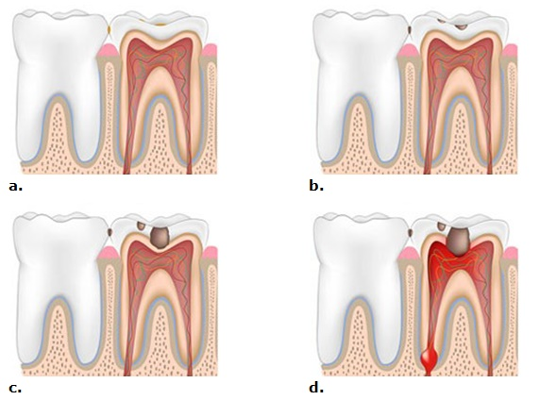
Figure 1. Progression of plaque into dental caries throughout teeth layers.
a. Healthy tooth with superficial plaque. b. Caries in enamel layer progressed from plaque.
c. Caries progress through tooth dentin layer.
d. Caries reach tooth pulp layer. (Siddiqui 2013)

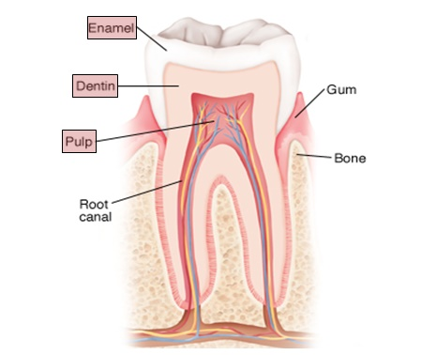
Figure 2. Teeth layers. Layers involved in dental caries mentioned earlier are highlighted (Stanford Children's Health 2016).

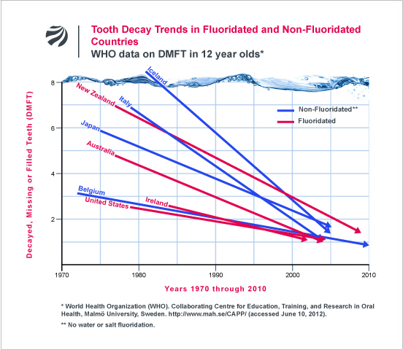
Figure 3. Data collected from 1970 to 2010 showing declination on dental caries in countries with fluoridated and non-fluoridated water. Almost equal declination is observed in both parameters (Connett 2012).

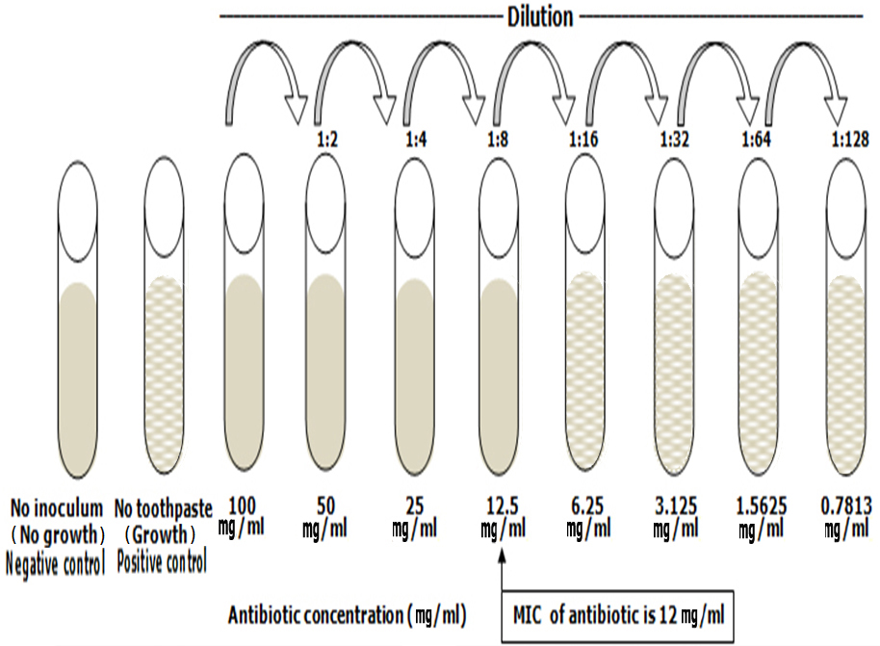
Figure 4. A presumed example of MIC technique used for this study

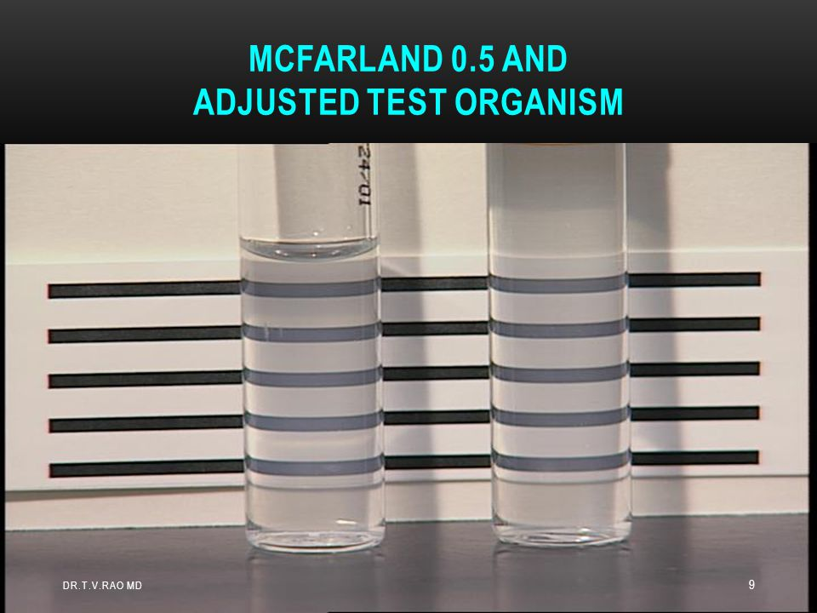
Figure 5. McFarland 0.5 standard and adjusted test organism (CDC 2002).
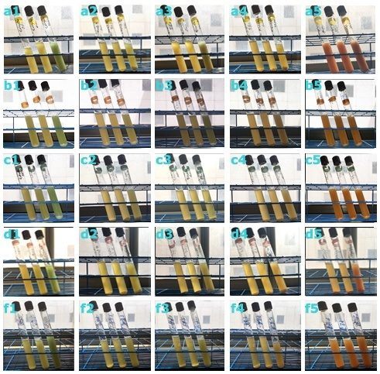
Figure 6. MIC of toothpastes and negative control.
S. mutans a1: Colgate Total toothpaste at different concentrations. a2: Oral-B toothpaste at different concentrations. a3: Siwak.F toothpaste at different concentrations. a4: Aloe Dent toothpaste at different concentrations. a5: Dabur Herbal toothpaste at different concentrations.
Staph. aureus b1: Colgate Total toothpaste at different concentrations. b2: Oral-B toothpaste at different concentrations. b3: Siwak.F toothpaste at different concentrations. b4: Aloe Dent toothpaste at different concentrations. b5: Dabur Herbal toothpaste at different concentrations.
Staph. epidirmidis c1: Colgate Total toothpaste at different concentrations. c2: Oral-B toothpaste at different concentrations. c3: Siwak.F toothpaste at different concentrations.
c4: Aloe Dent toothpaste at different concentrations. c5: Dabur Herbal toothpaste at different concentrations.
E-coli d1: Colgate Total toothpaste at different concentrations. d2: Oral-B toothpaste at different concentrations. d3: Siwak.F toothpaste at different concentrations. d4: Aloe Dent toothpaste at different concentrations. d5: Dabur Herbal toothpaste at different concentrations.
Negative control f1: Colgate Total toothpaste at different concentrations. f2: Oral-B toothpaste at different concentrations. f3: Siwak.F toothpaste at different concentrations. f4: Aloe Dent toothpaste at different concentrations. f5: Dabur Herbal toothpaste at different concentrations.
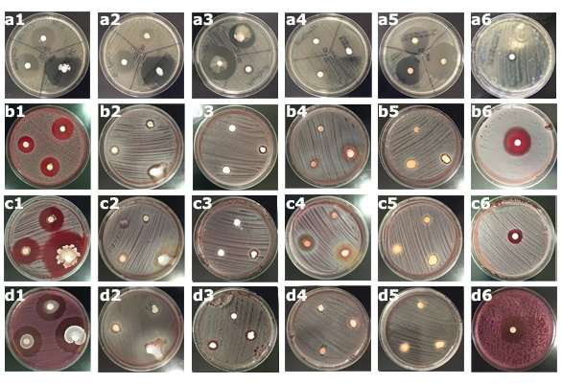
Figure 7. Zone of inhibition of toothpastes and positive control.
S. mutans a1: Colgate Total toothpaste at different concentrations. a2: Oral-B toothpaste at different concentrations. a3: Siwak.F toothpaste at different concentrations. a4: Aloe Dent toothpaste at different concentrations. a5: Dabur Herbal toothpaste at different concentrations. a6: Positive control.
Staph. aureus b1: Colgate Total toothpaste at different concentrations. b2: Oral-B toothpaste at different concentrations. b3: Siwak.F toothpaste at different concentrations. b4: Aloe Dent toothpaste at different concentrations. b5: Dabur Herbal toothpaste at different concentrations. b6: Positive control.
Staph. epidirmidis c1: Colgate Total toothpaste at different concentrations. c2: Oral-B toothpaste at different concentrations. c3: Siwak.F toothpaste at different concentrations.
c4: Aloe Dent toothpaste at different concentrations. c5: Dabur Herbal toothpaste at different concentrations. c6: Positive control.
E-coli d1: Colgate Total toothpaste at different concentrations. d2: Oral-B toothpaste at different concentrations. d3: Siwak.F toothpaste at different concentrations. d4: Aloe Dent toothpaste at different concentrations. d5: Dabur Herbal toothpaste at different concentrations. d6: Positive control.
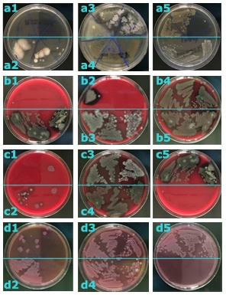
Figure 8. MBC of toothpastes.
S. mutans a1: Colgate Total toothpaste MBC at different concentrations. a2: Oral-B toothpaste MBC at different concentrations. a3: Siwak.F toothpaste MBC at different concentrations. a4: Aloe Dent toothpaste MBC at different concentrations. a5: Dabur Herbal toothpaste MBC at different concentrations.
Staph. aureus b1: Colgate Total toothpaste MBC at different concentrations. b2: Oral-B toothpaste MBC at different concentrations. b3: Siwak.F toothpaste at MBC different concentrations. b4: Aloe Dent toothpaste MBC at different concentrations. b5: Dabur Herbal toothpaste MBC at different concentrations.
Staph. epidirmidis c1: Colgate Total toothpaste MBC at different concentrations. c2: Oral-B toothpaste MBC at different concentrations. c3: Siwak.F toothpaste MBC at different concentrations. c4: Aloe Dent toothpaste MBC at different concentrations. c5: Dabur Herbal toothpaste MBC at different concentrations.
E-coli d1: Colgate Total toothpaste MBC at different concentrations. d2: Oral-B toothpaste MBC at different concentrations. d3: Siwak.F toothpaste MBC at different concentrations. d4: Aloe Dent toothpaste MBC at different concentrations. d5: Dabur Herbal toothpaste MBC at different concentrations.

