“TRENDS IN DENTAL CARIES FROM 1981 TO 2010 IN INDIA- AN META ANALYSIS”

Abstract
Background: Dental diseases are widely prevalent in India. Though most of them are not life-threatening, these diseases are often very agonizing, expensive to cure and cause loss of several man-days. The purpose of this study was to conduct a meta analysis of trends in dental caries prevalence in the Indian population, over a 30-year period, from 1981 to 2010, and the likely reasons for these trends.
Methods: A systematic search for published dental articles was entailed for the period from 1981 through 2010 were collected from the data bases like PubMed, and peer reviewed National level Journals ( JIAPHD, IJPH, JISPPD, JIDA, IJDR, and IJS). Data from NCMH Background Papers, government survey reports and unpublished university theses were also included. The study sample had to be indigenous Indian general population; and group sample had to be a minimum of 20. The age groups were chosen to provide information on the primary dentition in children and the permanent dentition in adolescents and mature adults. Sample sizes, the prevalence of caries were recorded for each study group. Data filtering was done in a specified meta- analysis protocol and the testing of the significance of heterogeneity of studies was based on Chi square test and tau square. The obtained results were tabled and trend lines were formulated. Trends in dental caries in different age groups from 1980 t0 2010 were described using fixed & random effect model.
Results: Total available studies were 287, the studies satisfied inclusion criteria were 107, among that 23 were primary studies, and 84 were secondary. Prevalence from 1981-2010 in 4- 6 years & 30 – 44 years age group varied from 25.5% to 57.5 % & 36.02 % to 83.42 % showing a steady increase in the dental caries trend. To the contrary, prevalence in dental caries from 1981-2010 in 11 - 13 years & 14 - 16 years age group varied from 49.5% to 79.8 % & 36.8% to 70.2% showing a steady decreasing trend.
Conclusion: This kind of meta analysis provides important descriptive information about the disease status, measurement of change in disease level is an important component of epidemiology, the reasons for the changes, as well as its impact on the society are observed. In conclusion, trends in dental caries presented in this paper are more accurate and precise compared to the individual studies as meta-analysis reduces the standard error by increasing the sample size.
Keywords: prevalence, heterogeneity coefficient, systematic review, funnel plot

INTRODUCTION
Dental diseases are widely prevalent in India. Though most of it are not life-threatening, these diseases are often very agonizing, expensive to cure and cause loss of several man-days.¹ It has now been identified that oral and general are closely interconnected. Poor oral health impacts the features of mastication and speech, and eventually the overall well-being of an individual. Dental caries is one such common oral disease.
Dental caries is a disease of civilized society, prevalence of which is influenced by many risk factors such as sex, age, socioeconomic status, dietary patterns and oral hygiene habits, but genetics also plays a role. It’s very high morbidity potential has brought this disease into the spotlight of dental practice. There is practically no geographical area in the world whose inhabitants do not display some evidence of dental caries. Non-communicable diseases are fast becoming the leading cause of disability and mortality in the developing nations and as a result, the health policy-planners may face remarkable challenges to make proper health policies towards such diseases.²

A developing country like India, faces many challenges in rendering oral health needs. It is essential to monitor changes in prevalence and severity of oral disease and to assess relevant and putative risk factors over time. Knowledge of caries distribution is essential for understanding the potential opportunities and likely impact of new biotechnologies and biomaterials so as to reduce the caries burden in the country.
The previous literature existing on the status of the dental caries in the Indian population shows that during 1940 the prevalence of dental caries in India was 55.5%, during 1960 it was reported to be 68%.¹ A very extensive and comprehensive National Health Survey conducted in 2004 throughout India showed that the prevalence of dental caries was 51.9% in 5 year-old children, 53.8% in 12 year-old children, 63.1% in 15 year-old adolescent, 80.2% in adults aged years-old, 85.0% in adults aged 65-74 years old people.³ Overall the general impression is that dental caries has increased in prevalence and severity in urban and cosmopolitan population. However there is no clear picture as yet regarding the disease status in rural and backward areas of country.
The prevention of dental caries has long been considered as an important task of the dental profession. In order to assess the magnitude of the preventive task it is necessary to know the extent and severity of the disease.Oral health surveys and caries prevalence studies provide essential descriptive information about the disease status, measurement of change in disease level, the reasons for the observed changes, as well as its impact on the society.
The purpose of this study was to conduct a systematic review of trends in dental caries prevalence and severity in the Indian population, over a 30-year period, from 1981 to 2010, and the likely reasons for these trends, thereby providing insights for the prevention and treatment of the disease. As of date, there are no such documented studies on the subject which encompass a vast window period of three decades. The ensuing information thereof may as such provide invaluable contribution towards the implication of National Oral Health Policy for the country.

MATERIALS AND METHOD

Authentic scientific research papers are collected from the data bases like PubMed, and peer reviewed National level Journals like JIAPHD, IJPH, JISPPD, JIDA, IJDR, and IJS. Data from NCMH Background Papers, government survey reports and unpublished university theses were also included.
A systematic search for published dental articles was entailed for the period from 1981 through 2010. The key words used in searching were Trends, India, Dental Caries, Prevalence, Oral Health Status and Treatment Need.
For inclusion in the review an article had to have clearly defined ages within five grouping namely 4-6 years, 11-13 years, 14-16 years, 30- 44 years; investigator’s name, place and year of the study; standard diagnostic criteria (Henry, Palmer and Knutson-DMFT/WHO criteria). The study sample had to be indigenous Indian general population; and group sample had to be a minimum of 20. The age groups are chosen to provide information on the primary dentition in children and the permanent dentition in adolescents and mature adults. Sample sizes, the prevalence of caries were recorded for each study group.
Database on extracts from literature based results had been developed in a specified meta- analysis protocol. The numerous columns were potentially added to code each objective found in all the sources of experimental data.
Data filtering was done in three steps. First, the study under consideration had to be coherent with the objectives of the meta analysis (Table – 1).The second step consisted of a thorough and critical review of each publication under consideration, focusing on the detection of errors in the reporting of quantitative results (Table – 2,3,4,5). In the third step, it was important to ensure that the selected publication did not appear to be an outlier with respect to the characteristics and relations under consideration.
The testing if the significance of heterogeneity of studies is based on Chi square test and tau square. Depending on the Tau (heterogeneity coefficient), fixed effect and random effect models were selected for integrating the results. When the Tau value was zero, the Inverse variance method was used as fixed effect model, otherwise a random effect model by Der Simonian and Laird method (DL method) used. Random effect model allows the study variation by coefficient of heterogeneity to some extent while integrating results and in the present study, the maximum Tau² is allowed was 20 so as to avoid the larger heterogeneity among the studies.^{4,5}
Inverse-Variance Method: The Inverse-Variance Method (IV method) was used to pool either binary, continuous or correlation data. This approach has wide applicability since it can be used to combine any estimate that has standard error available. The effect size or mean are combined to give a pooled estimate (denoted by θ) by calculating weighted average of the treatment effects from the individual studies as follows.
θᵢᵥ=$\frac{\sum{wᵢθᵢ}}{\sum{wᵢ}}$
Where the weights w_{i} are calculated as,
wᵢ = $\frac{1}{SE{\left(θᵢ\right)}^{2}}$
That is, the weight for the i_{th} study is equal to its precision of the estimate.
The standard error of θ_{IV} is given by,
SE=(θ_{IV})=$\frac{1}{\sqrt{\sum{wᵢ}}}$
The heterogeneity statistic (denoted by Q_{w}) is given by,
Q_{w} =∑w_{i}(θ_{i} − θ_{IV})²
The Q_{w} follows chi-square distribution with (k-1) degrees of freedom, where k is the number of studies included in the meta-analysis.
DerSimonian and Laird Method: The DerSimonian and Laird method (DL method) of meta-analysis is based on the random effects model. Under the random effects model, the assumption of common effect is relaxed, and the effect size or mean θ_{i} are assumed to have a normal distribution with mean θ and variance τ². The usual DL estimate for τ² is given by,
τ²= $\frac{Q_{w}– \left(k-1\right)}{\sum{wᵢ} - \frac{\sum{Wᵢ²}}{\sum{Wᵢ}}}$
where, Q_{w} is the heterogeneity statistic, and the weights w_{i} are calculated as in the IV Method, and k is the number of studies. The τ² is set to zero if Q_{w}<(k-1). In this approach, the weights for each study effect size $w_{i}^{'}$ are as given below.
$w_{i}^{'}$= $\frac{1}{SE{\left(θ\right)}^{2}+τ^{2}}$
The pooled estimate is given by,
θ_{DL}= $\frac{∑w_{ᵢ}^{'}θᵢ}{\sum{w_{ᵢ}^{'}}}$
With standard error,
SE(θ_{DL})=$\frac{1}{\sqrt{\sum{wᵢ´}}}$
The heterogeneity statistic and its test of significance is a given in the IV method. The obtained results were tabled and trend lines were formulated. Comprehensive meta analysis (version 2) was used for statistical analysis. In the meta analysis, random effect model and fixed effect model are commonly used for analysis. Funnel plot was used to check possibility of publication bias. To verify visual inspection of funnel plot, Egger’s test and Begg’s test was used.

Studies on prevalence of dental caries considered for meta-analysis
DATA COLLECTION ( TABLE -1)
SL NO | AGE GROUPs | TOTAL AVAILABLE | INCLUDED | NUMBER OF PRIMARY DATA INCLUDED | NUMBER OF SECONDARY DATA  INCLUDED
1 | 4-6 | 102 | 38 | 13 | 25
2 | 11-13 | 79 | 34 | 06 | 28
3 | 14-16 | 56 | 22 | 02 | 20
4 |  | 50 | 13 | 02 | 11
Total |  | 287 | 107 | 23 | 84

TABLE-2: Studies on prevalence of dental caries among 4-5 years old considered for meta-analysis
Sl no | Investigator | Year | Part of India | State | Sample size | Prevalence
1 | Tewari et al.⁶ | 1985 | North | Haryana | 157 | 38.1
2 | Virjee Shankar aradhya.⁶ | 1987 | South | Karnataka | 673 | 66.3
3 | Virjee Shankar aradhya.¹ | 1987 | South | Karnataka | 394 | 58.3
4 | Thapar.¹ | 1989 | West | Rajasthan | 40 | 13.2
5 | Gangwar et al.¹ | 1990 | North | Uttar pradesh | 133 | 36
6 | Gangwar et al.¹ | 1990 | North | Uttar pradesh | 223 | 46
7 | Sarkar et al.¹ | 1992 | North | North India | 50 | 25.5
8 | Sethi and Tendon et al.¹ | 1996 | South | Karnataka | 404 | 65.5
9 | Goyal et al.¹ | 1997 | North | Chandigarh | 137 | 28.5
10 | Goyal et al.¹ | 1997 | North | Chandigarh | 21 | 32
11 | Goya et al.¹ | 1997 | North | Chandigarh | 124 | 48
12 | Ali et all.¹ | 1998 | West | Maharashtra | 508 | 61.4
13 | Tiwariet al.¹ | 1999 | North | Haryana | 113 | 36.4
14 | Tiwariet al.¹ | 1999 | North | Haryana | 157 | 38.2
15 | Rao et al.¹ | 1999 | South | Karnataka | 771 | -
16 | Tiwari et al.¹ | 2001 | North | Haryana | 509 | 38
17 | Mandal et al.¹ | 2001 | East | W.bengal | 480 | 52.4
18 | Mandal et al.¹ | 2001 | East | W.bengal | 340 | 48.3
19 | Mandal et al.¹ | 2001 | East | Orissa | 424 | 56
20 | Mandal et al.¹ | 2001 | East | Orissa | 321 | 48.7
21 | Mandal et al.¹ | 2001 | North east | Sikkim | 346 | 61.8
22 | Mandal et al.¹ | 2001 | North east | Sikkim | 356 | 22
23 | Tyagi et al.⁷ | 2001 | North | Haryana | 509 | 34
24 | Ashwathnarayanan et al.⁸ | 2002 | South | Karnataka | 1806 | 41.53
25 | Dash et al.⁹ | 2002 | East | Orissa | 328 | 57.9
26 | Sudha et al.¹ | 2003 | South | Karnataka | 193 | 94.3
27 | NOH³ | 2003 | South | Andhra pradesh | 1880 | 41.5
28 | NOH³ | 2003 | South | Karnataka | 1246 | 40.5
29 | NOH³ | 2003 | South | Kerala | 838 | 73
30 | NOH³ | 2003 | South | Tamilnadu | 1795 | 49.8
31 | NOH³ | 2003 | South | Pondichery | 314 | 53.5
32 | NOH³ | 2003 | East | Orissa | 1523 | 51.2
33 | NOH³ | 2003 | West | Gujarat | 2017 | 47.8
34 | NOH³ | 2003 | West | Maharashtra | 1537 | 52.9
35 | NOH³ | 2003 | West | Goa | 266 | 86.5
36 | NOH³ | 2003 | North east | Assam | 617 | 68.9
37 | NOH³ | 2003 | Central | Madyapradesh | 1143 | 54
38 | NOH³ | 2003 | North | Harayana | 926 | 40.7
39 | NOH³ | 2003 | North | Himachal | 629 | 51.1
40 | NOH³ | 2003 | North | Jammu | 941 | 50.6
41 | NOH³ | 2003 | North | Punjab | 996 | 71.5
42 | NOH³ | 2003 | North | Uttar pradesh | 629 | 42.3
43 | NOH³ | 2003 | North | Chandigarh | 315 | 85.4
44 | NOH³ | 2003 | North | Delhi | 361 | 37.1
45 | Sahanahegde et al.¹⁰ | 2005 | West | Maharashtra | 294 | 86.7
46 | Saravanan et al.¹ | 2005 | South | Pondichery | 1009 | 44.4
47 | Mahesh et al.¹ | 2005 | South | Tamilnadu | 600 | 83
48 | Girish et al.¹¹ | 2005 | West | Gujarat | 505 | 60.7
49 | Dhar et al.¹² | 2005 | West | Rajasthan | 188 | 18.62
50 | Mahjabeen et al.¹³ | 2006 | South | Karnataka | 1500 | 54.1
51 | Goyal et al.¹⁴ | 2007 | North | Chandigarh | 459 | 79.7
54 | Mohanty et al.¹⁵ | 2009 | North | Uttar pradesh | 336 | 57
55 | Shipra et al.¹⁶ | 2009 | North | Uttar pradesh | 991 | 89.7
56 | Shipra et al.¹⁶ | 2009 | North | Uttar pradesh | 1020 | 87.4
57 | Dhar et al.¹² | 2009 | West | Rajasthan | 750 | 51.5
58 | Bharadwaj et al.¹⁷ | 2010 | North | Himachal | 800 | 44.2
59 | Senthil et al.¹⁸ | 2010 | South | Tamilnadu | 274 | 56.6
60 | Arora et al.¹⁹ | 2010 | North | Uttar pradesh | 544 | 31.44

TABLE-3: Studies on prevalence of dental caries among 11-13 years old considered for meta-analysis
Sl no | Investigator | Year | Part of India | State | Sample size | Point prevalence
1 | Damle et al.¹ | 1982 | North | Haryana | 152 | 89.5
2 | Gauba et al.¹ | 1983 | North | Punjab | 173 | 86.1
3 | Tiwari et al.¹ | 1985 | East | Orissa | 159 | 63.1
4 | Pandit et al.⁶ | 1986 | North | Delhi | 165 | 39
5 | Gauba et al.⁶ | 1986 | North | Punjab | 134 | 85
6 | Gangwar et al.¹ | 1990 | North | Uttarpradesh | 263 | 38
7 | Damle et al.¹ | 1994 | West | Maharashtra | 367 | 80
8 | Rodriguez et al.¹ | 1998 | North | Haryana | 256 | 55.5
9 | Narboo et al.¹ | 1998 | North | Kashmir | 69 | 29
10 | Narboo et al.¹ | 1998 | North | Kashmir | 73 | 35.8
11 | Gopinath et al.¹ | 1999 | South | Tamilnadu | 232 | 61.2
12 | Singhet al.¹ | 1999 | North | Haryana | 233 | 33.1
13 | Menonet al.¹ | 1999 | South | Karnataka | 488 | 24.6
14 | Raoet al.¹ | 1999 | South | Karnataka | 771 | 67.1
15 | Retnakumariet al.¹ | 1999 | South | Karnataka | 119 | 67.2
16 | Goelet al.¹ | 2000 | South | Karnataka | 203 | 59.6
17 | Kulkarniet al.¹ | 2002 | South | Karnataka | 301 | 45.85
18 | Kulkarniet al.¹ | 2002 | South | Karnataka | 265 | 37
19 | Kulkarniet al.¹ | 2002 | South | Karnataka | 505 | 43
20 | Dashet al.⁹ | 2002 | East | Orissa | 331 | 62.2
21 | NOH³ | 2003 | North | Haryana | 956 | 49.3
22 | NOH³ | 2003 | North | Himachal | 629 | 72.5
23 | NOH³ | 2003 | North | Jammu | 941 | 47.5
24 | NOH³ | 2003 | North | Punjab | 1004 | 81.9
25 | NOH³ | 2003 | North | Uttar pradesh | 630 | 51.1
26 | NOH³ | 2003 | North | Chandigarh | 315 | 93.4
27 | NOH³ | 2003 | North | Delhi | 350 | 46.8
28 | NOH³ | 2003 | South | Andhrapradesh | 1881 | 53.1
29 | NOH³ | 2003 | South | Karnataka | 1272 | 22.3
30 | NOH³ | 2003 | South | Kerala | 785 | 66.5
31 | NOH³ | 2003 | South | Tamilnadu | 1840 | 52.2
32 | NOH³ | 2003 | South | Pondicherry | 318 | 38.6
33 | NOH³ | 2003 | East | Orissa | 1686 | 52.4
34 | NOH³ | 2003 | West | Gujarat | 2178 | 43.9
35 | NOH³ | 2003 | West | Maharashtra | 1588 | 58
36 | NOH³ | 2003 | West | Goa | 267 | 60.7
37 | NOH³ | 2003 | North east | Assam | 617 | 68.1
38 | NOH³ | 2003 | Central | Madyapradesh | 1122 | 61.7
39 | David et al.²⁰ | 2005 | South | Kerala | 838 | 27
40 | Maheshet al.²⁰ | 2005 | South | Tamilnadu | 600 | 80
41 | Goyal et al.¹⁴ | 2007 | North | Chandigarh | 207 | 80
42 | MS²¹ | 2007 | North | Delhi | 923 | 48.6
43 | MS²¹ | 2007 | North | Uttar pradesh | 1059 | 49
44 | MS²¹ | 2007 | South | Pondicherry | 2158 | 71.5
45 | MS²¹ | 2007 | East | Orissa | 374 | 23
46 | MS²¹ | 2007 | West | Maharashtra | 1029 | 50.4
47 | MS²¹ | 2007 | West | Rajasthan | 1079 | 53.8
48 | MS²¹ | 2007 | North east | Arunachal pradesh | 836 | 44.4
49 | Swathi et al.²² | 2010 | West | Rajasthan | 495 | 26.22
50 | Nanak et al.²² | 2010 | North | Haryana | 440 | 42.3
51 | Bhaskar et al.²³ | 2010 | South | Karnataka | 812 | 63.57
52 | Patel et al.¹⁸ | 2010 | West | Gujarat | 200 | 70.9
53 | Harpreetet al.²⁴ | 2010 | North | Delhi | 253 | 52.13

TABLE-4: Studies on prevalence of dental caries among 14-16 years old considered for meta-analysis
Sl no | Investigator | Year | Part of India | State | Sample size | Point prevalence
1 | Damle et al.¹ | 1982 | North | Punjab | 230 | 77.2
2 | Gauba et al.¹ | 1983 | North | Punjab | 101 | 88.1
3 | Tiwari et al.¹ | 1985 | West | Maharashtra | 202 | 96
4 | Tiwari et al¹ | 1985 | North | Himachal | 191 | 49
5 | Tiwari et al¹ | 1985 | East | Bihar | 202 | 49.5
6 | Tiwari et al.⁶ | 1985 | Central | Madhya pradesh | 162 | 68
7 | Mehta et al.¹ | 1987 | North | Uttarkand | 202 | 45
8 | Mehta et al.¹ | 1987 | North | Uttarkand | 112 | 38.2
9 | Gupta et al.¹ | 1987 | South | Karnataka | 98 | 42.86
10 | Gupta et al.¹ | 1987 | South | Andhra pradesh | 85 | 34.12
11 | Sharma et al.¹ | 1987 | North east | Nagaland | 195 | 63.08
12 | Mandal et al.¹ | 1994 | East | Orissa | 121 | 19.8
13 | Mandal et al.¹ | 1994 | North east | Sikkim | 106 | 30.2
14 | Mandal et al.¹ | 1994 | North east | Sikkim | 106 | 17.9
15 | Damle et al.¹ | 1994 | West | Maharashtra | 460 | 83
16 | Damle et al.¹ | 1994 | West | Maharashtra | 360 | 78
17 | Chopra et al.¹ | 1995 | North | Delhi | 392 | 20.9
18 | Narboo et al.¹ | 1998 | North | Kashmir | 69 | 39.5
19 | Singh et al.¹ | 1999 | North | Haryana | 207 | 42.5
20 | Menon et al.¹ | 1999 | South | Karnataka | 127 | 30.8
21 | Mandal et al.¹ | 2001 | East | W.bengal | 773 | 21
22 | Mandal et al.¹ | 2001 | East | Orissa | 789 | 18.3
23 | Mandal et al.¹ | 2001 | North east | Sikkim | 683 | 30.1
24 | Kulkarni et al.¹ | 2002 | South | Karnataka | 461 | 51.84
25 | NOH.³ | 2003 | North | Haryana | 959 | 57.7
26 | NOH.³ | 2003 | North | Himachal | 629 | 75.4
27 | NOH.³ | 2003 | North | Jammu | 940 | 62.7
28 | NOH.³ | 2003 | North | Punjab | 1004 | 90.7
29 | NOH.³ | 2003 | North | Uttar pradesh | 631 | 73.4
30 | NOH.³ | 2003 | North | Chandigarh | 314 | 96.5
31 | NOH.³ | 2003 | North | Delhi | 334 | 54.8
32 | NOH.³ | 2003 | South | Andhra pradesh | 1877 | 57.9
33 | NOH.³ | 2003 | South | Karnataka | 1257 | 33.1
34 | NOH.³ | 2003 | South | Kerala | 789 | 68
35 | NOH.³ | 2003 | South | Tamilnadu | 1801 | 60.9
36 | NOH.³ | 2003 | South | Pondicherry | 314 | 46.1
37 | NOH.³ | 2003 | East | Orissa | 1668 | 56.3
38 | NOH.³ | 2003 | West | Gujarat | 2178 | 64.2
39 | NOH.³ | 2003 | West | Maharashtra | 1473 | 65
40 | NOH.³ | 2003 | West | Goa | 268 | 67.2
41 | NOH.³ | 2003 | North east | Assam | 618 | 69.6
42 | NOH.³ | 2003 | Central | Madhya pradesh | 1155 | 72.6
43 | MS.²¹ | 2007 | North east | Arunachal pradesh | 1166 | 48.5
44 | MS.²¹ | 2007 | West | Maharashtra | 1357 | 58.5
45 | MS.²¹ | 2007 | West | Rajasthan | 1394 | 55.4
46 | MS.²¹ | 2007 | East | Orissa | 473 | 24.3
47 | MS.²¹ | 2007 | South | Pondicherry | 3242 | 83.4
48 | MS.²¹ | 2007 | North | Delhi | 1165 | 52.4
49 | MS.²¹ | 2007 | North | Uttar pradesh | 1370 | 54.9
50 | Shivanjali et al.²⁵ | 2010 | North | Uttar pradesh | 398 | 48.5
51 | Patel dhaval et al.²⁶ | 2010 | West | Gujarat | 470 | 70

TABLE-5: Studies on prevalence of dental caries among 35-44 years old considered for meta-analysis
Sl no | Investigator | Year | Part of India | State | Sample size | Point prevalence
1 | Damle et al.¹ | 1982 | North | Haryana | 667 | 61
2 | Damle et al.¹ | 1982 | North | Haryana | 101 | 46.5
3 | Damle et al.¹ | 1982 | North | Haryana | 200 | 68
4 | Tewari et al.¹ | 1985 | North | Chandigarh | 156 | 81.4
5 | Tewari et al.¹ | 1985 | North | Chandigarh | 196 | 82.1
6 | Tewari et al.¹ | 1985 | North | Uttarpradesh | 199 | 47
7 | Tewari et al.¹ | 1985 | North | Uttarpradesh | 118 | 45.8
8 | Chopra et al.¹ | 1985 | North | Punjab | 144 | 34.72
9 | Chopra et al.¹ | 1985 | North | Punjab | 145 | 30.34
10 | Chopra et al.¹ | 1985 | North | Punjab | 140 | 20
11 | Chopra et al.¹ | 1985 | North | Punjab | 149 | 24.16
12 | Tewari et al.¹ | 1985 | Central | Madhyapradesh | 66 | 70
13 | Tewari et al.¹ | 1985 | Central | Madhyapradesh | 201 | 80
14 | Gupta et al.¹ | 1985 | South | Kerala | 103 | 79.61
15 | Gupta et al.¹ | 1985 | South | Kerala | 104 | 78.9
16 | Gupta et al.¹ | 1985 | South | Kerala | 90 | 47.8
17 | Gupta et al.¹ | 1985 | South | Andhrapradesh | 111 | 64.86
18 | Gupta et al.¹ | 1985 | South | Andhrapradesh | 87 | 44.83
19 | Gupta et al.¹ | 1985 | South | Karnataka | 98 | 73.47
20 | Gupta et al.¹ | 1985 | South | Karnataka | 102 | 68.63
21 | Gupta et al.¹ | 1985 | South | Karnataka | 102 | 48.04
22 | Sharma et al.¹ | 1985 | North-east | Meghalaya | 196 | 54.6
23 | Sharma et al.¹ | 1985 | North-east | Manipur | 199 | 63.82
24 | Sharma et al.¹ | 1985 | North-east | Assam | 244 | 66
25 | Sharma et al.¹ | 1985 | North-east | Nagaland | 202 | 62.4
26 | Mandal et al.¹ | 1994 | North-east | Sikkim | 107 | 29.91
27 | Mandal et al.¹ | 1994 | North-east | Sikkim | 107 | 24.53
28 | Mandal et al.¹ | 1994 | East | Orissa | 51 | 24.35
29 | Mandal et al.¹ | 1994 | East | Orissa | 114 | 20.17
30 | Mandal et al.¹ | 1994 | East | West bengal | 28 | 19.49
31 | Mandal et al.¹ | 1994 | East | West bengal | 20 | 18.18
32 | Chopra et al.¹ | 1995 | North | Delhi | 388 | 24.5
33 | Tewari et al.¹ | 1995 | North | Bihar | 149 | 69
34 | Tewari et al.¹ | 1995 | North | Bihar | 193 | 63.2
35 | NOH.³ | 2003 | North | Haryana | 981 | 77.2
36 | NOH.³ | 2003 | North | Himachal | 628 | 96.5
37 | NOH.³ | 2003 | North | Jammu | 957 | 87.2
38 | NOH.³ | 2003 | North | Punjab | 1026 | 96
39 | NOH.³ | 2003 | North | Uttar pradesh | 628 | 94.3
40 | NOH.³ | 2003 | North | Chandigarh | 315 | 97.5
41 | NOH.³ | 2003 | North | Delhi | 387 | 77.4
42 | NOH.³ | 2003 | South | Andhra pradesh | 1953 | 76.7
43 | NOH.³ | 2003 | South | Karnataka | 1278 | 63.3
44 | NOH.³ | 2003 | South | Kerala | 992 | 87.7
45 | NOH.³ | 2003 | South | Tamilnadu | 1907 | 80.4
46 | NOH.³ | 2003 | South | Pondichery | 318 | 83.4
47 | NOH.³ | 2003 | East | Orissa | 1885 | 69.2
48 | NOH.³ | 2003 | West | Gujarat | 2383 | 78.2
49 | NOH.³ | 2003 | West | Maharashtra | 1639 | 77.6
50 | NOH.³ | 2003 | West | Goa | 272 | 86.4
51 | NOH.³ | 2003 | North-east | Assam | 638 | 78.1
52 | NOH.³ | 2003 | Central | Madhyapradesh | 1252 | 84.8
53 | MS.²¹ | 2007 | North | Delhi | 3668 | 86.2
54 | MS.²¹ | 2007 | North | Uttar pradesh | 3376 | 83.2
55 | MS.²¹ | 2007 | South | Pondicherry | 3067 | 73.3
56 | MS.²¹ | 2007 | East | Orissa | 1383 | 48.1
57 | MS.²¹ | 2007 | West | Maharashtra | 4263 | 86.4
58 | MS.²¹ | 2007 | West | Rajasthan | 1986 | 66.5
59 | MS.²¹ | 2007 | North-east | Arunachal pradesh | 2106 | 62.1
60 | Patro et al.²⁷ | 2008 | North | New Delhi | 452 | 82
61 | Satpreet et al.²⁸ | 2010 | North | Punjab | 560 | 86.84

RESULTS: Prevalence of dental caries in 1981-1985 was 37.57, but it increased steeply to 56.67 in 1986-1990. During 1991-95 it abruptly decreased to 25.5, again during 1996-2000 there was a sharp rise to 57.54, which again slightly decreased to 52.75 during 2001-2005. During 2006-2010 caries prevalence was almost similar to last five years i.e. 52.11. Over all analysis shows there is an increasing trend from 1981-2010 in 4-6 year age group. (Table-6) (Figure-1). Prevalence of dental caries during 1981-1985 was 79.85, but it decreased abruptly to 49.57 during 1986-1990. During 1991-95 there was a sharp rise to 79.93, followed by a sharp decrease to 50.69 again during 1996-2000. During 2001-05 it was 50.61, which is almost similar to last 5 year. During 2006-2010 it slightly decreased to 49.14. Over all analysis shows there is a decreasing trend from 1981-2010 in 11-13 year age group. (Table-7) (Figure-2).
Prevalence of dental caries in 1981-1985 was 70.28, which decreased drastically to 36.82 during 1986-1990. In the year 1991-1995 it gradually increased to 52.97, followed by a sharp decrease to 37.9 during 1996-2000. During 2001-05 it sharply increased to 52.09 and during 2006-2010 it slightly increased to 53.94. Over all analysis shows there is a decreasing trend from 1981-2010 in 14-16 year age group. (Table-8) (Figure-3).Prevalence of dental caries during 1981-1985 was 58.29, but it decreased to 36.02 during 1991-1995. During the year 2001-2005 there was peak at 83.428, again during 2006-2010 there was a gradual decrease to 70.63.
Over all analysis shows there is an increasing trend from 1981-2010 (Table-9) (Figure-4). Funnel plots was employed to assess the possibility of publication bias. In the absences of publication bias, studies are distributed symmetrically around the mean prevalence. By contrast, in the presence of publication bias, it is expected that bottom of funnel plot would show a higher concentration of studies on one side of mean than the other. Funnel plot for primary dentition (Figure 5) appeared symmetrical at the top, middle and bottom of the funnel plot. For more confirmation, the visual impression Egger’s and Begg’s test were used to test publication bias. Egger’s test (p=0.022) and Begg’s test (p=0.99) supported visual impression and did not indicate any publication bias.
The “trim-and-fill” method was used to find out the missing number of studies, which could help remove publication bias, results showed that there were no missing studies, and the method suggested the same calculated prevalence and class interval. Funnel plot for permanent dentition (Figure 6,7,8) was symmetrical at the top and in the middle, as well. Egger’s and Begg’s test showed dissimilar results. Begg’s test for age 12, 15 and 35 – 44 years age group with p=0.004, 0.09, 0.5 did not indicate publication bias, Egger’s test for age 12, 15 and 35 – 44 years age group p=0.21,0.65,0.4 respectively based on regression, showed no publication bias. The estimated prevalence changed from 36.8 –70.2 for 15 year & 36.02 – 70.6 for 35 – 44 year age group in the random effect model, and from 25.5 – 37.52 in 5 year & 50.6 to 79.9 in 12 year age groups in the fixed effect model.
TABLE – 6: Trends in dental caries prevalence from 1981-2010 in 4- 6 years age group
Year | Age group | Sample | Tau²value | Effect | Prevalence(%) | P- value
1981-1985 | 4-6 | 157 | 0 | Fixed | 37.57962 | 0.0001
1986-1990 | 4-6 | 1463 | 15748 | Random | 56.67122 | 0.0001
1991-1995 | 4-6 | 50 | 0 | Fixed | 25.5 | 0.0012
1996-2000 | 4-6 | 1454 | 6195.7 | Random | 57.54225 | 0.0001
2001-2005 | 4-6 | 26181 | 29997 | Random | 52.74734 | 0.0000
2006-2010 | 4-6 | 6674 | 26699 | Random | 52.11079 | 0.0001

TABLE – 7: Trends in dental caries prevalence from 1981-2010 in 11-13 years age group
Year | Age group | Sample | Tau²value | Effect | Prevalence(%) | P- value
1981-1985 | 11-13 | 484 | 438 | Random | 79.85121 | 0.00012
1986-1990 | 11-13 | 562 | 731.6 | Random | 49.57562 | 0.00000
1991-1995 | 11-13 | 367 | 0 | Fixed | 79.93466 | 0.00000
1996-2000 | 11-13 | 2444 | 8001.09 | Fixed | 50.69785 | 0.00001
2001-2005 | 11-13 | 21219 | 28918 | Fixed | 50.61318 | 0.00000
2006-2010 | 11-13 | 9865 | 23569 | Random | 49.1436 | 0.000000

TABLE – 8: Trends in dental caries prevalence from 1981-2010 in 14-16 years age group
Year | Age group | Sample | Tau²value | Effect | Prevalence(%) | P- value
1981-1985 | 14-16 | 1088 | 3275 | Random | 70.2807 | 0.0001
1986-1990 | 14-16 | 692 | 1272.7 | Random | 36.82081 | 0.0000
1991-1995 | 14-16 | 1545 | 1574.7 | Random | 52.97453 | 0.0000
1996-2000 | 14-16 | 403 | 748.7 | Random | 37.90665 | 0.0001
2001-2005 | 14-16 | 20915 | 22735.06 | Random | 52.09751 | 0.0000
2006-2010 | 14-16 | 11035 | 12475 | Random | 53.94333 | 0.0001

TABLE – 9: Trends in dental caries prevalence from 1981-2010 in 35-44 years age group
Year | Age group | Sample | Tau²value | Effect | Prevalence(%) | P- value
1981-1985 | 30-44 | 4120 | 2374.726 | Random | 58.2949 | 0.0000
1991-1995 | 30-44 | 1147 | 891.048 | Random | 36.0248 | 0.0000
2001-2005 | 30-44 | 19439 | 22927.12 | Random | 83.42861 | 0.0001
2006-2010 | 30-44 | 20861 | 11975 | Random | 70.62579 | 0.0000

GRAPHS

FIGURE – 1: Trends in dental caries prevalence from 1981-2010 in 4-6 years age groups

FIGURE – 2: Trends in dental caries prevalence from 1981-2010 in 11-13 years age groups

FIGURE – 3: Trends in dental caries prevalence from 1981-2010 in 14-16 years age group

FIGURE – 4: Trends in dental caries prevalence from 1981-2010 in 35-44 years age group

Funnel plot of precision by mean for all age groups
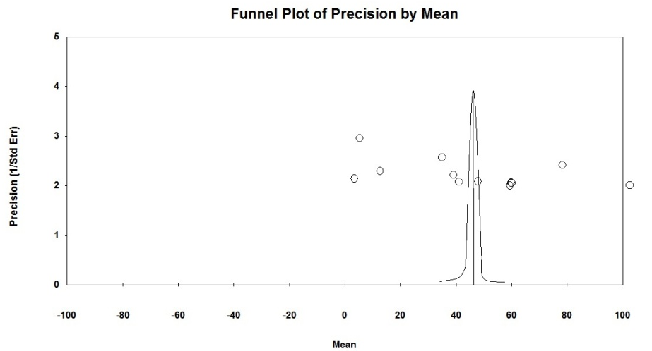
FIGURE – 5: Mean caries prevalence in primary teeth according to precision of 5 year age group (1981-2010)
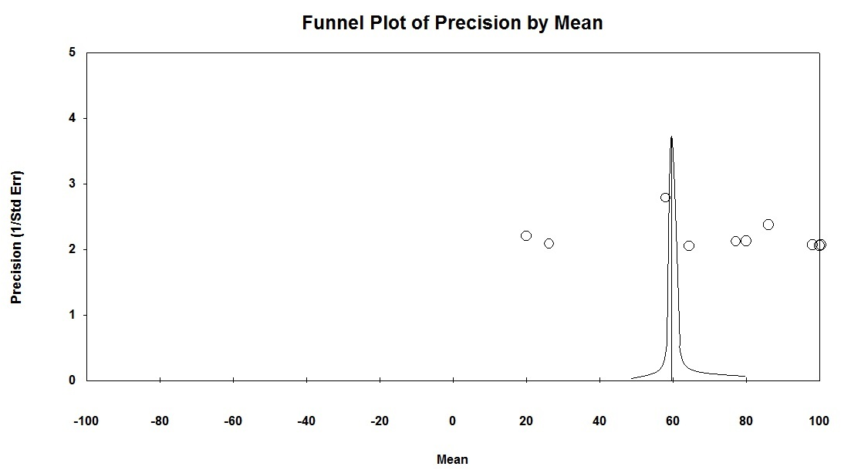
FIGURE – 6: Mean caries prevalence in permanent teeth according to precision of 12 year age group (1981-2010)
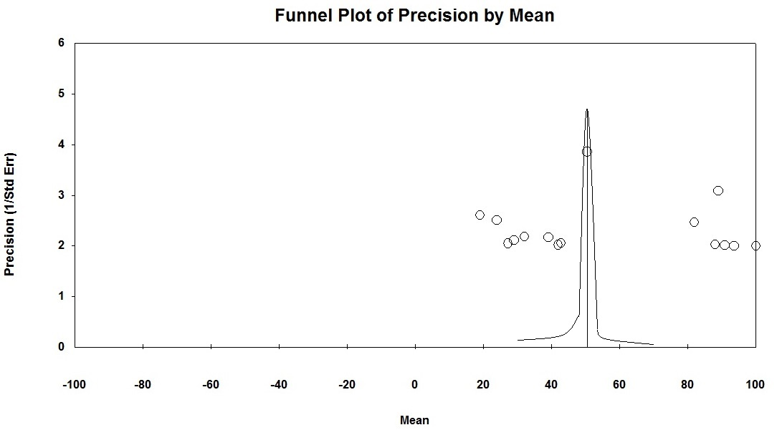

FIGURE – 7: Mean caries prevalence in permanent teeth according to precision of 15 year age group (1981-2010)

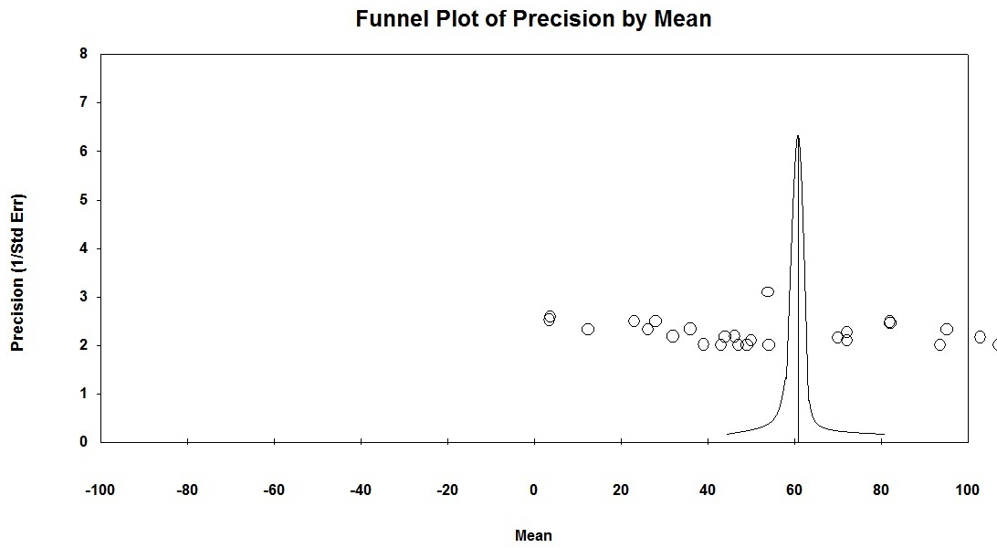
FIGURE – 8: Mean caries prevalence in permanent teeth according to precision of 35 - 44 year age group (1981-2010)

DISCUSSION: To the best of our knowledge and belief, this is the first study to report the meta-analysis of trends of dental caries. Meta-analysis is used increasingly as a method of summarizing data that tests the same hypothesis in several different published studies. The validity of a choice of meta-analytical methods depends on pattern of variability (heterogeneity) observed in the study results. However, there is no empirical guidance currently available to judge which methods are appropriate in which circumstances so as to yield better results.
Funnel plot and statistical tests were used to check publication bias. No publication bias was found when checked for all the age groups. The “trim-and-fill” method suggested funnel plot was symmetrical for all age groups and estimated prevalence changed from 36.8 –70.2 for 15 year & 36.02 – 70.6 for 35 – 44 year age group in the random effect model, and from 25.5 – 37.52 in 5 year & 50.6 to 79.9 in 12 year age groups in the fixed effect model. Dental caries trend was determined in Africa in 1999.
Public health agencies have a long tradition of monitoring trends in rates of disease and death and trends in medical, dental, social, and behavioural risk factors that may contribute to these adverse events. Trends in observed rates provide invaluable information for needs assessment, program planning, program evaluation, and policy development activities. Examining data over time also permits making predictions about future frequencies and rates of occurrence. Trend analysis is used for public health surveillance and monitoring, for forecasting, for policy analysis, and for etiologic analysis.
A total of 287 studies were collected which were distributed across 22 states in India but only 107 studies met the inclusion criteria. Although 180 studies had the potential sources of information but they could not meet the inclusion criteria. This may be due to tremendous variation in age grouping reported in studies, in spite of 40 years of WHO guidelines which attempts to standardize information for comparison. Many of the excluded studies had not followed the WHO criteria for their studies hence had to be excluded from the analysis and also many of the articles had not mentioned the much needed point prevalence which is required for the analysis. For the inclusion of National oral health survey data, in this analysis state wise caries prevalence data was taken into consideration.

PRINCIPLE FINDINGS
This study has shown the following trend:
Over all from 1981 to 2010
According to our study in 4-6 years age group – From 1981 to 2000 there is an increase in caries trend, but there is a slight decreasing caries trend in 2010 when compared to 2000. As there were not enough studies during period 1991 to 1995, there is a steep decrease in caries trend which may be due to fixed effect used in statistical analysis. Bonecker et al study of Time-lag analysis showed a marked and statistically significant decline in the prevalence and severity of dental caries between 1970 and 2000 in 5-6 year-old in a Latin American and Caribbean state study. It may be due to the fact that caries rates in these regions of developing countries studied with same systematic methodology have shown the same trends, indicate a common process not yet clarified. In contrast, our study shows an increasing trend in 5-6 year olds.³⁰ This increase in caries trend in our study might be attributed to factors like family income, parental education, parents dental knowledge, attitude&behaviour, the child’s dietary and oral hygiene habits, place of residence, increasing urbanization with switch from traditional starchy staple foods to more refined carbohydrates, frequent snacking habit, and irregular feeding practices from the mothers.
According to our study in 11-13 years age group – From 1981 to 2010 there is a decrease in caries trend. Bonecker et al study of Time-lag analysis showed a marked and statistically significant decline in the prevalence and severity of dental caries between 1970 and 2000 in 11-13 year-old in a Latin American and Caribbean states.³⁰ Similar decrease in dental caries also reported in South Africa and Swaziland in a systematic review of 1919-2007 by Cleaton-Jones et al.³⁴
According to our study in 14-16 years age group – From the last 30 years i.e. from 1981 to 2010 there is a decreasing in caries trend, when compared to 1981. From the year 1986-2000 the caries prevalence had decreased. During 2001-2005 caries prevalence had increased. The caries trend during 2006-10 was similar to that observed during 2001-2005. Similar decrease in dental caries prevalence was also reported in South Africa and Swaziland in a systematic review of 1919-2007 by Cleaton-Jones et al.³⁴
The apparent general decline in dental caries in 11-13 and 14-16 years shown in this review is although pleasing is not tangible. The apparent reduction in dental caries in our opinion could not be due to changing diagnostic standards. This can be substantiated based on the following three observations – Firstly, the oral health surveys include the use of a probe until 1997, there after the surveys did not include probing as per WHO recommendation. Secondly, clinical and laboratory comparisons of caries diagnostics methods have shown similar results with and without the use of probes. Finally, one of the reasons for the decline in dental caries prevalence can be partly attributed due to the introduction of the ADA approved fluoridated tooth pastes into the Indian markets.
According to our study in 30-44 years age group – From 1981 to 2010 there is an increase in caries trends. Due to lack of the published and unpublished literature, the trends between 1986-1990 and between 1996-2000 were not included in the analysis. This apparent increase can be due to the cumulative effect of the dental caries experience may be attributed to factors like unmet dental needs, lack of preventive regimens and public dental health programmes and lack of oral health policy in India. There are no enough published and unpublished systematic review literature of the Indian caries trend scenario available for comparison to our results.
STRENGTH AND WEAKNESS OF STUDY
Determining trends in any disease with a systematic review is dependent on the number of studies available and the quality of data from the studies. All the published investigations in the current review used the same WHO diagnostic methods and hence are reasonably comparable from diagnostic view point.
The majority of the articles have following deficiencies
1. No description of sampling technique
2. No description of condition under which a survey was conducted.
3. Some reports show only the prevalence rate and some only mean DMFT.
UNANSWERED QUESTIONS AND FUTURE RESEARCH
An ideal situation would be worldwide surveillance of disease rates in the same regions through repeat surveys enabling true incidence investigation. But for obvious monetary reasons, this may not be feasible. However, these could be done at a limited number of sites as for example 5-yearly intervals, co-ordinated through an international agency such as WHO.
There is a clear need for caries surveillance through regular field survey in selected parts of country. There is also a need for international data base system for monitoring changes in oral health that is more robust than what is existant in the WHO oral data bank to enable systematic reviews like this.

CONCLUSION
The present meta analysis was planned to get the data from different corners of the country on dental caries prevalence by following standardized methodology. Present study results it is shown that in 11-13 and 14-16 years age groups there is decreasing caries trend from 1981 to 2010, but it is increasing in 5 and 35-44 years old. So the prevention of dental caries has long been considered as an important task for the health profession. In order to assess the magnitude of the preventive task it is necessary to know the extent and severity of the disease. This kind of meta analysis provides important descriptive information about the disease status, measurement of change in disease level is an important component of epidemiology, the reasons for the changes, as well as its impact on the society are observed. In conclusion, trends in dental caries presented in this paper are more accurate and precise compared to the individual studies as meta-analysis reduces the standard error by increasing the sample size.

REFRENCES
- Naseem S. Oral and dental diseases: Causes, prevention and treatment strategies,NCMH Background Papers. Burden of Disease in India 2005 (Last accessed on 04th May 2017).
- Joyson M et al. Status and treatment needs among 5 to 15 year old school going children. Journal of clinical and diagnostic research 2011;5(1):146-151.
- National oral health survey report 2004. (Last accessed on 04th May 2014).
- Glass G.V. Primary, secondary and meta-analysis of research. Educational Researcher Vol. 5, No. 10 (Nov., 1976), pp. 3-8.
- S. Mondal. Endocrine Profiles of Oestrous Cycle in Buffalo: A Meta-analysis. Asian-Aust. J. AnimSci February 2010; 23(2):169–174.
- Amman. Phd thesis to Australian university on children caries prevalence in India 2008 (Last accessed on 04th May 2014).
- Tyagi R. The prevalence of nursing caries in Davangere preschool children and its relationship with feeding practices and socioeconomic status of the family. J Indian Soc Pedod Prev Dent 2008;26(4):153-7.
- Aswath , Shankar. Oral Health Status and Treatment requirements of (3-5) Years old Pre- school Children In Bangalore City-A Survey. J Indian Assoc Public Health Dent 2002;2(2):1-2.
- Dash JK, Sahoo PK, Bhuyan SK, Sahoo SK. Prevalence of dental caries and treatment needs among children of Cuttack (Orissa). J Indian Soc Pedod Prev Dent 2002;20(4):139-43.
- R Clumdan Agali, C.V.K. Reddy. A study needs assess the oral health status and treatment needs and distribution of dental manpower in Mysore District : A situation analysis. J Indian Assoc Public Health Dent 2008;6(11):1-9.
- Girish P. Management of Dental Caries in selected rural areas of Gujarat through Atraumatic Restorative Technique (ART) Report GoI - WHO Collaborative Program (2006-07) Government Dental College and Hospital, Ahmedabad – 380 016, India (Last accessed on 04th May 2014).
- Shenoy R,Sequeira PS, Rao A, Pai D. Dental caries experience of pre-school children in Mangalore, India. Journal of Nepal Dental Association 2009; 10(1):25-30. (http://eprints.manipal.edu/2070/1/16.1.pdf - Last accessed on 04th May 2017)
- R Mahejabeen, P Sudha, SS Kulkarni, R Anegundi Dental caries prevalence among preschool children of Hubli: Dharwad City. J Indian Soc Pedod Prev Dent 2006; 24(1):19-22.
- Goyal A, Gauba K, Chawla HS, Kaur M, Kapur A. Epidemiology of dental caries in Chandigarh school children and trends over the last 25 years. J Indian Soc Pedod Prev Dent 2007;25(3):115-8.
- Mohanty U, Prakash H, Khuller N, Basavaraj P. Oral health status of school children in Murad Nagar UP. J Indian Assoc Public Health Dent 2009;14: 33-37.
- Shipra Jaidka, Rishi Jaidka, Deepti Jawa Singh, Sanjeet Singh, Ripin Singh Garewal. Area wise distribution of dental caries among 5 year old government school children in Meerut city: A descriptive epidemiological survey. Indian J Stomatol 2011;2(2):98-101.
- Joyson moses, B N Rangeeth, Deepa gurunathan. Prevalence of dental caries, socio-economic status and treatment needs among 5 to 15 year old school going children of Chidambaram. Journal of Clinical and Diagnostic Research. 2011;5(1):146-151.
- M senthil Kumar,S bala gopal,Sridhar reddy. Caries Prevalence among 5-12 years School Children residing in Rural Chennai. J Indian Assoc Public Health Dent 2011; 18(3): 1040-1043.
- Arora Sachit, A,Sumeet, Setia,Puneet,Ahuja,Darrel,Singh,Anil,Chandna et al. Prevalence Of Dental Caries Among Pre-school Children Of Greater Noida City, Up (India). Indian J Dent Sci 2012;4(2):4-6.
- Joshi N, Rajesh R, Sunitha M. Prevalence of dental caries among school children in Kulasekharam village: A correlated prevalence survey. J Indian Soc Pedod Prev Dent 2005;23(3):138-40.
- Multicentric oral health survey report 2008.
- Swati Sharma, Shivalingesh, Srinath Shetty. Dentition Status and Treatment Needs among 12 and 15 year old School going Children of Udaipur City, Rajasthan. J Indian Assoc Public Health Dent 2011;9(18):16-21.
- Abhishek Mehta, Jyoti Gupta, Sumati Bhalla, Rosy Arora, Ikreet Singh Bal. Prevalence of Dental Caries among 3-17 year old Children Studying in Various Government and Private Schools at Chandigarh. J Indian Assoc Public Health Dent 2011;9(18):89-93.
- Harpreet Grewal, Mahesh Verma, Ashok Kumar. Prevalence of dental caries and treatment needs amongst the school children of three educational zones of urban Delhi, India. Indian J Dent Res 2011;22(4):517-519.
- Shivanjali Grover, P Anuradha. Prevalence and Treatment Needs of Dental Caries among 12 and 15 years old School Going Children in Lucknow city. J Indian Assoc Public Health Dent 2011;9(18):105-111.
- Patel DR,Parkar SM. Assessment of Gingival and Dental Caries Status among 12 and 15 years old School going Children of Ahmadabad City - A Pilot Study. The Journal of Ahmedabad Dental College and Hospital 2011;2(1):17-21.
- Patro BK, Ravi Kumar B, Goswami A, Mathur VP, Nongkynrih B. Prevalence of dental caries among adults and elderly in an urban resettlement colony of New Delhi. Indian J Dent Res 2008;19(2):95-8.
- Satpreet Singh, Rabinder Kaur, Sunil Chadha, Gurpreet Singh. Prevalence of Dental Caries among 21-60 years-olds in Rural Punjab and its relationship to their Oral Hygiene and Life Style Habits. J Indian Assoc Public Health Dent 2011;9(18): 447-451.
- Chakraborty M, Saha JB, Bhattacharya RN, Roy A, Ram R. Epidemiological correlates of dental caries in urban slum of west Bengal. Indian J Public Health 1997;41(2):56-60, 67.
- Bönecker M, Cleaton-Jones P. Trends in dental caries in latin American and Caribbean 5-6 and 11-13 year old children: a systematic review. Community Dent Oral Epidemiol 2003;31(2):152-7.
- Bönecker M, Ardenghi TM, Oliveira LB, Sheiham A, Marcenes W. Trends in dental caries in 1 to 4 years old children in a Brazilian city between 1997 and 2008. Int J Paediatr Dent 2010;20(2):125-31.
- Poul Erik Petersen. The World Oral Health Report 2003. (http://www.who.int/oral_health/media/en/orh_report03_en.pdf- Last accessed on 04th May 2017)
- Sahana Hegde-Shetiya, Prakash Patil, Mamatha Reddy. Oral Health assessment of Children in Dr. D.Y. Patil Public School, Pimpri, Pune - A Descriptive Study. J Indian Assoc Public Health Dent 2005;5(5):39-43.
- Cleaton-Jones P, Fatti P. Dental caries in children in south Africa and Swaziland : a systematic review 1919-2007. Int Dent J.2009;59(6):363-8.

