AWARENESS OF POST EXPOSURE PROPHYLAXIS AMONG DENTAL UNDERGRADUATE STUDENTS
Deepti Diwakar
INTRODUCTION :
Every year , approximately 3 million health care workers ( HCW’s) are exposed to blood borne viruses¹ , most of which could be prevented . Blood remains the main source of all occupationally acquired infections . Exposures occur through needles, blades , or cuts from other sharp instruments contaminated with the patient’s blood used during practice or contact of the eyes , nose or mouth with the patients blood.
Exposures result in the transmission of blood borne pathogens such as hepatitis B virus ( HBV), hepatitis C virus ( HCV) and HIV. Although avoiding exposures is very important for preventing transmission of pathogens, post exposure prophylaxis is an essential element for the safety of HCW’s.
Post exposure prophylaxis (PEP) refers to the medical response given to prevent the transmission of blood –borne pathogens following a potential exposure. This will include immediate washing of the exposed area , first aid , counseling , assessment of the risk of exposure to the infection , evaluation of the source patient for acquired immune deficiency syndrome (AIDS) ,injection of hepatitis B vaccine and immunoglobulin , consumption of anti – retroviral drugs , evaluation and follow up of the exposed HCW. A study conducted by Cardo et al, showed that consuming zidovudine after injury with a needle contaminated by HIV-positive patients blood reduced the risk of transmission by approximately 80%².After exposure to HBs-Ag⁺ blood , injecting either hepatitis B vaccine or immunoglobulin can reduce the risk of HBV infection by nearly 70% according to the Centre for Disease Control and Prevention².
Dentists are more prone to occupational exposure because of close contact with the patients oral cavity , using sharp instruments and operating with high speed rotary instruments , which produce infectious aerosols . According to a study conducted at a dental college , 73% of dental students had experienced injury with a sharp instrument atleast once during their practice². In another recent study conducted , it was observed that only 76% of junior doctors were aware the PEP would reduce the transmission of HIV. Another study showed that only 11% of the HCW’s sought medical care after occupational exposure² .
In the recent times , there is increasing attention towards occupational hazards in HCW’s and in order to reduce the hazards , several protocols and guidelines have been established in developed countries.
MATERIALS AND METHODS :
A questionnaire comprising of 17 questions was distributed among dental 100 dental undergraduate students – third years , final years and interns.
The responses were collected and then analysed.
FIGURE 1:
RESULT :
The responses were analysed statistically , to obtain the following results .
KNOWLEDGE:
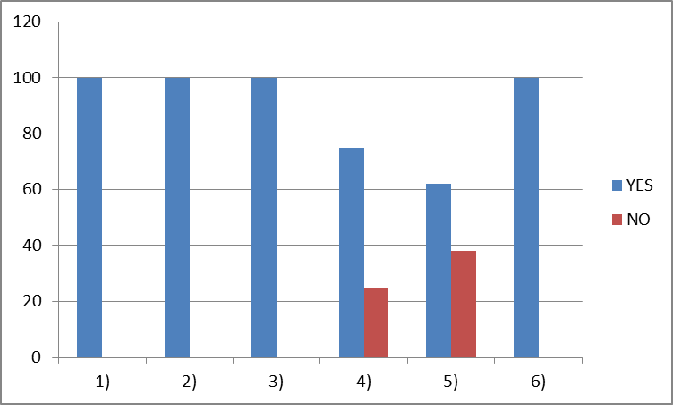
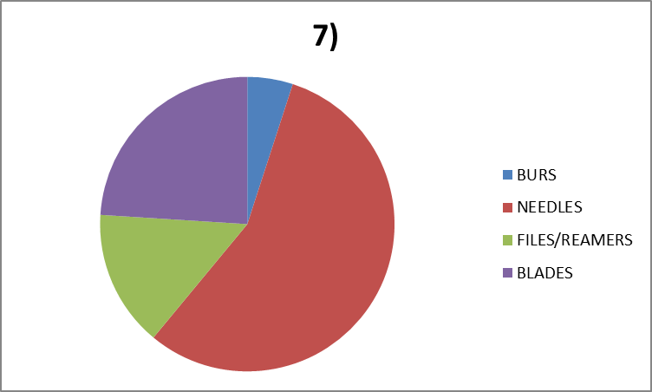
ATTITUDE:
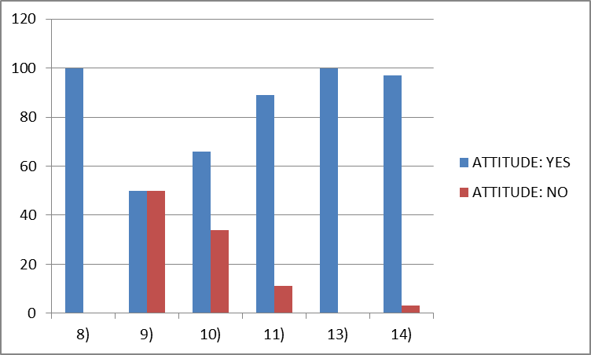
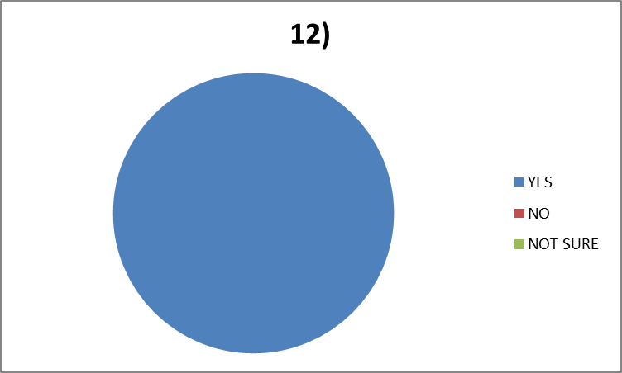
PRACTICES:
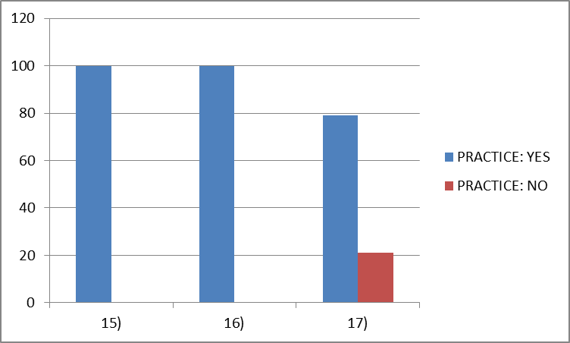
DISCUSSION :
On analyzing the responses obtained , it was observed that all the students (100%) were aware about post exposure prophylaxis , considered post exposure prophylaxis to be a significant part in their practice and were aware that PEP plays a significant role in reducing the risk of acquiring aids , hepatitis . Only 75% of the dental students were aware about the PEP regimen for Hepatitis B. 76% of the dental students were aware of the PEP regimen for HIV , whereas 24% were not . All the students had a non sterile occupational percutaneous injury during their practice . 5% of the students had an injury due to burs used , 56% had a needle injury , 15% were injured by files or reamers, and 24% by blades.
Attitude towards PEP:
100% of the dental students responded that they would wash the affected art with water immediately after an exposure and 50 % of them felt that washing immediately helps in preventing from acquiring aids , hepatitis b etc , whereas the other 50% felt it did not help. 90% answered that they would disinfect their skin after a sharp injury and 10 % answered that they wont . 89% of the students were only vaccinated for hepatitis B , the rest 11% were not. All the students felt that practising universal guidelines will prevent from acquiring infection from blood and body fluids. 97% of them are willing to treat patients with infectious diseases , 3% are not. 100% of them felt that all patients should be treated as potentially infectious .
Practices:
All the students followed universal precautions and used personal protective equipment while treating all patients and have also been given training at their institution for infection control . 79% of them felt more training should be given on PEP protocol.
After BDS , many dentists start with private practice . As a student when they treat potentially infectious patients , they are guided by the faculty members. However in private practice they should be competent to handle needle stick , blade or other injuries which they encounter.
CONCLUSION :
Through this study it can be concluded that all the students are well aware of PEP and its significance in reducing the risk of transmission of HIV, Hepatitis B etc. Only 75% of the students were aware about the PEP regimens for hepatitis B and HIV and only 89% of them were vaccinated for hepatitis B .Hence the awareness regarding the PEP regimens and vaccination should be improved among the students. The students must also be trained to use instruments carefully . Also , the training regarding post exposure prophylaxis must be improved at every institution .
REFERENCES:
1)Ssahil Mukesh Popat et al . Knowledge , attitude and practice of post exposure prophylaxis by students and clinical staff at dental school. June-october 2009
2)S.Shaghaghian et al . Knowledge , attitude and practice of dentists towards prophylaxis after exposure to blood and body fluids. IJOEM , Vol 5,Num3; July 2014.

