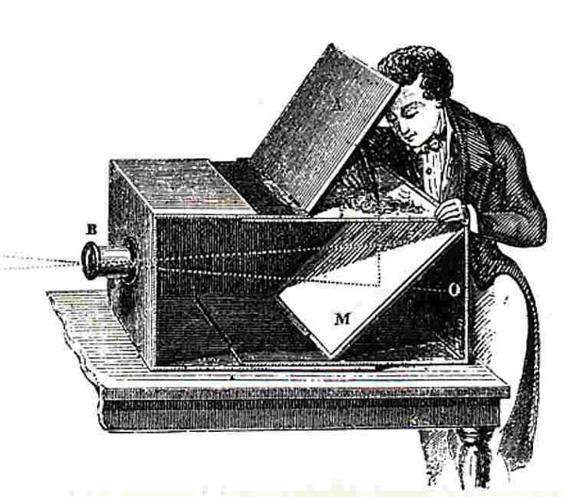

**Fig 1: One of the first cameras**



**Fig 2: Eye is optically similar to a camera. (a) human eye (b) camera.**

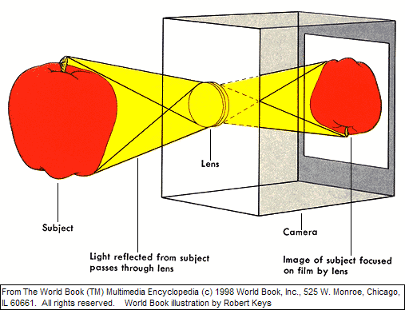

**Fig 3: Light rays from the top of the subject form the lower part of the image (upside down)**



**Fig 4: Aperture universal measurement system**

**Fig 5: Diagrammatic representation of an SLR camera**

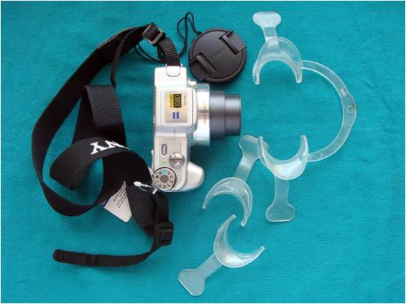

**Fig 6: digital camera with retractors**