ELLIS CLASSIFICATION MODIFIED BY HOLAND (1988)

Class 1: Fracture of enamel only
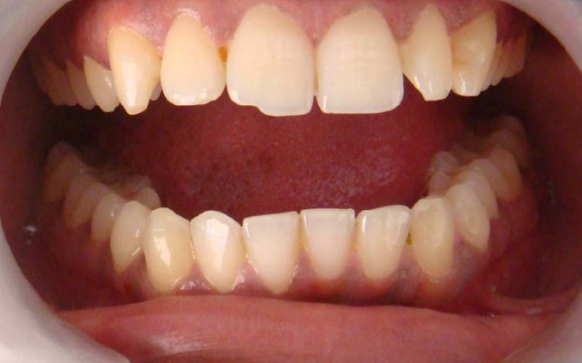

Class 2: Fracture includes enamel and dentine, without pulp involvement.
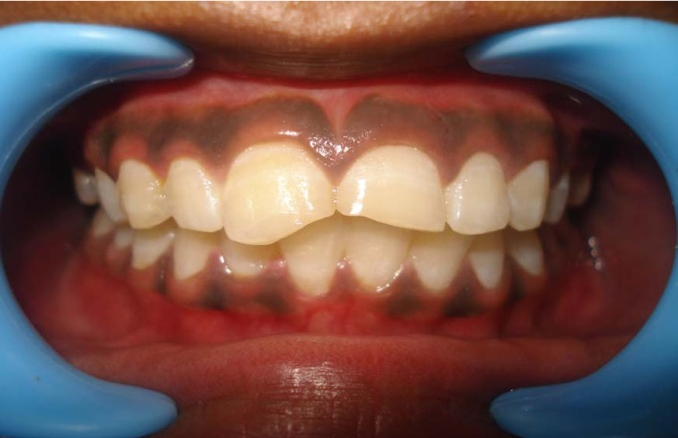

Class 3: Fracture of enamel and dentine with pulp involvement.
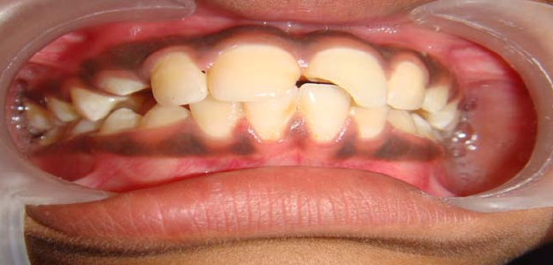

Class 4: Discolouration of the tooth as a result of concussion to the tooth, with or without a sinus.
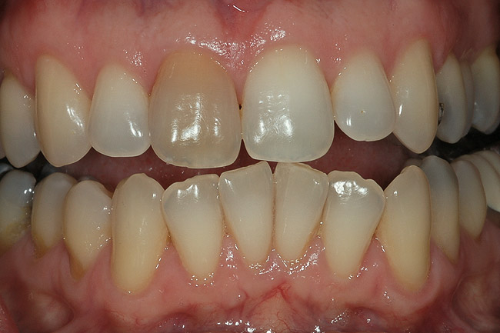
Class 5: Displacement; extrusion, intrusion, and lateral displacement.
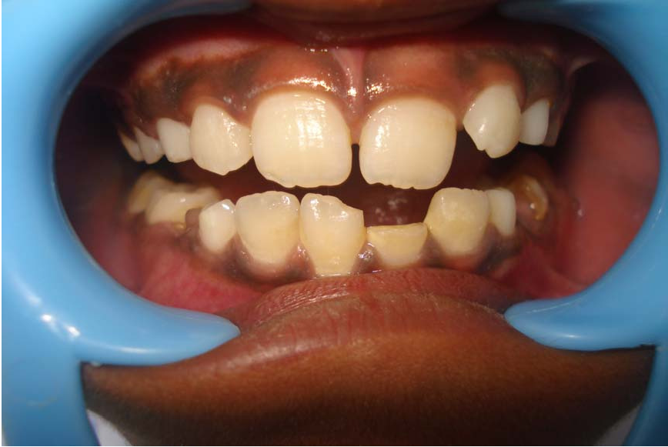

Class 6: Tooth loss as a result of trauma.
