Solitary Plasmacytoma in Mandible with 7 year follow up data

Authors :

- Balreddy. P MDS
Professor,
Department of Oral and maxillofacial Surgery
Government Dental College and Hospital, Hyderabad
Telangana, India.

- Prashanth Panta MDS
Senior Lecturer,
Department of Oral medicine and Radiology
MNR Dental College and Hospital
Narsapur road, Sangareddy (502294)
Telangana, India.

- Sridhar Reddy B MDS.
Associate Professor,
Department of Oral and maxillofacial Surgery
Government Dental College and Hospital, Hyderabad
Telangana, India.
- Sandhya Gokavarapu MDS
Department of Oral and maxillofacial Surgery,
Head and Neck Oncology,
Shanghai stomotology key laboratory,
Ninth Peoples hospital school of medicine,
Shanhai Jiao Tong University school of Medicine.,
Shanghai,
200011, China

Address for correspondence: Prashanth panta
Senior Lecturer,
Department of oral medicine and radiology
MNR Dental College and Hospital
Narsapur road, Sangareddy (502294)
Telangana, India.
E Mail ID: maithreya.prashanth@gmail.com
Telephone number: 91-9701806830

Conflict of interest: None

ABSTRACT
Solitary plasmacytoma is a plasma cell dyscrasia that rarely involves the jaws. Most of the solitary plasmacytomas progress into multiple myelomas over a period of 3-4 years. Although they are similar to multiple myeloma, these lesions must be differentiated from multiple myeloma as prognosis between the both varies considerably. Plasmacytoma is benign and does not require aggressive therapy. Multiple myeloma on the other hand are associated with poor prognosis and systemic involvement. This report describes a plasmacytoma in the mandible of a middle aged Indian male. He was treated by radiotherapy at a regional cancer center and reported to us after 7 years from the date of initial presentation. To our surprise even after so many years post radiotherapy, he did not develop multiple myeloma. We present a discussion on plasmacytoma, its relationship to multiple myeloma, prognosis and current therapies.

Key words: Solitary plasmacytoma, multiple myeloma, mandible.

INTRODUCTION
Solitary plasmacytomas (SP) are very rare. Plasmacytomas may be localized or disseminated. Localized variant can occur in bone or in soft tissues (extramedullary from) [1]. Patients with solitary plasmacytoma of bone present with localized pain, fractures, progressive bone swelling and radiological examination shows a well defined radiolucent lesion. The disseminated form is often a late presentation of localized disease and is referred to as multiple myeloma (MM). Therefore a careful differentiation between solitary plasmacytoma and multiple myeloma is necessary. Unlike multiple myeloma, solitary plasmacytoma has a better prognosis. Few authors have suggested these lesions to be the first manifestation of multiple myeloma. Durie and Salmon staging system considers plasmacytoma as a stage I myeloma [2]. These two conditions are closely related representing two ends of the same disease. They share a similar blood picture. Plasmacytomas are more common among males (M/F ~ 3:2) with peak incidence in 5th decade [3, 4]. It most frequently involves the vertebrae, ribs, clavicle and scapula, and sternum, mainly the axial skeleton [4].
Even from histology stand point, plasmacytoma lesions cannot be easily differentiated from multiple myeloma and accurate diagnosis is possible only after thorough examination of patient. Criteria for establishing solitary plasmacytoma [3, 5] include: (a) Presence of solitary bone tumor confirmed by a skeletal survey (b) A biopsy showing plasma cell histology (c) Normal bone marrow biopsy (<10% plasma cells) (d) Absence of anemia, hypercalcemia or renal involvement (e) Absence of any changes in immunoglobulin chemistry or low monoclonal component on serum electrophoresis (IgG < 5 g/dL, IgA < 3 g/dL ) . The present report describes the case of a 31 year male patient who was treated with radiotherapy.

CASE REPORT
A 31 years old male patient presented with a swelling in the jaw [Figure 1]. On inquiry, he revealed that he first noticed changes 7 years back and he reported a gradual increase in jaw size. For this complaint, the patient underwent radiotherapy in 2006. His reports revealed that previous radiotherapy was incomplete. Previous investigations suggested solitary plasmacytoma of left side of mandible.
Following were the investigations done in 2006:
(a) Bone scan findings consistent with highly vascular expansile predominantly lytic lesion involving right mandible (ascending ramus) correlating with radiological findings of plasmacytoma, no other skeletal lesions were seen [Figure 2].
(b) Histology suggested dense plasma cells with round to oval nucleus and vesicular nuclear chromatin pattern with perinuclear halo.
(c) Immune histochemical profile noted lambda light chain restriction with negative kappa.
(d) Agar gel protein electrophoresis showed normal pattern; monoclonal peak was absent.
Since the patient already had these reports, we have only advised for haematological investigations, biochemical investigations, FNAC of residual lesion and Contrast Enhanced CT of mandible [Figure 3]. FNAC suggested plasma cell neoplasm and hematological and biochemical investigations were within normal range. CECT suggested ill defined, expansile, osteolytic and sclerotic lesion epicentered in the mandibular angle with complete destruction of ascending ramus and partial destruction of body of the right side of mandible. The surrounding soft tissues were displaced by the bony mass and there was no evidence of abnormal enhancement of soft tissue component. The mass was approximately 7.1 X 4.6 X 7.2 centimetres in size [Figure 3]. All the features were suggestive of a partially healed residual plasmacytoma involving the right side mandible
Patient was given 40 Gray IMRT in twenty fractions in October 2013. Complete regression of the lesion was noted; FNAC done after 6 months of therapy did not show any evidence of recurrence. The patient is asymptomatic since 3 years and is still under follow up.
DISCUSSION
Solitary plasmacytoma is defined as a proliferation of monoclonal plasma cells without evidence of significant bone-marrow plasma-cell infiltration. Multiple myeloma should be carefully excluded since the prognosis of these two entities varies considerably. Overall 5 year survival of MM is 23% to 25%, whereas for SP it is 72% [6]. Localized plasma cell neoplasm within is associated with progression into multiple myeloma in maximum cases. Prognosis of SP is good, but quite poor if they progress to MM [6]. Nearly 20 percent of solitary plasmacytomas progress to multiple myeloma but they are mostly benign. Knobei et al in their multicenter study reported a mean period of 21 months for progression of these lesions into multiple myeloma even after definitive therapy with a 5 year probability of 51% [6]. Evaluation of prognostic factors revealed ‘old age’ as being the only factor which statistically influenced progression of these lesions into multiple myeloma. The favourable factors that limited progression include young age and tumor size <5cm.

Being highly radiosensitive, majority of them regress with moderate dose of radiation; radiotherapy is the treatment of choice. However, recurrence or progression into multiple myeloma was not statistically significant with treatment modality chosen [6, 7]. Although few researchers showed better local control and survival with surgery in extramedullary plasmacytoma, careful analysis and stratification of SEER database and from that of multicentre studies clearly suggested better survival of patients treated with surgery or radiation or both; there was no difference in the survival of patients depending on the treatment given [6, 7, 8].
Being a rare tumour, there is insufficient prospective data to derive information about treatment protocols. However, based on the retrospective studies and based on the radiosensitivity of this tumor, radiation is a preferred option [8]. Although many centers deliver a radiation dose of 50 Gy, some authors argue on the absence of dose response benefit beyond 30-40 Gy [8, 9]. Tsang reported that there was no improved dose response relationship beyond 35 gray for smaller tumours [10]. Combination of radiotherapy and surgery is preferred in bulky tumours. Considering the morbidity associated with surgery, radiation may be better. However, in cases with extensive bone involvement, surgery may be an inevitable choice due to pathological fracture associated with bone destruction. Although there was an extensive bone involvement in this case, radiographs did not show any pathological fracture. Surgery may be reserved for cases not thoroughly responding to radiation or in cases with pathological fracture. In the literature tumour size was reported to be an important prognostic factor; tumours with size larger than 5cm were associated with local failure [7, 10].
Progression of plasmacytoma into multiple myeloma occurs in two peaks. The first peak is within 3 years of treatment which is attributed to undetected existing disease and the second peak is after 6 to 7 years [7]. The patient in our report was diagnosed first time before 9 years and did not receive appropriate therapy because of neglect. An important point to be noted is that this patient did not progress to multiple myeloma even after 7 years (until 2013, when he reported once again) despite insufficient therapy. There were no obvious haematological or biochemical variations in 2013. During the last 3 years, due to adequate radiotherapy in 2013, patient did not show any symptoms of recurrence. Besides the tumour size, factors such as age must have favoured a good prognosis.
The observation that 59% of patients of plasmacytoma progressed to multiple myeloma questions the ability of modern investigation techniques. The 5 year survival of patients diagnosed as plasmacytoma initially, who developed multiple myeloma subsequently were similar to the patients diagnosed as multiple myeloma during the first visit. Jawad et al in their analysis of SEER database of 1164 patients of skeletal plasmacytoma have clearly reported a small cohort of patients with plasmacytoma who did not progress to multiple myeloma [6]. In that cohort, the 5year survival was 74%; the reasons of death in these patients were heart and cerebro-vascular diseases but not multiple myeloma related causes. It is noteworthy that most of these patients were older than 60 years of age at diagnosis (63.7% of cases) [6]. Thus it appears that untreated cases of plasmacytoma are at risk of slow progression in size but do not develop into multiple myeloma unless cases of multiple myeloma were misdiagnosed as plasmacytoma initially. Current diagnostic tools are highly applicable to differentiate patients with plasmacytoma and multiple myeloma [7]. CT can help in delineating these lesions to measure the extent of destruction and MRI can help in examining bone marrow and vertebral involvement. Scintigraphy may sometimes show extensive involvement of other bones and helps upstage solitary plasmacytomas to multiple myeloma.
The present case fulfils the criteria for plasmacytoma: (a) The tumor was solitary (b) Biopsy showed Plasma cell neoplasm, (c) Patient had normal hematological and biochemical investigations. The patient had received incomplete treatment initially despite which he remained asymptomatic for 6 years before he received full treatment again indicating the importance of radiation and sensitivity of the tumour to radiotherapy. FNAC done 6 months after treatment (2014) was negative and the patient is currently asymptomatic.

CONCLUSION
The present case indicates that solitary plasmacytoma may not always progress into multiple myeloma. Plasmacytomas are highly radiosensitive and radiation is the treatment of choice. Surgery is reserved for cases unresponsive to radiation or where it is inevitable due to lack of sufficient bulk of remaining bone. Studies are necessary and may be helpful in the standardization of treatment outcomes, especially pertaining to the radiation dose that is necessary. This case represents a rare possibility where plasmacytoma has not lead to multiple myeloma even after 7 years. Our message to clinicians is to closely follow up these patients atleast for a period of 3 to 4 years after diagnosis irrespective of treatment strategy. Some authors also argue trauma as a possible reason for plasmacytomas, investigation in this area can lead to deeper insights into its pathogenesis.

REFERENCES
1. Bachar G¹, Goldstein D, Brown D, Tsang R, Lockwood G, Perez-Ordonez B et al. Solitary extramedullary plasmacytoma of the head and neck—Long‐term outcome analysis of 68 cases. Head Neck. 2008; 30:1012-9.
2. P. Durie BG, Salmon SE. A clinical staging system for multiple myeloma. Correlation of measured myeloma cell mass with presenting clinical features, response to treatment, and survival. Cancer. 1975; 36: 842-54.
3. Sevil Kilciksiz, Omur Karakoyun-Celik, Fulya Yaman Agaoglu, Ayfer Haydaroglu. A Review for Solitary Plasmacytoma of Bone and Extramedullary Plasmacytoma ScientificWorld Journal. 2012; 2012: 895765.
4. Dimopoulos MA, Moulopoulos LA, Maniatis A, Alexanian R. Solitary plasmacytoma of bone and asymptomatic multiple myeloma. Blood. 2000; 96: 2037-44.
5. Durie BG, Kyle RA, Belch A, Bensinger W, Blade J, Boccadoro M et al. Myeloma management guidelines: a consensus report from the Scientific Advisors of the International Myeloma Foundation. Hematol J. 2004; 5: 285.
6. Jawad, M. U, Scully, S. P. Skeletal Plasmacytoma: Progression of disease and impact of local treatment; an analysis of SEER database. J Hematol Oncol. 2009; 2: 41
7. Knobel D, Zouhair A, Tsang RW, Poortmans P, Belkacémi Y, Bolla M, et al. Prognostic factors in solitary plasmacytoma of the bone: a multicenter Rare Cancer Network study. BMC Cancer. 2006; 6: 118.
8. Hu K, Yahalom JRadiotherapy in the management of plasma cell tumors. Oncology. 2000; 14: 101-8.
9. Soutar R, Lucraft H, Jackson G, Reece A, Bird J, Low E et al. Guidelines on the diagnosis and management of solitary plasmacytoma of bone and solitary extramedullary plasmacytoma. Br J Haematol. 2004; 124: 717-26.
10. Tsang RW, Gospodarowicz MK, Pintilie M, Bezjak A, Wells W, Hodgson DC. Solitary plasmacytoma treated with radiotherapy: impact of tumor size on outcome. Int J Radiat Oncol Biol Phys. 2001; 50: 113-20.
FIGURE and LEGENDS

Figure1: A massive swelling on the right side of mid face after partial treatment of solitary plasmacytoma. This photograph was taken in 2013

Figure 2: Whole body bone Technetium-99m MDP Skeletal Scintigraphy taken in 2006. There is no evidence of uptake in rest of the body except for mandible revealing that it is only a solitary plasmacytoma.

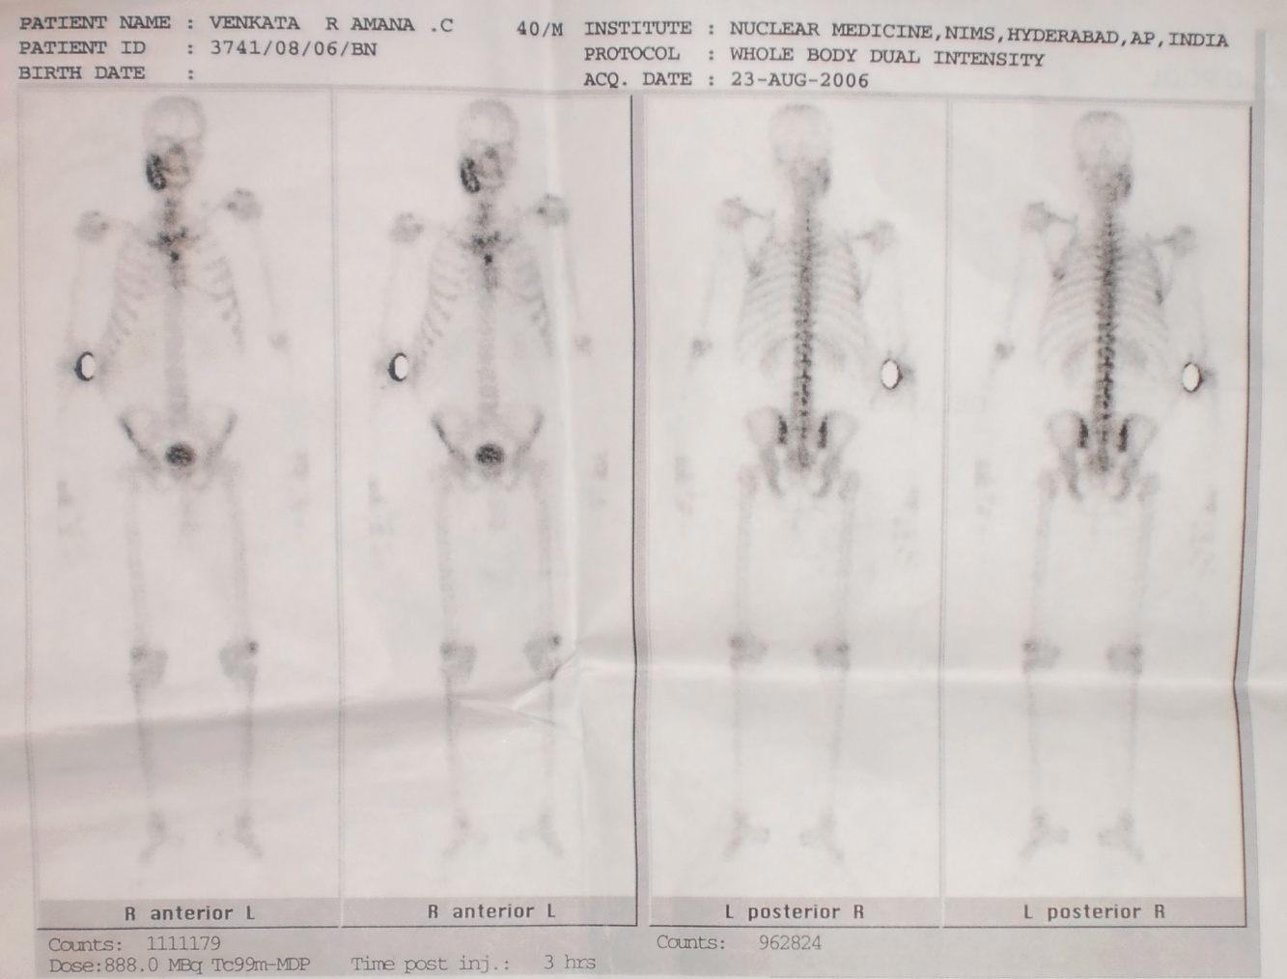

Figure 3: Axial sections of Contrast Enhanced Computed Tomography suggestive of an ill defined expansile, osteolytic and sclerotic lesion epicentered in the mandibular angle with destruction of ascending ramus and body of the right side of mandible.
