Figure 2a

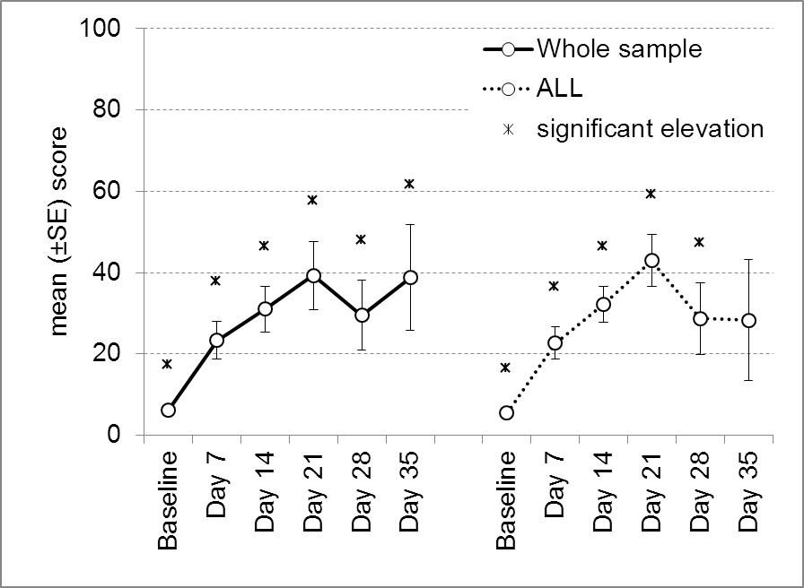
ӿ: statistically significant difference from the baseline
Differences were considered significant if p<0.05.

