Effect of short-term steroid use on bone healing around implants
Dr Jaber Yaghini¹, Dr Ahmmad mogharehAbed², Dr Mozhgan Izadi³, Dr Reza birang⁴, Dr Nakisa Torabinia⁵
1.Associate Professor, Department of Periodontics, School of Dentistry, Isfahan University of Medical Sciences, Isfahan, Iran
2.Professor, Department of Periodontics, School of Dentistry, Isfahan University of Medical Sciences, Isfahan, Iran
3.Assistant Professor, Department of Periodontics, School of Dentistry, Isfahan University of Medical Sciences, Isfahan, Iran
Email:Mozhgan.izadi.1165@gmail.com
Tel:00989131012493
4. Professor, Department of Periodontics, School of Dentistry, Isfahan University of Medical Sciences, Isfahan, Iran
5. Associate Professor, Department of Periodontics, School of Dentistry, Isfahan University of Medical Sciences, Isfahan, Iran
Abstract
Introduction: Prednisolone is a glucocorticoid used for treatment of immune-mediated inflammatory disorders such as rheumatoid arthritis and lupus erythematosus. There is no consensus regarding the effect of short-term steroid use on implant osseointegration. The aim of the current study was to evaluate the short-term effect of prednisolone on the osseointegration process in a canine model.
Materials and Methods: The 2nd, 3rd, and 4th mandibular premolar teeth (bilaterally) of 8 mature dogs were extracted under general anesthesia. After 3 months of healing, the dogs were allocated into study(receiving 4 mg/day prednisolone for 4 weeks followed by 2 mg/day for another 4 weeks) and control groups. Six implants (bone level) were inserted at the mandible of each dog. In 4 dogs (2 in each group), the reverse torque and the bone-implant contact (BIC) of the implants were evaluated at 1 week post-operatively and in the remaining dogs at 4 weeks. Data were analyzed using two-way ANOVA with 95% confidence interval.
Results: The reverse torque of all implants at 1 and 4 weeks pos-operatively was at the highest value of implant ratchet (Dental implant kit, DENTIS implant company, Seongseoseo-ro, Dalseo-gu, Daegu, Korea (Woram-dong)). The microscopic evaluation revealed that the BIC was significantly higher in controls in comparison to the prednisolone group (P-value < 0.05). In addition, the BIC of both groups significantly increased at 4 weeks when compared to the value at 1 week (P-value < 0.05). The newly formed bone around implants at 1 and 4 weeks pos-operatively was woven and lamellar, respectively.
Conclusion: Prednisolone has the potential to disrupt the osseointegration process.
Key words: Dental implants, Steroids, Bone, Osseointegration

Introduction
Branemark introduced the concept of osseointegration for the first time in 1969 (1). Osseointegration means a direct structural and functional bone-to-metal interface without interposition of non-bone tissue. The bone could become so fused with the titanium oxide layer of the dental implant surface that the two could not be separated without fracture. Based on the literature, osseointegration is defined as a cicatricial event leading to bone formation at the surface of the inserted implants. The outcome of osseointegration is the fixation of the implant to the alveolar bone via the newly formed bone (2).

While the osseointegration process involves bone formation, it is dependent on the turnover and remodeling of alveolar bone. As a result, various factors have the potential to affect the osseointegration process; among which, implant characteristics, surface properties, primary stability, loading condition, and intake of systemic medications during osseointegration process could be mentioned (3-5).
Among systemic medications, non-steroid anti-inflammatory drugs (NSAIDs) especially COX-2 inhibitors, Cyclosporine A, and immunosuppressive drugs may interfere with the osseointegration process. In addition, it has been reported that long-term intake of glucocorticoids has adverse effects on the osseointegration and the success rate of dental implants (6, 7).
The evidence on the effect of short-term glucocorticoid therapy on osseointegration is limited; Carvas et al (8) observed that administration of methylprednisolone led to significant reduction of BIC in a rabbit model after 12 weeks. As glucocorticoids have anti-inflammatory properties in short-term administration, there exists a possibility that it would interfere with the osseointegration process (9). Hence, the aim of the current study was to evaluate the effect of prednisolone on the osseointegration process in a canine model. The null hypothesis of the study was that there would be no significant differences in osseointegration in the study and control groups.

Materials and Methods
This experimental study was approved in the Ethics Committee of Isfahan University and was conducted in accordance with the Animal Welfare Act and the Guide for the Care and Use of Laboratory Animals.

Study Sample
To evaluate the study hypothesis, 8 local mature canines aged 16-20 months and weighing between 11 and 13 Kgs were selected. Canines were excluded from the study if: Domesticated, had rabies, uncontrollable behavior, or were aggressive.

Surgical Procedures
Surgery was performed at three stages; at the first stage teeth were extracted , at the second stage implants were inserted and at third stage implants were excised by a trephine drill.
First stage
To induce general anesthesia, 1% Acepromazine (0.2 cc/kg), 10% Ketamine (10 mg/kg), and Atropine (0.04 mg/kg) were administered. The anesthesia was maintained with Halothane. Following general anesthesia, a full thickness flap was elevated at the mandibular-premolar region (from the first to the forth premolar tooth). Next, the second, third, and forth premolar teeth of each side were sectioned buccolingually and extracted using a periotome. Then, the flap was sutured with 4-0 nylon (Mersilk,Ethicon Co., Livingston, UK).

Allocation and second stage surgery
After 3 months of healing (after first surgery stage), the dogs were allocated into study(4 dogs) and control(4 dogs) groups. In the study group, dogs received oral Prednisolone (4 mg/day) for 4 weeks and continued with the dosage of 2 mg/kg for another 4 weeks and in the control group, dogs received oral Placebo. A blood sample was taken every 2 weeks to ensure the significant reduction in leucocyte population during the corticosteroid therapy. At the end of the 4th week of placebo and prednisolone administration, the implants were inserted in the groups. The second stage of surgery was performed under general anesthesia. The night prior to surgery, all dogs received 20000 IU of Penicillin and Streptomycin (1g/10kg) (corresponding to 4 days of antibiotic coverage); after 4 days, another antibiotic regimen was administrated to maintain the coverage till the 8th day. At this stage, a crestal incision was made at the mandibular premolar region and three identical bone level implants with 3.4 mm diameter and 10 mm length (Dental implant, DENTIS implant company, Seongseoseo-ro, Dalseo-gu, Daegu, Korea (Woram-dong) were placed bilaterally at the 2nd, 3rd, and 4th mandibular premolar sites. Flaps were sutured with non-absorbable suture and the implants were submerged. In the study group, dogs received anti-acid treatment to prevent gastrointestinal side effects of corticosteroids. In addition, an antibiotic regimen was used to prevent infection.
Implant Evaluation
Inserted implants in 4 dogs (2 in each group), were evaluated one week after surgery and in the other half, at 4 weeks postoperatively. Following anesthesia, a blinded operator measured the reverse torque of all implants with implant ratchet (Dental implant kit, DENTIS implant company, Seongseoseo-ro, Dalseo-gu, Daegu, Korea (Woram-dong)).
To analyze the BIC, all of the implants were excised by a trephine drill (size: 10 mm) and maintained in 10% formalin solution. Specimens were mounted in resin blocks and sectioned (Accutom 50, Struers, Copenhagen, Denmark) mesiodistaly twice to a thickness of 50 μm. Sections were fixed to a microscope slide and stained using H&E staining technique. Stained sections were observed under a light microscope at 40X magnification to measure the BIC (Figure 1, 2). Samples were re-examined with Photoshop software version 7.0 (San Jose, CA, USA).
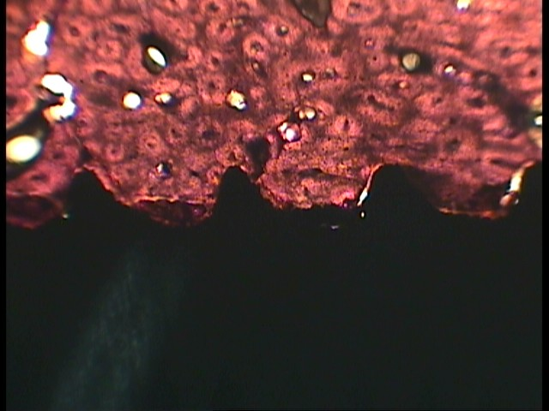
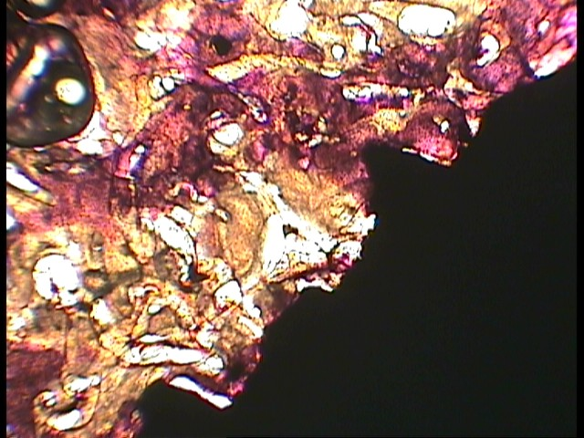

Figure 1. Sections with 50 μm thickness of study group. Sections were fixed to a microscope slide and stained using H&E staining technique. Stained sections were observed under a light microscope at 40X magnification to measure the BIC. Right, 1week postoperatively. Left, 4 week postoperatively

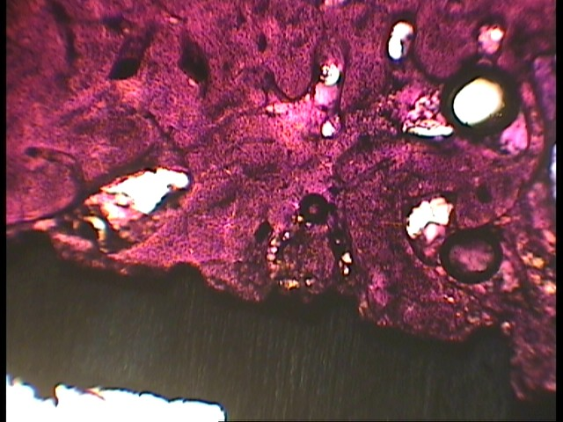
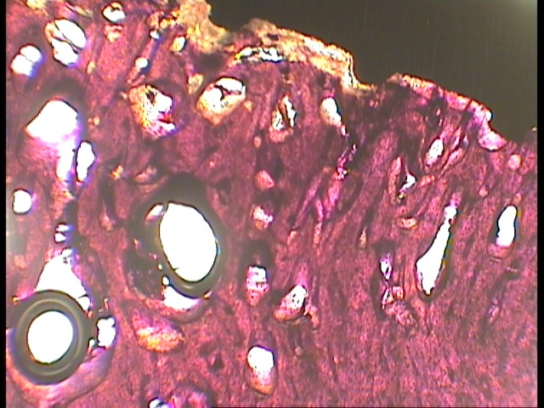

Figure2. Sections with 50 μm thickness of control group. Sections were fixed to a microscope slide and stained using H&E staining technique. Stained sections were observed under a light microscope at 40X magnification to measure the BIC. Right, 1week postoperatively. Left, 4 week postoperatively

Statistical Analysis
Appropriate descriptive statistics (mean, standard deviation, minimum, and maximum) were computed. To analyze the data, two-way ANOVA was performed using SPSS version 11.5 (Microsoft, Chicago, IL, USA) with 95% confidence interval. P value<0.05 was considered statistically significant.

Results
Eight mature dogs with a mean age of 17.12 ± 1.29 months and a mean weight of 11.91 ± 0.83 kgs received a total of 48 implants. Based on the Kolmogorov-Smirnov test, all data were distributed normally (P-value > 0.05).
The reverse torque of all implants was the same and at the maximum value in both groups (. The mean BIC of the implants is presented in Table 1 and Figure 3. According to the two-way ANOVA (Table 2), no significant interaction was observed between time and grouping of the implants (P-value > 0.05). In addition, the BIC significantly increased at 4 weeks in comparison to 1 week (P-value < 0.05). Furthermore, the BIC of the study group was significantly lower than that of the control group (P-value < 0.05).
According to the histological evaluation, the newly formed bone was woven and lamellar in all samples at 1 and 4 weeks, respectively.

Table 1. The BIC of implants according to the treatment group and time intervals
Time | Group | Number of dogs | Number of implants | Minimum | Maximum | Mean | SD
1 week | Study | 2 | 12 | 53 | 80 | 69.75 | 6.38
 | Control | 2 | 12 | 80 | 86 | 82.33 | 2.19
4 weeks | Study | 2 | 12 | 78 | 91 | 84.58 | 4.54
 | Control | 2 | 12 | 86 | 100 | 92.08 | 3.59

Figure 3. The changes in the BIC over time in the study and control groups

Table 2. Results of two-way ANOVA
Factor | Df | Mean Square | F | P-value
Intercept | 1 | 324229.69 | 16383.69 | < 0.001
Group | 1 | 1210.02 | 61.14 | < 0.001
Time | 1 | 1813.02 | 91.61 | < 0.001
Group * Time | 1 | 77.52 | 3.92 | 0.054

Discussion
The aim of the current study was to evaluate the effect of short-term administration of prednisolone on the osseointegration process of implants in a canine model. Our null hypothesis was that there would be no significant differences between prednisolone and control groups regarding osseointegration. The null hypothesis was refuted as the BIC of the control group was significantly higher than that of prednisolone group.
According to the results of the current study, all implants in both groups had the maximum reverse torque. The reverse torque test was introduced by Roberts et al, (10) in 1984 and was later developed by Johansson and Albrektsson (11, 12). It is among the most reliable techniques to assess the implant-alveolar bone integrity and is very accurate in estimating the clinical BIC. However, the reverse torque test is an aggressive method, which is highly destructive and should solely be used in animal models (13, 14).
The results of the current study revealed that short-term administration of prednisolone had a negative effect on the osseointegration process. At both 1 and 4 weeks, it was demonstrated that BIC of the study group was significantly lower than that of controls. In accordance with the present findings, Carvas et al. (8) found deleterious changes in BIC of the inserted implants in rabbit tibias after 18 weeks of methylprednisolone administration. Although the findings of Carvas et al, (8) and the current study are comparable, there are several differences in the study design and interpretations; firstly they evaluated a rabbit model while we used a canine model (15). Secondly, they inserted implants in the tibia bone, which has less similarity to the human jaw (15). Thirdly, they investigated the long-term effect of corticosteroids while we investigated the short-term effect of prednisolone.
Based on the literature, 18 weeks administration of corticosteroids is sufficient to induce osteoporosis in an animal model (16); however, osteoporosis is a long-term side effect of corticosteroids. One of the short-term effects of corticosteroids is their anti-inflammatory effect, which is beneficial in immune-mediated systemic disorders including lupus erythematosus, rheumatoid arthritis, polyarteritis nodosa, asthma, and allergy (17). In the mentioned disorders, the first treatment step is to administer high doses of glucocorticoids to acutely suppress the phenomena. Following the resolution of signs of the disorder, the dosage of the glucocorticoid is gradually decreased (18). In the current study, to simulate treatment protocol of aforementioned disorders in human, the adjusted dosage of prednisolone to a canine model was 4 mg/day prednisolone for 4 weeks followed by 2 mg/day for another 4 weeks (19).
The anti-inflammatory properties of prednisolone are due to the lipocortin-1 (annexin-1) synthesis. Lipocortin-1 suppresses phospholipase A2 and eicosanoid production and it inhibits various leukocyte inflammatory events including epithelial adhesion, chemotaxis, migration, and phagocytosis. Hence, glucocorticoids not only suppress the immune response, they also inhibit synthesis of prostaglandins and leukotrienes (two main inflammatory markers). Glucocorticoids inhibit the synthesis of prostaglandins at the level of phospholipase A2 in addition to the level of cyclooxygenase (COX-1 and COX-2) (9).
Chikazu et al. (20) demonstrated that the activity of COX-2 was essential for the osseointegration process. In addition, the first stage of osseointegration involves an inflammatory phase (21, 22). The BIC percentage at both 2 and 4 weeks could be explained by the fact that prednisolone inhibits the inflammatory phase of osseointegration.
In the current study, the implants were inserted after 4 weeks of prednisolone administration. Similarly, Carvas et al. (8) inserted implants following 6 weeks of methylprednisolone administration.
At 1 week postoperatively, type of the newly formed bone around all implants was woven bone; while at 4 weeks, histological evaluation revealed lamellar bone around all the implants. The change in bone types was in line with the increase in BIC.
One of the advantages of the current study design was that it provided a chance to investigate the short-term effects of prednisolone on the osseointegration process without the interference of the underlying inflammatory disorder for which the corticosteroids may be administrated (i.e. lupus erythematosus).
In conclusion, within the limitations of the current study, short-term administration of prednisolone has the potency to attenuate the osseointegration process, which could be regarded as a side effect in treatment of patients with systemic disorders including lupus erythematosus, asthma, and allergies in need of dental implants.

References
- Albrektsson T, Wennerberg A. The impact of oral implants - past and future, 1966-2042. J Can Dent Assoc. 2005 May;71(5):327.
- Mavrogenis AF, Dimitriou R, Parvizi J, Babis GC. Biology of implant osseointegration. J Musculoskelet Neuronal Interact. 2009 Apr-Jun;9(2):61-71.
- Marco F, Milena F, Gianluca G, Vittoria O. Peri-implant osteogenesis in health and osteoporosis. Micron. 2005;36(7-8):630-44.
- Søballe K. Hydroxyapatite ceramic coating for bone implant fixation. Mechanical and histological studies in dogs. Acta Orthop Scand Suppl. 1993;255:1-58.
- Başarır K, Erdemli B, Can A, Erdemli E, Zeyrek T. Osseointegration in arthroplasty: can simvastatin promote bone response to implants? Int Orthop. Jun 2009; 33(3): 855–859
- Pablos AB, Ramalho SA, König B Jr, Furuse C, de Araújo VC, Cury PR. Effect of meloxicam and diclofenac sodium on peri-implant bone healing in rats. J Periodontol. 2008 Feb;79(2):300-6.
- Sakakura CE, Marcantonio E Jr, Wenzel A, Scaf G. Influence of cyclosporin A on quality of bone around integrated dental implants: a radiographic study in rabbits. Clin Oral Implants Res. 2007 Feb;18(1):34-9.
- Carvas JB, Pereira RMR, Bonfá E, Silveira CA, Lima LL, Caparbo VF, et al. No deleterious effect of low dose methotrexate on titanium implant osseointegration in a rabbit model. Clinics (Sao Paulo). Jun 2011; 66(6): 1055–1059.
- Goppelt-Struebe M, Wolter D, Resch K. Glucocorticoids inhibit prostaglandin synthesis not only at the level of phospholipase A2 but also at the level of cyclo-oxygenase/PGE isomerase. Br J Pharmacol. 1989 Dec;98(4):1287-95.
- Roberts WE, Smith RK, Zilberman Y, Mozsary PG, Smith RS. Osseous adaptation to continuous loading of rigid endosseous implants. Am J Orthod. 1984 Aug;86(2):95-111.
- Johansson C, Albrektsson T. Integration of screw implants in the rabbit: a 1-year follow-up of removal torque of titanium implants. Int J Oral Maxillofac Implants. 1987 Spring;2(2):69-75.
- Johansson CB, Albrektsson T. A removal torque and histomorphometric study of commercially pure niobium and titanium implants in rabbit bone. Clin Oral Implants Res. 1991 Jan-Mar;2(1):24-9.
- Atsumi M, Park SH, Wang HL. Methods used to assess implant stability: current status. Int J Oral Maxillofac Implants. 2007 Sep-Oct;22(5):743-54.
- Roberts WE, Helm FR, Marshall KJ, Gongloff RK. Rigid endosseous implants for orthodontic and orthopedic anchorage. Angle Orthod. 1989 Winter;59(4):247-56.
- Pearce AI, Richards RG, Milz S, Schneider E, Pearce SG. Animal models for implant biomaterial research in bone: a review. Eur Cell Mater. 2007 Mar 2;13:1-10
- Martin-Monge E, Tresguerres IF, Blanco L, Khraisat A, Rodríguez-Torres R, Tresguerres JA. Validation of an osteoporotic animal model for dental implant analyses: an in vivo densitometric study in rabbits. Int J Oral Maxillofac Implants. 2011 Jul-Aug;26(4):725-30.
- Dowling PM. Immunosupressive drug therapy. Clinical pharmacology. Can vet J.1995 Dec;36:781-783.
- Schimmer P.S, Funder J.W. Goodman &Gilman’s The pharmacological Basis of Therapeutic. 5th ed. Lurance Burton.2008:1209-1236
- Srephen J. Ettinger, Edward C. Feldman. Textbook Vererinary internal medicine.2010. 7th ed.Saunders Elsivier; chapter158: 728-743.
- Chikazu D1, Tomizuka K, Ogasawara T, Saijo H, Koizumi T, Mori Y, et al. Cyclooxygenase-2 activity is essential for the osseointegration of dental implants. Int J Oral Maxillofac Surg. 2007 May;36(5):441-6.
- Futami T, Fujii N, Ohnishi H, Taguchi N, Kusakari H, Maeda T. Tissue response to titanium implants in the rat maxilla: ultrastructural and histochemical observation of the bone-titanium interface. J. Periodontol .2000;71(2):287-298.
- Berglundh T, Abrhamsson I, Lang NP, Lindhe J. Denovo alveolar bone formation adjacent to endosseous implants. A model in the dog. Clin Oral Implants Res. 2003; 14: 251-262

