Type of manuscript: Review of literature.
Name of the title: The possible role of Meditation in Myofascial pain syndrome - A speculation
Running title: Meditation and myofascial pain
Names of all authors:
Prashanth Panta¹

Affiliation:
¹ Senior lecturer, Department of Oral Medicine and Radiology, MNR Dental College and Hospital, Narsapur road, Sangareddy(502294), Medak District, Telangana, India.

Full Address for correspondence: Dr. Prashanth.Panta
Department of oral medicine and radiology
MNR Dental College and Hospital
Narsapur road, Sangareddy (502294)
Telangana, India.
E Mail ID: maithreya.prashanth@gmail.com
Telephone number: 91-9701806830

Conflict of interest: NIL

Acknowledgement:

This paper is dedicated to my father Swami maitreya, who is a spiritual guru in India. His wisdom and enlightenment have touched many lives, and this paper would not have come out without his inspiration.

The possible role of Meditation in Myofascial pain syndrome - A speculation

Abstract:

Myofascial pain syndrome (MPS) is a very common musculoskeletal pain disorder of the head and neck. In the past, several theories were put forth to explain its etiopathogenesis, but, there is no consenses view. According to one school of thought, myofascial pain reflects the psychological makeup of the individual and psychosocial factors directly contribute to this disorder. Hence, myofascial pain syndrome is considered as a psychosomatic disorder. Treatment for MPS is generally directed towards medications, trigger point therapy, acupuncture, muscle exercises, appliances, behavioural modification; of all these, behavioural modification is important. In this article, the possible role of meditation in myofascial pain syndrome is highlighted. In meditation, ‘mindfulness’ is used as a tool to unlock and release the hidden inner psychological tendencies that result in various organic diseases. However, till now, no direct evidence is available on the effect of meditation in myofascial pain syndrome. In this critical evidence-based review of literature, several mechanisms were identified and we anticipate that this paper may ignite new research on the effect of meditation in myofascial pain syndrome.

Keywords: Meditation, myofascial pain, psychosomatic disorder, pain relief.

1. Myofascial pain syndrome: Its nature and overview of the current treatment methods

Myofascial pain syndrome is a common dysfunction affecting up to 85% of the general population. [1]. It predominantly affects the muscles of mastication and neck muscles, and is a collection of sensory, motor, and autonomic symptoms. Myofascial pain syndrome exhibits multisystem involvement, associated with neurological, otologic, musculoskeletal and gastrointestinal features. The most significant event in MPS is the accumilation of acetylcholine at the neuromuscular junction (Figure 1).

Myofascial pain syndrome is a condition originally described by Janet Travell (John F. Kennedy's physician) and David Simons. Kellgren in the 1930s, published seminal papers and mapped myotomal referral patterns of pain after injecting hypertonic saline into muscles and ligaments, and had introduced the concept of trigger points [2, 3]. In 1952, Travell described the genesis of pain in MPS; she illustrated this by specific referred pain patterns of over 30 muscles [4]. In a review on clinical features of 164 MPS patients, it was revealed that there was tenderness at points in firm bands of skeletal muscle, specific patterns of pain referral associated with each trigger point, frequent emotional and behavioral contributing factors ( which explains the role of psychosomatic factors) [5]. The effected muscles in MPS are usually shortened with increased tone and tension. In addition, myofascial pain syndrome is characterised by the presence of tender zones called trigger points, and each trigger point is composed of hypercontracted muscle fibres. Palpation of this trigger point provokes radiating pain. Some research suggests that myofascial pain syndrome is a spinal reflex disorder (due to a connection between sensory afferents and the motor efferents) caused by a reverberating circuit of sustained neural activity in a specific spinal cord segment [6-8]. Chronic myofascial pain is usually a result of, and sometimes a product of, both emotional influences and physical factors [6]. According to Friction and others, myofascial pain syndrome is a regional muscle disorder that is associated with several behavioral, psychosocial and cognitive contributing factors, making this condition, predominantly a psychosomatic disorder [9-15]. Once the contributing factors are recognized, they should be minimized. This may be possible with meditation. MPS is treated mostly by patient education, stretch, massage, thermotherapy, electrotherapy, laser therapy, dry needling, acupuncture, shockwave therapy, botulinum toxin type A injection, trigger point injections, pharmacological methods and according to a recent report even hyperbaric oxygen therapy can also be used [16-21]. Though, there are several therapies available, the first reported technique was acupuncture [21]. Pharmacological treatment methods for MPS include, diclofenac patch, tramadol, tropisetron, opioids, lidocaine patch, tizanidine, benzodiazepines, cyclobenzaprine, thiocolchicoside, gabapentin, pregabalin, amitriptyline, duloxetine, sumatriptan, botulinum type A toxin, ketamine, L-tryptophan, memantine and others [22]. Although medications provide improvement in acute cases, they carry a risk of adverse effects. Non pharmacological methods such as meditation can provide gradual relief in MPS and do not carry the risk of any adverse effects (Table 1) [21].

Patients with myofascial pain commonly experience depression, sleep disturbance, anger, fatigue, and decreased overall physical and mental functioning [11]. They frequently require an interdisciplinary approach to address all the dimensions of pain experience. Although in most of the occasions medications are advised, meditation can provide equally good results. However, the role of meditation has been underestimated in the scientific community and has never been experimented as a sole therapy in MPS. Therefore, we have reviewed the possible role of meditation in the resolution of myofascial pain.

2. Meditation in Myofascial pain syndrome
Meditation is a very ancient practice that originated in India and has spread to the western world. In the recent years, it has emerged as a new field, that challenges even modern science as a treatment modality, capable of improving health and emotional well-being [23]. The origin of the word meditation is from the latin word ‘meditatio’ which means to contemplate. The sanskrit root would be ‘dhyana’. Mindfulness is essentially a buddhist concept - the word itself is an english translation of the Pali term ‘sati’.
The essence of meditation is ‘mindfulness or awareness’ or simply ‘being in the moment’. A good meditator will witness all experiences regardless of their origin and valency (pleasant, unpleasant, or neutral) [24]. Meditation is of many kinds. They can range from simple mantra chanting (Transcendental Meditation-TM) to more powerful mindfulness meditations as taught in Zen. Despite the technique used, awareness and equanimity are the essence of all forms of meditation. Awareness (of thoughts and emotions), liberates the hidden psychological tendencies that lie dormant in the mind, and results in emotional well-being [25-27]. In mindfulness, there is expression of ruminative and repressed thoughts. The hidden tendencies lead to thoughts which further reinforce emotions, ultimately leading to the maintenance of negative emotions. This vicious cycle can be broken by detached attention, ie., awareness of thoughts. Mental stress, which is directly related to the number and quality of thoughts influences emotions, which can influence the state of myofascial pain [26- 30]. Meditators do not engage with the content of thoughts but they aim to experience them as they are, without any judgement or analysis [27].

Meditation decreases sympathetic activity and heart rate, lowers cortisol (indicator of stress), increases skin resistance, causes cortical thickening, and brings specific changes in the electroencephalogram that correspond to mental relaxation [31]. It also activates certain areas in the brain, responsible for emotion regulation [32]. Therefore, mindfulness-based treatment programmes were applied in the management of chronic pain, anxiety, emotional disorders and also fibromyalgia, a similar and a more generalized form of MPS [33-37]. According to Buckler, TM can affect the state of myofascial pain syndrome by reducing pain due to muscle tension, especially when there are trigger zones present [38]. The possible mechanisms are described in the subsequent sections.

2.1 Meditation, pain modulation and central processing of myofascial pain
Myofascial pain syndrome, a form of chronic orofacial pain, is a multidimensional phenomenon that produces a characteristic brain signature [39]. Several functional neuroimaging studies have revealed a network of brain regions involved in the processing of nociceptive information. The literature regarding functional and structural changes in the brain of TMD patients, including patients with myofascial pain, showed significant changes in blood-oxygen-level, cerebral blood flow, gray matter and white matter anatomy [40, 41 ]. Changes were found in the thalamus and the primary somatosensory cortex, indicating the thalamocortical pathway as the major site of plasticity.
Brain plays a prominent role in the generation and modulation of pain in MPS. Brain is a powerful endogenous pain modulatory system, and hyperalgesia from myofascial trigger points is partially controlled by supraspinal pain control mechanisms and descending pain inhibitory mechanisms (via periaqueductal gray) [42]. This link between brain and MPS can be explored in a positive way by therapeutical interventions such as meditation, which has a direct effect on regions of the brain responsible for pain modulation. Recent neuroimaging data suggest that MPS is associated with abnormal hippocampal hypoactivity [42]. According to Kupers et al, induced Jaw-muscle pain (model mimicks MPS) is associated with significant increases in regional cerebral blood flow in the posterior insula, anterior cingulate, prefrontal cortices, right posterior parietal cortex, brainstem, cavernous sinus and cerebellum [43]. Myofascial pain is associated with changes in cerebral blood flow and meditation improves cerebral perfusion [44]. Mindfulness meditation not only enhances cerebral blood flow in anterior cingulate cortex, medial prefrontal cortex, insula (region involved in the regulation of emotions), but also regulates the autonomic nervous system by a ventral midfrontal brain system [44]. The key neurological processes that enable detachment during meditation include the activation of prefrontal cortex (PFC) impulse control, anterior cingulate cortex (ACC) stimulus discrimination and attentional focus. Regular mindfulness practice causes a greater activation of ACC and less utilisation of PFC. This event signifies a greater reliance on perceptual stimulus discrimination rather than control strategies [44]. It is proven that with proper practice, the utilization of the PFC-ACC regions and its connectivity with the amygdala (A) and insula is also enhanced.

Electroencephalographic studies on Zen meditation found increased alpha and theta activity in the frontal cortex, generally related to relaxation [45]. Theta activity in particular, is a marker of deeper relaxation and is directly related to the degree of experience, being greater in more senior practitioners. A number of sources have suggested a strong link between pain and cortical acitivity, as measured by electroencephalogram (EEG). The experience of pain is associated with relatively lower amplitudes of slower wave (delta, theta, and alpha) activity and relatively higher amplitudes of faster wave (beta) activity [46]. By trying to affect EEG rhythms directly using neuro-modulatory approaches such as meditation, pain modulation is possible at the cortical level [46, 47].

There is sufficient data on the effect of meditation in fibromyalgia. Hence, in this section, we tried to correlate those findings with the currect topic. Literature suggests that myofascial pain syndrome and fibromyalgia are overlapping syndromes with somewhat similar neurobiology and pathogenesis [37, 48, 49]. Both are associated with local tenderness, taut muscle bands, muscle twitches and active trigger zones [48]. Recently, in patients with fibromyalgia and fatigue syndrome, the two conditions that represent the upper and lower limits of MPS, the brain wave pattern revealed to have an alpha rhythm disturbance (7.5-11 Hz) and alpha delta sleep (alpha intrusions in non-rapid eye movement sleep) [50-52]. A similar phenomenon is believed to occur in MPS. As meditation increases alpha activity, corrects the disturbed cortical activity, it can be considered in patients with MPS.

2.2 Meditation can eliminate psychosocial contributors of myofascial pain

The connection between the body and mind is well established, and literature clearly points that the state of the mind affects the condition of the body. MPS is in essence a psychosomatic condition, fundamentally associated with stress, chronic pain, sleep disturbances, anxiety, anger and autonomic dysfunction [53]. As meditation has a substantial effect on pain perception, sleep patterns, psychological morbidity and sympathetic nervous system, we hypothesized that it can control the severity of MPS.

Several researchers point sleep deprivation as a contributory factor for myofascial pain. Meditation on the other hand reduces the need for sleep and improves the quality of sleep [54, 55]. In this way meditation indirectly helps in the resolution of MPS by arresting further progression. Adequate sleep is crucial for proper brain function and sleep deprivation usually diminishes mental performance. Shortage of sleep is an important cause of stress and anxiety, and both stress and anxiety contribute to MPS. When an individual has inadequate sleep, it is difficult to cope with already existing stress and anxiety. So, a lack of sleep causes stress, anxiety and depression, and depression on the other hand can cause sleep disturbances. As meditation reduces sleep disturbances, stress and anxiety, it can be used as a tool to reverse MPS [26]. Travell and Simon emphazised in their book titled ' Myofascial Pain and Dysfunction: Upper half of body’, that a careful inquiry into the nature of sleep is important for MPS patients [56]. They stated that anxious and depressed patients have a trouble of falling asleep. Painful muscles in MPS interrupt sleep and disrupted sleep can make the muscles even more painful forming a vicious cycle [56]. Impaired sleep occurs at a greater frequency in patients with severe myofascial pain syndrome [56]. Smythe considered sleep disturbances as one of the 4 important criteria for the diagnosis of fibromyalgia, a more generalized form of MPS [56]. Most of the fibromyalgia patients demonstrate an overnight increase in the tenderness of the muscles. Improving sleep quality can reduce pain and fatigue, further supporting the hypothesis that sleep dysfunction is a pathogenic stimulus [57]. Sleep deprivation in healthy individuals can cause symptoms of myalgia, tenderness and fatigue, suggesting the possible role of sleep dysfunction in chronic muscle pain [57, 58]. Epidemiological studies indicate that poor sleep quality is a risk factor for the development of chronic muscle pain. Also, sleep deprivation impairs descending pain-inhibition pathways that are important in coping with pain.

In modern medicine it is well known that a clear relationship between emotional state and organic disease exists. Emotional upheaval can cause a wide variety of diseases (psychosomatic conditions) of which myofascial pain syndrome is one of them [10, 11]. Stress and anxiety are the body’s alarm response to perceived physical and mental stress. Though anxiety is a short lived phenomenon in the general population, in a few, it is almost a permanent state. In a meta-analysis it was concluded that clinicians should discuss with their patients about the role of meditation programmes to reduce psychological stress [59]. In several studies it was identified that stress is an important cause of MPS. Hence, the role of stress in the progression of MPS cannot be underestimated. As meditation reduces stress, it can be considered in MPS patients [60]. Mindfulness meditation has promising potential as a non-pharmacologic treatment of chronic pain for patients with MPS [61]. The common benefits with mindfulness meditation include less pain, acceptance of pain, better sleep, enhanced well-being, which brings about improved quality of life (Figure 2) [55, 62, 63]. MPS is an outcome of chronic anxiety, depression and other psychological states [64]. It is important to eliminate these perpetuating factors and provide adequate education to patients so that recurrent or chronic pain can be avoided.

2.3 Meditations equalizes autonomic nervous system imbalances
The role of Autonomic nervous system is pivotal in the genesis of MPS (Figure 3). It was shown in several studies that MPS patients have autonomic nervous system imbalances [53]. Meditation is a wakeful state accompanied by a lowering of cortical and autonomic arousal [65]. According to a study by park et al, mindfulness meditation is a technique that lowers the muscle sympathetic nerve activity (MSNA) [66]. They observed a significant reduction in MSNA as compared with the controls. In another study physiological indices of stress were found to be lower in people who regularly practiced Transcendental Meditation than in non-meditating control subjects. In that study a noxious loud tone (100 db, 0.5 sec, 3000 Hz) was presented to subjects during normal waking and the stress reaction to each tone, as indicated by the galvanic skin response (GSR) was compared between the two groups [67]. Habituation of the GSR to tones was faster for meditators than for controls, and meditators made fewer multiple responses during habituation indicating greater stability in response to stress. In a few other experiments meditators were found to make fewer spontaneous GSR’s than control subjects, both during meditation when compared with rest (eyes closed), and while out of meditation with eyes open. Thus meditators were found to be more stable than controls on three autonomic indices: rate of GSR habituation, multiple responses, and spontaneous GSR. In myofascial pain subjects, the autonomic nervous system responses are unstable, where as in meditators, the responses are steady [68-71]. Autonomic nervous system is relatively stable in meditators. Hence, meditation can play an important role in treating the underlying autonomic dysfunction in myofascial pain syndrome.
2.4 Myofascial pain, free radicals and meditation

According to the most recent reports, MPS involves the formation of oxygen free radicals. In the striated muscle, the accumulation of reactive oxygen species (ROS) contributes to contractile dysfunction and myopathy, both these process occur in MPS [72]. Superoxide which is generated by the addition of a single electron to ground state oxygen is the primary ROS in the Striated muscle [73]. Superoxide is acted upon by superoxide dismutases (SOD) to convert it into hydrogen peroxide (H2O2) [74]. H2O2 activates several signaling pathways, and is broken down by either catalase or glutathione peroxidase to form water and oxygen [75]. Previously, the most important source of superoxide was believed to be the electron transport chain (ETC) in the mitochondria [76-79]. However, according to the most recent work, ROS are generated not only in ETC but by three additional muscle sources. They include via the participation of enzymes xanthine oxidase(XO), phospholipase A2 (PLA2 ) and nicotinamide adenine dinucleotide phosphate oxidase 2(NADPH oxidase) [ 80- 82].

During sustained vigorous contractile activity, which occurs in MPS, the mitochondrial function increases atleast by 50-fold [77]. Reactive oxygen species generated in mitochondria and other nearby sites, cause damage to mitochondrial components to initiate a degradative processes [78]. At the cellular level, mitochondria dysfunction is central to the pathogenesis of MPS [72]. Ca (2+) overload seen in MPS, is detrimental to mitochondrial function, and is a cause of mitochondrial ROS generation. Ca(2+) overload can cause, an increase of metabolic rate, elevated nitric oxide production, cytochrome c dissociation, cardiolipin peroxidation and protein kinases activation [ 79, 82]. In simple words, mitochondrial ROS rise can modulate Ca (2+) dynamics and augment Ca (2+) surge. The interactions between Ca (2+) induced ROS increase and ROS modulated Ca (2+) elevation may cause a self-amplified loop, creating a great amount of cellular damage [82].

In the past, the role of mitochondria was highlighted in a wide variety of clinical conditions ranging from simple neuropathic pain to chronic fatigue syndrome, both are seen in MPS [83]. Meditation, both transendental and zen, have been showed to diminish oxidative stress [84]. The activity of antioxidant enzymes such as superoxide dismutase, catalase, glutathione peroxidase and glutathione reductase is enhanced in meditators [84]. Meditation mainly upregulates superoxide dismutase activity and reduces lipid peroxidation, and is hence an antioxidant therapy (Figure 1) [84, 85, 86 87, 88]. A lower oxidative stress, can improve mitochondrial performance, which is important for effective calcium transport during muscle contraction [72, 89].

3. Conclusion

In this review, the link between myofascial pain syndrome, psychological factors and meditation was explained. An agitation in the mind, due to altered mental states such as anger, anxiety, and stress, principally affects certain areas in the brain, the sensitive nerve channels and muscle fibers leading to myofascial pain syndrome. Meditations can provide significant improvement in MPS, as it reduces stress and psychological morbidity which are triggers of MPS and brings about emotional wellbeing. An overactivity of the sympathetic nervous system is frequently seen in individuals with myofascial pain syndrome, and there is enough evidence that suggests that meditation reduces the sympathetic tone. Also during stressful situations the muscle tone automatically increases due to the effect of the sympathetic nervous system. Muscle relaxation occurs as a spontaneous byproduct of meditation. Meditation reverses the condition of MPS, following the same psychosomatic route which has actually caused it. Based on our insight and understanding of myofascial pain syndrome, we put forth meditation as a novel technique and as a possible intervention for MPS patients. However, more clinical trials and research is needed in this area, inorder to determine the exact effect of meditation on MPS subjects.

References:

1. Fleckenstein J, Zaps D, Rüger LJ, Lehmeyer L, Freiberg F, Lang PM et al. Discrepancy between prevalence and perceived effectiveness of treatment methods in myofascial pain syndrome: results of a cross-sectional, nationwide survey. BMC Musculoskelet Disord. 2010; 11: 32.

2. Kellgren JH. Referred Pains from Muscle. British Medical Journal. 1938; 1: 325-327.

3. Bennett R. Myofascial pain syndromes and their evaluation. Best Pract Res Clin Rheumatol. 2007; 21: 427-45.

4. Travell JG, Rinzler SH. The myofascial genesis of pain. Postgrad Med 1952;11:452-434.

5. Fricton JR, Kroening R, Haley D, Siegert R. Myofascial pain syndrome of the head and neck: a review of clinical characteristics of 164 patients. Oral Surg Oral Med Oral Pathol. 1985; 60: 615-23.

6. Wheeler AH. Myofascial pain disorders: theory to therapy. Drugs.2004; 64: 45-62.

7. Hong CZ, Simons DG. Pathophysiologic and electrophysiologic mechanisms of myofascial trigger points. Arch Phys Med Rehabil. 1998; 79: 863-72.

8. Kuan TS, Hong CZ, Chen JT, Chen SM, Chien CH. The spinal cord connections of the myofascial trigger spots. Eur J Pain. 2007; 11: 624-34.

9. Fricton JR. Myofascial pain syndrome. Neurol Clin. 1989;7: 413-27.

10. Fricton JR. Clinical care for myofascial pain. Dent Clin North Am. 1991; 35: 1-28.

11. Lorys Castelli, Federica De Santis, Ilaria De Giorgi, Andrea Deregibus, Valentina Tesio, Paolo Leombruni et al. Alexithymia, anger and psychological distress in patients with myofascial pain: a case-control study. Front Psychol. 2013; 4: 490

12. Shamim T. A simple working type classification proposed for the psychosomatic disorders of the oral cavity. J Coll Physicians Surg Pak. 2012; 22: 612

13.van Selms MK, Lobbezoo F, Visscher CM, Naeije M. Myofascial temporomandibular disorder pain, parafunctions and psychological stress. J Oral Rehabil. 2008; 35: 45–52.

14. Kim YK, Kim SG, Im JH, Yun PY. Clinical survey of the patients with temporomandibular joint disorders, using Research Diagnostic Criteria (Axis II) for TMD: preliminary study. J Craniomaxillofac Surg. 2012; 40: 366–372.

15. Shamim T. The psychosomatic disorders pertaining to dental practice with revised working type classification. Korean J Pain. 2014; 27: 16-22.

16. Borg-Stein J, Iaccarino MA. Myofascial pain syndrome treatments. Phys Med Rehabil Clin N Am. 2014; 25: 357-74.

17. Wright A, Sluka KA. Nonpharmacological treatments for musculoskeletal pain. Clin J Pain. 2001;17: 33-46.

18. Grant JA. Meditative analgesia: the current state of the field. Ann N Y Acad Sci. 2014; 1307: 55-63

19. Kuan TS. Current studies on myofascial pain syndrome. Curr Pain Headache Rep. 2009; 13: 365-9.

20. Kiralp MZ, Uzun G, Dinçer O, Sen A, Yildiz S, Tekin L, Dursun H. A novel treatment modality for myofascial pain syndrome: hyperbaric oxygen therapy. J Natl Med Assoc. 2009; 101: 77-80.

21. Chou LW, Kao MJ, Lin JG. Probable mechanisms of needling therapies for myofascial pain control. Evid Based Complement Alternat Med. 2012; 2012: 705327.

22. Desai MJ, Saini V, Saini S. Myofascial pain syndrome: a treatment review. Pain Ther. 2013; 2:21-36.

23. Bishop SR. What do we really know about mindfulness-based stress reduction? Psychosom Med. 2002; 64: 71-83.

24. Desbordes G, Gard T, Hoge EA, Hölzel BK, Kerr C, Lazar SW. Moving beyond Mindfulness: Defining Equanimity as an Outcome Measure in Meditation and Contemplative Research. Mindfulness (N Y). 2015; 6: 356–372.

25. Grossman P, Niemann L, Schmidt S, Walach H. Mindfulness-based stress reduction and health benefits. A meta-analysis. J Psychosom Res. 2004; 57: 35-43.

26. Manocha R, Black D, Sarris J, Stough C. A randomized, controlled trial of meditation for work stress, anxiety and depressed mood in full-time workers. Evid Based Complement Alternat Med. 2011; 2011: 960583.

27. Grecucci A, De Pisapia N, Kusalagnana Thero D, Paladino MP, Venuti P, Job R. Baseline and strategic effects behind mindful emotion regulation: behavioral and physiological investigation. PLoS One. 2015; 10: e0116541

27. Shapiro SL, Carlson LE, Astin JA, Freedman B. Mechanisms of mindfulness.J Clin Psychol. 2006; 62: 373-86.

28. Benson H, Beary JF, Carol MP. The relaxation response. Psychiatry. 1974; 37: 37-46.

29. Smith JC. Steps toward a cognitive-behavioral model of relaxation. Biofeedback Self Regul. 1988; 13: 307-29.

30. Killingsworth MA, Gilbert DT. A wandering mind is an unhappy mind. Science. 2010; 330: 932.

31. Wallace RK. Physiological effects of transcendental meditation. Science. 1970 Mar 27;167(3926):1751-4.

32. Heather Buttle. Measuring a Journey without Goal: Meditation, Spirituality, and Physiology. BioMed Research International, Article ID 891671, in press.

33. Kabat-Zinn J. An outpatient program in behavioral medicine for chronic pain patients based on the practice of mindfulness meditation: theoretical considerations and preliminary results. Gen Hosp Psychiatry. 1982; 4: 33-47.

34. Kabat-Zinn J, Lipworth L, Burney R. The clinical use of mindfulness meditation for the self-regulation of chronic pain. J Behav Med. 1985; 8: 163-90.

35. Kaplan KH, Goldenberg DL, Galvin-Nadeau M. The impact of a meditation-based stress reduction program on fibromyalgia. Gen Hosp Psychiatry. 1993; 15: 284-9.

36.Kabat-Zinn J, Massion AO, Kristeller J, Peterson LG, Fletcher KE, Pbert L. Effectiveness of a meditation-based stress reduction program in the treatment of anxiety disorders. Am J Psychiatry. 1992; 149: 936-43.

37. Chandola HC, Chakraborty. A. Fibromyalgia and Myofascial Pain Syndrome-A Dilemma. Indian Journal of Anaesthesia. 2009;53: 575-581.

38. Buckler WS. Transcendental meditation. Can Med Assoc J. 1976; 115: 607.
39. May A. Neuroimaging: visualising the brain in pain. Neurol Sci. 2007; 28 Suppl 2: S101-7.

40. Younger JW, Shen YF, Goddard G, Mackey SC. Chronic myofascial temporomandibular pain is associated with neural abnormalities in the trigeminal and limbic systems. Pain. 2010; 149: 222-8.

41. Lin CS. Brain signature of chronic orofacial pain: a systematic review and meta-analysis on neuroimaging research of trigeminal neuropathic pain and temporomandibular joint disorders.PLoS One. 2014. 23; 9: e94300.

42. Niddam DM, Chan RC, Lee SH, Yeh TC, Hsieh JC. Central modulation of pain evoked from myofascial trigger point. Clin J Pain. 2007; 23: 440-8.

43. Kupers RC, Svensson P, Jensen TS. Central representation of muscle pain and mechanical hyperesthesia in the orofacial region: a positron emission tomography study. Pain.2004; 108: 284-93.

44. Tang YY, Ma Y, Fan Y, Feng H, Wang J, Feng S et al. Central and autonomic nervous system interaction is altered by short-term meditation. Proc Natl Acad Sci U S A. 2009; 106: 8865-70.

45. Chiesa A. Zen meditation: an integration of current evidence. J Altern Complement Med. 2009; 15: 585-92.

46. Jensen MP, Hakimian S, Sherlin LH, Fregni F. New insights into neuromodulatory approaches for the treatment of pain. J Pain. 2008; 9: 193-9.

47. Jensen MP, Day MA, Miró J. Neuromodulatory treatments for chronic pain: efficacy and mechanisms. Nat Rev Neurol. 2014; 10:167-78.

48. Wolfe F, Simons DG, Fricton J, Bennett RM, Goldenberg DL, Gerwin R. The fibromyalgia and myofascial pain syndromes: a preliminary study of tender points and trigger points in persons with fibromyalgia, myofascial pain syndrome and no disease. J Rheumatol. 1992; 19: 944-51.

49. Simons DG. Fibrositis/fibromyalgia: a form of myofascial trigger points? Am J Med. 1986; 81: 93-8.

50. Goldenberg DL. Fibromyalgia, chronic fatigue, and myofascial pain syndromes. Curr Opin Rheumatol. 1992; 4: 247-57.

51. Manu P, Lane TJ, Matthews DA, Castriotta RJ, Watson RK, Abeles M. Alpha-delta sleep in patients with a chief complaint of chronic fatigue. South Med J. 1994; 87: 465-70.

52. Branco J, Atalaia A, Paiva T. Sleep cycles and alpha-delta sleep in fibromyalgia syndrome. J Rheumatol. 1994; 21: 1113-7.

53. Perry F, Heller PH, Kamiya J, Levine JD. Altered autonomic function in patients with arthritis or with chronic myofascial pain. Pain. 1989; 39: 77- 84.

54. Kaul P, Passafiume J, Sargent CR, O'Hara BF. Meditation acutely improves psychomotor vigilance, and may decrease sleep need. Behav Brain Funct. 2010; 29;6:47

55. Morone NE, Lynch CS, Greco CM, Tindle HA, Weiner DK. "I felt like a new person." the effects of mindfulness meditation on older adults with chronic pain: qualitative narrative analysis of diary entries. J Pain. 2008; 9: 841-8.
56. Simons, David G., Janet G. Travell, and Lois S. Simons. Travell & Simons' myofascial pain and dysfunction: upper half of body. Vol. 1. Lippincott Williams & Wilkins, 1999.

57. Choy EH. The role of sleep in pain and fibromyalgia. Nat Rev Rheumatol. 2015 Apr 28.

58. Ashburn MA, Staats PS. Management of chronic pain. Lancet. 1999; 353: 1865-9.

59. Goyal M, Singh S, Sibinga EM, Gould NF, Rowland-Seymour A, Sharma R. Meditation programs for psychological stress and well-being: a systematic review and meta-analysis. JAMA Intern Med. 2014; 174: 357-68.

60. Fjorback LO. Mindfulness and bodily distress. Dan Med J. 2012;59:B4547.

61. Hassed C. Mind-body therapies--use in chronic pain management. Aust Fam Physician. 2013; 42: 112-7.

62. Cramer H, Haller H, Lauche R, Dobos G. Mindfulness-based stress reduction for low back pain. A systematic review. BMC Complement Altern Med. 2012;12:162.

63. Kabat-Zinn J, Lipworth L, Burney R. The clinical use of mindfulness meditation for the self-regulation of chronic pain. J Behav Med. 1985;8: 163-90.

64. Velly AM, Gornitsky M, Philippe P. Contributing factors to chronic myofascial pain: a case-control study. Pain. 2003; 104: 491-9.

65. Woolfolk RL. Psychophysiological correlates of meditation. Arch Gen Psychiatry. 1975;32: 1326-33.

66. Park J, Lyles RH, Bauer-Wu S. Mindfulness meditation lowers muscle sympathetic nerve activity and blood pressure in African-American males with chronic kidney disease. Am J Physiol Regul Integr Comp Physiol. 2014; 307: R93-R101.

67. Orme-Johnson DW. Autonomic stability and Transcendental Meditation. Psychosom Med. 1973; 35: 341-9.

68. Telles S, Desiraju T. Autonomic changes in Brahmakumaris Raja yoga meditation. Int J Psychophysiol. 1993; 15: 147-52.

69. Telles S, Raghavendra BR, Naveen KV, Manjunath NK, Kumar S, Subramanya P. Changes in autonomic variables following two meditative states described in yoga texts. J Altern Complement Med. 2013; 19: 35-42.

70. Deshmukh VD. Neuroscience of meditation. ScientificWorldJournal. 2006; 6:2239-53.

71. Wallace RK. Physiological effects of transcendental meditation. Science. 1970; 167: 1751-4.

72. Jafri MS. Mechanisms of Myofascial Pain. Int Sch Res Notices. 2014;2014. pii: 523924.
73. H. Tsutsui, S. Kinugawa, S. Matsushima. Oxidative stress and heart failure, Am J Physiol Heart Circ Physiol. 2011; 301: H2181-90.

74. Fridovich I. The biology of oxygen radicals. Science. 1978; 201: 875-80.
75. S. K. Powers, M. J. Jackson. Exercise-induced oxidative stress: cellular mechanisms and impact on muscle force production. Physiol Rev. 2008; 88: 1243-76.

76. M. Bayeva, H. Ardehali. Mitochondrial dysfunction and oxidative damage to sarcomeric proteins. Curr Hypertens Rep. 2010; 12: 426-32

77. Sakellariou GK, Vasilaki A, Palomero J, Kayani A, Zibrik L, McArdle A et al. Studies of mitochondrial and nonmitochondrial sources implicate nicotinamide adenine dinucleotide phosphate oxidase(s) in the increased skeletal muscle superoxide generation that occurs during contractile activity. Antioxid Redox Signal. 2013; 18: 603-21.

78. Cadenas E, Davies KJ. Mitochondrial free radical generation, oxidative stress, and aging. Free Radic Biol Med. 2000; 29: 222-30.

79. Ott M, Gogvadze V, Orrenius S, Zhivotovsky B. Mitochondria, oxidative stress and cell death. Apoptosis. 2007;12: 913-22.
80. Stofan DA, Callahan LA, DiMARCO AF, Nethery DE, Supinski GS. Modulation of release of reactive oxygen species by the contracting diaphragm. Am J Respir Crit Care Med. 2000; 161: 891-8.

81.Powers SK, Nelson WB, Hudson MB. Exerciseinduced oxidative stress in humans: cause and consequences. Free Radic Biol Med. 2011; 51: 942-50.

82. Gong MC, Arbogast S, Guo Z, Mathenia J, Su W, Reid MB. Calcium-independent phospholipase A2 modulates cytosolic oxidant activity and contractile function in murine skeletal muscle cells. J Appl Physiol. 2006;100: 399-405.

83. Pieczenik SR, Neustadt J. Mitochondrial dysfunction and molecular pathways of disease. Exp Mol Pathol. 2007; 83: 84-92.

84. Mahagita C. Roles of meditation on alleviation of oxidative stress and improvement of antioxidant system. J Med Assoc Thai. 2010; 93: S242-54.
85. Epel E, Daubenmier J, Moskowitz JT, Folkman S, Blackburn E. Can meditation slow rate of cellular aging? Cognitive stress, mindfulness, and telomeres. Ann N Y Acad Sci. 2009; 1172: 34-53.

86. Brown RP, Gerbarg PL. Yoga breathing, meditation, and longevity. Ann N Y Acad Sci. 2009; 1172: 54-62.

87. Schneider RH, Nidich SI, Salerno JW, Sharma HM, Robinson CE, Nidich RJ et al. Lower lipid peroxide levels in practitioners of the Transcendental Meditation program. Psychosom Med. 1998; 60: 38-41.

88. Kim DH, Moon YS, Kim HS, Jung JS, Park HM, Suh HW et al. Effect of Zen Meditation on serum nitric oxide activity and lipid peroxidation. Prog Neuropsychopharmacol Biol Psychiatry. 2005; 29: 327-31.

89. Supinski GS, Callahan LA. Free radical-mediated skeletal muscle dysfunction in inflammatory conditions. J Appl Physiol. 2007;102: 2056-63.

Figure 1: Shows the various factors responsible for myofascial pain syndrome and the possible sites of action of Meditation
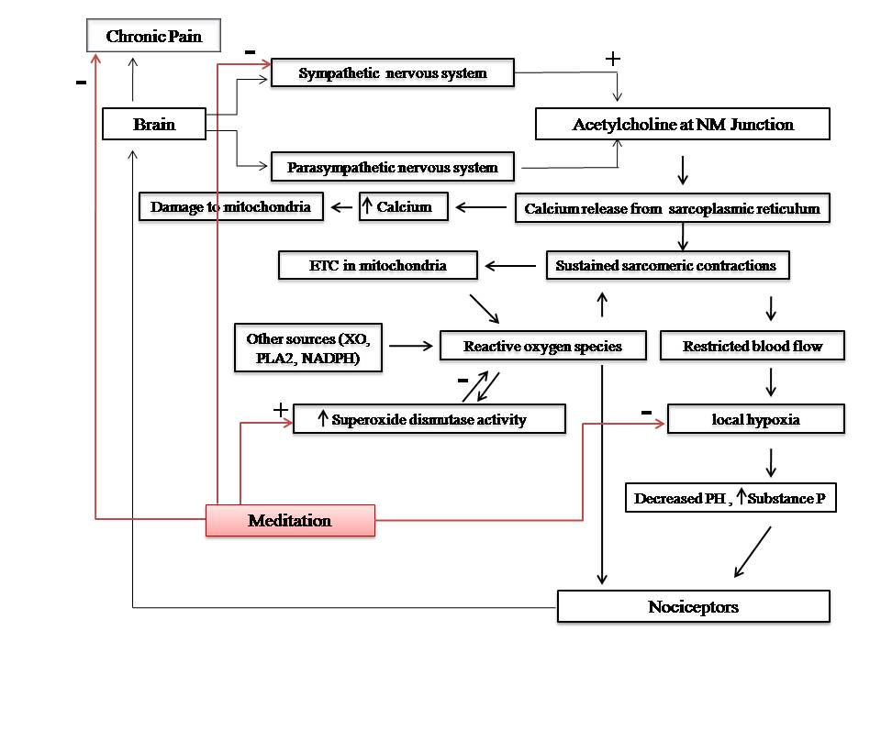

Figure 2: Meditation is a neuromodulatory practice that is capable of neutralizing the effect of perpetuating factors on MPS.

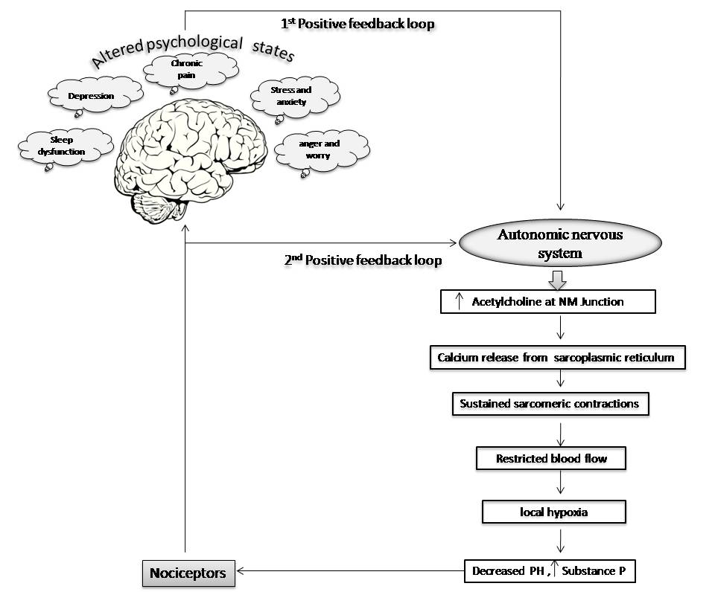
Figure 3: The 1st Positive feedback loop is maintained by the psychological factors and the 2nd feedback loop is maintained by the inherent link between the autonomic nervous system and the central nervous system. Both the loops form a vicious cycle.

Table 1: The role of meditation in Myofascial pain syndrome
