Title of the article: Evaluation of Lactobacillus and Streptococcus mutans by addition of probiotics in the form of curd in the diet

Abstract:
Context: Probiotics are defined as live microorganisms which when administered in adequate amounts confer a health beneﬁt on the host. They have been used to improve gastrointestinal health and their popularity has prompted increased interest for their role in promotion of oral health also. Objective: To evaluate the influence of diet alteration on oral microflora with addition of probiotics in the form of curd in the diet. Settings and Design: Sample pool included total 20 children, 15 in active group; who were given curd containing probiotic bacteria in their daily diet and 5 children in control group; who were denied of food containing probiotics. All the children were followed for over a period of 1 year. A pre and post quantitative analysis of Streptococcus mutans and Lactobacilli were done in the saliva of both active and control groups and caries score was recorded. Statistical analysis used: The data thus compiled were statistically evaluated using Chi Square Test and Pearson correlation on SPSS software Version 14. Results: In active group, 87% children showed decrease and 7% showed increase in Streptococcus mutans count (p-value 0.83), where as 67% showed increase and 7% decrease in Lactobacilli count (p-value 0.002) after 1year of follow up. Conclusions: Probiotics are emerging as a fascinating field in oral health. Efforts should be made to increase the awareness of the general dental practitioners with this aspect of oral disease therapy and encourage the implementation of the concept of “food rather than medicine”.
Key-words: Probiotics; Streptococcus Mutans; Lactobacilli; Curd; Microorganisms; Oral and Gastrointestinal Health.

Introduction:
Probiotics are defined as live microorganisms which when administered in adequate amounts confer a health beneﬁt on the host.¹ They have been used to improve gastrointestinal health and their popularity has provoked increased interest for their role in promotion of oral health also. The concept of probiotics evolved from Elie Metchnikoff’s ideas that the bacteria in fermented products could compete with ailment causing microbes which are detrimental and health compromising and thus minimize their ill-effects.²
Probiotics can improve patient condition in medical disorders such as diarrhoea, gastroenteritis, short-bowel syndrome, inflammatory intestinal diseases (Crohn’s disease and ulcerative colitis), cancer, immunosuppressive states, inadequate lactase digestion, paediatric allergies, growth retardation, hyperlipidaemia, liver diseases, infections with Helicobacter pylori and genitourinary tract infections.^{3,4,5}
Ingestion of probiotics in any form, such as in food stuff (cheese, yogurt , fermented milk, fruit juice or chewing gum) or as that contained in tablets and capsules, has been shown to have a health gaining effect on oral tissues like reducing the incidence of dental caries, improved management of periodontitis, abridged halitosis and oral candidal infections.⁴
Hence the present study was conceded to access the influence of probiotics in the form of curd when given in the daily diet of the study group on the salivary levels of Streptococcus mutans and Lactobacilli at initial and after one year of follow up.
Subjects and Methods:
This prospective study was planned and carried out in the Department of Oral Pathology in association with Microbiology Department. The ethical committee clearance was obtained from the concerned authority. A verbal and signed inform consent was obtained from the children and the concerned personages were also notified regarding the same. Government Primary School children aged 10 – 15 years were examined and a total of 20 healthy children free from any form of mucosal or dental abnormalities were included in the present study, out of which 15 were engaged as active group who were given curd containing probiotic bacteria in their daily morning diet and 5 as control group who were denied of food containing probiotics over a period of one year. The counts of Streptococcus mutans and Lactobacilli in saliva of these subjects were determined twice by using Dentocult SM Strip mutans and Dentocult Lactobacilli Strip [Orion Diagnostica, Espoo, Finland] at the initial intervention and after a follow up period of one year. Caries scores were recorded before the commencement of the study and after the period of one year. To estimate Streptococcus mutans, children were instructed to swallow excess saliva and then the rough surface of round tipped strip was pressed against the saliva remaining on tongue. The strips were then placed in a selective culture broth supplied by the manufacturer; which were then labelled and incubated in an upright position at 37°C for 48 hours. The cap was opened one quarter of a turn to allow growth of the organisms as per the instructions given by the manufacturer (figure 1). After incubation, the presence of Streptococcus mutans was confirmed by identifying light-blue to dark-blue raised colonies on the inoculated surface of the strip. The results were evaluated according to the manufacturer’s guidelines as follows: Class 0: <10,000 CFU/ml, Class 1: <100,000 CFU/ml, Class 2: 100,000-1,000,000CFU/ml, Class 3: >1,000,000 CFU/ml (figure 2).
To estimate Lactobacilli counts, the early morning saliva samples were collected from all the children. Before taking the samples, children were instructed to avoid eating, drinking and brushing of teeth for 1 - 2 hours. Children were instructed to sit in a relaxed upright position until 1 - 2ml of unstimulated whole saliva was collected in the floor of the mouth. They were later asked to spit in a disposable sterile plastic container. Saliva was then poured over the modified rogosa agar surface, screwed tightly, labelled and was placed in an incubator at 37°C for 4 days (figure 3). The presence of Lactobacillus after incubation was evidenced by white to transparent colonies on the modified Rogosa agar surface. The results were evaluated according to the manufacturer’s guidelines as Class 0: 10³ CFU/ml, Class 1: 10⁴ CFU/ml, Class 2: 10⁵ CFU/ml, Class 3: 10⁶ CFU/ml (figure 4).
After 1 year of follow up the saliva samples were again collected from both the groups as previously described. All the data thus accumulated were statistically analysed using Chi square test and Pearson Correlation on SPSS software version 14.
Results
The semiquantitative analysis of Streptococcus mutans count in active group under class 0, I, II and III at the initial intervention of 0 month showed nil, nil, 5 (33%) and 10 (67%); at 12 months were 2 (13%), 7 (47%), 5 (33%) and 1 (7%) respectively. The semiquantitative analysis of Lactobacilli count in active group under class 0, I, II and III at the initial intervention of 0 month showed 2 (13%), nil, 10 (67%) and 3 (20%); at 12 months were nil, 2 (13%), 1 (7%) and 11 (73%) respectively. During the 12 months of follow up, Streptococcus mutans decreased in 13(87%) children, increased in 1 (7%), remain unchanged in 1 (7%) children and Lactobacillus increased in 10(67%) children, decreased in 1 (7%), remain unchanged in 4 (26%) children in active group (table 1). P-value was not significant with p=0.832 for decrease in Streptococcus mutans (table 2) and was significant with p=0.02 for increase in Lactobacillus (table 3) after one year use of probiotic in active group. Where as in the control group, within the 12 months period of follow up, Streptococcus mutans decreased in 2 (40%) children, increased in 1 (20%) and remain unchanged in 2 (40%) and Lactobacillus decreased in 2 (40%) children, increased in 1 (20%) and remain unchanged in 2 (40%). P-value was insignificant with p=0.239 for Streptococcus mutans and p=0.789 for Lactobacillus in control group. Caries scores remain unchanged in 14 out of 15 children and was increased in 1 child in active group with insignificant Pearson correlation (r)= 0.960 and significant p value= 0.000. In control group caries scores was unchanged in 4 children out of 5 and was increased in 1 child with insignificant Pearson correlation (r)= 0.612 p value= 0.272. In active group caries score shifted in 1 child from 0 to 1 in active group in which Streptococcus mutans count was increased from class II to class III over a period of 12 months. In control group caries score shifted in 1 child from 0 to 1 in active group in which Streptococcus mutans count was increased from class I to class II over a period of 1 year.
Discussion
Probiotics are bacterial cultures or living microorganisms upon ingestion in certain quantity promote and enhance health benefits. An International Life Science Institute Europe consensus document proposed a simple and widely accepted definition of probiotics as ‘Viable microbial food supplements which beneficially influence the health of human’. These bacteria should belong to the natural flora in order to resist gastric secretion and survive during intestinal transit.⁶
In India the prevalence of dental caries in children has been reported to be 87%. In low socio-economic strata the prevalence of caries was reported to be higher (96.2%) than high socio-economic strata.⁷ A major part of the population in India resides in rural areas (70%) where there is little awareness about the oral health especially for children who have unhealthy eating habits with large quantities of cariogenic products in their diet. For research to be successful in India it has to be directed towards cost effectiveness and easy availability of products for health.⁸ The subjects selected in this prospective study were in the 10-15 years age group, which was important for the present study in two ways. First, this is the period during which permanent teeth are erupting and new surfaces would be colonised by pathogenic bacteria. Any measure directed towards prevention against early colonization might be beneficial in the long term for the prevention of dental disease. The second reason for selecting this age group was the intellectual ability of the child. In accordance with Jean Piaget at the age of seven years a child largely corresponds to an increase in cognitive development whereby the child develops a sense of semi-logical reasoning to infer physical cause effect relationships.⁸ Thus, in this age group a positive compliance could be expected from a child.
The results of present study after addition of probiotic in the form of curd over a period of one year in daily diet of 15 children in active group showed decrease in streptococcus count in 87% and increase in lactobacillus count in 67% of the study subjects. Similar results were found in a study carried by Ahola AJ et al., after consumption of probiotic in the form of cheese over period of three weeks.⁹ In a in-vitro study, yoghurt with live bacteria showed selective anti-mutans activity, suggesting that the overall decrease in mutans streptococci in-vivo could be due to a bactericidal effect on S.Mutans.¹⁰ Cagler et al., have also shown a reduced streptococcus mutans level in oral cavity of patients receiving fluid or tablet in the form of probiotics.¹¹ The previous studies present in literature concerning intervention of probiotics are short term studies according to us this is the first study carried out for a long period of one year.
The lactobacilli as a probiotic are believed to have antimicrobial activity and ability to interfere with pathogens on epithelial cells.^{12,13} They are also able to stimulate the immune system and alter the pH milieu of the host.¹ When lactic acid bacteria are consumed in milk products, the buffering capacity of milk hampers the bacterial acidogenity.¹⁴ The presence of calcium and other constituents may also protect tooth surfaces and inhibit the adherence of dental pathogens.¹⁵ Lactobacilli have been used to deliver vaccine components for active immunization in vivo.¹ The mechanism of interfering involves the release of bio-surfactants, a structurally diverse group of surface active molecules synthesized by microorganisms and are able to inhibit adhesion of various other microorganisms. In a study carried by Arezoo T, et al., they showed that the bio-surfactant derived from probiotic bacteria (L. acidophilus, L. fermentum and L. rhamnosus) could reduce the adhesion of streptococcus mutans to the surfaces.¹² Nase et al., reported reduced caries in kindergarten children on long term consumption of milk containing the probiotic Lactobacillus rhamnosus CG strain.¹⁶ In order to assess whether naturally occurring oral lactobacilli have probiotic properties, lactobacilli were isolated from saliva and plaque from children and adolescents, with or without caries lesions, twenty three Lactobacillus species completely inhibited the growth of all mutans streptococci tested.¹
According to Koll-Klais et al., high levels of Lactobacillus in microbiota caused an 82% and 65% inhibition in Porphyromonas gingivalis and Prevotella intermedia growth, respectively.³ The use of probiotic chewing gum containing L. reuteri also decreased levels of pro-inflammatory cytokines in GCF and the use of L. brevis decreased matrix metalloproteinases (collagenase) activity and other inflammatory markers in saliva.¹⁷
Bacteriotherapy in the form of probiotics seems to be a natural way to maintain health and protect oral tissues from disease which are mainly due to significantly reduced levels of cariogenic as well as periodontal pathogens.¹⁴
Conclusion: Probiotics are emerging as a fascinating field in oral health.⁶ There was decrease in Streptococcus mutans count and increase in Lactobacillus count observed in oral microbial flora between the active study group after consumption of probiotics in the form of curd over a period of 1 year. Efforts should be made to increase the awareness of the general dental practitioners with this aspect of oral disease therapy and encourage the implementation of the concept of “food rather than medicine”.¹⁰

References
- Bhushan J, Chachra S. Probiotics Their Role in Prevention of Dental Caries. J Oral Health Comm Dent 2010;4(3):78-82.
- Bhardwaj SB. Probiotics and Oral health: An update. Int J Cont Dent 2010;1(3):116-9.
- Antonio J, Fernández F, Teresa AD, David PO, Miguel PD. Probiotic treatment in the oral cavity: An update. Med Oral Patol Oral Cir Bucal 2010;15(5):677-80.
- Darwazeh A. Probiotics and Oral Disease: An Update. Smile Dent J 2011;6:6-8.
- Suvarna VC, Boby VU. Probiotics in human health: A current assessment. Cur Sci 2005;88:1744-8.
- Kedar S, Shashikanth MC, Tulasi P, Sultana N, Nallan CSK. Probiotics - Do they have a Role in Medicine and Dentistry? J Assoc Phy India 2010;58:488-92.
- Pannu P, Gambhir R, Sujlana A. Correlation between the salivary Streptococcus mutans levels and dental caries experience in adult population of Chandigarh, India. Eur J Dent 2013;7:191-5.
- Jindal G, Pandey RK, Agarwal J, Singh M. A comparative evaluation of probiotics on salivary mutans streptococci counts in Indian children. European Archives of Paediatric Dentistry 2011;12(4):211-5.
- Ahola AJ, Yli-Knuuttila H, Suomalainen T, Poussa T, Ahlstrom A, Meurman JH, et al. Short-term consumption of probiotic containing cheese and its effect on dental caries risk factors. Arch Oral Biol 2002;47:799-804.
- Agarwal E, Bajaj P, Guruprasad CN, Naik S, Pradeep AR. Probiotics: a novel step towards oral health. Arch Oral Sci Res 2011;1(2):108-15
- Cagler E, Kargula B. Bacteriotherapy and probiotics role on oral health. Oral Dis 2005;11:131-7.
- Arezoo T. Probiotics and the Reduction of Dental Caries Risk. In: Contemporary Approach to Dental Caries. 1st ed. Ming-yu Li, editor. Intech, China; 2012. 271-288p.
- Koll P, Mandar R, Marcotte H, Leibur E, Mikelsaar M, Hammarström L. Characterization of oral lactobacilli as potential probiotics for oral health. Oral Microbiol Immunol 2008;23:139-47.
- Twetman S, Christina SB. Probiotics and oral health effects in children. International J Paed Dent 2008;18:3-10.
- Sheikh S, Shambulingappa P, Kalucha A, Kaur H. Probiotics. Going on the natural way. J Clin Exp Dent 2011;3(2):e150-4.
- Nase L, Hatakka K, Savilahti E, Saxelin M, Ponka A, Poussa T, et al. Effect of long-term consumption of a probiotic bacterium, Lactobacillus rhamnosus GG, in milk on dental caries and caries risk in children. Caries Res 2001;35:412-20.
- Haukioja A. Probiotics and Oral Health. Eur J Dent 2010;4:348-55.
Table 1: Semiquantitative analysis of Streptococcus mutans and Lactobacillus in active group
Class | No. (%) of children
 | At the initial intervention |  | After 1 year
 | Streptococcus mutans | Lactobacillus | Streptococcus mutans | Lactobacillus
0 | - | 2 (13%) | 2 (13%) | -
I | - | - | 7 (47%) | 3 (20%)
II | 5 (33%) | 10 (67%) | 5 (33%) | 1 (7%)
III | 10 (67%) | 3 (20%) | 1 (7%) | 11 (73%)

Table 2: Shifting of counts of Streptococcus mutans in active group after 12 months of follow up
Streptococcus mutans count at 0 month in active group |  | Shifting of counts after 12 months of follow up
Class | No. of children | No. of children
 |  | Class 0 | Class I | Class II | Class III
0 | - | - | - | - | -
I | - | - | - | - | -
II | 5 | 1 | 1 | 2 | 1
III | 10 | 1 | 5 | 4 | -
p –value | 0.83

Table 3: Shifting of counts of Lactobacilli in active group after 1 year of follow up
Lactobacilli count at initial intervention in active group |  | Shifting of counts after 1 year of follow up
Class | No. of children | No. of children
 |  | Class 0 | Class I | Class II | Class III
0 | 2 | - | 2 | - | -
I | - | - | - | - | -
II | 10 | - | 1 | 1 | 8
III | 3 | - | - | - | 3
p-value | 0.002

Figure 1: Dentocult SM Strip mutans kit and procedure for sample collection.
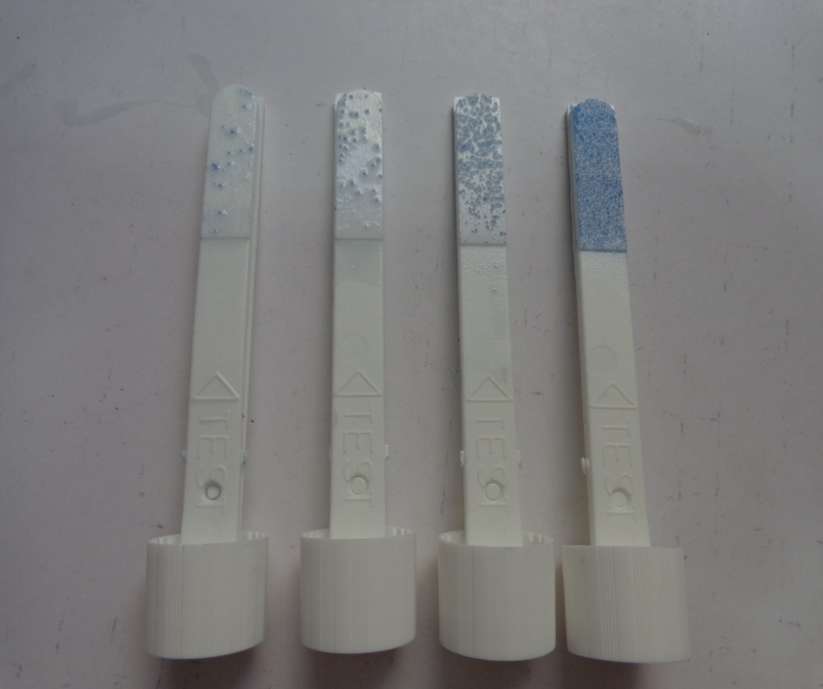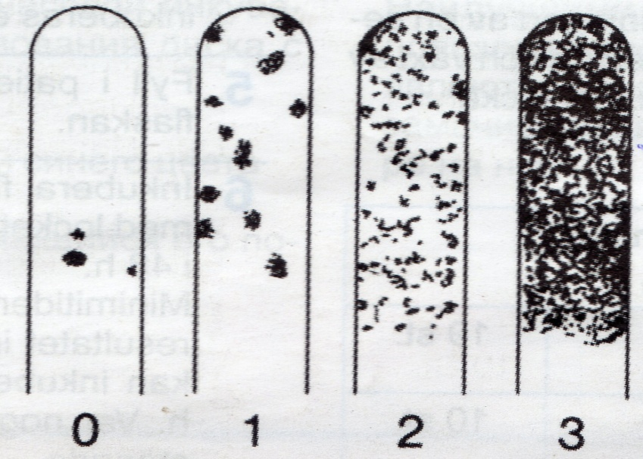

Figure 2: : Light-blue to dark-blue, raised colonies on the inoculated surface of the Streptococcus mutans strip and manufacturer’s guidelines for interpretation of Streptococcus mutans count.

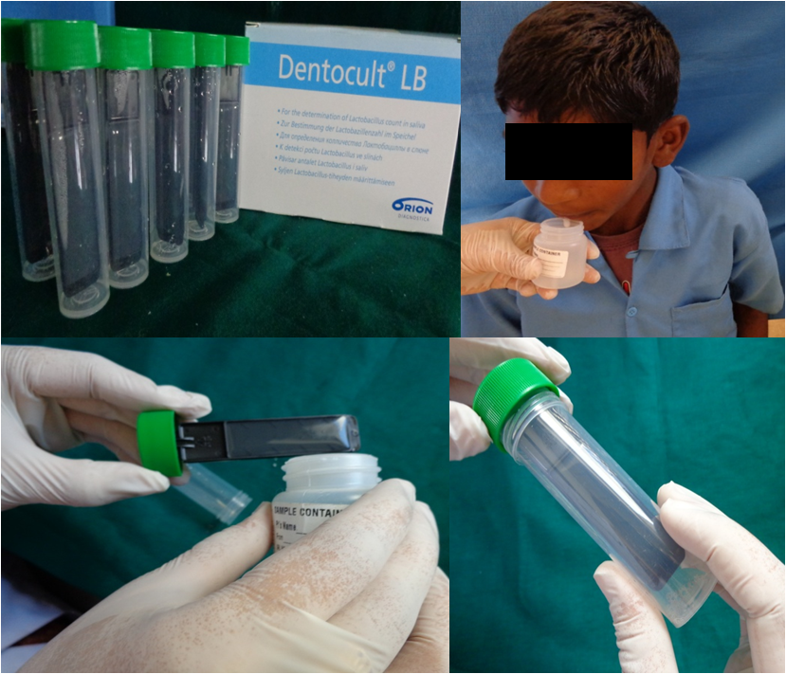
Figure 3: Dentocult Lactobacilli Strip kit and procedure for sample collection.

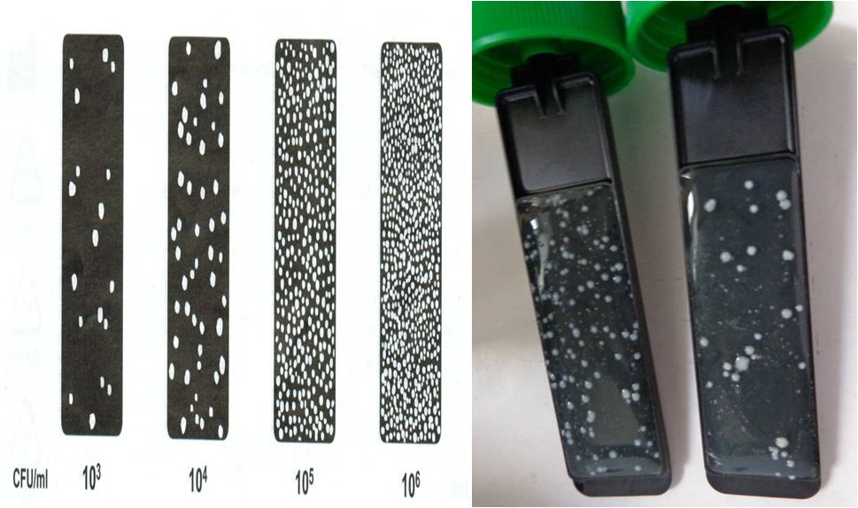

Figure 4: Manufacturer’s guidelines for interpretation of Lactobacillus count and white to transparent colonies of Lactobacillus on modified Rogosa agar surface.

