An investigation into stress distribution and determination of optimum force for torque movement using the finite element method (FEM)

SHAHR Fariba, Assistant Professor, Department of Oral and Maxillofacial Surgery, School of Dentistry, Zahedan University of Medical Sciences, Zahedan, Iran.
Email: sahar145@yahoo.com

RISBAF Sirous, Assistant Professor, Department of Oral and Maxillofacial Surgery, School of Dentistry, Zahedan University of Medical Sciences, Zahedan, Iran.
Email: srisbaf@gmail.com
Corresponding author:
RISBAF Sirous, Assistant Professor, Department of Oral and Maxillofacial Surgery, School of Dentistry, Zahedan University of Medical Sciences, Zahedan, Iran.
Email: srisbaf@gmail.com
Tel: 0098 541 3438

An investigation into stress distribution and determination of optimum force for torque movement using the finite element method (FEM)

Abstract
Aims: The purpose of this study is to determine the optimum force for producing torque movement, and to identify the way stress is distributed in the periodontium of a tooth, by using FEM.
Materials and Methods: In this descriptive, analytical study, the 3-dimensional FEM model of a maxillary right canine tooth was constructed based on the average anatomical morphology given by Wheeler, including tooth, periodontal ligament, and compact and cancellous bones with 89402 and 101872 nodes, and it was assumed that the materials display linear elastic behavior. The trial and error method was utilized for determination of optimum torque value, and the optimum force and torque of 7 N and 8 N.mm were obtained, respectively. The pattern and amount of stress (principal, axial, and shear) at the root surface, periodontal ligament, and compact and cancellous bones were examined using ANSYS v8.
Findings: The optimum force of 7 N and torque of 8 N.mm were obtained for torque movement. In all cases, the stress concentration was observed in the cervical region of the root. Contrary to expectations, the stress concentration was not seen in the apex. The stresses were tensile and compressional in the labial region and palatal areas, respectively.
Conclusion: The amount of stress in the root was higher than in the bone, and, in the bone, it was greater in comparison to the stress in the periodontal ligament. The stress distribution in the periodontal ligament was not uniform.
Keywords: Stress analysis, finite element method, periodontal ligament, torque movement, optimal orthodontic force
Introduction
Ideal orthodontic therapy requires a force within a sound range to produce the desired movement of teeth with biologic reactions and without adverse side effects [1, 2].
Moreover, the initial factor for starting biologic changes during the application of orthodontic force is the stress produced in the periodontal tissues. Therefore, the stress due to orthodontic force is highly important [3].
In the field of orthodontics, numerous efforts have been made to evaluate the reaction of the tooth and its periodontal tissues to the application of force. The applied models include animal, mathematical, and mechanical, as well as photo-elastic stress analysis and laser holography. Each of these methods has its own shortcomings and advantages. For example, it is not possible to reconstruct a true reflection of the human model though animal studies, and it is difficult to match the level of force by the image of the tissue. Mathematical models are necessary for the design of an ideal model that is able to provide a satisfactory answer. In the photo-elastic stress method, the results are highly dependent on the materials and models utilized. Laser holography is only suitable to analyze the stress at the surface of the objects [4].
The finite element method (FEM) is a powerful computer simulation model for solving problems related to stress and strain [5].
FEM is a numerical analysis technique that allows investigation into the stress distribution in biological systems. It enables us to examine the amount of stress and strain within the structure of the objects, and also to design complicated three-dimensional geometries [3]. This technique is free of tissue damage. In addition, non-conforming, heterogeneity, complexity, and asymmetry of objects do not restrict the technique. In this technique, the computerized calculations, which are reasonably accurate and repeatable, are applied [3, 4].
In FEM, the structure is designed precisely, and then divided into small fragments, namely, elements or meshes. These elements are connected through points, known as nodes. By knowing the properties of each element and gathering the effect of them, the behavior of the whole structure is obtainable [5]. In addition, torque is one of the most complicated forces in clinical application for which little credible information is available, in terms of the sound amount of force and its distribution pattern in the periodontium and bone. For this reason, the present study is conducted to determine the optimum force for producing torque movement in the buccolingual direction, and to investigate the stress produced in the periodontium of the maxillary right canine.
Materials and Methods
In this experimental study, the three-dimensional model of the maxillary right canine was designed based on the average dimensions of the anatomy and morphology given by Wheeler using the finite element method. This model includes teeth, periodontal ligament (PDL), and compact and cancellous bones. A tooth is composed of enamel, dentine, cementum, and pulp. As the mechanical properties of the dentine and cementum are the same, they were both considered as root dentine. In addition, for the enamel that covers the dentine, it is useless to consider them separately, as it makes the model far too complicated. Accordingly, to simplify the model in this study, only the mechanical properties of dentine have been used. To determine the dimensions of dental dentine and pulp, a scanned model from Wheeler’s book of a canine with its pulp were used. Then its dimensions were adapted to the dental model under study [4, 6].
A PDL with 0.25 thickness was assumed and an isotropic behavior was assigned thereto. In terms of bone, two different types – cancellous and compact – were considered (Table 1). As compact bone and lamina dura have the same mechanical properties, both were modeled as compact bone. The edge of the alveolar crest was assumed to be 1.08 mm to the CEJ of the bone. The marginal bone of this tooth was sheared exactly from the mid-center of the interdental bone, as the purpose was simply to investigate the stress in the canine. The mechanical properties of the above components were assumed based on the values in the study by Williams (Table 2). A 63.2×23.4 mm bracket was designed in a way that, mesiodistally, the center of it was positioned on the center of the buccal surface on the most prominent part of the crown.
Table 1: The dimensions of maxillary right tooth canine.
Table 2: The properties of different components of the model.
To design the tooth model, initially, the labial, palatal, distal, and mesial views of the given tooth were taken by scanner and converted into JPG files. After that, the files were imported into AutoCAD, the boundary lines were plotted via spline curves. The plotted DWG files were generated and imported into Solid Work to produce three-dimensional volumetric models of the said tooth’s components (Figure 1). After the volumetric model of the said tooth was completed, the output x-t file was imported into ANSYS.
In the next stage, the meshing process was carried out. Due to the asymmetric geometry of the pulp and tooth, the meshes of solid92 were used for reconstruction of all the components. The total number of meshes used in the model was 89402, and the total number of nodes was 101872 (Figure 1). To determine the optimum force, based on trial and error, the amount of force and torque changed in each analysis until the torque movement was reconstructed. The optimum force of 7 N and torque of 8 N.mm were obtained. Then, the principal and axial stresses in the tooth, shear stresses syz and principal stresses in the periodontal ligament, and principal bone stresses in the compact and cancellous bones were examined. In the principal and axial stresses, the negative mark indicates the compressional stress and the positive mark indicates the tensile stress.
Figure 1: Meshing the components of the model.

Findings
An optimum force of 7 N and 8 N.mm of torque were obtained for producing torque movement using the trial and error technique. Based on this, the torque to force ratio of 4.11 was obtained (Figure 2).
Figure 2: Simulation of torque movement.

In the axial stresses on the labial view, the maximum stress occurred in the crown area where the force was applied, while, in the root, the maximum stress occurred in the cervical region. On the lingual view, stress was distributed smoothly (Figure 3).
Figure 3: SZ stresses of tooth from labial view (A) and lingual view (B).

In the principal stresses in the mesial view, the maximum stress was observed in the area where the force was applied. In the labial view, the minimum stress was observed on the incisal edge of the crown, root apex, and cervical region (Figure 4).
Figure 4: S1 stress from mesial view.

The principal stresses in the mesial view indicate that the maximum stress was in the area where the force was applied, the minimum stress was in the cervical area of the crown, and the maximum stress was in the cervical region in the root (Figure 5).
Figure 5: S3 stresses from labial view.
In PDL, the maximum principal stress was seen in the form of a strip in the labial region, and the minimum stress was observed in the lingual area, in the form of a strip, with an increasing trend towards the cervical region (Figure 6).
Figure 6: S1 stress from mesial view of PDL.

These stresses were similar except that the minimum and maximum stresses were concentrated in the epical area. The shear stresses in the epical and lingual areas were maximum, while in the cervical region they were minimum. In addition, the distribution of stress was very asymmetric.
In the compact bone, the maximum stress was observed in the alveolar crest mesiolabial in the form of a small region at the edge of mesiolabial, and the minimum stress was seen in the cervical region (Figures 7 and 8).
Figure 7: S1 stress from mesiolabial view of compact bone.
Figure 8: S3 stress from mesiolabial view of compact bone.
In the cancellous bone, the maximum stress was observed in the alveolar crest distolabial in the form of a small region at the edge of distolabial close to the alveolar crest, and the minimum stress was seen in the distolingual crest (Figures 9 and 10).
Figure 9: S1 stress from distolabial view of cancellous bone.
Figure 10: S3 stress from distolabial view of cancellous bone.
Discussion
In this study, the force of 7 N and torque of 8 N.mm were obtained as the optimum force for producing torque movement. This amount was in the range of 1-5.0 N, which was introduced as the optimum force for this movement by Profit et al.
In the present study, the ratio of torque to force obtained was equal to 4/11, which differs from 25/9 obtained by Tanne et al. [3]. However, in their study the force was measured for upper incisor teeth. Therefore, the difference could be due to the difference in the type of tooth and accuracy of design. In our study, the design was developed very carefully. It included dentine, pulp, bone (compact and cancellous), and periodontal ligament. In this study, displacement of the crown was zero. It seems that the torque movement was reconstructed correctly and the ratio of torque to force was also precise.
The investigation into stress changes includes the following:
Vertical or axial stress (Normal Stress): axial stress is known as the intensity of the vertical force on the cross-sectional area of an object. If this stress causes strain in a material cross section, it is called tensile stress, and if it compresses a material cross section of the object it is called compressional stress. In a 3D object, it includes Sx, Sy, and Sz.
Shear stress: other component of stress coplanar with cross section.
Principal stress: planes on which maximum axial stresses are produced, and where there are no shear stresses, are called principal planes. In every body, there are three principal stresses in three planes perpendicular to each other, which, in descending order of magnitude, are called maximum principal tension (S1), intermediate principal stress (S2), and minimum principal stress (S3).
In this study, changes in stress in the mesial root surface, PDL, and bone were more uniform than in the distal, since, in comparison to the distal surface, mesial surface is more aligned, smoother, and less curved.
Regardless of being tensile or compressional, the minimum amount of stress was in the PDL, bone, and, finally, in the root. The reason could be that the elastic modulus of Dl is less than that of bone and tooth. In addition, as the stress is applied directly on the crown, the amount of stress in the tooth is higher than that in the bone and PDL. These results are in contrast to Viecilli, McGuinnes, Tanne, and Puente, [3, 4, 8, 9] as the least stress was seen in these studies. However, it is in consistent with Hemanth. [10] Nevertheless, in studies conducted by Burrstone, Koeimy, Mulligan, and Tharaw, the amount of stress in the bone, periodontal, and root were found to be equal, [8] since mathematical models were utilized; while, in this study, we used a three-dimensional model.
Our study showed that the cervical region of the root and the areas close to the alveolar crest are among the main areas of stress concentration. This is in consistent with previous findings and can justify the analysis of the root and alveolar bone in this area, provided in Reitman and Storey. However, the distinctive point in our study was that no stress concentration was seen in the apex area. While, according to the studies conducted by McGuinness, Williams, Sakuda, Tanne, and Puente, the tip of the apex was a point with the maximum amount of stress [3, 4, 8, 11].
In this study, the amount of principal stresses in the PDL was very similar to that in Tanne and Bantleon [3].
The pattern of stress distribution in the labial surface, root, periodontal ligament, and bone was tensile, and in the lingual surface it was compressional, which was in consistent with previous studies. The stress range in the labial and lingual surfaces was greater than for the mesial and distal surfaces. This is because, in these regions, the stress is mostly transmitted in the form of shear stress from the tooth to the PDL and then to the bones, which was in consistent with previous studies.
The distribution of stress was smoother in the compact and cancellous bones than in the tooth and PDL, as stress transmission is done via a soft material, such as PDL. These findings were in consistent with Tanne and Cobo.
In the present study, the designed model had an asymmetric geometry in which the ridges and grooves were considered according to dental anatomy. In addition, one of the shortcomings of FEM is that the existence of such areas causes the concentration of stress, as prominent areas and curves do not allow stress the opportunity for rapid change. However, according to Saint-Venant’s principle, FEM is reliable except for stress-concentrated areas.

Conclusion:
- To decrease the amount of stress in the stress concentration points in torque movement, 7 N of force and 8 N.mm of torque should be used.
- The maximum stress is concentrated in the PDL, and the stress distribution is heterogeneous.
- The maximum stress in the root was in the cervical area rather than the apex
- The amount of stress in the PDL was less than in the bone and in the bone was less than in the root.
REFRENCES
1. Burstone CJ, Koenig HA. Optimizing anterior and canine retraction. American Journal of Orthodontics. 1976; 70: 1-9.
2. Nikola RJ. On optimum orthodontic force theory as applied to canine retraction. American Journal of Orthodontics. 1975; 68: 290-302.
3.Tanne K, Sakuda M, Burstone CJ. Three dimentional finite element analysis for stress in the periodontal tissue by orthodontic force. American Journal of Orthodontics and Dentofacial Orthopedics. 1999; 115: 267-274.
4. Mc Guinness NJP, Wilson AN, Jones ML, Middleton J. A stress analysis of the periodontal ligament under various orthodontic loadings. European Journal of Orthodontics. 1991; 13: 231-242.
5. Joen PD, Turly PK, Moon HB, et al. Analysis of stress in the periodontium of maxillary first molar with a three dimensional finite element model. American Journal of Orthodontics and Dentofacial Orthopedics. 1999; 115: 267-274.
6. Ash M. Wheeler’s dental anatomy, physiology and occlusion.6th ed St Louis. CV Mosby; 1984. pp155-160.
7. Proffit WR, Fields HW, Sarver DM. Contemporary orthodontics. 4th ed St Louis: Mosby Elsevier; 2007.
8. Puente MI, Galban L, Cobo JM. Initial stress differences between tipping and torque movement : A three dimensional finite element analysis. European Journal of Orthodontics. 1996; 18(4):329-339.
9. Viecilli RF, Katana TR, Chen J. Three dimensional mechanical environment of orthodontic tooth movement and root resorption. American Journal of Orthodontics and Dentofacial Orthopedics. 2008; 133(6):791.e 11–791.e26.
10. Hemanth M, Siddharth DL. Orthodontic force distribution: A three dimensional of dentistry. World Journal of Dentistry. 2010; 1(3):159-162.
11. Williams KR, Edmuson JT. Orthodontic tooth movement analysis by the finite element method. Biomaterials1984; 5: 347-351.

Figure 1: Meshing the components of the model.

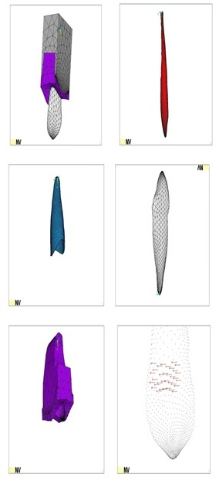

Figure 2: Simulation of torque movement.

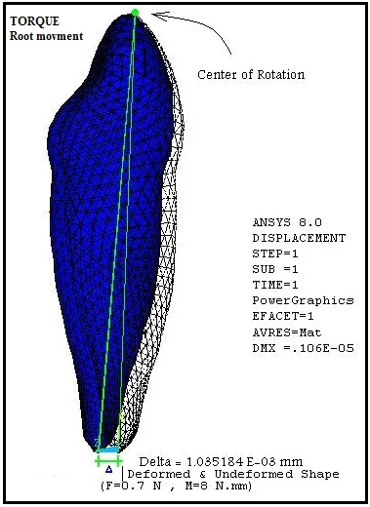

Figure 3: SZ stresses of tooth from labial view (A) and lingual view (B).
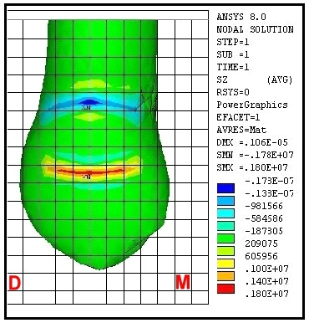
Figure 4: S1 stress from mesial view.
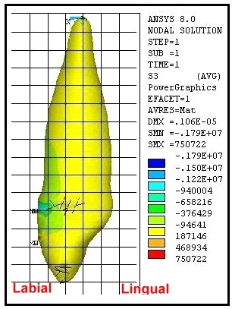

Figure 5: S3 stresses from labial view.
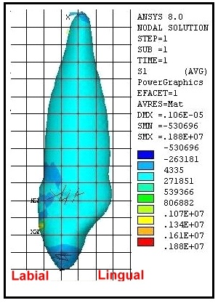
Figure 6: S1 stress from mesial view of PDL.
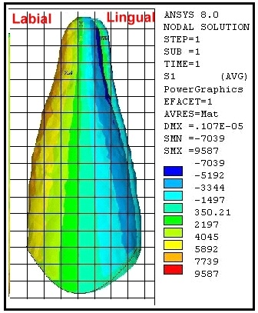

Figure 7: S1 stress from mesiolabial view of compact bone.
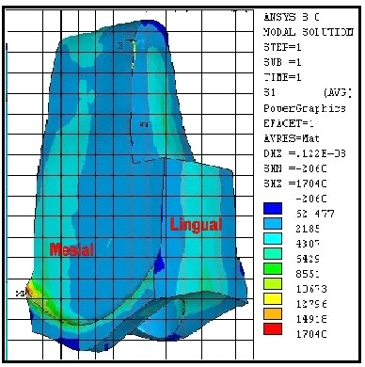
Figure 8: S3 stress from mesiolabial view of compact bone.
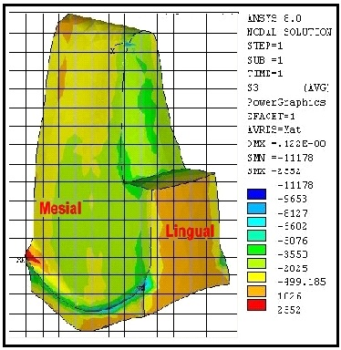
Figure 9: S1 stress from distolabial view of cancellous bone.
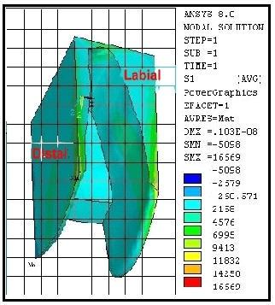
Figure 10: S3 stress from distolabial view of cancellous bone.
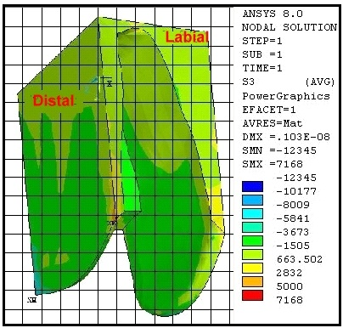

Table 1. The dimensions of maxillary right tooth canine
Cervico Incisal Length of Crown | 10
Length of Root | 17
Mesio Distal Diameter of Crown | 5.7
Mesio Distal Diameter of Crown At Cervix | 5.5
Labio Lingual Diameter of Crown | 8
Labio Lingual Diameter at Cervix | 7
Curvature of Cervical Line Mesial | 5.2
Curvature of Cervical Line Distal | 5.1

Table 2: The properties of different components of the model
poissons Ratio | Young's Modulus
 | N/mm² | kg/mm²
33.0 | 41.8×10 | 25.8×10³ | Enamel | Tooth Canine
31.0 | 83.1×10⁴ | 8.1×10³ | Dentine
45.0 | 3.2 | 2.0 | Pulp
49.0 | 9.6×10⁻³ | 8.6×10⁻² | PDL | PDL
26.0 | 4.3×10 ⁵ | 8.33 ×10³ | Cortical & Lamina Dura | Bone
38.0 | 37.1×10⁴ | 35.1×10³ | Cancellous

