Osteomyelitis as a possible cause of rootless Turner’s tooth: A case report

Abstract
Tooth extraction is an ordinary procedure that is performed routinely at dental treatment units. The procedure of dental extraction may be accomplished without any collateral complications or, on the other hand, be followed by problematic consequences. Many factors control the outcome of the extraction procedure, whether it is conducted smoothly or in a vigorous way.
In the current study, we present a case of an ordinary extraction of a primary tooth revealed a more advanced infection, i.e. chronic suppurative osteomyelitis, which might have caused a cease of the root formation and hypoplasia of the crown of the succedaneous tooth.

Keywords: osteomyelitis, extraction, hypoplasia.

Introduction
Osteomyelitis is an infection of bone (periosteum and bone marrow), including the harvesian system, of which many clinical varieties are known. For example, chronic recurrent multifocal osteomyelitis is an aspetic inflammatory condition whose etiology is not yet known and it affects mainly children and adolescents [1]. Osteomyelitis can be manifested as an acute episode of osseous infection (acute type) or chronic low-grade inflammation (chronic type).
The occurrence of osteomyelitis is sometimes associated with the formation of a fragment of necrotic bone that has separated from the adjacent vital bone, known as sequestrum. In the facial skeleton, the occurrence of osteomyelitis in the mandible is more common than in the maxilla, owing to the poorer blood supply of the former [2]. The etiology of osteomyelitis is varied; but form, dental abscess is the primary cause where periapical infection can spread through the marrow spaces and cause infection. Physical injury, e.g., local trauma such as fracture, penetrating wounds, surgery, and extraction can also predispose the bony tissue to osteomyelitis [2].
The infectious agents can also migrate through a hematogenous route as in the case of upper respiratory tract infection [3]and staphylococcal infection of skin.
In addition, special infections such as tuberculosis, syphilis, actinomycosis can associate with osteomyelitis [4].
Entry of microorganisms into bone marrow is followed by their proliferation in the marrow spaces, which gives rise to inflammatory reaction, tissue necrosis and suppuration. Once marrow spaces become filled with pus, suppuration tend to spread through the marrow spaces and cortical bone to involve the periosteum; the osteoblasts differentiate and necrotic bone (sequestrum), bathed in pus, separates from the surrounding vital bone.
The treatment spectrum of osteomyelitis ranges from drainage and/or removal of the cause such as non-vital tooth, and prescription of a course of antibiotics to prevent further spread and complications [5]. Surgical debridement of the sequestrum (sequestrectomy) becomes a necessity if such necrotic bone was encountered during the treatment [6].
Each case should be judged individually because of the variations in disease severity, type of the microorganisms involved and the patient’s immune status.
If osteomyelitis is left untreated it may develop into periostitis, soft issue abscess, or cellulitis raising the chances of pathological fracture [7].

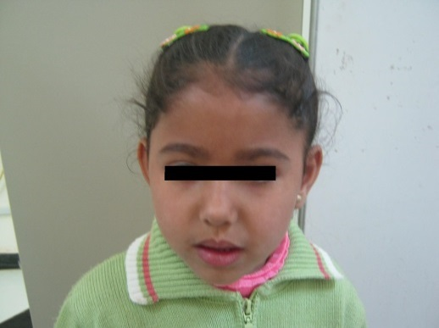
Case Report
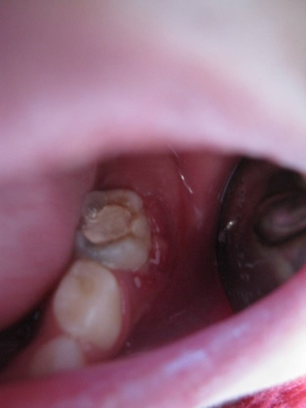
A five-year-old female patient (Fig. 1) presented to the Department of Pediatric Dentistry, Faculty of Dentistry, complaining of pain and swelling related to a lower left tooth in the posterior region. The culprit tooth had been previously treated with pulpectomy many months earlier. On examination, there was a temporary filling in lower left primary second molar. Besides being tender to finger pressure, it showed a mobility of grade 3. A dentoalveolar abscess was associated with the mobile tooth, and the buccal gingival margin surrounding the tooth had a reddish discoloration (Fig. 2).
Figure 1 showing 5-year-old child patient at first presentation.
Other than the area of complaint, all other soft tissues were normal. All primary teeth have already erupted. When the offending tooth was radiographed, inter- radicular radiolucency revealed. .
Figure 2 showing redness of the soft tissue in relation to the offending tooth.
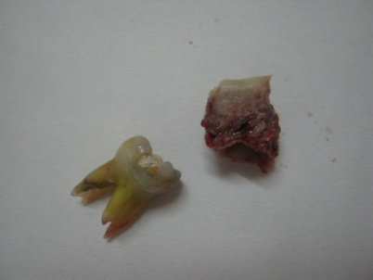
Later, the lesion was diagnosed as a chronic dentoalveolar abscess due to decayed lower left second primary molar. As a requirement of emergency treatment, the tooth was planned for extraction, followed by providing the patient and her parents with the proper oral hygiene instructions, and then the patient would be appointed for restoration of other carious teeth and construction of distal shoe space maintainer.
Figure 3 showing the bony sequestrum beside the removed tooth.
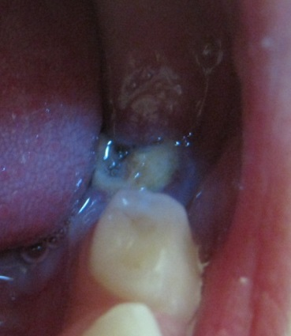
The tooth was anesthetized, and while the tooth was being removed, a piece of bone came along with the tooth. This bony piece (Fig. 3), which seemed to be a necrotic sequestrum, was nearly of the same size of the removed tooth and it came out smoothly without and surgical attempt. After removing both structures, the socket was sutured with pressure pack applied, and the patient was dismissed and kept on follow-up. Meanwhile, the bony mass was sent for histopathological examination; which revealed non-vital osseous tissue with empty canaliculi traversing the whole structure. A diagnosis of chronic suppurative osteomyelitis was confirmed.
Figure 4 showing the clinical appearance of the yet-erupting lower left second premolar.
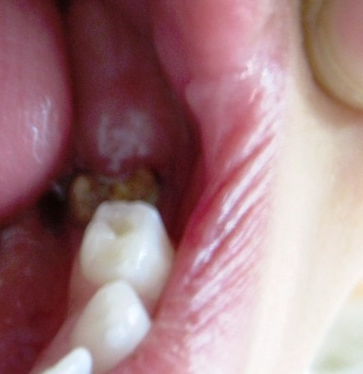
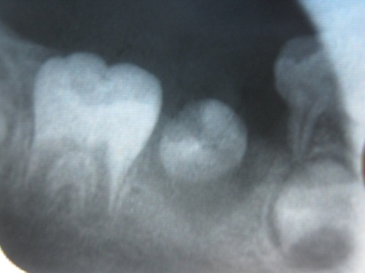
After three months, the patient came again complaining of pain in an upper front tooth. On examination, the cause of her discomfort was the upper right primary central incisor which was discolored; therefore an X-ray showed was requested. It was clear in the radiograph that there was a periapical lesion in relation to the culprit tooth. The patient refused any pulp treatment and insisted on extraction.
Figure5. The second premolar apparently had no root; only the crown can be seen.
Figure 6 showing the increased yellowish brown discoloration of the lower left second premolar.
Before performing the extraction and during the same visit, the area of previous extraction was examined and it seemed that it had healed uneventfully; while the lower left second premolar started eruption. By inspection, the succedaneous tooth was hypoplastic and poorly shaped (Fig. 4). To our surprise, the radiographic examination showed that the tooth was rootless (Fig. 5).
We proceeded with extracting the offending tooth for which the patient came i.e., upper right primary central incisor, and the patient was called for check-up.
After two weeks, the patient came and we noticed that the lower left second premolar became even more discolored (Fig. 6). Unfortunately, we have lost contact with the patient since then.
Discussion
Infection of the periapical area is often localized and does not spread beyond; thanks to the boundaries of the periapical dense tissues. However, under certain circumstances, the infectious microbes can supersede this confining barrier and spread to extra-alveolar spaces causing more devastating pathosis [8]. In this regard, osteomyelitis, which is defined as inflammation of the bone starting from the medullary cavity and rapidly involving the haversian system [9], can be among the devastating consequences of dental extractions.
In a Nigerian study, the prevalence of chronic osteomyelitis of the jaws, mostly of the mandible, was found to be six times more in women than men [10].
Among the etiological spectrum, chronic odontogenic infection, trauma, improperly treated fractured bone in the jaw and irradiation to the mandible constitute conventional causes of osteomyelitis. In addition, it can be secondary to other diseases of the bone such as osteoporosis [11], dysplastic bone diseases e.g., dysosteosclerosis [12]. Unlike chronic osteomyelitis, the acute form is usually associated with fever, malaise with redness and pus discharge [13].
Dental hypoplasia has been defined as a quantitative defect of the tooth enamel, owing to decreased number of ameloblasts, leading to visually as well as histomorphologically disturbances mostly associated with reduced thickness of enamel [14]. In this sense, dental hypoplasia is a condition which can affect a wide range of teeth in the mouth, sometimes all teeth are affected if the etiological agent is generalized e.g., in cases of infection or fluorosis. If the condition affects only one tooth, then it is referred to as Turner tooth or Turner hypoplasia [15].
In the present case, the condition started with a periapical infection around second primary molar, which is not uncommon in her age group. What extended beyond expectation was the existence of bone infection of the mandible (osteomyelitis) that ensued upon extracting the tooth.
Padmanabhan et al., reported a case where chronic osteomyelitis was associated with a developmental defect of a lower posterior tooth (affected with odontome) in a line of mandibular fracture [16].
In our case, there was no extra-oral involvement, i.e., no sinus or scar tissue had been observed on the patient’s face. The patient also denied any history of trauma to the area of interest. Thus, we believe that the osteomyelitis in our patient had already developed in her lower left posterior region due to the low-grade infection fuelled by the second primary molar. We cannot determine whether the pain originated from the tooth or the infected bone. The chronicity of the infectious process might explain the easy and smooth removal of the circumscribed bony piece along with the tooth. Consequently, and on her next appointment, we noticed that the erupting permanent tooth was hypoplastic. Indeed, it can be argued that the cause of hypoplasia of this particular tooth was due to the periapical infection of the preceding primary second molar. However, the unusual associated feature was the absence of roots of the permanent tooth, which raises the possibility of involvement of another more radical infection in this phenomenon. We assume that the bony infection has destroyed the Hertwig’s epithelial root sheath, thereby hampering the root development. What remains to be answered is how the tooth erupted without a root despite some claims that root formation is critical for teeth to make their paths to the oral cavity. Just recently, Wang suggested, based on previous experiments and case series observations, that for a tooth to erupt into the mouth does not necessitate the concomitant development of the root albeit it is important for later stabilization in the future dentition [17]. Unfortunately our loss of contact with the patient deprived us of following the case and thus assessing the durability of this rootless tooth to withstand the mastication process and other forces which require teeth with sound crowns and fully formed roots.
References
1. Monsour, P.A. and J.B. Dalton, Chronic recurrent multifocal osteomyelitis involving the mandible: case reports and review of the literature. Dento maxillo facial radiology, 2010. 39(3): p. 184-90.
2. Yeoh, S.C., S. MacMahon, and M. Schifter, Chronic suppurative osteomyelitis of the mandible: case report. Australian dental journal, 2005. 50(3): p. 200-3.
3. Lundberg, C., A. Heimdahl, and C.E. Nord, Clindamycin in the upper respiratory tract infections. Scandinavian journal of infectious diseases. Supplementum, 1984. 43: p. 50-5.
4. Smith, M.H., et al., Mandibular Actinomyces osteomyelitis complicating florid cemento-osseous dysplasia: case report. BMC oral health, 2011. 11: p. 21.
5. Kim, S.G. and H.S. Jang, Treatment of chronic osteomyelitis in Korea. Oral surgery, oral medicine, oral pathology, oral radiology, and endodontics, 2001. 92(4): p. 394-8.
6. Mallikarjun, K., et al., Chronic suppurative osteomyelitis of the mandible. Journal of the Indian Society of Pedodontics and Preventive Dentistry, 2011. 29(2): p. 176-9.
7. Boffano, P., et al., Pathological mandibular fractures: a review of the literature of the last two decades. Dental traumatology : official publication of International Association for Dental Traumatology, 2013. 29(3): p. 185-96.
8. Siqueira, J.F., Jr. and I.N. Rocas, Distinctive features of the microbiota associated with different forms of apical periodontitis. Journal of oral microbiology, 2009. 1.
9. Mehra, H., et al., Chronic suppurative osteomyelitis of mandible: a case report. Craniomaxillofacial trauma & reconstruction, 2013. 6(3): p. 197-200.
10. Lasisi, T.J., A.O. Adisa, and A.A. Olusanya, Appraisal of jaw swellings in a Nigerian tertiary healthcare facility. Journal of clinical and experimental dentistry, 2013. 5(1): p. e42-7.
11. Garcia, C.M., et al., Osteomyelitis of the mandible in a patient with osteopetrosis. Case report and review of the literature. Journal of maxillofacial and oral surgery, 2013. 12(1): p. 94-9.
12. Packota, G.V., J. Shiffman, and J.M. Hall, Osteomyelitis of the mandible in a patient with dysosteosclerosis. Report of a case. Oral surgery, oral medicine, and oral pathology, 1991. 71(2): p. 144-7.
13. Kusuyama, Y., et al., Rapidly progressing osteomyelitis of the mandible. Case reports in dentistry, 2013. 2013: p. 249615.
14. Jalevik, B. and J.G. Noren, Enamel hypomineralization of permanent first molars: a morphological study and survey of possible aetiological factors. International journal of paediatric dentistry / the British Paedodontic Society [and] the International Association of Dentistry for Children, 2000. 10(4): p. 278-89.
15. Geetha Priya, P.R., J.B. John, and I. Elango, Turner's hypoplasia and non-vitality: a case report of sequelae in permanent tooth. Contemporary clinical dentistry, 2010. 1(4): p. 251-4.
16. Padmanabhan, M.Y., R.K. Pandey, and R. Aparna, Erupted composite odontoma associated with malformed teeth - unusual dental aberrations following maxillofacial trauma. Romanian journal of morphology and embryology = Revue roumaine de morphologie et embryologie, 2013. 54(4): p. 1153-6.
17. Wang, X.P., Tooth eruption without roots. Journal of dental research, 2013. 92(3): p. 212-4.

