**‘Spotlight on koilocytes – determination of best fixative for koilocytes ’**

**PATIL Swati**

Professor

Department of Oral pathology & Microbiology

Sharad Pawar Dental College & Hospital

Sawagi (M), Wardha-442001, Maharashtra, INDIA

Email : [spaniwal@yahoo.co.in](mailto:spaniwal@yahoo.co.in)

Phone No.: +919850364714

**BONDE Dushyant**

Post graduate student

Department of Oral pathology & Microbiology

Sharad Pawar Dental College & Hospital

Sawagi (M), Wardha-442001, Maharashtra, INDIA

Email : [dushyantbonde@gmail.com](mailto:dushyantbonde@gmail.com)

Phone No.: +919923792507

**CHAUDHARY Minal**

Professor & Dean (Faculty of Dentistry)

Department of Oral pathology & Microbiology

Sharad Pawar Dental College & Hospital

Sawagi (M), Wardha-442001, Maharashtra, INDIA

Email : [minal53@yahoo.com](mailto:minal53@yahoo.com)

Phone No.: +919822200654

**GAWANDE Madhuri**

Professor & H.O.D

Department of Oral pathology & Microbiology

Sharad Pawar Dental College & Hospital

Sawagi (M), Wardha-442001, Maharashtra, INDIA

Email : [drmadhurigawande@rediffmail.com](mailto:drmadhurigawande@rediffmail.com)

Phone No.: +919822643373

**HANDE Alka**

Reader

Department of Oral pathology & Microbiology

Sharad Pawar Dental College & Hospital

Sawagi (M), Wardha-442001, Maharashtra, INDIA

Email : [alkahande11@gmail.com](mailto:alkahande11@gmail.com)

Phone No.: +919226789200

**JAIN Deepali**

Senior resident

Chirayu medical college & Hospital

Bhopal, Madhya Pradesh

INDIA

Email : [drdjain0211@gmail.com](mailto:drdjain0211@gmail.com)

Phone No.: +918305620625

**‘Spotlight on koilocytes – determination of best fixative for koilocytes ’**

**Abstract:**

**Aim and objective:** “To evaluate the better choice for fixation of Koilocytes”. **Materials and methods**: Samples will be taken from 30 patients that have been diagnosed clinically and histopathologically as OSCC, for the purpose of the study during excisional biopsy. These tissue samples were taken and fixed in the different fixatives (formaldehyde, glutaraldehyde and osmium tetra oxide) according to their respective protocols and subjected to routine hematoxylin and eosin staining. The presence of koilocyte will then be evaluated in tissue sections that have been fixed in these mentioned fixatives**. Results**: It is concluded that the finest demonstration of koilocytes is possible when the fixative is when Osmium tetroxide and then in Formaldehyde followed by Gluteraldehyde. **Conclusion**: Osmium tetroxide was the best fixative for the demonstration of the koilocyte. It demonstrates koilocytes with a sharp and well defined perinuclear halo and distinct nuclei. There is minimum background staining. Gluteraldehyde fixes the tissue more rapidly as compare to Formaldehyde, but the features of koilocytes are not as clear as those seen in tissues fixed in Formaldehyde and Osmium tetroxide.

Key words: Koilocytes, Fixation, Formaldehyde, Gluteraldehyde, Osmium tetroxide, OSCC

**Introduction:**

Koilocytes are defined as squamous cells, predominantly superficial and intermediate cells, with a large, well-demarcated, clear perinuclear zone surrounded by a dense peripheral cytoplasmic rim. Basically koilocyte is a squamous epithelial cell that has undergone a number of structural changes, which occur as a result of infection of the cell by human papillomavirus as it is the most reliable morphological evidence of human papilloma virus (HPV) infection. In 1951 a Canadian cytologist **Ernest Ayre** described and demonstrated squamous epithelial cell with a ‘perinuclear halo’ in smears from the uterine cervix.**1** These ‘halo cells’ were described as mononucleated or binucleated squamous cells with hyperchromatic nuclei and peri-nuclear clearing**. Koss** and **Durfee**, in 1956, renamed these cells as “koilocytes”, from the Greek word ‘koilos’ meaning ‘hollow cell’.**1** Later it was established that koilocytes are actually virus-infected squamous epithelial cells and the virus found in the nuclei of koilocytes were consistent with HPV. Koilocytosis or koilocytic atypia or koilocytotic atypia are terms used in histology and cytology to describe the presence of koilocytes in a specimen.**1**

The foundation of all good tissue specimen preparations is complete fixation. The primary function of tissue fixation is to prevent putrefaction and autolysis. Faults in fixation cannot be remedied at any later stage, and the finished product can only be as good as its initial fixation.**2** Function of an ideal fixative is:

1. To set organs or parts of organs so that microanatomical arrangement of tissue elements will not be altered.
2. To set intracellular inclusion bodies so that the histocytologic and cytologic conditions of cells may be studied.
3. To arrest autolysis, putrefaction, and other changes.
4. To bring out differences in refractive index of tissues.
5. To render cell constituents insoluble and make them resistant to subsequent processes

Fixation of tissues is the most crucial step in the preparation of tissue for observation in the microscopy. Fixation consists of two steps:

* Cessation of normal life functions in the tissue (killing)
* Stabilization of the structure of the tissue (preservation).

The goal of fixation is to preserve structure as faithfully as possible compared to the living state. Aldehydes are the most commonly used fixatives. They serve to stabilize the fine structural details of cells and tissues prior to examination by light or electron microscopy.**2**

Research workers, technicians, pathologists and others who regularly use aldehyde fixatives frequently do not appreciate the nature and properties of these compounds or the reasons for choosing to fix a specimen in formaldehyde, glutaraldehyde or a mixture of the two. Misconceptions are widespread also about formalin and paraformaldehyde, the commercial products from which formaldehyde-containing solutions are made.**3 Formaldehyde** has small molecules: HCHO, of which the -CHO is the aldehyde group that can combine with nitrogen atoms of proteins or with two such N atoms if they are very close together, forming a crosslink -CH2- called a methylene bridge.**3 Glutaraldehyde** has fairly small molecules, each with two aldehyde groups, separated by a flexible chain of 3 methylene bridges. It is HCO-(CH2)3-CHO. The potential for cross-linking is obviously much greater because this can occur through both the -CHO groups and over variable distances. In aqueous solutions, glutaraldehyde is present largely as polymers of variable size. There is a free aldehyde group sticking out of the side of each unit of the polymer molecule, as well as one at each end. All these -CHO groups will combine with protein nitrogens with which they come into contact, so there is enormous potential for cross-linking, and that is just what you get.**3 Osmium tetroxide** has an important, if limited, part in fixation for light microscopy as it is the only fixing agent known which completely and easily fixes fats. It is generally believed that fixation of cell membranes by osmium tetroxide (OsO4) involves unsaturated lipids.**4, 5, 6** There is less certainty as to the involvement of protein **4, 7, 8**, although the importance of OsO4-protein interaction has long been recognized.**9** There is evidence that OSO4 has a fixative or cross-linking function on tissue protein **10**and that protein-lipid cross-linking may occur.**11, 12**

***Materials and Method*:** The study was carried out at ***Sharad Pawar Dental College, Sawangi, Wardha*** in the Department of Oral and Maxillofacial Pathology. 30 samples were selected who had been diagnosed clinically and histologically with OSCC. Patients consent was taken prior to the conduction of the study. These samples had been procured during the curative surgical procedure for frozen section. After which each tissue sample was cut in to 3 parts with very adjacent margins and then kept in different fixatives as are 4% Formaldehyde, 2.5 % Gluteraldehyde and 1% Osmium tetroxide respectively. These tissue were cut in to 3 parts with very close margins so that each separate part will be evaluated for the same field under the microscope. Then the respective samples parts were fixed in different fixative with their prescribed time period (i.e*. 24 hours for formaldehyde; 6 hours for formaldehyde; 2 hours for Osmium tetroxide*) as prescribed in literature. After which the fixed tissue were embedded in to paraffin wax and then cut in to slides and labelled. After completing the whole sets of tissue of 30 samples, the cut section in the slides were stained together in normal Hematoxylin and Eosin stain and then evaluated for the appearances of koilocytes under light microscope.

***Results:***

30 samples, which were sectioned in to 3 parts and blindly evaluated under light microscope, following results were obtained

1. When evaluated for the staining characteristics
   1. The **formaldehyde fixed tissue** shows the nuclear detail and cytoplasmic details but not clearly demarcated. (fig 1)
   2. The **gluteraldehyde fixed tissue** shows the results for the same criteria (nuclear detail and cytoplasmic details) were found to be little obscure as compare to that of the previous, (fig 2)
   3. The tissue fixed in **osmium tetroxide** when evaluated gives the result far clearer and sharply delineated as compare to both formaldehyde and gluteraldehyde. (fig 3)

**Discussion:**

Oral squamous cell carcinomas (OSCCs) are reflected by multiphasic and multifactorial etiopathogenesis. Tobacco and alcohol are the most common risk factors for oral malignancy. Other factors, including DNA viruses, for example ***Human papilloma virus (HPV)*** have been found to play an important role in the initiation or development of these lesions.**13, 14** HPV involvement in OSCC was first proposed in 1983 by Syrjanen *et al*. and then supported by others on basis of the fact that HPV shows epitheliotropism and has the ability to immortalize human oral keratinocytes *in vitro.***15** The most recognized, pathognomonic feature of human papillomavirus (HPV) infection is the attendance of halo or koilocytotic cells in the differentiated layers of the squamous epithelium. These koilocytes are squamous epithelial cells that grasp an acentric, hyperchromatic nucleus that is moved or displaced by a large perinuclear vacuole.**16, 17** However, the formation of the cytoplasmic vacuole has remained unclear, particularly because both HPV-DNA replication and virion assembly occur exclusively within the nucleus. In clinical biopsies, koilocytosis is observed in both low- and high-risk HPV infections; and had been demonstrated that the E5 and E6 proteins from both low- and high-risk HPVs cooperate to induce koilocyte formation in human cervical cells *in vitro*, using both stable and transient assays.**16** Thepresence of koilocytes in Pap smears and cervical biopsies remains fundamental to pathological diagnosis.**16, 18** In HPV infections, koilocytosis is only observed in the uppermost, well-differentiated layers of stratified squamous epithelium and it is in these layers (and specifically in koilocytes) that the viral capsid proteins are expressed and assembled into infectious virions.

Fixation is the single most influential factor in the long sequence of steps between procurement of the specimen and cover-slipping the stained slide; nearly any other step can be reversed to ameliorate a problem.**19** Different fixatives produce their own morphological patterns. That is an objective fact that does not imply good or bad. Whether we like what we see is a subjective matter predominantly based on our individual training. Many chemicals act as fixatives in that they denature macromolecules, but few produce “acceptable” results because each creates its own unique pattern of changes visible at the level of the light microscope.

Some observers give high preference to mercuric fixatives over neutral buffered formalin (NBF) for lymphoid tissues, and picric acid for gastric biopsies, because of the extra sharp images they produce. Defining “good” fixation, then, is difficult because of varying personal preferences. However, there are well-documented and accepted minimum staining criteria that specify well-defined nuclear patterns, epithelial cell membranes, and cytoplasmic staining exhibited by well-fixed tissues. **19**

Aldehydes are the most commonly used fixatives. They serve to stabilize the fine structural details of cells and tissues prior to examination by light or electron microscopy. **Formaldehyde** is a gas. Its small molecules (HCHO, of which the -CHO is the aldehyde group) dissolve rapidly in water, with which they combine chemically to form methylene hydrate, HO-CH2-OH. This is the form in which formaldehyde exists in aqueous solutions; its chemical reactivity is the same as that of formaldehyde. Methylene hydrate molecules react with one another, combining to form polymers (Fig.4).**3**

The liquid known as formalin contains 37-40% of formaldehyde and 60-63% of water (by weight), with most of the formaldehyde existing as low polymers (*n* = 2 to 8 in the formula given in Fig. 4). Higher polymers (*n* up to 100), which are insoluble, are sold as a white powder, paraformaldehyde.**3**

**Reaction of formaldehyde with proteins:** The aldehyde group can combine with nitrogen and some other atoms of proteins, forming a cross-link -CH2- called a methylene bridge. Studies of the chemistry of tanning indicate that the most frequent type of cross-link formed by formaldehyde in collagen is between the nitrogen atom at the end of the side-chain of lysine and the nitrogen atom of a peptide linkage (Fig. 5), and the number of such cross-links increases with time (Gustavson, 1956). Fixative action of formaldehyde is probably due entirely to its reactions with proteins. Initial binding of formaldehyde to protein is largely completed in 24 hours (Helander, 1994) but the formation of methylene bridges proceeds much more slowly. Substances such as carbohydrates, lipids and nucleic acids are trapped in a matrix of insolubilized and cross-linked protein molecules but are not chemically changed by formaldehyde unless fixation is prolonged for several weeks.**3**

**Glutaraldehyde** has fairly small molecules, each with two aldehyde groups, separated by a flexible chain of 3 methylene bridges. It is HCO-(CH2)3-CHO. The potential for cross-linking is obviously much greater than with formaldehyde because it can occur through both the -CHO groups and over variable distances. In aqueous solutions, glutaraldehyde is present largely as polymers of variable size (Monsan *et al.*, 1975). There is a free aldehyde group sticking out of the side of each unit of the polymer molecule (Fig. 6), as well as one at each end. All these -CHO groups will combine with any protein nitrogen with which they come into contact, so there is enormous potential for cross-linking (Fig. 7).

**Reaction of glutaraldehyde with proteins:** Fixation of tissue is more efficient with glutaraldehyde than with formaldehyde and relies on its cross-linking properties. For reproducible results, highly purified glutaraldehyde is needed.**20** The chemical reaction of glutaraldehyde with protein is fast (minutes to hours), but the largermolecules, especially the oligomers, penetrate tissue slowly.**3** Objects fixed for a few hours in glutaraldehyde are no longer osmotically responsive (Paljarvi *et al.*, 1979). Both aldehyde groups of a single glutaraldehyde molecule react with proteins to form cross-linkage. Glutaraldehyde can also react with phospholipids containing free amino groups (e.g. phosphatidylserine, phosphatidylethanolamine). Glutaraldehyde introduces free aldehyde groups to the fixed tissue.**3** (fig 7). The stabilizing effect of glutaraldehyde is attributed to rapid and persistent intra- und intermolecular cross-linkages of tissue components. Glutaraldehyde is believed to react by a similar mechanism to formaldehyde. Glutaraldehyde, however, will give a more tightly linked product: its greater length as compared with formaldehyde and its two aldehyde groups allow glutaraldehyde to link more distant pairs of protein molecules as formaldehyde. This type reaction is a factor which makes glutaraldehyde an efficient fixative. The degree of cross-linking is progressive with time, and depends on the accessibility of ε-amino groups by aldehyde groups which leads to the formation of Schiff bases.**21**

**Osmium tetroxide** has come to take a predominant place as a fixative for studies of biological materials by electron microscopy. It is considered as the most suitable substance for preservation of the whole of the cellular constituents.**21**Osmium tetroxide is mostly used in buffered solutions, because it has been suggested that the quality of fixation by osmium tetroxide is largely dependent on the concentration of hydrogen ions. It is believed that when tissues are fixed in an unbuffered solution of osmium tetroxide, a wave of acidity precedes the osmium into the tissue, and that the structure of cells is best stabilized if the fixing solution is buffered slightly on the alkaline side of neutrality (Palade, 1952).**21** The value of *osmium tetroxide* for the preservation of cell structure has been already reported in 1927 (Strangeways TSP and Canti RG, 1927). With the development of electron microscopy in the early 1950s, it became apparent that osmium tetroxide was by far the best choice for the study of fine structure as compared with the then employed fixatives for light microscopy (Palade GE, 1952). The main disadvantage of osmium tetroxide is its slow penetrability into tissue blocks. Furthermore, the ionic constitution of the buffer influences the cellular fine structure (Trump BF and Ericsson JLE, 1965) as well as the rate of osmium penetration. Today, osmium tetroxide has still its important role as secondary fixative in electron microscopy.**20**

**Reaction of osmium tetroxide with proteins:** Previously reported *in vitro* studies **4, 22, 23** on the free amino acids found in membrane proteins show that they react rapidly with OsO4 to give black, uncharacterizable solids. This reaction, however, is simply due to the presence of the easily reduced α-amino groups (carboxyl groups are relatively inert to OsO4); for, if they are blocked to give linkages there is no such reaction.**4** By osmium tetroxide the investigation of the fine structure of biological material by means of the electron microscope has depended, to a very large extent, on the deposition of osmium compounds within the tissue during treatment with a buffered osmium tetroxide solution, and the value of such treatment in the fixing of structure and enhancement of contrast is well accepted.**24** The results indicate that nearly all of the osmium reaction occurs with lipid rather than protein. As the percentage protein in the molecule increased, the osmium uptake decreased, and the pure proteins used bound very little osmium. The many observations that OsO4 does not stain saturated lipids would seem to indicate that the fatty acid double bond is the most likely reaction site. However, in the investigations of Bahr,the protein components of tissue were thought to bind osmium as readily as did lipid. It is possible that the physical state of the biological material is of importance here and that tissue lipids and proteins in bulk behave differently from those in macromolecular form. **25, 26, 27, 28**

Amongst the three fixative on plotting graph for time taken for fixation of tissue by respected fixative (in Hrs) and demonstration of koilocytes by them (scored [0-10] from the mean value obtained from different observers who blindly grades the appearances of koilocytes on the basis of sharpness and contrast of koilocytes in the epithelium of OSCC samples.)(fig.8)

**Conclusion:**

With the aim of ‘evaluation of best fixative for koilocytes demonstration’, in samples of OSCC we found that osmium tetroxide consuming minimum time for fixation and demonstrate koilocytes with a clear and sharp image, followed by formaldehyde and then by glutaraldehyde. The possible mechanism behind this result could be that osmium tetroxide readily reacts with lipids which are the chief components of cell membrane of epithelial cells and so does of koilocytes along with the lysed cell organelles.**24.** The results indicate that nearly all of the osmium reaction occurs with lipid rather than protein. As the percentage protein in the molecule increased, the osmium uptake decreased, and the pure proteins used bound very little osmium.

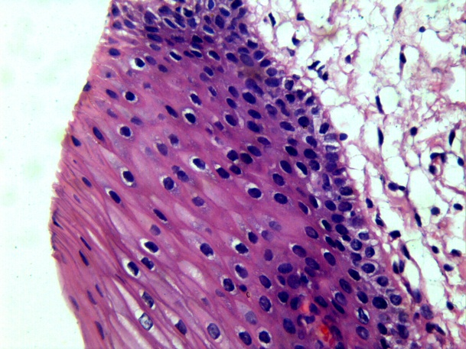Fig.1

Foramline fixed H&E stained tissue section in 40X magnification

Fig.2

Gluteraldehyde fixed H&E stained tissue section in 40X magnification

Fig.3

Osmium tetroxide ­fixed H&E stained tissue section in 40X magnification.

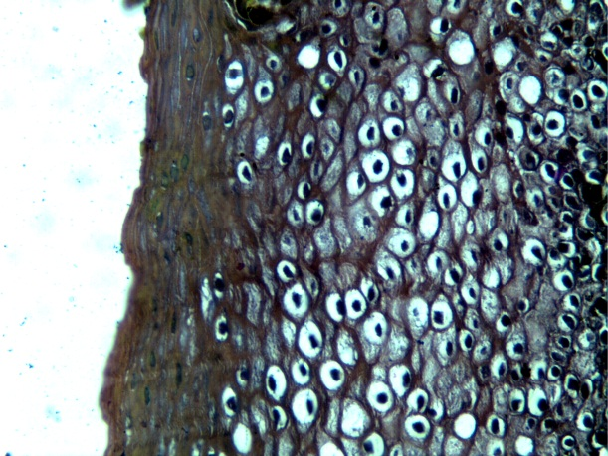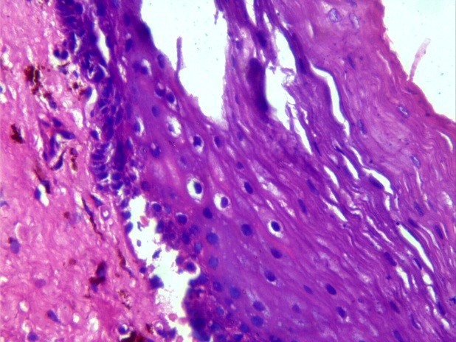

**Fig. 4.** Formation of formaldehyde polymers

(above), and depolymerization of paraformaldehyde (below).



**Fig. 5.** Reactions involved in

fixation by formaldehyde.

1. Addition of a formaldehyde molecule to a protein.

**(B)** Reaction of bound formaldehyde with another protein molecule toform a methylene cross-link.

**(C)** A more detailed depiction of the cross-linking of a lysine side-chain to a peptide nitrogen atom.

**Fig. 6**

**(A)** Three representations of a molecule of monomeric glutaraldehyde.

**(B)** Polymerization reaction of glutaraldehyde, showing an aldehyde side-chain on each unit of the polymer



**Fig.7.**

Reaction of

Poly (glutaraldehyde) with amino groups of proteins



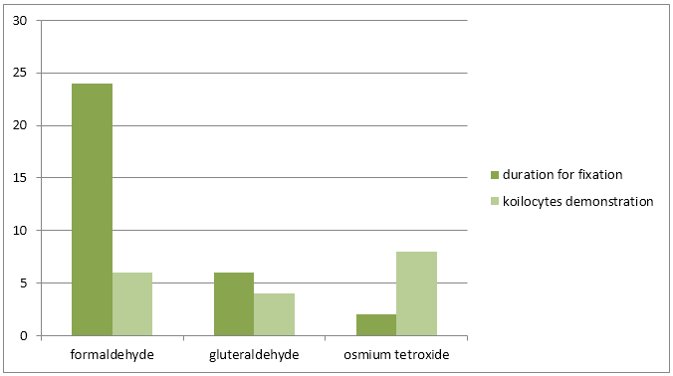

**Fig.8.** Graph for time taken for fixation of tissue by respected fixative (in Hrs) and demonstration of koilocytes by them {graded from value 0-10}

***References :***

1. ASSOCIATION OF HUMAN PAPILLOMA VIRUS WITH ORAL SQUAMOUS CELL CARCINOMA – A BRIEF REVIEW RAKESH S, MAHIJA JANARDHANAN, VINODKUMAR R B VIDYA M, ORAL & MAXILLOFACIAL PATHOLOGY JOURNAL [ OMPJ ] VOL 1 NO 2 JULY- DEC 2010 ISSN 0976-1225
2. FIXATION THE KEY TO GOOD TISSUE PRESERVATION DALE ULMER, P.A.; UNIVERSITY OF SOUTH ALABAMA COLLEGE OF MEDICINE, DEPARTMENT OF PATHOLOGY, MOBILE, AL
3. FORMALDEHYDE, FORMALIN, PARAFORMALDEHYDE AND GLUTARALDEHYDE: WHAT THEY ARE AND WHAT THEY DO. JOHN A. KIERNAN, MICROSCOPY TODAY 00-1 PP. 8-12 (2000).
4. TISSUE FIXATION BY OSMIUM TETROXIDE. A POSSIBLE ROLE FOR PROTEINS. LASTAIR J. NIELSON AND WILLIAM P. GRIFFITH THE JOURNAL OF HISTOCHEMISTRY AND CYTOCHEMISTRY VOL. 27, NO. 5, PP. 997-999, 1979
5. RIEMERSMA JC: CHEMICAL EFFECTS OFFIZATION ON BIOLOGICAL SYSTEMS, SOME BIOLOGICAL TECHNIQUES IN ELECTRON MICROSCOPY. EDITED BY DR PARSONS. ACADEMIC PRESS, NEW YORK, 1970, P69
6. SCHIECHL H: DER CHEMISMUS DER OS04-FIXIERUNG UND SEIN EINFLUSS AUF DIE ZELLSTRUKTUR. ACTA HISTOCHEM SUPPL 10:165, 1971
7. ADAMS CWM, ABDULLA YH, BAYLISS OB: OSMIUM TETROXIDE AS A HISTOCHEMICAL AND HISTOLOGICAL REAGENT. HISTOCHEM J 9:68, 1967
8. HOPWOOD D: FIXATION OF PROTEINS BY OSMIUM TETROXIDE, POTASSIUM DICHROMATE AND POTASSIUM PERMANGANATE. HISTOCHEM 18:250,1969
9. HARDY WB: ON THE STRUCTURE OF CELL PROTOPLASM. J PHYSIOL 24:158, 1899
10. JOST P, BROOKS UJ, GRIFFITH OH: FLUIDITY OF PHOSPHOLIPID BILAYERS AND MEMBRANES AFTER EXPOSURE TO OSMIUM TETROXIDE AND GLUTARALDEHYDE. J MOL. BIOL. 76:313, 1973
11. FINEAN JB: THE EFFECTS OF OSMIUM TETROXIDE FIXATION ON THE STRUCTURE OF MYELIN IN SCIATIC NERVE. EXP CELL RES 6:283, 1954
12. PORTER KB, KAILMAN F: THE PROPERTIES AND EFFECTS OF OSMIUM TETROXIDE AS A TISSUE FIXATIVE, WITH SPECIAL REFERENCE TO ITS USE FOR ELECTRON MICROSCOPY. EXP CELL RES 4:127, 1953.
13. HPV INVOLVEMENT IN OSCC: CORRELATION OF PCR RESULTS WITH LIGHT MICROSCOPIC FEATURES JOURNAL OF ORAL AND MAXILLOFACIAL PATHOLOGY VOL. 17 ISSUE 2 MAY - AUG 2013
14. VIDAL L, GILLISON ML. HUMAN PAPILLOMAVIRUS IN HNSCC: RECOGNITION OF A DISTINCT DISEASE TYPE. HEMATOL ONCOL CLIN. NORTH AM 2008;22:1125‑42.
15. SYRJANEN KJ, PYRHONEN S, SYRJANEN SM. EVIDENCE SUGGESTING HUMAN PAPILLOMAVIRUS (HPV) ETIOLOGY FOR THE SQUAMOUS CELL PAPILLOMA OF THE PARANASAL SINUS. ARCH GESCHWULSTFORSCH. 1983; 53:77-82.
16. KOILOCYTOSIS A COOPERATIVE INTERACTION BETWEEN THE HUMAN PAPILLOMAVIRUS E5 AND E6 ONCOPROTEINS
17. HAJDU SI: A NOTE FROM HISTORY: THE LINK BETWEEN KOILOCYTES AND HUMAN PAPILLOMAVIRUSES. ANN CLIN LAB SCI 2006, 36:485–487
18. YAMAMOTO LS, ALVES VA, MAEDA MY, LONGATTO-FILHO A, UTAGAWA ML, ELUF NETO J: A MORPHOLOGICAL PROTOCOL AND GUIDE-LIST ON UTERINE CERVIX CYTOLOGY ASSOCIATED TO PAPILLOMAVIRUS INFECTION. REV INST MED TROP SAO PAULO 2004, 46:189–193
19. FIXATION AND PROCESSING *FREIDA L. CARSON* HISTOLOGIC PREPARATIONS: COMMON PROBLEMS AND THEIR SOLUTIONS
20. FIXATION OF BIOLOGICAL SPECIMENS WOLF D. KUHLMANN, M.D. DIVISION OF RADIOONCOLOGY, DEUTSCHES KREBSFORSCHUNGSZENTRUM, 69120 HEIDELBERG, GERMANY
21. EXPERIMENTS ON FIXATION FOR ELECTRON MICROSCOPY ALKALIZED OSMIUM TETROXIDE S. K. MALHOTRA QUART. J. MICR. SCI., VOL. 103, PT. 3, PP. 287-96, 1962.
22. BAHR GF: OSMIUM TETROXIDE AND RUTHENIUM TETROXIDE AND THEIR REACTIONS WITH BIOLOGICALLY IMPORTANT SUBSTANCES. EXP CELL RES 7:457, 1954
23. HAKE T: STUDIES ON THE REACTIONS OF 0504 AND KMNO4 WITH AMINO ACIDS, PEPTIDES AND PROTEINS. LAB INVEST 14:1208, 1965
24. A QUANTITATIVE DETERMINATION OF THE OSMIUM TETROXIDE-LIPOPROTEIN INTERACTION THOMAS L. HAYES, FRANK T. LINDGREN, AND JOHN W. GOFMAN.
25. BAHR, G. F., IN PROCEEDINGS OF THE STOCKHOLM CONFERENCE IN ELECTRON MICROSCOPY, (F. S.SJ6STRAND AND J. RHODIN, EDITORS), NEW YORK,ACADEMIC PRESS, INC., 1956, 107.
26. BAHR, G. F., NATURWISSENSCHAFTEN, 1955, 42, 121.
27. BAHR, G. F., Z. NATURFO~SCH, 1955, 10 B, 156.
28. BAHR, G. F., Z. NATURFORSCH, 1956, LL B, 59.