ANATOMICAL VARIATIONS OF GREATER PALATINE CANAL AND FORAMEN IN RELATION TO GENDER IN SOUTH INDIAN POPULATION – A CROSS SECTIONAL STUDY USING CONE BEAM COMPUTERISED TOMOGRAPHY
AIM
The greater palatine canal (GPC) extends through the Pterygopalatine fossa and contains the greater palatine and lesser palatine nerves, which diverge to enter the hard palate at respective greater palatine foramina. The anatomical variations of greater palatine canal and their foramina have not been studied comprehensively in South-Indian population. We did a study to evaluate the position and characteristics of the GPF and canals in South Indian patients using cone beam computed tomography (CBCT) providing variations of the same in relation to gender.
MATERIALS AND METHODS:
This experimental study included 100 CBCT scans of maxilla (50males and 50females) from patients. All patients had informed consent for participation in this study. Inclusion criteria include age above 18 years old and exclusion criteria were: history of trauma or orthognathic surgery, presence of pathologic bone disease in maxilla and CBCT scans that did not include maxilla. The selected scans had paraxial slices with slice thickness of 0.3 mm. The greater palatine region was examined in the CBCT scans using Carestream 9300 3D imaging system, 70-90 kVp, 5-10 mA, voxel size 90-180m, field of view 10*5 cm. The effect of anatomical variations of greaterpalatine region on patient’s gender were evaluated using 7 different parameters.
RESULTS
Within the limits of this study, we concluded that in the South-Indian patients studied, the GPF location was more closely related to the second molar. Therefore, the second molar could be used as landmark for successful GPN block anesthesia. The measurement GPF to AR was found to be statistically significant among males and females. The mean CL was significantly different according to sex and side. Therefore GPF location, its distance to AR and its canal length could be used as a reliable clinical index.
CONCLUSION
This study will enlighten that 3D images of CBCT can detect precise anatomic routes to prevent complications of procedures carried out in greaterpalatine region.
Keywords: Anatomy, Alveolar ridge (AR), cone beam computed tomography, greater palatine foramen, greater palatine canal, mid-maxillary suture (MMS)
INTRODUCTION
The greater palatine canal (GPC) extends through the Pterygopalatine fossa (PPF), which then diverges to enter the hard palate at respective foramina. It houses the descending palatine artery (a branch of the third division of the maxillary artery) and greater and lesser palatine nerves (branches of the maxillary division of the trigeminal nerve) and their posterior inferio-lateral nasal branches. The canal helps direct access to the PPF, including the sphenopalatine ganglion, pterygopalatine ganglion, infraorbital nerve, internal maxillary artery, and the pterygoid venous plexus.¹ The anatomy of the greater palatine canal is of interest to dentists, oral maxillofacial surgeons, and otolaryngologists performing procedures in this area (e.g., administration of local anesthesia, dental implant placement, orthognathic Le Fort osteotomies, and sino-nasal surgeries).²
Although the greater palatine foramen is of great clinical importance, its exact location is not adequately described in any standard textbook on surgery or anatomy. Anatomy textbooks locate the foramen only in a general way, for example “in the posterolateral palate” or “opposite the last tooth”. Clinical textbooks on anesthesia are somewhat more specific in relating the GPF to the molar teeth. However. In a comparison of these texts one finds variation in the reported locations. Accordingly the position is cited as opposite the second molar, opposite the third molar or anywhere between the second and third molar³.
Variations in the location of GPF may pose difficulties in the local and regional anesthesia of the trigeminal maxillary division. In addition, difficulties may occur in identifying the emergence of the greater palatine artery within the oral cavity, which represents important information in the surgery of palatal free vascular flaps, cleft palate, or maxillary sinus.⁴
A good knowledge of the anatomy and average length of the GPC is crucial for avoiding possible complications like penetration of the orbit and nasal cavity, protopsis, blindness from vasoconstriction of the ophthalmic artery and/or intracranial spread of infection, intravascular injection, penetration of the nasopharynx, damage to neural tissue, and failed anesthesia. 3D images of cone beam computed tomography (CBCT) are becoming more readily available for use in maxillofacial applications and provides better image quality of teeth and their surrounding structures, compared with conventional CT scan. ¹
The aim of this study was to map the anatomical variations of the Greater palatine canal and greater palatine foramen using CBCT in the South-Indian population. Our results have been compared to the already existing anatomical data in other races and populations, might improve clinical success in maxillofacial and oral surgery.
MATERIALS AND METHODS
A descriptive analytical cross-sectional study was conducted on 100 CBCT scans of maxilla (50 males and 50 females) from patients. All patients had informed consent for participation in this study. The inclusion criteria included: presence of all upper erupted molars in both maxilla sides; male/female aged 18 years or older, and absence of any pathological conditions or deformities in the jaws. The exclusion criteria were: history of trauma or orthognathic surgery, presence of pathologic bone disease in maxilla, CBCT scans that did not include maxilla and syndromic patients. The selected scans had paraxial slices with slice thickness of 0.3 mm. The greater palatine region was in the CBCT scans. The CBCT examinations were carried out for every patient with Carestream 9300 3D imaging system. Full rotation scan was performed with 70-90 kVp, 5-10 mA and voxel size of 90-180 m. the size of field of view will be 10*5 cm. All images were taken using volume 1 (high-resolution) and high-contrast options.
To standardize the shape of the GPF, two different landmarks were introduced as its inferior limit; in the sagittal plane, the posterior wall of the GPF was used, and in the coronal plane, the inferior surface of the horizontal hard palate was used according to the method given by Sheiki et al. ¹ Also for this study, the pterygoid canal was selected as the superior limit instead of the foramen rotundum due to its ease of identification in relation to the greater palatine canal. Soft tissue depth was not included.²
Seven different variables were assessed, which are discussed subsequently.
- POSITION OF GPF IN RELATION TO UPPER MOLARS
To assess the position of the GPF with respect to the upper molars, the following evaluation was conducted on each image in axial reconstruction. Firstly, five tangents were drawn parallel to the middle of and interproximal to the face of the upper molars and the following classification was used to assess the position (Fig 1):
(A) From the medial face of second molar to its center;
(B) From the center of second molar up to its distal face;
(C) From the medial face of third molar up to its center;
(D) From the center of third molar up to its distal face and
(E) Distal from the third molar.
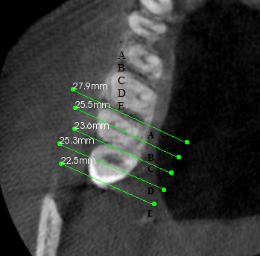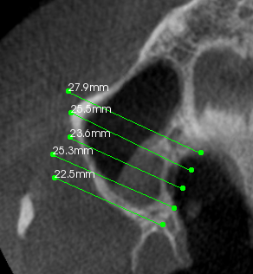(Fig 1)
The exact position of the GPF showing an overlap with the tangents was noted and recorded as JPEG. Coronal and sagittal reconstruction was made to standardize the exact position of the GPF through the intersection of horizontal and vertical markers.
- DIAMETER OF GPF
The average diameter of the GPF was determined using axial reconstruction (Fig.2).
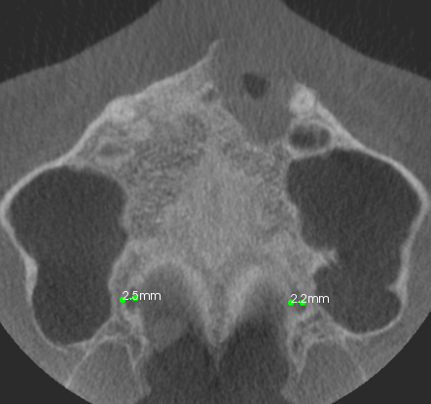(Fig 2)
- DISTANCE FROM GPF TO MMS
The study of anatomical landmarks such as the AR and the MMS is important because they can be used as a reference points to locate GPF in edentulous patients. Distance to AR and to MMS could be used to assess the location of GPF before anesthesia block or incision to harvest palatal mucosa graft. Axial sections were created to evaluate the distance from the GPF to the MMS. In the axial reconstruction, a perpendicular line was drawn from the center of the GPF to the MMS (Fig. 3). The resulting distance from each reconstruction was calculated.
\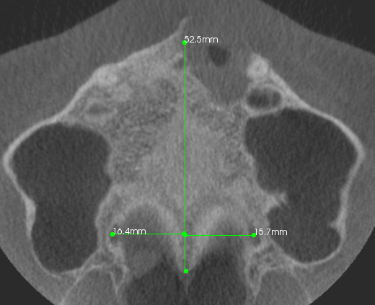(fig 3)

- DISTANCE FROM AR TO GPF
Distance from the GPF to the AR was measured in the axial reconstruction. In the depth of the upper molars, a line was drawn tangential to the AR. Following this, a perpendicular line was drawn in the depth of the GPF and the distance was determined from the AR to the medial GPF wall (Fig. 4).
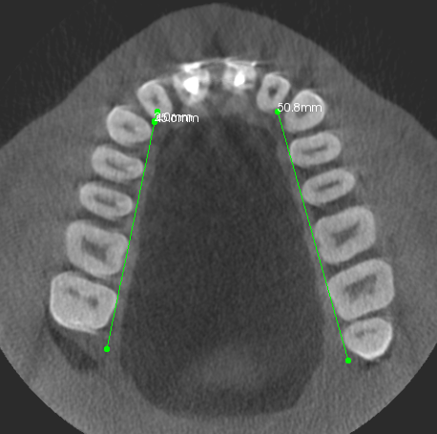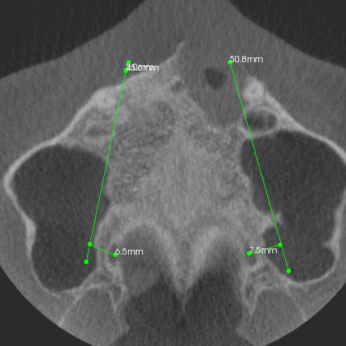(Fig 4)
- THE MEAN CANAL LENGTH(CL) OF GREATER PALATINE CANAL
The method described by Haward-Swirzinski, et al.^{[5]} was used to assess the CL and its paths insagittal plane. The length of the greater palatine canal was measured from the center of the pterygoid canal, as the center point of the pterygopalatine fossa to the greater palatine foramen on the inferior surface of the hard palate. It was measured in millimeters using the straightest linear path passing through the center of the canal. (Fig 5)
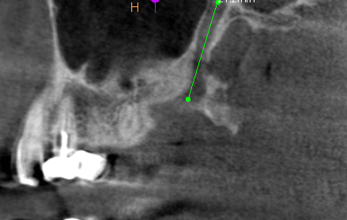(Fig 5)
- THE PATHWAYS OF GREATER PALATINE CANAL IN THE CORONAL PLANE
- THE PATHWAYS OF GREATER PALATINE CANAL IN THE SAGITTAL PLANE

STATISTICAL ANALYSIS
The analysis was conducted using the distance measuring tool of CS 3 D software and the images were saved as JPEG. The measurements were repeated 2 months later and intra-examiner agreement was performed (Dahlberg’s error and paired T test). All data were evaluated using SPSS software version 19 package.
A paired T test (P 0.05) was conducted to compare the measurements from the right and left side, and a T test was conducted to compare the values between the sexes. Independent t-test was used to compare the CL values and the distance from GPF to MMS and AR. One-way analysis of variance (ANOVA) was used to compare the CL and IOF between the two study groups. To identify the level of agreement between the CL on the right and left sides, an intra-class correlation coefficient (ICC) was used. A kappa coefficient was used to identify the degree of symmetry between the pathways on the right and left sides as viewed in the sagittal and coronal planes. A kappa values were considered as follows < 0.20 poor, 0.21-0.40 fair, 0.41-0.60 moderate, 0.61-0.80 good and 0.81-1.00 very good. A P-value less than the 0.05 level of significance was considered statistically significant. Further Discriminant analysis (ROC analysis) was used to assess the validity of linear measurements used in this study in differentiation of male gender from female according to method given by Sorlie(1995).¹⁴
RESULTS
POSITION OF GREATER PALATINE FORAMEN IN RELATION TO UPPER MOLARS
One hundred patients (50 males/50 females) with mean age of 35.80 (±10.99) years were examined. In 34 % of the total examinations, GPF was found to be located between the middle of the second molar and its distal face (position B), 25 % medial face of the third molar and its center (position C); 18 % between the middle of the third molar and its distal face (position D); 16 % between the medial face of the second molar to its center; 7 % distal to the third molar. From the 200 GPFs examined, 68 were in the positions B and of those 36 were in the right side and 29 in the left side.
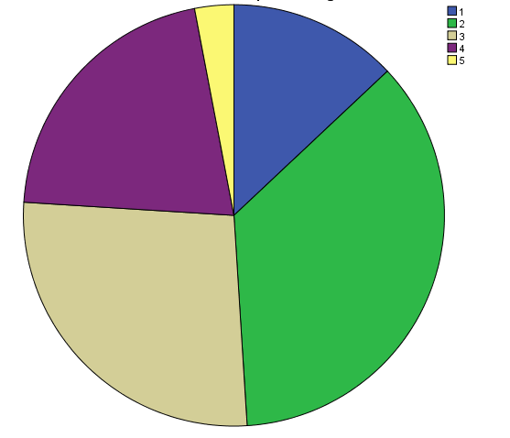
(1) From the medial face of second molar to its center;
(2) From the center of second molar up to its distal face;
(3) From the medial face of third molar up to its center;
(4) From the center of third molar up to its distal face and
(5) Distal from the third molar.
The mean diameter of lingual foramen on right side was found to be 2.03 mm (± 0.63), and on left side was found to be 1.94 mm (± 0.61).
The mean distance from GPF to MMS were 19.89 mm (±3.02) on right side and 19.39 mm (±2.97) on the left side.
The mean distance from GPF to AR were observed to be 29.47 mm (±4.43) and 28.65 mm (±4.5) in right and left sides respectively.
The measurement GPF to AR was found to be statistically significant among males and females (P=0.048)
The mean CL of the GPC was 28.61 ± 3.51 mm (26.7 ± 2.34 mm on the right side and 27.52 ± 2.40 mm on the left, intra-examiner reliability was 95%); a statistically significant difference in CL was observed between the right and left sides (P = 0.044). However, the ICC was 0.8422 with P < 0.001, which indicates a consistent mean CL.
The mean CL in females was 26.55 ± 1.74 mm and in males was 27.94 ± 2.17 mm, which was not a statistically significant difference (P = 0.001).
Gender | n | Right | Left | P value | ICC
Male | 50 | 28.46±3.37 | 28.39 ± 1.37 | 0.117 | 0.407
Female | 50 | 24.94±2.12 | 25.86± 2.27 | 0.028 | 0.682
ICC: Intra-class correlation coefficient, CL: Canal length
INCIDENCE OF PATHWAYS OF GREATER PALATINE CANAL
Investigations of the canal path revealed four path types in the sagittal plane and five path types in the coronal plane [Figures 1 and 2].IN SAGGITAL PLANE
FIGURE | PATHWAY | RIGHT CANAL | LEFT CANAL | BILATERALLY SYMMETRICAL | OVERALL INCIDENCE
Figure 6 | GPC travels in an anterior-inferior direction from the PPF | 16 | 15 | 12 | 15.5%
Figure 7 | GPC first travels in an inferior direction and then in an anterior-inferior direction through the remainder of the canal | 28 | 34 | 16 | 31%
Figure 8 | The GPC first travels in an inferior direction and then changes to an anterior-inferior direction,and subsequently in inferior direction through the remainder of the canal | 32 | 31 | 22 | 31.5%
Figure 9 | The GPC travels in  a directly inferior direction  from the PPF | 24 | 20 | 14 | 22%

(Figure 6)
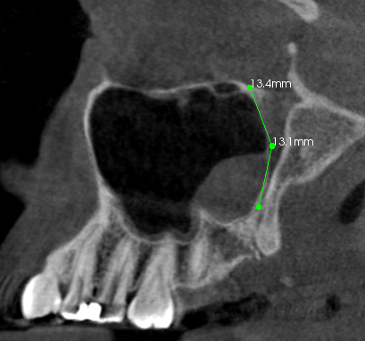(Figure 7)

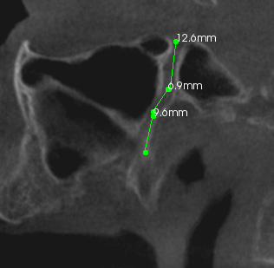(Figure 8)

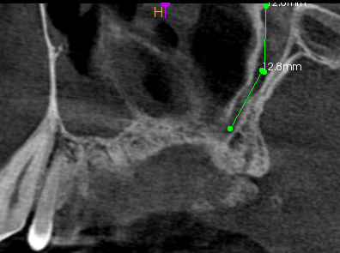(Figure 9)
IN THE CORONAL PLANE:
FIGURE | PATHWAY | RIGHT CANAL | LEFT CANAL | BILATERALLY SYMMETRICAL | OVERALL INCIDENCE
Figure 10 | The GPC travels in an inferior-lateral direction from the PPF and then in a directly inferior direction | 15 | 9 | 5 | 12%
Figure 11 | The GPC travels in an inferior-lateral direction for a certain distance and then changes to an inferior-medial direction through the remainder of the canal | 35 | 30 | 19 | 32.5%
Figure 12 | The GPC first travels in an inferior-lateral direction and then in a directly inferior direction, and finally in an inferior-medial direction | 23 | 34 | 15 | 26.5%
Figure 13 | The GPC travels in a directly inferior direction from the PPF | 16 | 15 | 8 | 15.5%
Figure 14 | The GPC first travels in an inferior direction and then changes to an posterio-inferior direction, and subsequently to an inferior direction through remainder of the canal | 11 | 12 | 4 | 11.5%
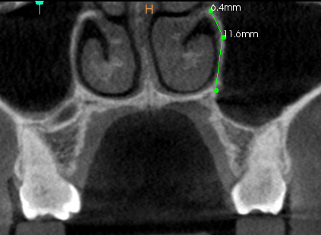(Figure 10)
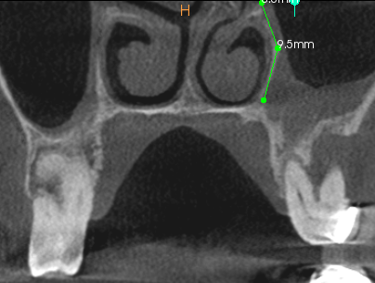 (Figure 11)
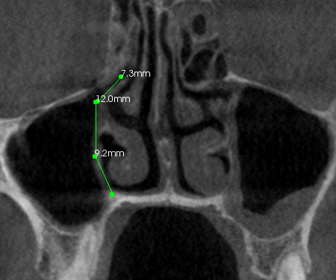(Figure 12)

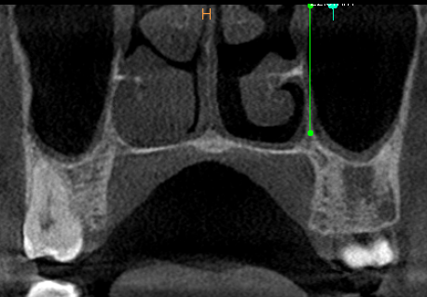(Figure 13)
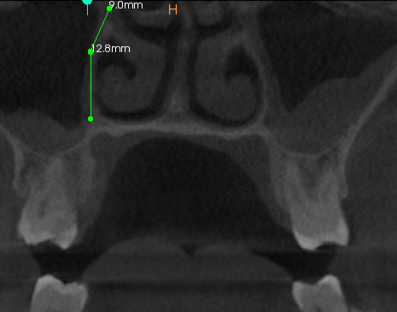(Figure 14)

DEGREE OF SYMMETRY BETWEEN THE PATHWAYS ON RIGHT AND LEFT SIDES
The different pathways and the degree of symmetry between the pathways on the right and left sides in the sagittal and coronal planes are shown in Figures 3 and 4 and in Table 3 (kappa), respectively.
PLANE | Sex | n | Kappa value | Strength of Agreement
Sagittal | Male | 50 | 0.000 | Poor
 | Female | 50 | 0.804 | Good
 | Total | 100 | 0.007 | Poor
Coronal | Male | 50 | 0.989 | Very good
 | Female | 50 | 0.025 | Fair
 | Total | 100 | 0.112 | Poor
RECEIVER OPERATING CHARACTERISTIC CURVE (ROC CURVE)
Discriminant analysis (ROC analysis) was used to assess the validity of linear measurements used in this study. The ROC curve gives us a typical cut-off for differentiating male from female by giving a typical cutoff values would be 100% specific to establish the diagnosis of gender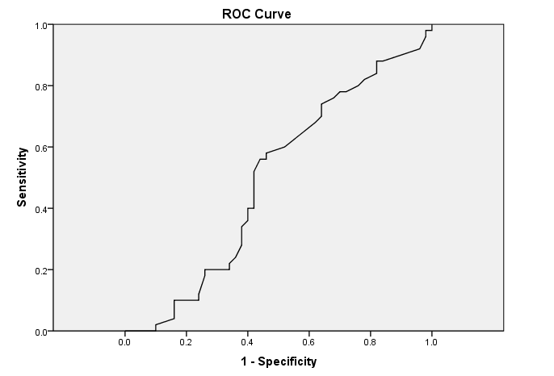

VALIDITY PARAMETERS TO PREDICT MALE AND FEMALE GENDERS USING ROC ANALYSIS
The typical cut-off value could predict the gender type with great accuracy, testing positive when it would predict gender with a value of high specificity and less sensitivity, testing negative when values would exclude gender with less specificity and high sensitivity.

PARAMETER | GENDER  (male) | GENDER  (Female) | TYPICAL CUT-OFF | AREA UNDER THE CURVE (AUC) | P value
GPF to MMS (Right canal) | 20.80 mm | 18.55 mm | 19.40 mm | 0.495 | 0.929
GPF to MMS (Left canal) | 19.30 mm | 18.30 mm | 17.60 mm | 0.512 | 0.833
GPF to AR(Right canal) | 31.10 mm | 27.65 mm | 28.70 mm | 0.578 | 0.181
GPF to AR(Left canal) | 29.85 mm | 27.10 mm | 28.10 mm | 0.632 | 0.023

DISCUSSION
Since the GPC technique is associated with several complications, this study was performed to determine the mean dimensions of the GPC, its foramina and the geometric pattern of this structure, as well as to identify a reliable clinical index that can be used to estimate the mean values for each sex using CBCT data.¹
From our study using a subset of South-Indian population, we were able to assess the location of the GPF in relation to the face of each upper erupted molar. The GPF was found to be located in the palatal side of second molar in the 59/100 of the cases studied; most of them (34/100) were in position B and 25/100 in position C. In our study, 16/100 of the GPF were medial to the second molar and 7/100 were distal to the third molar. In previous studies using Nigerian and Indian dry skulls ^{[6, 7]} it was found that GPF was medial to the third molar in 48 and 64 % of the cases, respectively. Also, 16% GPFs were found to be medial to the second molar in our study, compared to 13.3 % in the Nigerian study .⁶ In a study using dry skulls, it was found that 5.6 % were opposite to the second molar, 23.1 % between the second to third molars and 64.4 % opposite to the third molar.⁸ The percentage of GPFs found distal to the third molar in our study (7 %) is comparable to those mentioned in other studies 6.9 %⁸ and 2.9 % ⁶ .The average diameter of the GPF was found to be 1.98 mm, which was comparable to previous studies ^{[11, 12]}
Previous studies have showed the distances from the GPF to the MMS in Nigerian, Thai and Brazilian dry skulls to be 15.4, 14.7, and 14.68 mm, respectively^{[6, 9, 7]}. These values are higher in South-Indian population (19.89 mm).
Considering the AR as a reference landmark, we found the distance from the AR to the GPF to be 29.47 mm. We could not compare our AR to GPF distance to other studies ^{[6,7,10]} because usually they evaluate the distance from GPF to the posterior border of the palate instead of the distance from GPF to AR as we did.
Methathrathip et al.^{[8]} studied 105 dried skulls and reported that the length of the GPC and PPF from the GPF to the inferior border of the foramen rotendum ranged from 16.3 to 40.9 mm, with a mean of 29.7 ± 4.2 mm, which is consistent with the present study results (mean CL = 28.61 ± 3.51 mm). McKinney et al.¹³ analyzed the length of the GPC using high-resolution CT, and reported that the mean distance from the GPF to the sphenopalatine foramen to be 28.75 mm. Hwang, et al. repeated the study using 3D CT scans and reported a mean height of the PPF and mean CL that were also in agreement with our findings.
However, the mean CL reported by Douglas, et al.¹³ (40.1 mm) were not consistent with the present study; these differences could be explained by the small number of subjects included in the study or by differences in ethnicity.
In our study, the mean CL was higher in males than in females. Previous studies1 on sexual dimorphism have suggested that the craniofacial complex is highly variable in both size and shape by sex, and the zygomatic curve and skull size are generally larger in males than in females. Differences in the shape of the midsagittal curve, the skull roof, the upper one-third of the face, the nose, eyes, and palate are all statistically significantly different between males and females.
In the coronal plane, the most common pathway observed was consistent with that reported by Haward-Swirzinski et al ^{[2]} but this was not in agreement with the pathway they observed in the sagittal plane, which could be explained by the small number of subjects included in our study or by the differences due to ethnicity or sex. Also in our study we have calculated typical cut-off values which helps in predicting male and female genders, the values of which could be helpful in medico-legal cases and mass disorders (forensic identification).
. A limiting factor in the present study was the small sample size and we suggest that further studies to be performed on a larger group of subjects of different age and ethnicity. It is also suggested that GPF should be compared in adults and children as well as in subjects with specific craniofacial diseases.
CONCLUSION
Thus it is important to consider CBCT as an important diagnostic tool especially to study the most inaccessible areas which cannot be studied by other imaging modalities. The GPF may be an anatomical obstacle in oral and maxillofacial surgery procedures in the posterior area of the palate, but using CBCT the variations in its position can help the clinicians in providing improved surgical procedures and may also be helpful in forensic identification. Details on clinical anatomy of GPF can also be helpful in evaluating and predicting craniofacial growth.
REFERENCES
- Length and anatomic routes of the greater palatine canal as observed by cone beam computed tomography Mahnaz Sheikhi et al Dental research journal, vol 18, no 2, pp.155-161, 2013
- Haward-Swirzinski K, Edwards PC, Saini TS, Norton NS. Length and geometric patterns of the greater palatine canal observed in cone beam computed tomography. Int J Dent 2010; 2010.pii: 292753.10.
- An analysis of the position of the greater palatine foramen Akram et al J.Basic.med. Sc Vol.3, No.1, 2003
- Anatomical and clinical considerations regarding the greater palatine foramen V.Nimigean et al Rom J Morphol Embryol 2013, 54(3 Suppl):779–783
- Position of the greater palatine foramen: an anatomical study through cone beam computed tomography images Carla et al Surg Radiol Anat DOI 10.1007/s00276-013-1151-z
- Ajmani ML (1994) Anatomical variation in position of the greater palatine foramen in the adult human skull. J Anat 184: 635–637
- Saralaya V, Nayak SR (2007) The relative position of the greater palatine foramen in dry Indian skulls. Singapore Med J 48:1143–1146 skulls. Indian J Dent Res 16:99–102
- Methathrathip D, Apinhasmit W, Chompoopong S, Lertsirithong A, Ariyawatkul T, Sangvichien S (2005) Anatomy of greater palatine foramen and canal and pterygopalatine fossa in Thais: considerations for maxillary nerve block. Surg Radiol Anat 27:511–516
- Klosek SK, Rungruang T (2009) Anatomical study of the greater palatine artery and related structures of the palatal vault: considerations for palate as the subepithelial connective tissue graft donor site. Surg Radiol Anat 31:245–250
- Sharma NA, Garud RS (2013) Greater palatine foramen—key to dimensions at the palatal vault as a donor site. J Periodontol successful hemimaxillary anaesthesia: a morphometric study and 77:899–902 report of a rare aberration. Singapore Med J 54(3):152–159
- Kim HS, Kim DI, Chung IH (1996) High-resolution CT of the pterygopalatine fossa and its communications. Neuroradiology 38:120–126
- Mendel N, Puterbaugh PG (1938) Conduction, infiltration and general anesthesia in dentistry, 4th edn. Dental Items of Interest Publishing Co, New York, p 140
- Douglas R, Wormald PJ. Pterygopalatine fossa infiltration through the greater palatine foramen: where to bend the needle. Laryngoscope 2006; 116:1255-7
- Sex determination using linear measurements related to the mental and mandibular foramina vertical positions on digital panoramic images Sura A. Rashid J Bagh College Dentistry Vol. 23(special issue), 2011

