Microbiological status and clinical outcomes in peri-implant mucositis patients treated with or without adjunctive bioadhesive dental gel

Marisa Roncati ¹, Giuseppe Gola ², Francesco Carinci ³

¹Teaching Professor on Master Degree on Prosthodontics, Dental School, University of Bologna Italy.
²Professor of Oral Pediatrics, School of Dental Hygiene, “Vita-Salute S.Raffaele” University of Milan, Italy.
³Chair of Maxillofacial Surgery, School of Medicine, University of Ferrara, Italy.

Corresponding Author:
Francesco Carinci
Professor of Maxillofacial Surgery
Department of Morphology, Surgery and Experimental Medicine
University of Ferrara
Via Luigi Borsari 46, 44100 Ferrara, ITALY
Phone: +39.0532.455874
Fax: +39.0532.455582
Web: www.carinci.org

Microbiological status and clinical outcomes in peri-implant mucositis patients treated with or without adjunctive bioadhesive dental gel

ABSTRACT
Aim: Biological complications of restored dental implants share similarities with the biofilm infections of natural dentition. Mechanical non-surgical therapy could be effective in the treatment of peri-implant mucositis lesions. The objective of this study was to assess the efficacy of a commercially available dental gel containing 0.05% cetylpyridinium chloride (CPC) and essential oils for controlling established peri-mucositis.
Methods: This study was designed as a double-centre, double-blind, randomized, parallel group clinical trial. Microbiological changes were also recorded.
Results: Mathematical analysis demonstrated a statistically significant better outcome as regard bleeding (p = 0.016) and probing (p =o.001) in sites treated with HG. No statistical significant differences was detected between test and control sites as regards microbial loading. Periodontal pocket depth was reduced to 4.6 mm to 3.2 mm probing depth Nonsurgical treatment, seemed to provide evidence of some improvement of the bleeding index. Statistical significant improvement was detected on bleeding and probing depth by using HG in association with standard methods. Clinical parameters and levels improved in both groups after treatment. In peri-implantitis patients without pus formation, all parameters decreased and the additional and no surgery was necessary to improve the parameters. Conclusions: Both treatment modalities led to an improvement of the clinical parameters and a temporary reduction of microflora at implants with mucositis, but without significant inter-group differences after 6 weeks. Combination therapy may have beneficial effects. Besides a strict home care regimen and correctly performed supportive periodontal therapy, other therapeutic interventions could contribute enhancing the long-term outcomes of implant therapy.

Key Words: Nonsurgical periodontal treatment, mucositis, peri-implantitis, dental gel , microbiological evaluation, cetylpyridinium chloride , essential oils
INTRODUCTION
Dental implants have been reported to achieve long-term success, however they are not guarantee from potential complications due to improper treatment planning, surgical and prosthetic execution, material failure, and maintenance.¹ Included in the latter are the biologic complications of peri-implant mucositis and peri-implantitis, inflammatory conditions in the soft and hard tissues at dental implants,¹ requiring management through several strategies applied at different stages
To date, evidence suggests that peri-implant mucositis can be successfully treated, if they are detected early and when combined with effective nonsurgical efforts. ^{1,3,4} Careful monitoring and preventive care of peri-implant tissue health during maintenance is of paramount importance ². The long-term outcomes of implant therapy appear to be enhanced by supportive periodontal treatment for patients who are periodontally compromised⁵, but not in those who are not compliant.⁶
Maintenance of implants is imperative, since implants, like teeth, are susceptible to bacterial plaque accumulation and calculus formation, and thus at risk of developing peri-implant mucositis or peri-implantitis. ⁷ The dental team must play a critical role in educating patients to control plaque-biofilm associated with peri-implant tissues and associated restorations. ^{8,9}
Since tooth-paste/gel is the standard medical device used for in house plaque control and it potentially have positive effect in controlling peri-implant mucositis. Recently a new dental gel was introduce in Italian market, called Hobagel (“Hobama” srl, Milan – Italy)
The gel consists of an original mixture of various compounds. Some of those have a specific adhesive function (PVP copolymer, cellulose gum hydrated silica), while other substances (Cetylpyridinium chloride and triclosan) have an antiseptic action. Certain essential oils (Melaleuca alternifolia, thymus vulgaris and commiphora myrrha) offer antioxidant and antiflogistic properties, Sodium Hyaluronate has strong hydrating and healing capacity. Bisabolol and Vitamin E ,in microcapsules, can relieve pain.

METHODS AND MATERIALS
Study design
This study was designed as a double-centre, double-blind, randomized, parallel group clinical trial.
Microbiological changes were also recorded.
Subjects were well informed of the study protocol and objectives, and gave their written consent before participation. The study was conducted according to the European directives and ICH Harmonised Tripartite Guideline E6: Note for Guidance on Good Clinical Practice, CPMP/ICH/135/95 Step5 (http://www.ema.europa.eu)
Study population
Consecutive subjects (38 subjects) were screened and enrolled in this clinical trial if they fulfilled the following criteria:
Inclusion criteria
• ≥ 18 years old.
• Systemically healthy.
• Presence of at least 2 evaluable prosthetically restored implants in different quadrant.
• Light/Moderateperi-implant mucositis (≥40% bleeding on marginal probing, BOMP) (Van der Weijden et al. 1994a).
• Absence of probing pocket depths (PPD ≥7 mm).
• Subjects willing to participate and comply with the objectives of the study.
Exclusion criteria included: (1) pregnancy; (2) an history of taking antibiotics or using antibacterial mouth rinses for past 6 months; and (3) drug or alcohol abuse. (4) an ongoing dental or medical treatment, (5) allergy to previously used oral hygiene products or any known allergy to any of the ingredients of the study products.
Twenty four female and 14 males, 4 have diabetes, 30 do not smoke whereas four, two and two smoke less than 5, 10 and 15 cigarettes per days, respectively. The mean age was 58.8 ± 8.3 years. 17 maxillary and 22 mandibular mplant supported prostheses were evaluated, in the following sites: 4 incisors, two cuspids, 12 premolars and 20 molars.
Clinical methods
In each patient, implants with periimplant pathology were randomly assigned to test or control treatment according to a split mouth design (76 sites).After microbiologic diagnosis, all patients were treated at baseline and received individualized home oral hygiene instructions. Non-surgical periodontal instrumentation was performed with hand instrumentation,(Fig.1) utilizing a titan curette (Roncati implant care, by Martin KLS) and piezoelectric ultrasonic device with plastic fused to a metal insert (Piezon Master 700, EMS, PI insert) as needed. Test implants received adjunctive antimicrobial treatment by locally delivered bio-adhesive dental gel.(Fig.2)
Measuraments
At baseline and 6 weeks, the following measurements were taken at 6 sites per implants:
- Modified plaque index (PI) (Mombelli A, et al.,1987)
- Bleeding on probing (BoP) (Van der Weijden et al. 1994a).
- Clinical attachment level (CAL), using the top of the implant abutment as a reference point
For bacteria analysis, sites were isolated using cotton rolls. Sterile absorbable paper points (size 60) were used for the collection of subgengival samples and were immediately transferred to microbiological lab for processing. Porphyromonas gingivalis, Tannerella forsythia, Treponema denticola, Aggregatibacter Actinomycetemcomitans, Fusobacterium Nucleatum, Campylobacter Rectus and total bacterial loading were evaluated.
Real-Time Polymerase Chain Reaction:
Probes oligonucleotides were designed basing on 16S rRNA gene sequences of the Human Oral Microbiome Database (HOMD 16S rRNA RefSeq Version 10.1) counting 845 entries. All the sequences were aligned in order to find either consensus sequence or less conservative spots. Three real-time polymerase chain reaction (PCR) runs were performed for each sample. The first reaction quantified the total amount of bacteria using two degenerate primers and a single probe matching an highly conservated sequence of the 16S ribosomal RNA gene. The second reaction detected and quantified the three red complex bacteria, i.e. P. gingivalis, T. forsythia and T. denticola, in a multiplex PCR. The third reaction detected and quantified Aggregatibacter Actinomycetemcomitans, Fusobacterium Nucleatum, Campylobacter Rectus in a multiplex PCR. These two reactions included a total of six primers and three probes that were highly specific for each species. Oligonucleotide concentrations and PCR conditions were optimized to ensure sensitivity, specificity and no inhibitions in case of unbalanced target amounts. Absolute quantification assays were performed using the Applied Biosystems 7500 Sequence Detection System. The amplification profile were initiated by a 10 min incubation period at 95°C to activate polymerase, followed by a two-step amplification of 15 s at 95°C and 60 s at 57°C for 40 cycles. All these experiments were performed including nontemplate controls to exclude reagents contamination. Plasmids containing synthetic DNA target sequences (Eurofin MWG Operon, Ebersberg Germany) were used as standard for the quantitative analysis. Standard curves for each target were constructed in a triplex reaction, by using a mix of the same amount of plasmids, in serial dilutions ranging from 101 to 107 copies. There was a linear relationship between the threshold cycle values plotted against the log of the copy number over the entire range of dilutions (data not shown). The copy numbers for individual plasmid preparations was estimated using the Thermo NanoDrop spectrophotometer.
The absolute quantification of total bacterial genome copies in samples allowed for the calculation of relative amount of species. To prevent samples and polymerase chain reaction contamination, plasmid purification and handling was performed in a separate laboratory with dedicated pipettes.
After six-weeks microbiological samples were collected again from both sites in each patient. (Fig.3)
Statistical analysis
SPSS program and paired simple statistic T-test were used to detect statistical significant differences.

RESULTS
All 38 patients (76 sites, 38 test and 38 control) completed the study.
Periodontal pocket depth was reduced from to 4.6 mm to 3.2 mm whereas attachment level (CAL) were reduced from to 3.1 mm to 2.7 mm. Both therapies resulted in a statistically significant change in probing pocket depth and attachment level (CAL).
In both treatment groups, plaque index score (PI) showed a trend towards reduction at 6 weeks from 55.4% to 30.2%.
In test implant, combination of non surgical periodontal treatment and adjunctive topical application of micro-granular dental gel resulted in a trend towards reduced bleeding on probing (from about 90% to 16% (calculated as percentage of bleeding teeth/ total tested teeth).
Mathematical analysis demonstrated a statistically significant better outcome as regard bleeding (p = 0.016) and probing (p =o.001) in sites treated with HG. No statistical significant differences was detected between test and control sites as regards microbial loading.

DISCUSSION
The prevalence of peri-implant complications will increase as dental implant-retaining prostheses become worldwide. Peri-implant diseases are present in two forms: peri-implant mucositis and peri-implantitis. Plaque-induced mucositis is a reversible inflammation of the peri-implant gingiva. The description of the inflammatory process of peri-implant mucositis around an implant is quite similar to gingivitis around natural teeth. ² It is generally accepted that mucositis will eventually give rise to peri-implantitis, with inflammation encroaching on the alveolar support. Long-term maintenance care for high-risk groups is essential to reduce the risk of peri-implantitis.¹⁰Periodic evaluation of implants, surrounding tissues and oral hygiene are vital to the long-term success of the dental implant. ¹¹
Reviewing the literature, the available evidence for non-surgical treatment of peri-implant mucositis and peri-implantitis is scarce. ¹²
Peri-implant mucositis and peri-implantitis differ with respect to treatment. ¹ Depending on the severity of the peri-implantitis lesion, surgical or nonsurgical procedures should be implemented. ¹⁰
It was observed that mechanical non-surgical therapy could be effective in the treatment of peri-implant mucositis lesions.¹² Non-surgical treatments are also recommended for peri-implant defects with less than 2 mm destruction ¹³or as initial treatment, prior to surgical management. ¹⁰
The outcome of nonsurgical periodontal treatment of peri-implantitis is inconsistent and unpredictable.¹⁴ The decision as to whether a questionable implant should be treated and maintained non-surgically or surgically is complicated due to variables related to patient behavior. Nonsurgical periodontal treatment is indicated when a patient has medical or psychological contraindications. In peri-implant infections, 5 and 6 mm probing depths are frequently found and initially treated non-surgically.¹⁰
As peri-implant diseases are initiated and exacerbated by bacteria then microbiota and their products removal becomes essential. Commonly used approaches for non-surgical implant surface detoxification are both mechanical and chemical methods.
In the case of home-use oral-hygiene products, mechanical plaque control, together with the use of an antiseptic, may provide benefit in the treatment of peri-implant mucositis in terms of reduction of bleeding on probing and some-times in reduction of the plaque index.¹⁵
Combination therapy i.e. non-surgical periodontal treatment plus adjunctive antimicrobial treatment by locally delivered bio-adhesive dental gel showed a trend in reducing bleeding on probing scores in periimplant mucositis. These outcomes may improve patient’s comfort and the ability to perform proper oral hygiene. Improved periimplant mucosal health may also be associated with a reduced risk for the development of perimplantitis, therefore having a secondary preventive effect.¹⁶
Our results demonstrated that HG in association with standard treatment for peri-implant mucositis is effective in reducing probing depth (PD) and bleeding on probing (BOP) due to its antiflogistic and antiseptic properties, enhanced by the high bio-adhesive capability. The limited antibacterial effect on specific microflora can be explained since the quantity of antimicrobial agents is low in HG, while the depth of the controlled peri-implant pockets was 4-6 mm.
The scientific evidence supports the adjunctive use of local antimicrobials to debridement in deep or recurrent periodontal sites.¹⁷ Employing local antimicrobials as an adjunct to mechanical treatment in case of peri-implant mucositis and peri-implantitis demonstrated mean improvements of bleeding on probing (BOP) and probing depths, but this therapy did not resolve the lesion in all case.¹² The addition of chlorhexidine to mechanical debridement did not enhance the results, on peri-implant mucositis, as compared to mechanical debridement alone.⁷
Care should be exercised in the use of acidic chemicals to detoxify implant surfaces, due to surface alterations in the titanium oxide layer that appears to be necessary for reattachment¹⁸. Product safety and efficacy are highly required. The US Food and Drug Administration (FDA) non-prescription drugs advisory committee divided antimicrobials in three categories.¹⁹Among the ingredients reviewed, only two single active ingredients were recommended as Category I for both safety and efficacy: cetylpyridinium chloride (rinse) and stannous fluoride (dentifrice).
Microbiological analysis, performed by RT-PCR, assessed how the bacteria at implants and teeth could be reduced 24h after treatment; however, this reduction was not significant after 8 months.²⁰ Chlorhexidine is still considered “gold standard” of those antimicrobials, even if recent trials of evaluation of its effectiveness in peri-implant mucositis show some conflicting results.²¹ In a randomised controlled clinical trial, chlorhexidine gel application after debridement did not enhance clinical results in comparison with the mechanical cleansing procedure alone. Moreover, the use of an air-abrasive device or carbon curets in association with chlorhexidine digluconate resulted in a comparable but limited CAL gains at 6 months. The air-abrasive device was associated with significantly higher BOP reductions than chlorhexidine alone. ²²
Intensive application of chlorhexidine containing chips in sites with peri-implantitis after debridement resulted in a substantial improvement of clinical attachment levels. Bleeding on probing was reduced of 50%. ²³ Likewise, the decontamination achieved after surgical resection treatment on a wide group of patients affected by peri-implantitis with chlorhexidine and cetylpyridinium chloride leads to a great suppression of anaerobic bacteria than a placebo solution, without superior clinical results. ²⁴
It seems reasonable the use of other effective and safe antimicrobials agents in peri-implantitis. Short and long-term efficacy of citric acid, for its capability of biofilm removal, metronidazole, tetracycline, for its optimal pH and enzymatic inhibition, mynocycline and doxycycline, for its activity on polymorphonuclear cells, is well-known. Since periodontally compromised patients have a high risk of peri-implant pathologies, it is possible a bacterial contamination from periodontal to implants. However, in periodontal affected patients no evidence was found for an adjunctive effect on reduction of probe depth and BOP of chlorhexidine during scaling and root planning compared to the mechanical procedure alone ²⁵Consequently, it seems reasonable the employment of other effective periodontal substances as essential oils, triclosan and cytilpyridinium chloride. The adjunctive use of these substances provides a clinically significant and additional benefit in reducing plaque and tissues inflammation. ^{26,27,28}
In a recent double-blind randomized clinical trial, Pasini and coworkers, ²⁹ treated a group of periodontal adult patients with professional mechanical instrumentation followed by a three months application of a gel (Hobagel) containing a mixture of cytilpyridinium chloride, triclosan and essential oils, for a daily home use, in comparison with a placebo control group of cases. Both the plaque index and the B.O.P. have shown a significant reduction especially during the first month of use, continuing gradually till the third month. The plaque index reduction was improved of 10% in comparison with controls and the B.O.P. resulted significantly lower (35%) in the test group. The peculiarity of the gel is due to the inclusion in the formula of a specific essential oils: literature is today available about essential oils, showing their high healing and antioxidant activity related to their quick absorption and richness in monoterpens, sequiterpens and thrichetons.^{30,31,32} In long-term use, the effects of essential oils appear to be a reliable alternative to chlorhexidine with respect to parameters of gingival inflammation³³

CONCLUSION
Maintenance of implants is imperative, since implants, like teeth, are susceptible to bacterial plaque accumulation and calculus formation, and thus at risk of developing peri-implant mucositis or peri-implantitis. Both treatment modalities led to an improvement of the clinical parameters and a temporary reduction of the microflora at implants with mucositis, but without significant inter-group differences after 1 month.
Combination therapy i.e. non-surgical periodontal treatment plus adjunctive antimicrobial treatment by locally delivered bio-adshesive dental gel may have beneficial effects, showing a trend in reducing bleeding on probing scores ìn periimplant mucositis.
In summary, clinical trials evaluating the treatment of peri-implant mucositis provide a variety of effective protocols for reducing peri-implant tissue inflammation and therefore the clinician should select those that adapt better to the specific patient’s circumstances¹⁵. Randomized controlled clinical studies with sufficient statistical power are required to determine the optimal therapy for periimplant pathology.

REFERENCES
- American Academy of Periodontology. A.A.A. Peri-Implant Mucositis and Peri-Implantitis: A Current Understanding of Their Diagnoses and Clinical Implications.J. Periodontol. 2013; 84:4 pp 436-443
- Pontoriero R, Tonetti MP, Carnevale G, Mombelli A, Nyman SR, Lang NP. Experimentally induced periimplant mucositis. A clinical study in humans. Clin Oral Implants Res 1994;5:254-259.
- Pedrazzi V, Escobar EC, Cortelli JR, Haas AN, Andrade AK, Pannuti CM, Almeida ER, Costa FO, Cortelli SC, Rode Sde M.Antimicrobial mouthrinse use as an adjunct method in peri-implant biofilm control.Braz Oral Res. 2014 Jun 20;28(spe):0. Epub 2014 Jul 4.
- Salvi GE, Aglietta M, Eick S, Sculean A, Lang NP, Ramseier CA. Reversibility of experimental peri-implant mucositis compared with experimental gingivitis in humans. Clin Oral Implants Res 2012;23:182-190.
- Parma-Benfenati S, Roncati, M, Tinti C. Treatment of Peri-implantitis: Surgical Therapeutic Approaches Based on Peri-implantitis Defects. Int J Periodontics Restorative Dent; 2013: 33; 627-633
- Roccuzzo M, Bonino F, Aglietta M, Dalmasso P. Ten-year results of a three arms prospective cohort study on implants in periodontally compromised patients. Part 2: clinical results. Clin Oral Implants Res. 2012 Apr;23(4):389-395
- Porras R, Anderson GB, Caffesse R, Narendran S, Trejo PM. Clinical response to 2 different therapeutic regimens to treat peri-implant mucositis. J Periodontol. 2002 Oct;73(10):1118-1125.
- Roccuzzo M, De Angelis N, Bonino L, Aglietta M. Ten-year results of a three-arm prospective cohort study on implants in periodontally compromised patients. Part 1: Implant loss and radiographic bone loss. Clin Oral Implants Res 2010;21:490-496.
- Mishler OP, Shiau HJ. Management of peri-implant disease: a current appraisal. J Evid Based Dent Pract. 2014 Jun;14 Suppl:53-59.
- Roncati M, Adriaens LM. Treatment of peri-implantitis: Nonsurgical therapeutic approaches. Annals of Oral & Maxillofacial Surgery 2013 Jul 01; 1(3):21.
- American Academy of Periodontology. A.A.A. Parameter on periodontal maintenance. J Periodontol. 2000 May;71(5 Suppl):849-850.
- Renvert S, Roos-Jansåker AM, Claffey N. Non-surgical treatment of peri-implant mucositis and peri-implantitis: a literature review. J Clin Periodontol. 2008 Sep;35(8 Suppl):305-315.
- Hsu YT, Mason SA, Wang HL. Biological implant complications and their management. J Int Acad Periodontol. 2014 Jan;16(1):9-18
- Lindhe J, Meyle J. Peri-implant diseases: Consensus Report of the Sixth European Workshop on Periodontology. J Clin Periodontol. 2008 Sep;35(8 Suppl):282–285
- Figuero E, Graziani F, Sanz I, Herrera D, Sanz M. Management of peri-implant mucositis and peri-implantitis. Periodontol 2000. 2014 Oct;66(1):255-273.
- Schenk G, Flemmig TF, Betz T, Reuther J, Klaiber B. Controlled local delivery of tetracycline HCl in the treatment of periimplant mucosal hyperplasia and mucositis. A controlled case series. Clin Oral Implants Res. 1997 Oct;8(5):427-433
- Matesanz-Pérez P, García-Gargallo M, Figuero E, Bascones-Martínez A, Sanz M, Herrera D. A systematic review on the effects of local antimicrobials as adjuncts to subgingival debridement, compared with subgingival debridement alone, in the treatment of chronic periodontitis.J Clin Periodontol. 2013 Mar;40(3):227-241.
- Valderrama P, Blansett JA,Gonzalez MG, Cantu MG and Wilson TG Detoxification of Implant Surfaces Affected by Peri-Implant Disease: An Overview of Non-surgical Methods. The Open Dentistry Journal, 2014, 8, (Suppl 1-M5) 77-84
- Wu C.D, Savitt E.D. Evaluation of the safety and efficacy of over-the-counter oral hygiene products for the reduction and control of plaque and gingivitis. Periodontology 2000. 2002;28:91-105
- Lang NP, Bosshardt DD, Lulic M. Do mucositis lesions around implants differ from gingivitis lesions around teeth? J Clin Periodontol. 2011: Mar;38(11 Suppl) 182–187
- Heitz-Mayfield LJ, Salvi GE, Botticelli D, Mombelli A, Faddy M, Lang NP. Anti-infective treatment of peri-implant mucositis: a randomised controlled clinical trial. Clin Oral Implants Res. 2011 Mar;22(3):237–241
- Sahm N, Becker J, Santel T, Schwarz F. Non-surgical treatment of peri-implantitis using an air-abrasive device or mechanical debridement and local application ofchlorhexidine: a prospective, randomized,controlled clinical study. J. Clin. Periodont. 2011 ;38(9):872-878
- Machtei EE, Frankenthal S, Levi G, Elimelech R, Shoshani E, Rosenfeld O, Tagger-Green N, Shlomi B. Treatment of peri-implantitis using multiple applications of chlorhexidine chips:A double-blind, randomized multi-centre clinical trial. J. Clin. Periodontol. 2012; 39(12):1198-1220
- de Waal YC, Raghoebar GM, Huddleston Slater JJ, Meijer HJ, Winkel EG, van Winkelhoff AJ. Implant decontamination during surgical peri-implantitis treatment: a randomized, double-blind, placebo-controlled trial. J. Clin. Periodontol. 2013; 40(2): 186-95
- Hanes PJ, Purvis JP. Local anti-infective therapy:pharmacological agents. A systematic review. Ann. Periodontol.2003;8(1): 79-98
- Charles CH, Mosler KM, Bartels LL, Mankodi SM. Comparative antiplaque and antigingivitis effectiveness of a chlorhexidine and an essential oil mouthrinse: 6-month clinical trial. J. Clin. Periodontol. 2004; 31(10): 878-884
- Sharma N, Charles CH, Lynch MC. Adjunctive benefit of an eesential oil-containing mouthrinse in reducing plaque and gingivitis in patients who brush and floss regularly: a six-month study. JADA 2004; 135(4): 496-504
- Mankodi S, Bauroth K, Witt JJ. A 6-month clinical trial to study the effects of a cetylpyridinium chloride mouthrinse on gingivitis and plaque. Am. J. Dent. 2005;18:9A- 14A).
- Pasini G, Zorzo C, Gola G, Polizzi E. Valutazione clinica di un gruppo di pazienti, affetti da gengivite, dopo utilizzo di un gel a base di cetilpiridinio cloruro,triclosan e olii essenziali. Quintess. Intern. 2012; 1: 23-31
- Fine DH, Markowitz K, Furgang D, Gold smithD, Charles CH,Lisante TA, Lynch MC. Effect of an essential oil-containing antimicrobial mouthrinse on specific plaque bacteria in vivo. J. Clin. Periodontol. 2007;34:652-657
- Haffajee AD, Roberts C, Murray L, Veiga N, Martin L, Teles RP, Letteri M, Socransky SS. Effect of herbal,essential oil and chlorhexidine mouthrinses on the composition of the subgingival microbiota and clinical periodontal parameters. J. Clin Dent. 2009;20:211-217
- Lis-Balchin M, Hart SL, Deans SG. Pharmacological and antimicrobial studies on different tea-tree oils(Melaleuca Alternifolia,Leptospermum scoparium or Manuka and Kunzea ericoides or Kanuka) originating in Australia and New Zealand. J. Phytother. Res. 2000; 14:623-629
- Van Leeuwen MP, Slot DE, van der Weijden GA. Essential oils compared to chlorhexidine with respect to plaque and parameters of gingival inflammation: a systemic review. J. Periodontol. 2011; 82:174-194

Acknowlwdgmwnts
The participation of the subjects in this study are greatly appreciated and acknowledged.

NDHRA:
This study supports the objective: As­sess strategies for effective non surgical approach, in case of periimplantitis mucositis.

Fig.1
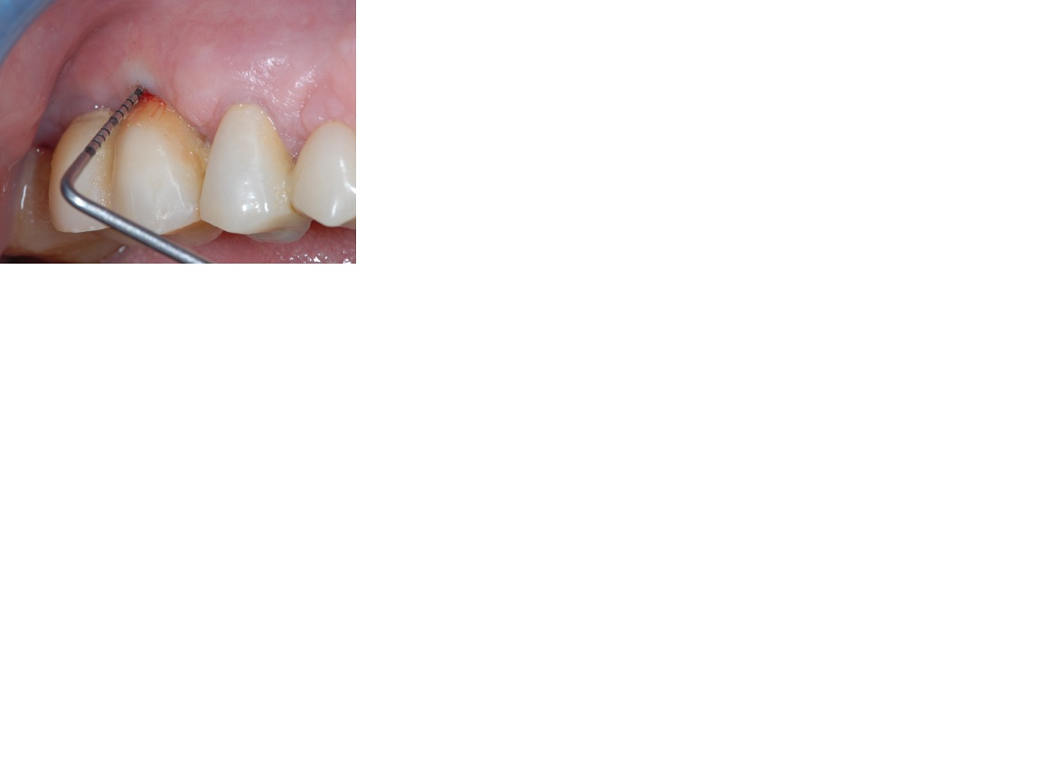

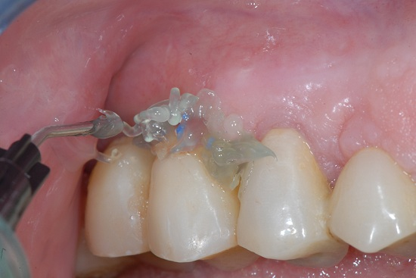
Fig.2

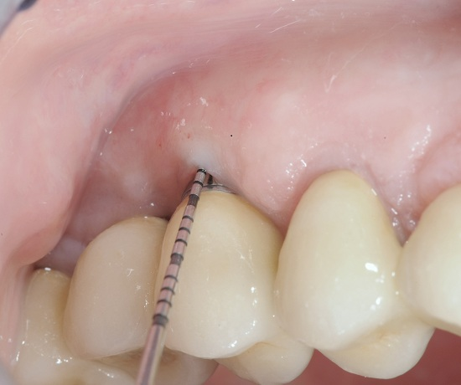

Fig.3

FIGURE LEGENDS
Fig.1 Probing depth (PD) is about 5 mm, buccally on posterior maxillary implant, BoP positive.
Fig. 2 The image illustrates the adjunctive antimicrobial treatment by locally delivered bio-adhesive dental gel.
Fig.3 The same site 6 weeks later. The peridontal probe measures 2 mm PD. The tissue surrounding the implant seems to offer better clinical stability, compared to initial clinical evaluation

