MANAGEMENT OF RADICULAR CYST USING PLATELET-RICH FIBRIN & ILIAC BONE GRAFT - A CASE REPORT

DR. DEEPALI JAIN
SENIOR RESIDENT
DEPARTMENT OF DENTISTRY
CHIRAYU MEDICAL COLLEGE AND HOSPITAL
BHOPAL-INDORE ROAD
BHOPAL
E-MAIL:- drdjain0211@gmail.com
Mobile no.:- 8305620625

DR.SOURABH JAIN
ASSISTANT PROFESSOR
DEPARTMENT OF SURGERY
CHIRAYU MEDICAL COLLEGE AND HOSPITAL
BHOPAL-INDORE ROAD
BHOPAL
E-MAIL:- drsourabhdevnagar@gmail.com
Mobile no.:- 7879281577

DR. GAURAV VIDHALE
LECTURER
DEPARTMENT OF ORAL PATHOLOGY AND MICROBIOLOGY
AMRAVATI DENTAL COLLEGE
AMRAVATI
E-MAIL:- gauravvidhale@rediffmail.com
Mobile no.:- 9096190966

DR. DEEP JAIN
ASSISTANT PROFESSOR
KOKILA DHIRUBAI AMBANI HOSPITAL
ANDHERI
MUMBAI
E-MAIL:- drdeepjain12e@gmail.com
Mobile no.:- 9899014597

ABSTRACT:-
Radicular cyst is one of the most commonly occurring cyst in the oral cavity which is usually preceded by trauma or an infectious condition that leads to its formation which is followed by enlargement. In recent times there are several treatment procedures that are being applied inorder to improve the the post- operative condition and to accelerate the process of healing and regeneration in the affected site. A 22 year old patient came to our OPD with the chief complain of swelling on the left side of the face since 2-3 months on investigating it was diagnosed as Radicular cyst which was treated initially by endodontic treatment of the involved tooth followed by enucleation of the cyst further an apicoectomy was done. Finally a PRF and iliac crest graft was given for esthetic rehabilitation with 21.

KEYWORDS:- Radicular Cyst, Platelet Rich Fibrin, Iliac Bone Graft, Regeneration, Repair

INTRODUCTION
Radicular cysts are those that arise from epithelial residues in the periodontal ligament as a consequence of inflammation, usually following death of dental pulp
- Most common odontogenic cyst
- Maxilla affected more than 3 times the mandible
- Males >Females
- 3-6th decade

PATHOGENESIS OF RADICULAR CYST:-
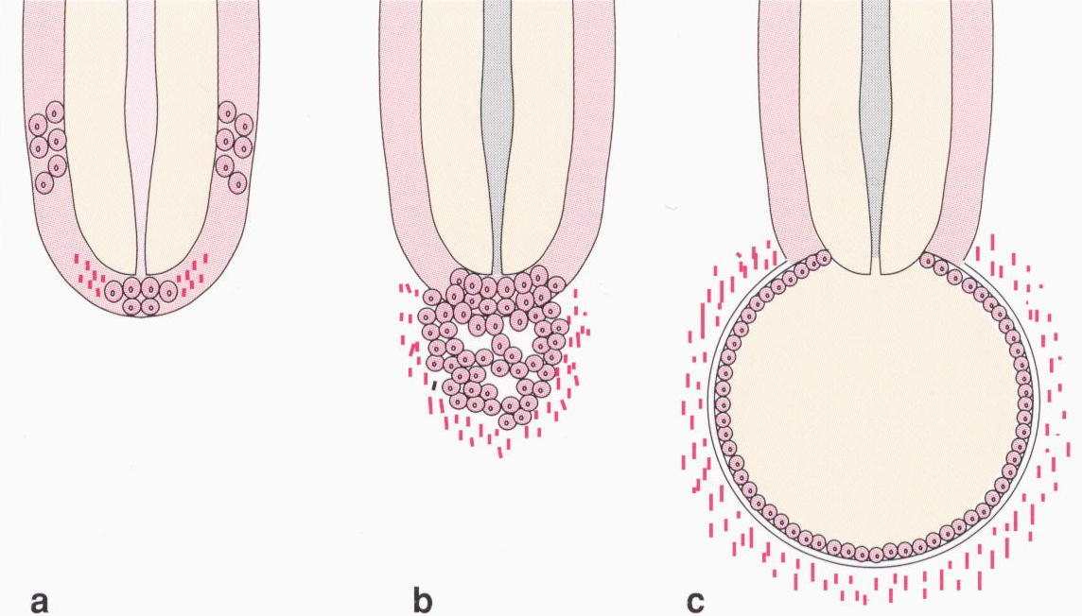
CYST
FORMATION

FFORMAYFORMSF
ENLARGEMENT
INITIATION
The process of pathogenesis of a cyst begins by initiation which gradually progresses to cyst formation and then enlarges to involve the adjacent bone and other vital structures in its surrounding.
The usual etiology is an infected tooth leading to necrosis of pulp. The toxins present here exit at the apex of the tooth, leading to periapical inflammation.
This inflammation stimulates the epithelial rests of Malassez, which are found in the apical periodontal ligament, resulting in the formation of periapical ligament, resulting in the formation of a periapical granuloma.
Over a period of time the epithelium undergoes necrosis that is caused by lack of blood supply which converts the granuloma to a cyst.

There are several types of Radicular Cyst:-
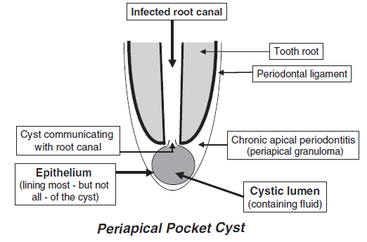

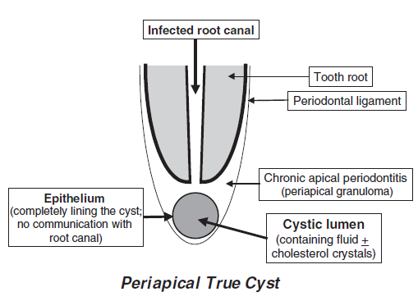

There are several treatment options to treat the cyst such as endodontic
treatment followed by enulecation and marsupilization.

CASE REPORT:-
A 22 year old male patient came to the OPD with the chief complain of swelling on the left side of the face since 2-3 months. A asking patient was apparently alright 3 months back then he had a fall from bicycle due to which 21 was fractured. The patient was alright than after 1 month he experienced pain and sensitivity which increased on taking cold beverages and was relived on its withdrawal after which he noticed pea sized swelling on the palatal surface and now has come for the same to our hospital. On extra oral examination a swelling of size 1x1cm approximately which is diffuse in nature with ill-defined margins that extends from infra-orbital margin up to corner of mouth which is not tender, Afebrile with skin same as that of adjacent area . On intraoral examination Ellis class 2 facture was seen in relation to 21. A swelling was seen on the palatal surface in relation with 21 which was approximately 0.5x0.5cm roughly oval in shape having color same as that of adjacent mucosa.
On basis of clinical evaluation we arrived to a provisional diagnosis of RADICULAR CYST WITH 21.

DIFFERENTIAL DIAGNOSIS:- Odontogenic keratocyst, Admentoid Odontogenic Tumor and Ameloblastoma.

CYST | ETIOLOGY | SITE | AGE & GENDER
OKC | Origin from primordial odontogenic epithelium, i.e. dental lamina or its remnants | Mandibular ramus | Males  Bimodal trend,  Pronounced in 2nd & 3rd  decades
AOT | Odontogenic origin, usually asociated with an impacted tooth | Anterior maxilla | Females more affected (3 :1)  3 - 19 years
Ameloblastoma | Arise from the enamel organ, remnants of dental lamina, lining of odontogenic cyst, or basal epithelial cells of the oral mucosa | Posterior mandible | Males more affected (1.6 :1)  3rd & 4th decade
Radicular cyst | Inflammatory changes following trauma or caries | Anterior maxilla | Males more affected  3-6th decade

Several investigations were carried out in order to obtain a confirmatory diagnosis namely:-
- OPG , IOPA & OCCLUSAL RADIOGRAPHS
- CT SCAN
- FINE NEEDLE ASPIRATION CYTOLOGY
- PULP TESTING
- ROUTINE BLOOD INVESTIGATIONS

On performing Electric Pulp Test:-

FNAC REPORT:-
- Straw- colored fluid
- Paucicellularity
- Polymorphs , macrophages and cell debris
- Rare squamous epithelium cells

On the basis of investigations the clinic-pathological diagnosis is diagnosed as Radicular Cyst.

Treatment was than planned based on the diagnosis:-
- Root canal treatment with 21 ,22 , 23
- Surgical enucleation of the cystic lesion
- Apicoectomy with 21, 22 ,23
- Placement of PRF and iliac bone graft
- Esthetic rehabilitation with 21
The obtained specimen is than grossed in order to obtain histopathological diagnosis showing features suggestive of Radicular Cyst.
The patient was evaluated 3 months post-operatively on taking an OPG it was observed that the radiopacity has increased as compared to earlier also, good amount of regeneration and repair at the site of injury was seen which could be subjected to the use of PRF and Iliac bone graft for the purpose repair of the wound.
DISCUSSION:-
The post-surgical process involves 2 main factors:-
- Regeneration
- Repair
(Ross ,1974 - Platelets have regenerative potential)
REGENERATION;-
Regeneration has been defined as the reproduction or reconstitution of a lost or injured part to restore the architecture and function of the periodontium.
It is possible with growth factors and bone grafts. Need for biological modulators resulted in development of Platelet Rich Plasma (PRP) by Whitmen et al 1997.
PLATELET RICH FACTOR:-
- New revolutionary step in the platelet gel therapeutic concept. Attempts to accumulate platelets and released cytokines in a fibrin clot.

ADVANTAGES OF PRP OVER PRP:-
- More efficient cell migration and proliferation
- Favourable healing due to slow polymerization
- Supportive effect on immune system

BONE GRAFTS:-
Several types of bone grafts are used such as autogenoug graft, allogenic graft,alloplastic graft and Xenogeneic graft. There are several bone grafts that are used for the purpose of osteoinduction, osteoconduction and osteoproliferation. Bone grafts alone without a blood clot or angiogenic factors are unlikely to promote sufficient periapical wound healing. PRF in the form of a platelet gel and can be used in conjunction with bone grafts.
Besides promoting wound healing, bone growth & maturation, PRF with bone graft have the advantages of graft stabilization, wound sealing, hemostasis and improved handling propertiesThe success of spontaneous bone healing is directly related to the size of bony defects, the anatomical location, the patient’s age and other parameters. Many researches advocate the filling of the remaining cystic cavities with bone grafts.
LIMITATIONS OF THE PROCEDURE:-
- Only radiographic evaluation can be done.
- Histological studies are required to examine the nature of newly formed tissue in the defect.
- Long-term, controlled clinical trials will be required.
CONCLUSION:-
The application of autologous platelet-rich fibrin along with bone graft could present new possibilities for enhanced healing and functional recovery. It could be more effective and economical than any other available regenerative materials.
The anterior iliac crest provides abundant cancellous bone & is ideal for condensing into bony defects, such as alveolar cleft and cystic cavities.

CONFLICT OF INTEREST:- NONE

REFERENCES:-

LEGEND OF FIGURES:-
LEGEND 1:- FIGURE NO.1:- EXTRAORAL VIEW
LEGEND 2:- FIGURE NO.2:- INTRAORAL VIEW SHOWING FACTURED 21
LEGEND 3:- FIGURE NO.3:- INTRAORAL VIEW SHOWING SITE OF LESION
LEGEND 4:- :- FIGURE NO.4:- RADIOGRAPHIC VIEW SHOWING SITE OF LESION IN AN IOPA AND OCCLUSAL VIEW WHICH APPEARS AS RADIOLUCENT AREA
LEGEND 5:- FIGURE NO.5:- AN ORTHOPENTOGRAM SHOWING RADIOLUCENCY IN RELATION 21,22,23,24.
LEGEND 6:- FIGURE NO.6:- CT SCAN IN AN AXIAL AND CORONAL SECTION SHOWING RADIOLUCENT LESION ON APICAL AREA OF MAXILLARY ANTERIORS
LEGEND 7:- FIGURE NO.7:- ENUCLEATION OF THE CYST UNDER GA, EXCISED CYSTIC SPECIMENALONG WITH SYRINGE CONTAINING CYSTIC FLUID.
LEGEND 8:- FIGURE NO.8:-APICOECTOMY FOLLOWED BY PRF & ILIAC BONE
GRAFT PLACEMENT FOLLOWED BY SUTURING
LEGEND 9:- FIGURE NO.9:-HISTOPATHOLOGICAL VIEW SHOWING FEATURES OF RADICULAR VIEW UNDER 10X.
LEGEND 10:- FIGURE NO.10:- POST-OPERATIVE EVALUATION OF PATIENT CLINICALLY AND RADIOGRAPHICALLY TO EVALUATE HEALING AND REGENERATIVE PROCESS 3 MONTHS LATER

