The Relationship between Dental Anxiety Level and Patients’ Knowledge of the Treatment Procedure

TAWFIG Ahmed, Clinical MD

ALSHATHRI Najlaa, BDS

DADA Bayan, BDS

ALGHOFAILI Rowa, BDS. rowamg@gmail.com 00966599888584. FAX

ALTWERQI Deema, BDS

ALDAWSARI Ghaida, BDS

ALZABIN Asma, BDS

The Relationship between Dental Anxiety Level and Patients’ Knowledge of the Treatment Procedure

Abstract

Aim:
6% of the general population avoids dental treatments due to anxiety related to dental treatment. The aim of this study is to determine the relationship between dental anxiety level and patients’ knowledge of the procedure steps to be conducted, and to perceive the biological correlation between heart rate and dental anxiety.

Material and Methods:
A random sample of patients were divided in to two groups, a study group and a control group. The study group were shown a video describing the dental procedure steps, after filling the Modified Dental Anxiety Scale (MDAS) questionnaire. The study group participant's heart rates were recorded four times with a pulse Oximeter; in the waiting area, while watching the video, on the dental chair before receiving anesthesia, and after the procedure. The control group did not watch the video and had their heart rates recorded three times.

Results:
In the waiting area; both groups showed normal heart rate readings. While watching the video, the study group showed an increased heart rate. When seated on the dental chair, both groups displayed increased heart rate readings.
Salivary cortisol level measurements for both groups were within the normal range. However, the study group showed a higher salivary cortisol level than the control.

Conclusion:
Salivary cortisol level and heart rate can be reliable methods to confirm patient’s anxiety level. Our study reviled increasing of dental anxiety among patients receiving detailed information about the producers’ steps prior to their treatment.

Key words: Cortisol, Dental Anxiety, Heart Rate, Dental Education

Introduction:

Three different terms have been used concerning dental apprehension in the literature:
Dental anxiety, fear and phobia of pain remain globally widespread and are considered major barriers to dental treatment [1]. Generally fear is defined as an individual’s response to a real threatening event or dangerous situation to protect his or her life [2] while Specific phobia is an anxiety disorder classification that represents unreasonable or irrational fear related to a specific object or situation [3].

Fear is considered to be aroused by a real, immediately present, specific stimulus (e.g. needles, drilling), whereas in the case of anxiety, the source of the threat is unclear, ambiguous, or not immediately present[4, 5].In1998 Canakci noted that a patient with a high DAS (Dental Anxiety Score) would be more likely to present a high pain response than a patient with a lower DAS[6]. People with high DAS exhibit more pain after dental treatment [7, 8].

A British study conducted in 2004, assessed the fear of dental pain among 1,800 students, and found that 17% reported dental fear, and 73% reported that oral health status affects quality of life [9].

In 2009 W. Al-Omari and M. Al-Omiri, concluded that the lack of adequate dental health education may result in a high level of dental anxiety among non-dental university students in Jordan [10]. Another study in 2011, involving 1,600 Saudi students, revealed that 22% displayed a high degree of dental fear [11]. In the same year, a different study was carried out in Pakistan, assessed discomfort with regard to dental treatment among 503 university students, and found that 21.6% of men and 24.0% of women reported negative sensations in relation to dental treatment [12].

Anxiety related to dental treatment is a well-known phenomenon that has been reported to cause 6% of the general population to avoid dental treatments [13].This avoidance of dental treatment, lead to poorer oral health and oral health-related quality of life [14,15].

Test of anxiety:
The biological correlates of anxiety have not been widely examined, but the social examination using questionnaires is often used as a stress indicator. Stress related effects have been noted for hematological indices such as red blood counts, hemoglobin [16] ,blood pressure, heart rate [17] ,immunity in the form of natural killer cells activity [18] , and hormones such as cortisol [19] .In addition, it appears that there is disparity between social examination (self-reported) and physiological stress that have not been correlated well enough in the literature. This demonstrates the importance of utilizing both social and physiological tests.

When the ANS (Autonomic Nervous System) gets activated, it releases epinephrine and nor epinephrine from the adrenal medulla [20].Upon activation of the hypothalamic-pituitary-adrenal axis, cortisol is secreted from the adrenal cortex to the saliva and all other body fluids [21]. It was demonstrated in the past that salivary cortisol increases in response to stress and anxiety, and that it also presents an easy, noninvasive way of measuring stress [22]. Cortisol levels were shown to be higher in patients undergoing wisdom teeth extractions and before emergency dental care [23]. Similar to alpha amylase, cortisol has a definite circadian rhythm [21].

In 2006, A.J.Van Wijk concluded that fear of pain for endodontic treatment can be decreased significantly by providing positive information about Endodontic treatment [24].A Saudi study found that oral health knowledge will enhance oral health by transforming knowledge into appropriate behaviors [25]. In 2005, an Indian study concluded that the impact of dental fear on oral health related quality of life was significantly higher among non-school going than school going children, due to low socioeconomic status and lack of awareness towards oral health and lack of dental visits [26].

Aim:
The major objective of this study is to determine the relationship between dental anxiety level and patients’ knowledge of procedure steps to be conducted and to prove the correlation between salivary cortisol level, and heart rate with dental anxiety.

Material and Method:
A random sample of eighty patients between the ages of 20 to 50 years old who attended Riyadh Colleges of Dentistry & Pharmacy’s dental clinic, were divided in to two groups, a study and control group. The study group was shown a video describing the dental procedure steps, after filling the Modified Dental Anxiety Scale (MDAS) questionnaire. The study group participants’ heart rates were recorded four times with a pulse Oximeter; in the waiting area, while watching the video, on the dental chair before receiving local anesthesia, and finally after the procedure. The control group did not watch the video and had their heart rates recorded three times: in the waiting area, on the dental chair and after the procedure. A saliva sample was collected utilizing the method of passive drooling. Participants were asked to allow the saliva to pool at the floor of the mouth first, before ejecting it. Sample collection was done over a maximum of 5 minutes; time and volume of the samples were recorded. All the samples were stored at 5 degrees Celsius until the saliva cortisol analysis was performed in the specialized laboratory. Any Patient with medical disorder, psychological disorder, under any pain or anxiety medication, smokers, alcoholics, pregnant women and patients who refused to give informed consent were excluded from the study; which was attached to the questionnaire. Riyadh Collages of Dentistry and Pharmacy’s ethical committee, prior to the data collection gave ethical approval.

The Questionnaire
The instrument of study used in this research will be based on the Modified Dental Anxiety Scale (MDAS); which is a brief, self-complete questionnaire consisting of five questions each with a 5 category rating scale from ‘not anxious’ to ‘extremely anxious’, It is the most well-known adult questionnaire designed to assess dental anxiety [27]. The original English version of the MDAS questionnaire was translated by experienced bilingual professional who was fluent in English (and for whom Arabic was her native language) translated the questionnaire from English to Arabic. The Arabic version of the MDAS had excellent internal consistency and reliability (Alpha coefficients> 0.90). The scale was uni-dimensional, and the percentage of patients with dental anxiety was 48.3% (15).

Physiological Test
Pulse Oximeter:
The Pulse Oximeter is a non-invasive method for monitoring a person's oxygen saturation and heart rate. Its most common (transmissive) application mode, a sensor device is placed on a thin part of the patient's body, usually a fingertip. The device passes two wavelengths of light through the body part to a photo detector. It measures the changing absorbance at each of the wavelengths, allowing it to determine the absorbance due to the pulsing arterial blood alone, excluding venous blood, skin, bone, muscle, fat, and nail polish (in most cases) [28].

Salivary Cortisol:
A saliva sample was collected at the same time range for both groups utilizing the method of passive drooling, using 2-mL cryovials. Participants were asked to allow the saliva to pool at the floor of the mouth first, before ejecting it into the cryovials through a short piece of straw. Samples collections were done over a maximum of 5 minutes; time and volume of the samples were recorded. The samples then were sent to the lab for salivary cortisol measurement. Suggested in this study and the test were performed and interpreted following instruction out lined in kit (Human Cortisol ELISA Kit) MyBioSource, USA.
Principle of the test
The kit uses a double-antibody sandwich enzyme-linked immunosorbent Assay (ELISA) to assay the level of Human Cortisol (CORTISOL) in saliva. Human Substance Cortisol (CORTISOL) of saliva were positively correlated assay procedure:
1. Standard dilution: this test kit will supply one original Standard reagent and dilution occurs according
to the instruction.
2.The quantity of the plates depends on the quantities of to-be-tested saliva and the standards.
3.Inject saliva: Blank well: don’t add saliva and CORTISOL –antibody labeled with biotin, Streptavidin-HRP, only Chromogen solution A and B, and stop solution are allowed; other operations are the same.
Standard wells: add standard 50µl, Streptavidin-HRP 50µl (since the standard already has combined biotin antibody, it is not necessary to add the antibody); to be test wells: add saliva 40µl, and then add both CORTISOL -antibody 10µl and Streptavidin-HRP 50µl. Then seal the sealing membrane, and gently shaking, incubated 60 minutes at 37C°.
4.Confection: dilute 30 times the 30×washing concentrate with distilled water as standby.
5. Washing: remove the membrane carefully, and drain the liquid, shake away the remaining water.
6. Add chromogen solution A 50µl, then chromogen solution B 50µl to each well. Gently mixed, incubate for 10 min at 37 C° away from light.
7. Stop: Add Stop Solution 50µl into each well to stop the reaction (the blue changes into yellow immediately).
8. Final measurement: take blank well as zero, measure the optical density (OD) under 450 nm wavelength which should be carried out within 15min after adding.
9. According to standards’ concentration and the corresponding OD values, calculate out the standard curve linear regression equation, and then apply the OD values of the saliva on the regression equation to calculate the corresponding saliva’s concentration.

Statistical Analysis:
All the data were statistically analyzed with the IBM-SPSS ver.21 data processing software (IBM corp. Armonk, NY, USA). One-way ANOVA test were used to compare control & study group salivary cortisol levels & heart rate differences in all stages. Cramer’s Contingency Coefficient test was used to compare MDAS score in both groups. While Pearson correlations were used to correlate between salivary cortisol levels & heart rate on the dental chair, and Spearman Rank Correlation were used to correlate between MDAS, heart rate & salivary cortisol levels.

Results:
The result obtained showed that from the 80 volunteers who participated in the research, 51 (63.75%) were female, and 29 (36.25%) were male. The mean age was 31.35 for both groups (Fig.1, 2). All of them followed this study’s inclusion criteria. Both groups had a normal heart rate value in the waiting area. An increase in the heart rate reading was found in the study group while watching the video. Both groups showed a noteworthy higher HR on the dental chair (P=0.36). While there was no significant difference in the HR after the procedure (P=0.771).
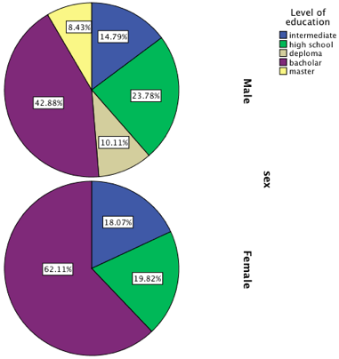
(Fig.1) Show’s Female and male level of education for control group.
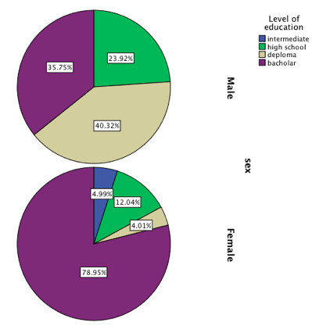
(Fig.2) Show’s Female and male level of education for Study group.

This study investigated the difference in cortisol level between the control and study group; and found out that the mean value for salivary cortisol level in the study group was higher than the control group, even though it was statistically not significant (P value= .163) (Table.1).
Salivary Cortisol Level
Patient group Type | N | Mean | Std. Deviation | Variance | Minimum | Maximum | Range
Control | 40 | 6.3487 | 2.55175 | 6.511 | 1.13 | 10.70 | 9.57
Study | 40 | 7.6306 | 5.12983 | 26.315 | .50 | 19.92 | 19.42
Total | 80 | 6.9897 | 4.07695 | 16.622 | .50 | 19.92 | 19.42
Table.1: Salivary cortisol levels for control and study groups.

Prior to dental treatment; in the waiting area; both control and study groups showed normal heart rate readings (< 90Beats/Minute). While watching the video, the study group showed an increased heart rate. When seated on the dental chair, both groups displayed increased heart rate readings, however when compared with the waiting area readings, the study group showed higher readings than the control group (Table 2)(Fig.3).
Heart Rate:
Patient groups during stages | N | Mean | Std. Deviation | Variance | Minimum | Maximum | Range
Heart Rate Waiting Area Control | 40 | 83.3250 | 13.82378 | 191.097 | 56.00 | 113.00 | 57.00
Heart Rate Waiting Area Study | 40 | 85.9750 | 11.19406 | 125.307 | 61.00 | 104.00 | 43.00
Heart Rate Dental Chair Control | 40 | 82.8500 | 15.82363 | 250.387 | 57.00 | 122.00 | 65.00
Heart Rate Dental Chair Study | 40 | 89.2000 | 13.95634 | 194.779 | 64.00 | 124.00 | 60.00
Heart rate After Procedure Control | 40 | 80.3250 | 12.72669 | 161.969 | 58.00 | 111.00 | 53.00
Heart rate After Procedure Study | 40 | 85.1750 | 12.80202 | 163.892 | 56.00 | 110.00 | 54.00
Heart Rate Study in Waiting | 40 | 85.9750 | 11.19406 | 125.307 | 61.00 | 104.00 | 43.00
Heart Rate Study while watching video | 40 | 87.3750 | 9.92714 | 98.548 | 64.00 | 110.00 | 46.00
Total | 320 | 85.0250 | 12.92852 | 167.147 | 56.00 | 124.00 | 68.00
Table 2: Patients heart rates during stages of treatment for both groups.
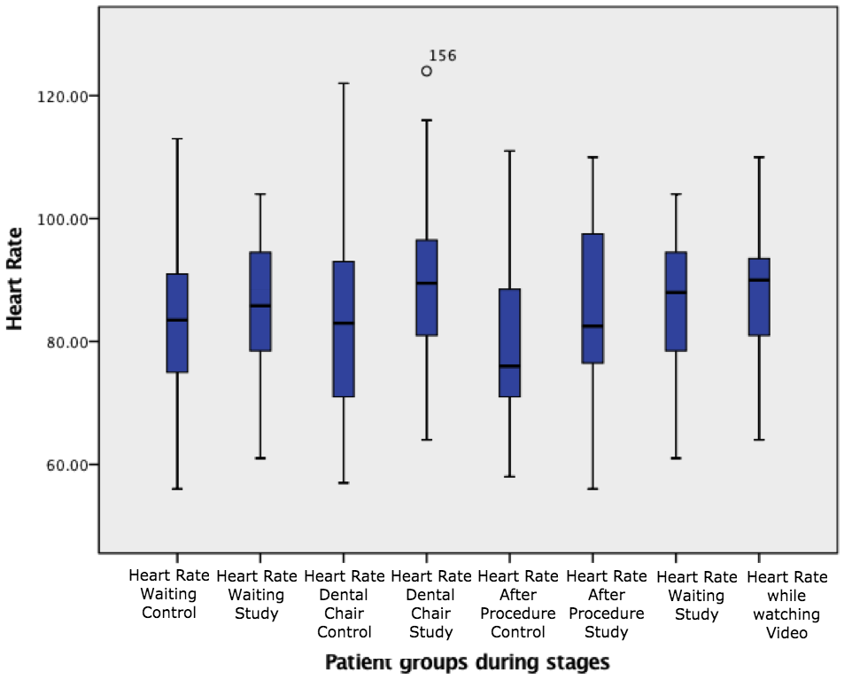
(Fig.3) Shows heart rate values in both groups through different stages.
From the sample we have in this study, we can say that all salivary cortisol level measurements for both groups were normally distributed, also there were no significant statistical differences between the groups means (±6.34). However, the study group had a higher salivary cortisol level than the control, this difference is consider unimportant statistically (Fig.4).
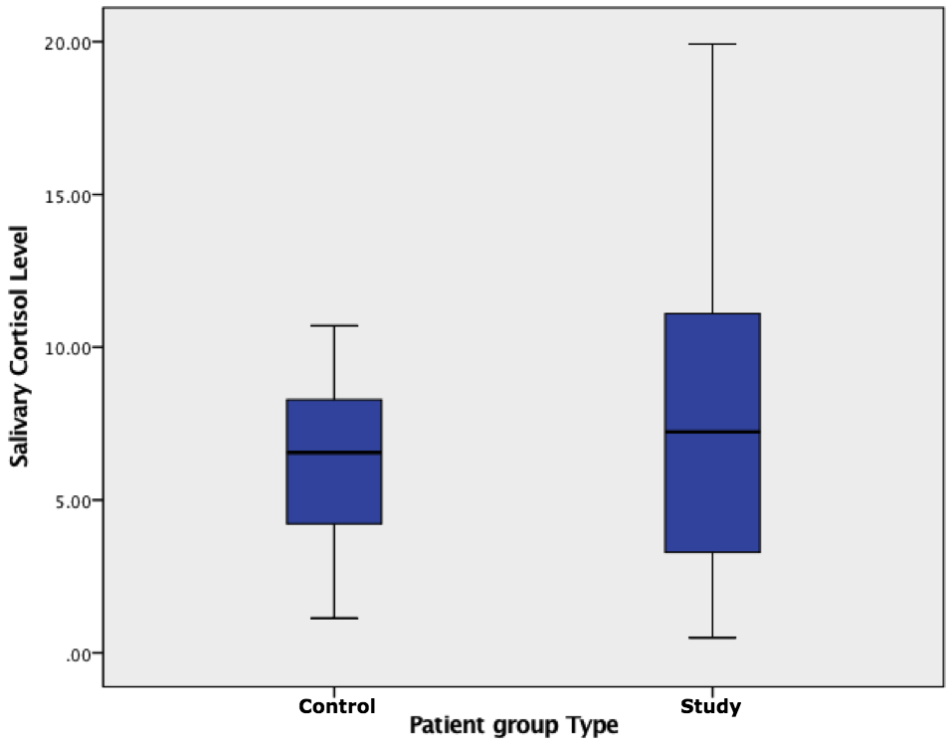
(Fig.4) Salivary cortisol levels in study and control groups.
There is no relation between heart rate readings and salivary cortisol levels within each group; moreover, ρControl and ρStudy are estimated to be 0.000 and they are equivalent (Table 3). There is no statistically significant relationship between the groups salivary cortisol (control and study) and questionnaire result.

Heart rate and salivary cortisol levels
 | Heart Rate on Dental Chair for Study | Cortisol level for Study | Heart Rate on Dental Chair for Control | Cortisol level for Control
N | 40 | 40 | 40 | 40
Minimum | 64.00 | .50 | 57.00 | 1.13
Maximum | 124.00 | 19.92 | 122.00 | 10.70
Range | 60.00 | 19.42 | 65.00 | 9.57
Table 3: Heart rate and salivary cortisol levels relation in both groups.

The MDAS questionnaire was evenly distributed for both groups, they were asked to answer the questions blindly (without knowing which group they belonged to). As seen in the Bar chart (Fig.5) both “Control” and “study” carry the same proportion when it comes to the Questionnaire results: p Slightly anxious = 62.5%, π other anxious level for each category = 9.375%.
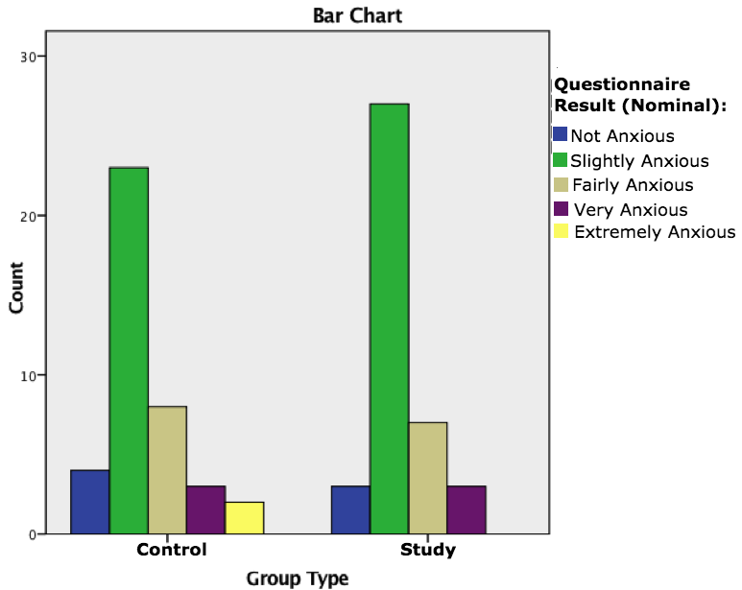
(Fig.5) Questionnaire results proportions in both groups.
There is no statistically significant correlation relationship between the salivary cortisol levels and questionnaire results for both groups (control & study). Both “Control” and “Study” have a value of ρsp =0.00 with salivary cortisol levels (Table 4, 5). Furthermore, there is no statistically significant correlation relationship between HR in the waiting area and the questionnaire results for both groups (control & study). Both “Control” and “Study” have a value of ρsp = 0.00 with HR in the waiting area (Table 6, 7).

Salivary cortisol levels and questionnaire results
 |  |  | Questionnaire Result | Salivary Cortisol Level
Spearman's rho | Questionnaire Result | Correlation Coefficient | 1.000 | .081
 |  | Sig. (2-tailed) | . | .618
 |  | N | 40 | 40
 | Salivary Cortisol Level | Correlation Coefficient | .081 | 1.000
 |  | Sig. (2-tailed) | .618 | .
 |  | N | 40 | 40
Table 4: Salivary cortisol levels and questionnaire results for control group.
Salivary cortisol levels and questionnaire
 |  |  | Questionnaire Result | Salivary Cortisol Level
Spearman's rho | Questionnaire Result | Correlation Coefficient | 1.000 | .175
 |  | Sig. (2-tailed) | . | .279
 |  | N | 40 | 40
 | Salivary Cortisol Level | Correlation Coefficient | .175 | 1.000
 |  | Sig. (2-tailed) | .279 | .
 |  | N | 40 | 40
Table 5: Salivary cortisol levels and questionnaire results for study group.

Heart rate in the waiting area and the questionnaire
 |  |  | Questionnaire Result | Heart Rate in the Waiting area
Spearman's rho | Questionnaire Result | Correlation Coefficient | 1.000 | -.021
 |  | Sig. (2-tailed) | . | .895
 |  | N | 40 | 40
 | Heart Rate in the Waiting area | Correlation Coefficient | -.021 | 1.000
 |  | Sig. (2-tailed) | .895 | .
 |  | N | 40 | 40
Table 6: Heart rate in the waiting area and the questionnaire results in control group.

Heart rate in the waiting area and the questionnaire results
 |  |  | Questionnaire Result | Heart Rate in the Waiting area
Spearman's rho | Questionnaire Result | Correlation Coefficient | 1.000 | -.104
 |  | Sig. (2-tailed) | . | .522
 |  | N | 40 | 40
 | Heart Rate in the Waiting area | Correlation Coefficient | -.104 | 1.000
 |  | Sig. (2-tailed) | .522 | .
 |  | N | 40 | 40
Table 7: Heart rate in the waiting area and the questionnaire results for study group.
Discussion:
Emotional stresses increase the activity of the HPA (hypothalamic-pituitary-adrenal axis), which results in an enhanced secretion of adrenocortical hormones, and salivary cortisol is a reliable measure for assessment of its activity [29]. In stressful situations, the sympathetic nervous system is responsible for the release of epinephrine and norepinephrine, which causes the acceleration of heart rate [30]. In this study the mean value for cortisol level in the study group was higher than the control group, even though it was statistically not significant (P value= .163) that might be due to a small sample size. Noriyasu Takai et al. participants also showed an increase in cortisol level when shown a stressful video. [22]

The lowest HR reading was recorded at the end of the procedure; although the study group showed a lower reading than the control group. A similar study was done in 2014 by S.C.Panie et al. also found that the lowest heart rate recorded was after procedure, while the highest was during implant placement [31]. Another study by J.C.Goylart et al. contradicted our findings, stating that the heart rate did not change during the dental treatment in relation to the anxiety level presented by the patients [32]. That might be because of different methodology in their study they used the “Dental Anxiety Scale”, aneroid sphygmomanometer and a professional cardiologic stethoscope to measure the heart rate and blood pressure, while in our study we used MDAS and pulse oximeter to measure the heart.

Salivary cortisol levels and questionnaire results are compared for both “Control” and “Study” groups and showed no statistically significant correlation, although a positive relation was present between both of them. In a disagreement with our result K.Kanegane et al. stated that there was a tendency for negative association between salivary cortisol and MDAS score [33]. That might be due to different saliva collection method, they asked their subjects to hold a soft cotton roll in the mouth until it was saturated with saliva then it was transferred to aplastic tube. Moreover, there is no statistically significant correlation between heart rate in the waiting area and questionnaire results for both groups.
Furtherer investigation with larger sample size is needed in the future to determine the correlation between the heart rate and salivary cortisol level.
Conclusion:
- Salivary cortisol level and heart rate can be reliable methods to confirm patient’s anxiety level.
- A positive relation found between anxiety scale and both heart rate and salivary cortisol, even though the correlation between them is not detected.
- Our study reviled increasing of dental anxiety among patients receiving detailed information about the producers’ steps prior to their treatment.

References:

1. Yuzugullu B, Gulsahi A, Celik C, Bulut S. Dental anxiety and fear: relationship with oral health behavior in a Turkish population. The International journal of prosthodontics. 2014;27(1):50-3.
2. Bay EJ, Algase DL. Fear and anxiety: a simultaneous concept analysis. Nursing diagnosis : ND : the official journal of the North American Nursing Diagnosis Association. 1999;10(3):103-11.
3. LeBeau RT, Glenn D, Liao B, Wittchen HU, Beesdo-Baum K, Ollendick T, et al. Specific phobia: a review of DSM-IV specific phobia and preliminary recommendations for DSM-V. Depression and anxiety. 2010;27(2):148-67.
4. Milgrom P WP, Getz T. Treating fearful dental patients a patient management handbook. 1995(2nd ed).
5. Aartman IH, van Everdingen T, Hoogstraten J, Schuurs AH. Self-report measurements of dental anxiety and fear in children: a critical assessment. ASDC journal of dentistry for children. 1998;65(4):252-8, 29-30.
6. Canakci CF, Canakci V. Pain experienced by patients undergoing different periodontal therapies. J Am Dent Assoc. 2007;138(12):1563-73.
7. Maggirias J, Locker D. Psychological factors and perceptions of pain associated with dental treatment. Community dentistry and oral epidemiology. 2002;30(2):151-9.
8. Sullivan MJ, Neish NR. Psychological predictors of pain during dental hygiene treatment. Probe. 1997;31(4):123-6, 35.
9. McGrath CB, R. The association between dental anxiety and oral health-related quality of life in Britain. Commnunity Dent Oral Epidemiol. 2004;32:67-72.
10. Wael Mousa AL-OMARI MKA-O. DENTAL ANXIETY AMONG UNIVERSITY STUDENTS AND ITS CORRELATION WITH THEIR FIELD OF STUDY. J Appl Oral Sci. 2009;17(3):199-203.
11. Abu-Ghazaleh SBR, L.D.; Sonbol, H.N.; Aljafari, A.K.; Elkarmi, R.F.; Humphris, G. The Arabic version of the modified dental anxiety scale.Psychometries and normative data for 15–16 years old. Saudi Med J. 2011;32:725-9.
12. Shaikth MAK, A. Over dental anxiety problems among university students: Perspective from Pakistan. J Coll Physicians Surg Pak. 2011;21:237-8.
13. Kleinknecht R BD. The assessment of dental fear. Behav Ther 1978;9:626-34.
14. Eitner S, Wichmann M, Paulsen A, Holst S. Dental anxiety--an epidemiological study on its clinical correlation and effects on oral health. J Oral Rehabil. 2006;33(8):588-93.
15. Jason M. Armfield, and GDS, Spencer AJ. Dental fear and adult oral health in Australia Community dentistry and oral epidemiology. 2009;37(3):220-30.
16. Maes Mea. Influence of academic examination stress on hematological measurements in subjectively healthy volunteers. Psychiatry Research. 1998;80:201-12.
17. Hughes BM. Academic study, college examinations, and stress: issues in the
interpretation of cardiovascular reactivity assessments with student participants. Journal of Applied Biobehavioral Research. 2004;9:23-44.
18. Borella PA, Rovesti, S., Pinelli, S., Vivoli, R., Solfrini, V., & Vivoli, G. Emotional stability, anxiety, and natural killer cell activity under examination stress. Psychoneuroendocrinology. 1999;24:613-27.
19. Hellhammer DH, Heib, C., Hubert, W., & Rolf, L. IRCS Medical Science. Psychology and Psychiatry. 1985;13:1179-80.
20. Nater U, N R. Salivary alpha-amylase as a noninvasive biomarker for the sympathetic nervous system: current state of research. Psychoneuroendocrinolog. 2009;34: 486-96.
21. Sadi H, Finkelman M, Rosenberg M. Salivary cortisol, salivary alpha amylase, and the dental anxiety scale. Anesth Prog. 2013;60(2):46-53.
22. Takaia N YM, Aragakia T, Etoa K, Uchihashia K, Nishikawa Y. Effect of psychological stress on the salivary cortisol and amylase levels in healthy young adults. Arch Oral Biol. 2004;49:863-968.
23. Miller CS, Dembo JB, Falace DA, Kaplan AL. Salivary cortisol response to dental treatment of varying stress. Oral Surg Oral Med Oral Pathol Oral Radiol Endod. 1995;79(4):436-41.
24. van Wijk AJ, Hoogstraten J. Reducing fear of pain associated with endodontic therapy. International endodontic journal. 2006;39(5):384-8.
25. Wyne AH, Chohan AN, Al-Abdulsalam Z, Al-Qedrah A, Al-Qahtani S. Oral health knowledge and sources of information among male secondary school children in Riyadh. Saudi Dental Journal.2005;17.
26. Goyal A, Sharma A, Gaur T, Singh J, Pachori Y, Chhabra KG, et al. Impact of dental fear on oral health-related quality of life among school going and non-school going children in Udaipur city: A cross-sectional study. Contemporary clinical dentistry. 2014;5(1):42-8.
27. Dailey YM, Humphris GM, MA L. The use of dental anxiety questionnaires: a survey of a group of UK dental practitioners. Br Dent J. 2002;190:450-3.
28. Brand TM , Brand ME, GD; J, Jay B. Enamel nail polish does not interfere with pulse oximetry among normoxic volunteers. J Clin Monit Comput 2002;17(2).
29. king SL HK. stress hormones: how do they measure up? Biol Res Nurs. 2002;4:92-103.
30. Seaward BL. Managing stress principles and strategies for health and well-being 5th edition ed.
31. Pani SC. Assessment of the Impact of Stress and Anxiety on Pain Perception in Patients Undergoing Surgery for Placement of their First Dental Implant. journal of oral health and dental management. June, 2014;13(2).
32. Goulart JCF, Pinheiro MD, Rodrigues RV, Santos FdSAd, Martins AT, Scannavino FLF. Influence of anxiety on blood pressure and heart rate during dental treatment. Rev Odonto Cienc. 2012;27(1):31-5.
33. Kazue Kanegane, Sibele S. Penha, Munhoz CD, Rocha RG. Dental anxiety and salivary cortisol levels before urgent dental care. Journal of Oral Science. 2009;51(4):515-20.

